**The location in the morning**

**Trump's Days of Defiance**

By [Dirk Kurbjuweit](https://www.spiegel.de/impressum/autor-d6a694ab-0001-0003-0000-000000001319), author in the SPIEGEL capital office

Dear reader, good morning,

today we deal with hard bandages in the USA, with lawsuits against masks in Germany, with the revolutionary Robert Blum and with the salt shaker.

11-09-2020, 05:36 AM

**The Hour of Judges I**

Even losers can do a lot of damage, in a legal way. This is the path **donald Trump** has taken. From today on, he wants to let his lawyers [run more strongly against the election results.](https://www.spiegel.de/ausland/us-wahl-2020-die-usa-zwischen-joe-biden-und-donald-trump-a-118fcb1b-ce70-4d78-9652-a24f433789f4) That is his right, even if there is no evidence so far that Trump, as he claims, has been cheated.

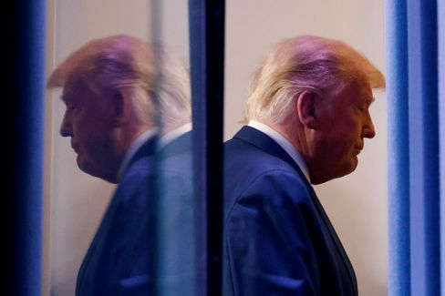

Donald Trump

Photo: CARLOS BARRIA / REUTERS

The question is whether one should make the most of one's possibilities to the last. The democracy researchers Steven Levitsky and Daniel Ziblatt have pointed out that democracies also rely on **"institutional omission":** "It is an act of deliberate self-restraint - we do not fully exploit the power to which we are legally entitled."

Trump's fight may help his ego, though it seems punier with each passing day of defiance, but it impedes the transition, scratching at the legitimacy and thus the power of the future president. Trump's actions are contrary to the spirit of the Constitution by using it mercilessly for his own purposes. This is called "constitutional hardball", **constitutional struggle with hard bandages.** Levitsky and Ziblatt: "With every failing or failed democracy, constitutional hardball abounds."

It is not over, the fight for US democracy continues. Now it depends on the judges.

* [Resistance to US election results: Trump's man for the rough](https://www.spiegel.de/ausland/richard-grenell-donald-trumps-mann-fuers-grobe-a-2bec8d33-7a8b-4ded-844d-e9bb7b00fdb7)

**The Hour of Judges II**

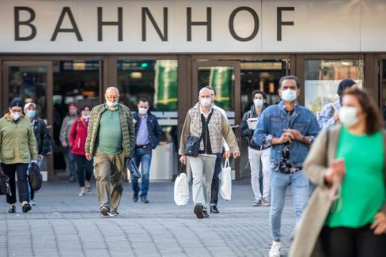

People with masks in Düsseldorf (April 2020)

Photo: Marcel Kusch/ DPA

There is also a kind of "constitutional hardball" in Germany these days, but with less drama. An administrative court is expected to decide today whether the mask requirement is permissible **for the Düsseldorf city area.**  Citizens challenge this requirement with urgent applications.

There have recently been some judgments that have overturned political decisions in the fight against Corona, [the ban on accommodation in Baden-Württemberg](https://www.spiegel.de/politik/deutschland/corona-gericht-kippt-beherbergungsverbot-in-baden-wuerttemberg-a-7fd414c8-f59d-458d-9479-f1a4720e0761) or [the curfew for some Berlin innkeepers.](https://www.spiegel.de/politik/deutschland/corona-bestimmungen-gericht-kippt-berliner-sperrstunde-a-0c6b23db-f9c1-42b1-bba1-1c6b7ad85197) There will be more lawsuits, more judgments. That is what the rule of law is for; in case of doubt, it also protects the interests of the individual against the majority. I will always defend this principle, but I think it would be appropriate for some people to decide not to take legal action, so that we can see whether the political decisions can help this country out of the crisis. It's not that bad to wear a mask.

Otherwise, it just depends on the judges.

* [Simulation of the course of the pandemic: These are the scenarios for the corona winter](https://www.spiegel.de/wissenschaft/medizin/corona-in-deutschland-das-sind-die-szenarien-fuer-den-winter-a-00000000-0002-0001-0000-000173898802)

**Death in the early morning**

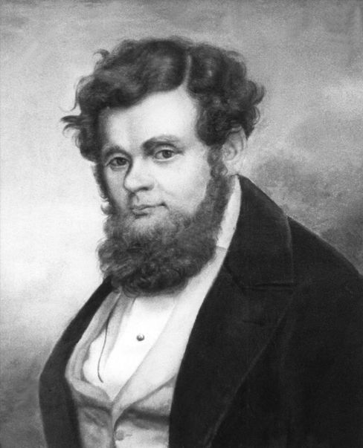

Robert Blum (undated archive image)

Photo: DPA

On November 9, 1848, **Robert Blum** was awakened at five o'clock in the morning. At six o'clock he stood in front of a firing squad. His last words are said to have been these: "I die for freedom, may the fatherland be mindful of me." Today, this wish should finally come true, at least a little bit. Federal President **Frank-Walter Steinmeier** will inaugurate the new Robert **Blum Hall** at Bellevue Palace; art on the history of German democracy hangs on the walls.

Blum was one of the early German democrats, born on November 10, 1807 in Cologne. He learned the profession of yellow caster, which made buckles or hinges out of brass. Later he worked at the theater in Leipzig, where he led the revolution of 1848 and moved into the Paulskirchen parliament in Frankfurt as a member of parliament. Soon he went to Vienna, because the revolution there seemed more promising to him, was arrested and executed. Then the Germans forgot about him. For a long time, they had a hard time with the subject of democracy.

All the more beautiful that the Federal President honours him from today on with a hall in the castle, especially since 9 November also stands for **two other German revolutions**, the one of 1918 and the one of autumn [1989 in the GDR](https://www.spiegel.de/geschichte/9-november-1989-nacht-des-mauerfalls-wir-fluten-jetzt-a-1191238.html). And, of course, for the anti-Semitic atrocities that Germans caused, the Reichspogromnacht of 1938.

* [Freedom fighter Blum: The Martyr of 1848](https://www.spiegel.de/wissenschaft/mensch/wiener-oktoberrevolution-1848-robert-blum-stirbt-als-freiheitskaempfer-a-972580.html)

**List of losses I: The salt shaker**



Fear of smear infections: The salt shaker has disappeared from many restaurants

Photo: Karl-Josef Hildenbrand/ dpa

There is a book by the writer Judith **Schalansky** entitled **'Directory of some losses'**. I borrow these beautiful words and this week I will write daily about things or phenomena that have been lost to us in the **pandemic.**

In the past, the salt shaker was on every table in many restaurants. It wasn't the expensive restaurants, certainly not the ones with the stars. If you were to ask Tim Raue in Berlin or the Klaus Erfort guest house in Saarbrücken for a salt shaker, the cook would probably be deprived (perhaps also the guest).

Salt shakers were more likely to be at the Pizza Italian, the Greek or the German Corner. They were useful to mask the weaknesses of the kitchen, or helped the coarse palate to a taste sensation. On the other hand, salt is not exactly considered to be beneficial to health, which is why the country's top health guru, the politician Karl Lauterbach, never consumes salt. When I was once with him in the restaurant Facil (2 stars), he asked for saltless dishes, but then found out already at the first course by malaise that the cook had cheated on him a pinch of salt, which almost led to the self-deposition of the cook.

Now the salt shakers have disappeared from many restaurants, for fear of smear infections. [The presumed first German corona outbreak](https://www.spiegel.de/wissenschaft/medizin/erster-corona-fall-in-deutschland-die-unglueckliche-reise-von-patientin-0-a-2096d364-dcd8-4ec8-98ca-7a8ca1d63524) at the company Webasto probably had to do with a salt shaker. If this loss leads to all cooks making more effort and we live healthier lives, the loss of the salt shaker is not really a loss.

**The latest news from the night**

* **Joe Biden's first big battle:** 130,000 cases a day – Corona has the US firmly under control. How will Joe Biden tackle the crisis when he takes over the White House? [He is already presenting his task force](https://www.spiegel.de/ausland/joe-bidens-erste-grosse-schlacht-gewaehlter-us-praesident-gegen-coronavirus-a-83f72d92-0c42-4ee4-aeb8-46fcdca6da04)
* **"Up to 40 percent of the population are at risk":** The number of infections is soaring in Germany. [For Health Minister Jens Spahn, this is also related to the age structure – and the life of prosperity](https://www.spiegel.de/wissenschaft/medizin/jens-spahn-sieht-bis-40-prozent-der-bevoelkerung-als-risikogruppe-fuer-corona-a-e60b80f4-19a2-47d3-b7de-1d37cac2dab8)
* **According to the report, Orbán is threatening to veto the EU budget:** anyone who dismantles the rule of law should soon receive less EU money – Hungary, among others, does not like that at all. [According to a media report, Prime Minister Viktor Orbán is now clearly](https://www.spiegel.de/ausland/viktor-orban-droht-laut-bericht-mit-ungarns-veto-gegen-eu-haushalt-a-5dd6744d-cb08-4591-a052-80c8b3aec218)