Formularbeginn

Formularende

Formularbeginn

Formularende

## The location in the morning

## A new lockdown must be well founded

By [Mathieu von Rohr,](https://www.spiegel.de/impressum/autor-8a88df66-0001-0003-0000-000000005881) Head of Foreign Affairs

Dear reader, good morning,

Today we are dealing with the question of which new measures Angela Merkel and the Prime Ministers decide. We look at Donald Trump's money needs in the election campaign - and we also look at Friedrich Merz and Kim Kardashian.

28.10.2020, 05.40 a.m.

### This time we need better reasons

Today is the **day of decisions:** Federal Chancellor [Angela Merkel](https://www.spiegel.de/thema/angela_merkel/) is pushing for new measures against the Corona pandemic, and today she is discussing this with the prime ministers at a **federal-state conference.** [According to a survey,](https://www.spiegel.de/politik/deutschland/coronakrise-mehrheit-der-deutschen-haelt-lockdown-fuer-notwendig-umfrage-a-816eea88-66fa-4175-93ba-0abacc7d6484) a **majority of Germans** are **in favour of a new "lockdown"** (an imprecise term because Germany has not yet had any curfews - but it seems to be asserting itself).

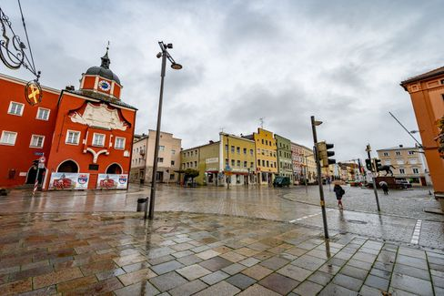

In the Bavarian parish church the second lockdown is already there

Photo: Armin Weigel / dpa

Scientists have proposed different types of lockdowns: the ["wavebreaker"](https://www.spiegel.de/politik/deutschland/corona-pandemie-karl-lauterbach-wirbt-fuer-wellenbrecher-shutdown-a-6f0358fc-e2b0-4747-be11-6ba5f69772db) **(everything too for two weeks;** preferred by Drosten and according to media reports by Merkel) or a stage variant: In the first step, **only people from two households** should meet **in one apartment.** At funerals, weddings, baptisms, a maximum of 15 participants would be allowed. As expected, some country leaders are responsible for fast and decisive action (Markus Söder, Bayern), some are positioned in the middle (Armin Laschet, NRW), [some are stubborn](https://www.spiegel.de/politik/deutschland/corona-krise-bodo-ramelow-kritisiert-entscheidungen-von-bund-und-laendern-a-085e84e6-f40a-4826-b19f-39bb4979e249) and don't want to close anything (Bodo Ramelow, Thuringia).

The Corona figures are developing so dramatically that **new measures** are **urgently needed** - **but they must also be well-founded.** For example, if restaurants had to be closed again, it really meant the end for large parts of the industry this time - but data is missing so far, which shows that many people are contagious in restaurants. This time, the **courts** will be more critical of what will be decided by regulation - and, if necessary, repeal rules if there is a lack of good justification. It would therefore be useful for **democratic legitimacy,** but also for **legal certainty,** if **Parliaments** were to come back into play at this stage of the pandemic.

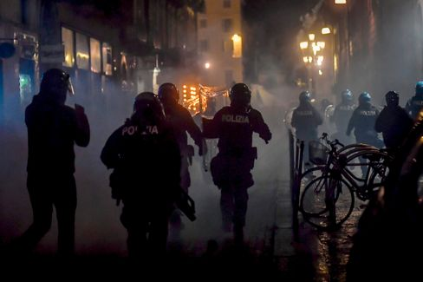

Policemen and demonstrators meet at a protest in Turin

Photo: Claudio Furlan / AP

In **Italy,** where the population has so far kept very disciplined to all the rules, there are [road protests against the recent restrictions for the first time](https://www.spiegel.de/politik/ausland/corona-massnahmen-in-italien-ausschreitungen-bei-protesten-in-turin-a-67ac2178-4d12-47ef-a0da-16c31c6ffc01) (a kind of lockdown starting at 6 p.m.). In **France,** President **Emmanuel Macron** announced a television address for tonight at 8 p.m. It is quite possible that France (where the figures are much more dramatic) will be in a new, real lockdown as of tomorrow.

* [Bars should close, schools should stay open: Federal Government urges drastic Corona measures in November](https://www.spiegel.de/politik/deutschland/corona-massnahmen-in-deutschland-bars-sollen-schliessen-die-schulen-offen-bleiben-a-312e9267-a0aa-411f-aed4-aa5db6b87c70)

### Trump plays after 2016

It feels like a time travel, we are back in 2016. [Donald Trump](https://www.spiegel.de/thema/donald_trump/) and his helpers are increasingly talking about **Hillary Clinton** in their campaign appearances – a woman who hasn't held political office for eight years. The president, who [according to polls is far behind,](https://projects.fivethirtyeight.com/polls/president-general/national/) puts everything at the last meters in the northeastern states of **Pennsylvania, Michigan, Wisconsin and Ohio.** At that time, four years ago, this strategy came up surprisingly.

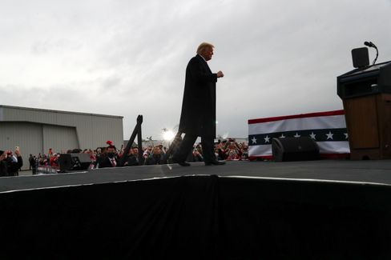

Trump in Martinsburg, Pennsylvania

Photo: LEAH MILLIS / REUTERS

And this time? While Joe Biden swims in money, the president runs out of money. He puts the remaining money mainly in the northeastern states, which helped him win four years ago. But does it help him to win that he talks about Hillary Clinton in his appearances and [downplays the Corona pandemic?](https://twitter.com/Acosta/status/1321178584082452480)

The fact that Trump puts everything on Pennsylvania is understandable: He practically can't win without this state - and Joe Biden, by the way, can't. I recommend [this very educational tool from the US data website FiveThirtyEight,](https://projects.fivethirtyeight.com/trump-biden-election-map/?cid=abcnews) which allows you to play through various scenarios for the election outcome yourself. As it comes in reality, we will see.

And [here you can subscribe to our newsletter "The Situation - USA 2020",](https://www.spiegel.de/thema/die-lage-usa-2020/) which provides stories and assessments of our eleven-member reporter team in the USA every day from today to the election - and then comes weekly.

### Recommendation: Election report from Florida

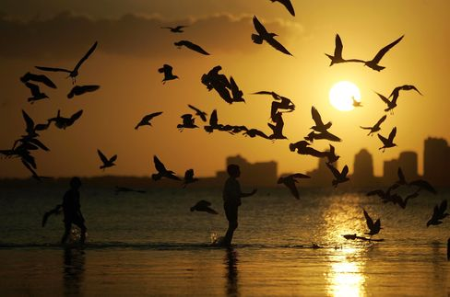

Symbol picture Florida

Photo: Joe Raedle/ Getty Images

Another important swing state is Florida with its 29 electoral votes - Trump must also not lose him. He's got to be shaking here, too. This is due in particular to a voter group, which is particularly numerous here in the sunny south and has traditionally elected reliable republican: pensioners. Our reporter Alexandra Rojkov visited the senior settlement "The Villages" in Florida this week - and here's nothing like it used to be: **Many pensioners have had enough of Donald Trump,** not least because of his failure in the Corona pandemic. Read your report here:

* [Pensioner Uprising in Florida: In the golf waltz against Trump](https://www.spiegel.de/politik/ausland/florida-vor-der-us-wahl-2020-rentner-aufstand-gegen-donald-trump-a-0053e3ec-2389-431f-bcda-5f8c3a696df7)

### All against Merz

The **Left Party** has now also cancelled its **party congress** planned for the weekend - as the CDU had already done on the previous day. This relieves a little of the fears of CDU candidate **Friedrich Merz** that the "establishment" had robbed him of his safe victory in December. With his **conspiracy theory,** Merz has not done himself any favors, the criticism instigates on him from all sides.

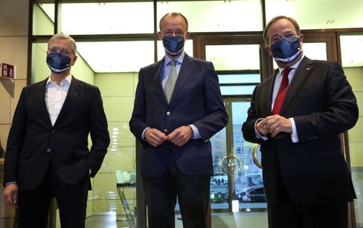

Roettgen, Merz and Laschet at an appearance in Berlin on 17 October

Photo: ADAMBERRY/POOL/EPA-EFE/Shutterstock

The conservative **"Frankfurter Allgemeine Zeitung"** has obviously had enough of him. In the front page commentary, [Jasper von Altenbockum writes today:](https://www.faz.net/aktuell/politik/inland/kommentar-ueber-die-cdu-merz-spaltet-die-partei-17022903.html) "All this is sacrificialism, populism, narcissism, foaming in one. There are enough statesmen in the world of this kind. If the CDU needs one, does Germany need one at the top? Merz has made the election of the CDU president on this one question: What type of party leader and candidate for chancellor do we want?"

Armin Laschet, of all people, defends his opponents - with the sentence: ["Compared with Trump is completely out of place."](https://www.spiegel.de/politik/deutschland/cdu-armin-laschet-verteidigt-friedrich-merz-vor-trump-vergleich-a-6dff2ce0-6249-4d86-aa7b-8b2783e07bd2) Repeating a comparison to contradict it is an elegant way to remember it again - or is that a conspiracy theory now?

* [Attack à la Trump: Merz beats Merz](https://www.spiegel.de/politik/deutschland/friedrich-merz-gegen-cdu-fuehrung-attacke-a-la-donald-trump-a-2f04f2ee-70a0-4b0b-a59e-ff02d117d78f)

### Winner of the day...



Kim Kardashian

Photo: Willy Sanjuan/ dpa

...is **Kim Kardashian,** who told the common people on Twitter about the celebration of her 40th birthday. Under the hashtag #humbled (so: [She posted glamorous pictures and wrote:](https://twitter.com/KimKardashian/status/1321151217482014726) "After two weeks with several health checks and asking everyone to go into quarantine, I surprised my closest inner circle with a trip to a private island, where for a short moment we could just pretend that everything was normal."

She was "decently reminded of how privileged her life was: "We danced, cycled, swam near whales, kayaked, watched a movie on the beach and so much more."

We wonder why more people don't just sit down on a private island with private jets instead of going into the breakwater lockdown and give Kim Kardashian the title "Marie Antoinette of the Corona pandemic".

External content

[More information in our privacy policy.](https://www.spiegel.de/datenschutz-spiegel)

### The latest news from the night

* **120 years imprisonment for self-help guru Keith Raniere:** He is said to have used his self-help group Nxivm to sexually exploit women. [Now the sentence was announced for Keith Raniere, to whom also a well-known US actress had fallen](https://www.spiegel.de/panorama/justiz/sekte-nxivm-120-jahre-haft-fuer-selbsthilfe-guru-keith-raniere-a-36dbb129-e1b0-4c14-99b0-bd503cbdd54c)
* **Website of Trump's election campaign hacked for a short time:** Unknown people manipulated Donald Trump's election campaign's website and demanded the payment of a cryptocurrency. [Now they're looking for the perpetrators](https://www.spiegel.de/politik/ausland/donald-trump-website-von-wahlkampagne-kurzzeitig-gehackt-a-c817102f-0192-4e96-acfa-29eff7429585)
* **Gladbach playfully win against Real Madrid in the replay period** : They had Real Madrid on the brink of defeat, but then Casemiro met in the replay: Borussia Mönchengladbach was unable to finish a lead in the Champions League. [Again](https://www.spiegel.de/sport/fussball/borussia-moenchengladbach-spielt-nur-remis-gegen-real-madrid-in-der-champions-league-a-ac0861db-db39-43c7-ac43-786e4f8085a7)