## The location in the morning

## National Efforts - Policy Efforts and Consequences

By [Susanne Beyer,](https://www.spiegel.de/impressum/autor-77cf5313-0001-0003-0000-000000001532) author at the SPIEGEL Capital Office

Dear reader, good morning,

Today we are concerned with what we learn from the new Corona decisions and what the round of Chancellors and Prime Ministers can learn from the criticism of them. We also look at the consequences of the decisions on the economy, and we find a single reason to rejoice.

29.10.2020, 05.45 a.m.

### Corona I. - A lot of criticism of decisions taken by Chancellor and Prime Minister

Starting to think about Christmas at the end of October is common practice, since the first cinnamon stars are already lying out in the shops. But over the past 24 hours there has been a lot of talk about Christmas: **A somewhat normal celebration** - also a somewhat normal pre-Christmas business - became a rhetorical means of promoting **understanding of the hard Corona measures** decided by the panel of chancellor and prime minister yesterday, and which the chancellor called a **"national effort",** with emphasis on "national" already to make it clear that she managed to prevent individual prime ministers from slipping out this time.

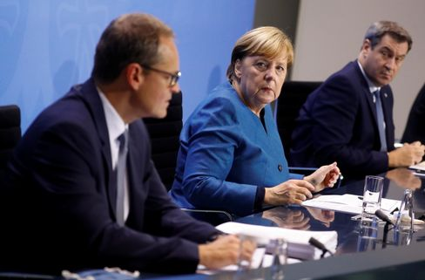

Angela Merkel with Berlin's mayor Michael Müller and Bavarian Prime Minister Markus Söder

Photo: Fabrizio Bensch / dpa

From 2 November onwards, only **members of two households** may meet in public - a maximum of ten people. Not necessary **private trips** and **visits of relatives** should be **avoided,** **catering establishments must close, as well as cosmetic studios, massage practices and tattoo studios.** **Professional sports** should only take place without spectators, the **amateur sports business** is completely discontinued. **Theatres, operas and concert halls, also casinos, arcades, betting venues and brothels have to close,** as well as **cinemas, amusement parks and fairs and also hotels,** at least for tourists.

Although the chancellor and the prime ministers may have been quite unanimous this time, the reactions outside the panel were partly harsh. Scientists and doctors around the virologist **Hendrik Streeck** think it is wrong to shut down public life again anyway. **Gastronomers complained** that they had really taken care of everything, purchased air purification filters, implemented hygiene concepts - and now that. **Theatre directors sent open letters** : "We think it's wrong to ban cultural events."

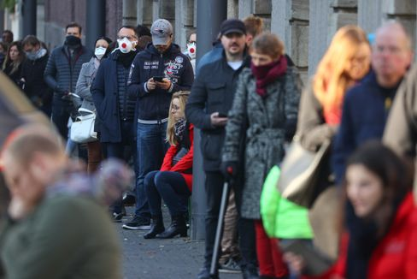

People in front of a Corona test center in Frankfurt

Photo: KAI PFAFFENBACH/ REUTERS

In fact, restaurants, cinemas and theatres, where responsible rules apply and are respected, have **not** so far **proved** to **be a source of infection** - everything has been done, but having failed to achieve the goal is always frustrating. But even if it is really unfair for many individuals, in the past few weeks it has become apparent that the rule-break had become too impenetrable, that there were too many loopholes, that the conditions of a cold season require a harder, clearer grip. The calculation (infection activity as measured by the utilization of the intensive beds) was jasimpel - it could not go on like this.

To take the measures, to limit them to one month, to provide financial compensation is all right. However, if the figures should now go down again, **the time gained must be used to carefully examine the critics' arguments** and then, if necessary, to take other paths from December onwards.

* [Corona measures: These restrictions apply from Monday](https://www.spiegel.de/politik/deutschland/corona-krisengipfel-beschliesst-massive-einschraenkungen-ab-montag-a-da1173bc-9728-4930-9eef-92975f075210)

### Corona II. - The economy is facing a terrible November

The fact that the infection is likely to improve over the next few weeks is a well-founded hope - it had already worked once in the spring, but at higher temperatures - but it is already clear: **November will be terrible.** The big slump had so far failed in Germany, the economy had been able to recover a little over the summer, but the new situation will have consequences.

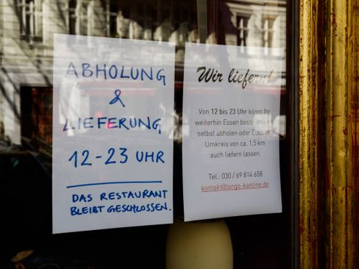

Closed Café in Berlin

Photo: Carsten Thesing / imago images/Carsten Thesing

**"There is no longer a good scenario, it's only about the question of how bad things are going to be,"** my colleagues **Simon Book, Markus Dettmer and Michael Sauga** write in the economic section of the new SPIEGEL magazine, which will be published tomorrow and will be online from this afternoon. The return of the pandemic could destroy tens of thousands of economic existences. **50,000 businesses could close, fears the Handelsverband Deutschland (HDE).** Christmas can no longer be a good thing, a halfway-limited catastrophe would be the goal.

* [Merkel and the Prime Ministers: Four weeks against the wave](https://www.spiegel.de/politik/deutschland/corona-angela-merkel-und-die-ministerpraesidenten-beschliessen-shutdown-light-a-2ecb7ed1-87ea-4fc1-85d5-8e563431d968)

### Corona III - EU Special Summit: Does the Heads of State and Government create cohesion this time?

For tonight, EU Council President **Charles Michel** has convened a virtual special summit to enable **Heads of State and Government** to coordinate **in the fight against the Corona crisis.** Almost all **EU countries have high levels** of infection. France's President **Emmanuel Macron** announced yesterday in a speech to the nation's again initial restrictions, in his words: **"a brutal braking maneuver."** Michel hopes for progress, especially in the testing strategy and in the follow-up of contacts.

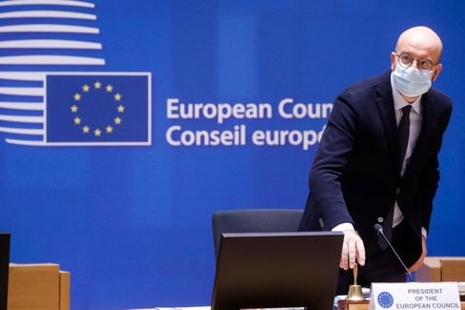

Head of EU Council Charles Michel

Photo: POOL THIERRY ROGE / imago images/Reporters

This evening's meeting will focus less on individual measures, but above all on whether or not it will be possible to achieve **cohesion in principle.** The competences for border management and public health are in any case not in the EU, but in the Member States or even in their regions. But the President-in-Office's attempt to work informally to ensure that the EU gives a better picture in these weeks than in the spring, for example, when borders were closed without a vote, cannot do any harm. Impressions do a lot. The impression in spring was devastating.

* [Plan against the virus: Corona test for the EU](https://www.spiegel.de/ausland/coronakrise-wie-die-eu-die-die-pandemie-einheitlich-bekaempfen-will-a-1a3bb0d7-fe23-4acc-80e0-e4fbb0cb4b58)

### Winner of the day...

...is the city **of Chemnitz.** The fact that yesterday there would still be news images like those from the city in the Erzgebirge was amazing: Rejoice, tears of joy and in the background "joy of beautiful sparks of gods", when the **European selection jury for the "European Capital of Culture 2025"** announced that it **recommends** this Saxon city **as the title winner.**

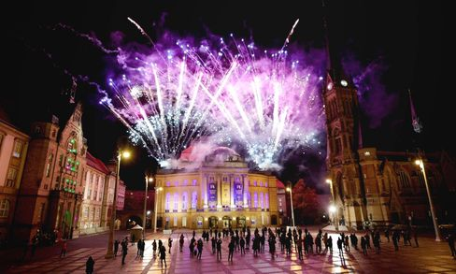

Theaterplatz in Chemnitz during the announcement of the jury

Photo: Harry Haertel / imago images/HärtelPRESS

Two years ago, extreme right-wing riots had taken place in the city, and it looked quite bad for the application. But the city has done a lot to show that it wants to get rid of its bad reputation, it's serious about it; it deserves its chance. Unlike Dresden, which had also applied and had long since left, Chemnitz is not exactly full of culture, **the city has to have it freshly produced.** Well, let's go, good luck.

* [Jury recommendation: Chemnitz to become the European Capital of Culture in 2025](https://www.spiegel.de/kultur/chemnitz-wird-2025-kulturhauptstadt-europas-empfehlung-der-jury-a-a71b2db4-5ed4-4cf4-b9c8-5e351ee6e433)

### The latest news from the night

* **USA charges eight alleged Chinese agents:** They are said to have harassed, persecuted and coerced Chinese dissidents in the US: The judicial authorities are accusing eight alleged agents. [The prosecutor speaks of the first case of this kind](https://www.spiegel.de/ausland/usa-klagen-acht-angebliche-chinesische-agenten-wegen-einschuechterung-von-dissidenten-an-a-142fdd39-ab1d-4d95-810c-63e8bcec3d35)
* **Thousands of federal police are to control compliance with the Corona rules:** Interior Minister Seehofer wants to use the federal police in hotspots and big cities to enforce the Corona measures. [The requirement for quarantine will also be subject to greater scrutiny.](https://www.spiegel.de/politik/deutschland/corona-regeln-tausende-bundespolizisten-sollen-einhaltung-kontrollieren-a-4aa8545e-ed9e-4c8b-bace-a26953fbe23b)
* **Stadtbahn Hannoverschleibt passenger hundred meters with:** He grabbed in the wagon to pick something up - then the door went to: In Hanover, a man was seriously injured by a city railway. [The police are investigating](https://www.spiegel.de/panorama/stadtbahn-hannover-schleift-fahrgast-hundert-meter-mit-a-233da5a8-14da-4afb-a54e-0a2971fffd8e)