## The location in the morning

## The Denunciant: a nasty boob

By [Markus Feldenkirchen,](https://www.spiegel.de/impressum/autor-843a42fd-0001-0003-0000-000000001992) author in the SPIEGEL capital office

Dear reader, good morning,

today we deal with the late opening of a regional airport. The self-criticism of Wolfgang Schäuble. And a particularly unpleasant contemporary: the denunciant.

31.10.2020, 06.49 a.m.

### Berlin opens an airport - exclusively for Berlin and Brandenburg

Two days ago, I landed again in Berlin-Tegel. It was a strange feeling, a touch of farewell pain. Because with all the disadvantages he had, I liked this airport. He was kind of cuddly. Tegel exuded the charm of the untimely. He had to wait nine years for his retirement in the airport retirement age.

Today the **breakdown airportBER** is finally opened. **But does he also think what many of him have promised themselves?**

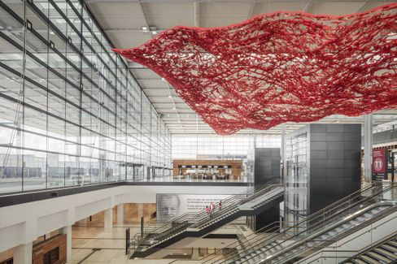

Airport BER: Wide world - or provincial airport?

Photo: Marcus Bredt / GMP

With the new Berlin airport was always connected **the dream** that he could **finally connect the capital to the big wide world.** There were hardly any intercontinental flights from Tegel. The BER was to become another **German hub,** next to Frankfurt and Munich. However, my colleagues **Dinah Deckstein,** **Claus Hecking** and **Martin U. Müller** will not be able to do anything about this. There is exactly one long-distance connection to the start - and that is actually none at all. The gate for the Airbus A380 was built for nothing anyway. Airbus has long since declared that the production of the megajet will cease. **"The BER will be an airport for Berlin and Brandenburg,"** Müller believes. **"That's all."**

* Berlin-Brandenburg Airport: [The would-be turntable](https://www.spiegel.de/wirtschaft/unternehmen/flughafen-berlin-brandenburg-ber-die-drehscheibe-die-keine-ist-a-00738e3a-0736-48cc-9f99-c31bb90863e9)

### Climate rescue or freedom?

My colleague Jonas Schaible and I met with activist **Luisa Neubauer** and Bundestag President **Wolfgang Schäuble** to discuss the **climate crisis:** What is the fault of the generation Schäuble? Is it exaggerating the Generation Neubauer?

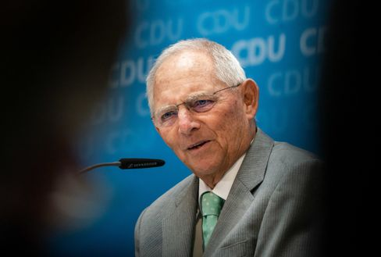

Wolfgang Schäuble

Photo: Michael Kappeler/DPA

Schäuble, that must be left to him, proved extremely self-critical. **"We exaggerated capitalism,"** he admitted, for example.

The most exciting thing I found was the statements of the two of them about the problem that democratic processes are often laborious and slow, perhaps too slow to stop climate change. **"When I am faced with the alternative of achieving something quickly or slowly, I'm more of a slow one,"** said Schäuble. **"For the price of quick action is the loss of freedom."**

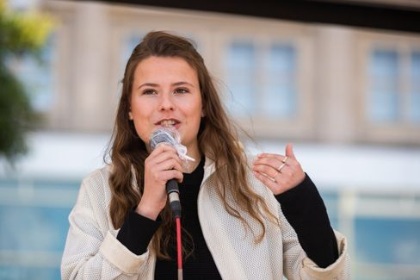

Luisa Neubauer

Photo: Christoph Soeder / dpa

Neubauer strongly contradicted: **"The price of slow action is an escalating climate crisis. And nothing will rob us more of freedom than this crisis. The slower we are, the greater the destruction, the greater the limitation of freedom in the end."** The fatale is: **Both are right in some ways.**

* President of the Bundestag meets climate activist: ["If Mrs. Neubauer says yes now, it's bullshit"](https://www.spiegel.de/politik/deutschland/luisa-neubauer-und-wolfgang-schaeuble-ueber-die-schuld-der-aelteren-generation-am-klimawandel-a-00000000-0002-0001-0000-000173621997)

### Who rides the tiger

For two years, a man in **Islamabad,** who the world actually knows as a sports ace and cricket world champion, has ruled a sort of Franz Beckenbauer of the subcontinent: **Imran Khan.** At some point, the Oxford pupil had had enough of the Playboy life in London. He went into politics to free Pakistanis from poverty and corruption. That was 24 years ago. Now the Khan has arrived at the top.

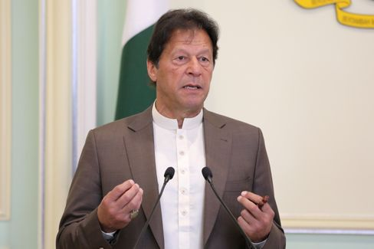

Imran Khan

Photo: LIM HUEY TENG / REUTERS

My colleague Susanne Koelbl met **an austere prime minister** in Islamabad, who wrestles **with all kinds of demons** at **the same time:** With the **powerful army generals** who play their own dark game with him and keep the country under control. With the **opposition** that conspired against him since Khan threatened to put their leaders behind bars for morbid kleptocracy. Moreover, the nuclear state with its 220 million inhabitants is actually **bankrupt.** And then there is the neighbor and **archenemy India,** a country for which Khan finds drastic words in the interview: "India has the most extreme, racist government on the subcontinent and is a threat to its neighbours, even to China." It was "a fascist state inspired by the Nazis in the 1920s and 1930s."

To rule Pakistan, it is said, is to ride like a tiger. Kahn is having this experience right now. But he's determined to stay up for even longer.

* Pakistan's Premier Khan: ["India is a fascist state inspired by the Nazis"](https://www.spiegel.de/ausland/pakistans-premier-imran-khan-indien-ist-ein-faschistischer-staat-inspiriert-von-den-nazis-a-00000000-0002-0001-0000-000173743587)

### Losers of the day...

...are **all denunciants in Germany.** Today I mean above all those unpleasant contemporaries who sat behind **Armin Laschet** in an **airplane from Cologne to Berlin** a few days ago. (No, it wasn't Friedrich Merz). He secretly photographed Laschet, whose mask at the moment of the recording was only on his left ear dangling. Later he sent the recording to the "Bild" newspaper.

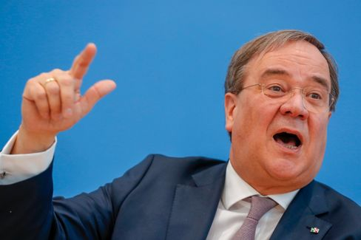

Armin Laschet

Photo: Odd Andersen / AFP

How do you feel about doing something like that? **In the Rhineland there is a nice term for such types: nasty boob.** The fact that the "picture" newspaper, which otherwise likes to complain sharply about denunciants, presented the photo on its front page did not make the matter any better.

### The latest news from the night

* **Azerbaijan reports further territorial gains - Exchange of dead agreed** : In negotiations in Switzerland, Armenia and Azerbaijan seem to have approached minimally in the Nagorno-Karabakh conflict. [In the meantime, the conquest of new areas in the conflict region is accumulating](https://www.spiegel.de/ausland/bergkarabach-aserbaidschan-meldet-nach-friedensgespraechen-weitere-gebietsgewinne-a-21023c1a-b7bc-4420-90dc-569c24f4e500)
* **Tens of thousands of Poles are once again demonstrating against stricter abortion law:** In Warsaw, thousands have once again taken to the streets to counter a tightening of abortion law. [President Duda, meanwhile, announced changes to the proposed law](https://www.spiegel.de/ausland/polen-zehntausende-demonstrieren-erneut-gegen-strikteres-abtreibungsrecht-a-0fffb4bb-df01-4edc-b436-e5be6ebbe1f9)
* **Judges stop US plans for Aus by TikTok in November:** Donald Trump wanted to ban the TikTok app from November 12th. At first, however, it becomes nothing more: [A court in Pennsylvania has issued an injunction](https://www.spiegel.de/netzwelt/apps/tiktok-richterin-stoppt-us-plaene-fuer-aus-von-app-im-november-a-8f6cfcdb-7744-4427-96b4-69716b4706c3)