## The location in the morning

## Germany rides down again

By [Sebastian Fischer,](https://www.spiegel.de/impressum/autor-9c4e5259-0001-0003-0000-000000000166) Head of the SPIEGEL Capital Office

Dear reader, good morning,

What a week this is going to be! What's this gonna be for a week? exclamation mark, question mark, all right. Today we deal with the approaching US elections and the beginning Corona shutdown in Germany.

02.11.2020, 05.48 a.m.

### The decision of the year

This week, on Tuesday, the Americans have the choice between a democracy destroyer and a democracy keeper. All of us, **the whole world will be shaped by the outcome of this election.** We can't go along with this.

It still sounds surreal: The country that brought us democracy before a human age is now seriously struggling with this alternative: Destroyer Donald Trump vs Keeper Joe Biden. The fact that Trump has a realistic chance to remain in office is still evading **political rationality** despite so many enlightening approaches.

And realistic is the chance at all times.

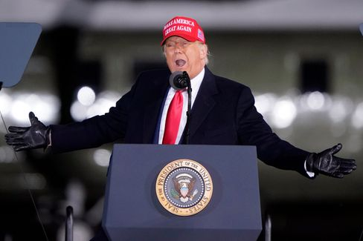

Trump in North Carolina on November 1st

Photo: Chris Carlson / AP

The clear lead in the polls, which Biden can record for himself nationwide and in important Swing States two days before the election, is a **purely virtual lead.** According to the recent New York Times survey, Biden is ahead of Trump in Pennsylvania, Wisconsin, Florida, and Arizona. All four had won Trump against Hillary Clinton in 2016, paving the way for him to win.

Are they taking him to the losing street now? But would he accept a defeat at all?

On the weekend, the president sought to reassert [distrust with regard to the electoral process and the ballots:](https://www.spiegel.de/ausland/us-wahlen-donald-trump-prophezeit-chaotisches-durcheinander-a-ef3f3484-7a3b-42ab-8534-005b1ee478e9) "The whole world and our country will wait and wait and wait to know who won, you will wait for weeks." November 3rd will come and go, and one will not know: "And you will have **chaotic confusion** in our country."

In the meantime, more than 90 million Americans have already voted - two thirds of the total number of votes in 2016. A **record voter participation** is to be expected. Although record is relative: If 65 percent of the electorate voted, that would already be a top mark for US relations.

* [Presidential elections in the USA: Another four years of Trump?](https://www.spiegel.de/wirtschaft/wahlen-in-den-usa-halten-wir-vier-weitere-jahre-donald-trump-aus-a-a70ed0f3-0e92-40da-a919-79e7e7af5eb4)

### Will Trump stay when Biden comes?

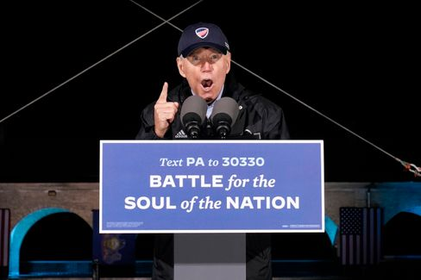

Joe Biden in Philadelphia on November 1st

Photo: Andrew Harnik / dpa

If **Joe Biden** wins, he won't be able to just reset the country to the old track. Even if he promises that and Trump may see it only as a mistake in history. In fact, Biden would not be able to connect to where Barack Obama left off four years ago - but **would have to connect to Trump.**

Therefore, I would like to recommend our current [SPIEGEL title story:](https://www.spiegel.de/ausland/donald-trump-was-von-ihm-bleibt-selbst-wenn-er-gehen-muss-a-00000000-0002-0001-0000-000173743533) What remains of Trump - even if he has to leave. Trump is not only the cause of the nation's division, but a **symptom of a deep-reaching crisis** that does not disappear when Trump disappears.

And there's one more thing: We humans tend to get used to everything. This ensures our survival, but that sometimes makes us blind. **We got used to Trump,** his hatred, his stupidity, his racism.

The great US narrator Philip Roth wrote in his book "Conspiracy against America", which imagined a presidency of the pilot and Nazi Charles Lindbergh in the 1940s, of the "Terror of the Unforseen". In historical retrospect, such unforeseen events would unfortunately be presented as inevitable, one event now follows the other chronologically. Means: They tend to rationalize the fractures. A disaster, writes Roth, then simply becomes a narrative. We should never forget the disaster Trump.

* [Hatred, cultural struggle, discord: What remains of Trump](https://www.spiegel.de/ausland/donald-trump-was-von-ihm-bleibt-selbst-wenn-er-gehen-muss-a-00000000-0002-0001-0000-000173743533)[-](https://www.spiegel.de/ausland/donald-trump-anhaenger-rammen-joe-bidens-wahlkampffahrzeug-fbi-ermittelt-a-930dc76f-cbd9-4565-9918-2955f4ecbc7c) [even if he has to leave](https://www.spiegel.de/ausland/donald-trump-was-von-ihm-bleibt-selbst-wenn-er-gehen-muss-a-00000000-0002-0001-0000-000173743533)

### Closed society

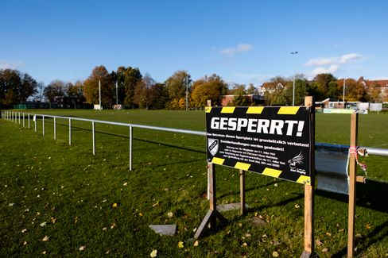

Lock sign in front of Kieler Sportplatz: Today starts the partial shutdown in Germany

Photo: Frank Molter / dpa

As of today, we are all faced with big decisions every day in our country: [The second shutdown in the fight against the Coronavirus](https://www.spiegel.de/wissenschaft/coronavirus-news-am-sonntag-zweiter-lockdown-kostet-wirtschaft-19-milliarden-euro-und-600-000-jobs-a-2d897a43-cfca-43a8-bfd3-251dbc977281) is **expected to** begin **by the end of the month.** How many will stick to it? And how large is the minority in the future, which in recent months has partly lost its initial successes with its unsolidar behaviour?

If the first wave in spring was still a natural disaster, to which society, science and politics had to find (new) answers, the second wave is mainly **man-made.** Because we knew what to do and what to leave.

This last weekend before the shutdown was not only encouraging. There was a note from a club at my house entrance: You want to party again and apologize for the volume.

Probably the volume is our least problem.

Hit another one before we all sit back in it. If every day counts, as they say, it's a pretty stupid strategy. And it once again illustrates that our present problem is man-made. The bigger the ego, the bigger the crisis.

Apart from schools and kindergartens as well as supermarkets and shops (and of all services) everything is now shut down again. Because the regionally specific measures of the past few weeks did not apply, only the hope remains for this more general, so-called **breakwater model.**

Is that fair? No, it's not. It can't be. Because now also dedicated entrepreneurs, artists, restaurant owners pay the colliery for the fact that we all couldn't do it together. The details of the individual measures can be found [here.](https://www.spiegel.de/politik/deutschland/shutdown-diese-massnahmen-gelten-ab-montag-a-bcda226e-72d0-41b8-b363-417acd7726c4)

In addition, I would like to suggest an exciting **SPIEGEL book project** at this point: Today, **"Lockdown"** appears - 21 authors from different departments have retold and analysed the political fight against crises in detail in the first phase, such as tangible conflicts between ministries - and at the end asked what politics, what we as a society can learn from it for the future. And what that means with a view of the rolling second wave.

### Losers of the day...

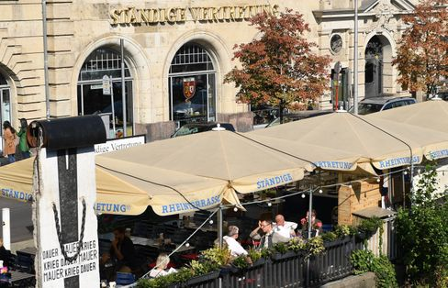

"Permanent representation" in Berlin (archive picture)

Photo: Britta Pedersen / dpa

...is the **StäV.** Due to the Corona shutdown Angela Merkel, Olaf Scholz, the Governing Mayor Michael Müller, Bavaria's Prime Minister Markus Söder and others, the Berlin Kölsch-Kneipe "Standige Representation" near Friedrichstraße station does not (more) host. [No house for politicians.](https://www.spiegel.de/politik/deutschland/berlin-staendige-vertretung-erteilt-merkel-scholz-und-anderen-politikern-hausverbot-a-3b0c39b4-6e93-47f8-9a0d-fd76b889babd) This is difficult, of course, first under shutdown conditions anyway, secondly, it is not known whether Merkel and Co. had planned a visit to the locality in the near or distant future at all, and thirdly, it is for a shop that advertises that political prominence is passing by every now and then, perhaps not as a target to banish political prominence.

### The latest news from the night

* **Spahn swears to Germans on "Months of Restrictions":** The measures will take effect from Monday - and they are significant: Before the new escalation in the fight against the virus, the Minister of Health finds clear words: [According to Jens Spahn, the country is facing a hard time](https://www.spiegel.de/politik/deutschland/jens-spahn-schwoert-deutsche-wegen-corona-krise-auf-monate-der-einschraenkungen-ein-a-71e2889d-8b0d-4f16-af7d-11715f7ef556)
* **Trump supporters ram Biden's campaign vehicle** -**FBI investigates:** Dangerous situation in Texas: Fans of Donald Trump have attacked the column of challenger Joe Biden. [From the White House came praise and ridicule - the federal police intervene](https://www.spiegel.de/ausland/donald-trump-anhaenger-rammen-joe-bidens-wahlkampffahrzeug-fbi-ermittelt-a-930dc76f-cbd9-4565-9918-2955f4ecbc7c)
* **"No human being is planning something at the moment":** Anne Will asks about the meaning and nonsense of the restrictions in the second shutdown. [Markus Söder apologizes in advance](https://www.spiegel.de/kultur/tv/anne-will-zu-aktuellen-corona-einschraenkungen-kein-mensch-plant-im-moment-irgendwas-a-ff1d9f67-5c39-430f-94a8-f97c9d6f7b36) [-](https://www.spiegel.de/ausland/donald-trump-anhaenger-rammen-joe-bidens-wahlkampffahrzeug-fbi-ermittelt-a-930dc76f-cbd9-4565-9918-2955f4ecbc7c) [and trumpeter Till Brönner is worried about the daunting cultural industry](https://www.spiegel.de/kultur/tv/anne-will-zu-aktuellen-corona-einschraenkungen-kein-mensch-plant-im-moment-irgendwas-a-ff1d9f67-5c39-430f-94a8-f97c9d6f7b36)