## The location in the morning

## What do you choose, America?

By [Sebastian Fischer,](https://www.spiegel.de/impressum/autor-9c4e5259-0001-0003-0000-000000000166) Head of the SPIEGEL Capital Office

Dear reader, good morning,

today we are dealing with the election day in the USA, the consequences of a possible defeat by Donald Trump, the terrorist attack in Vienna and with new whirlwinds in the fight for the CDU presidency.

03.11.2020, 05.40 a.m.

### Terrorist attack in Vienna

Terrible scenes in Austria's capital: On Monday [night, shots were fired at six crime scenes in downtown.](https://www.spiegel.de/ausland/wien-tote-und-verletzte-nach-attacke-in-oesterreich-a-595a4284-9080-4f11-99cc-cd092ee77599) According to the Vienna police, there are so far two dead passers-by and 15 partially seriously injured persons.

A perpetrator with a rifle had been shot. In addition, he is said to have carried a gun and a machete. **At least another perpetrator is still on the run,** said Interior Minister Karl Nehammer. He called on the population to stay at home for the time being, and compulsory schooling is suspended. The entire center was locked off at night, soldiers were deployed to support the police.

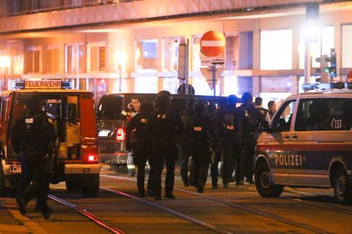

Heavy armed forces on Monday evening in Vienna

Photo: Ronald Zak / dpa

The first shots were fired in the Seitenstettengasse, a busy street in the centre. There is also a synagogue. **"It has been shot indiscriminately at people in the bars,"** said Vienna's mayor Michael Ludwig - especially at people who had been travelling in beer gardens. Austria's Chancellor Sebastian Kurz spoke of a "disgusting terrorist attack". In the early morning, the authorities want to inform about the state of the investigation.

* [Terror in Austria: Dead and severely injured in attack in Vienna](https://www.spiegel.de/ausland/wien-schuesse-in-der-innenstadt-medienberichte-sprechen-von-angriff-auf-synagoge-a-6a0a9f7c-a940-4394-a7f9-71ab9cdd8ff4)

### What's at stake today in America

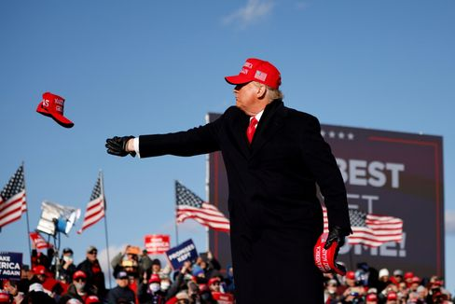

US President Trump in the campaign sprint

Photo: CARLOS BARRIA / REUTERS

Quite exactly eight years ago, I witnessed **political triumph and failure** in Chicago. At half past six o'clock in the morning, 15,000 supporters of the president cheered for Barack Obama's re-election at his election party in a trade fair hall under the sounds of "Do You Love Me". The magic of victory. Shortly before, Mitt Romney had confessed his defeat in Boston.

It was a **look in the engine room of the Republic.** goose bumps caused me not so much the frenetic cheer around me, but the almost sacral democratic choreography: One victory was the other failure, then the congratulations by phone, the public admission of defeat in a *concession speech,* finally the appearance of the winner.

Of course, at that time, the country was long divided, **the Republican Party's infiltration by the radicals was in full swing** - all the factors that the Trump presidency would later enable. But Romney and Obama still confirmed this democratic ideal in their dealings with each other.

**What will happen on the coming election night?** [Joe Biden is partly clearly ahead in polls.](https://www.spiegel.de/ausland/us-wahl-2020-die-wichtigsten-umfragen-im-rennen-donald-trump-vs-joe-biden-a-b15ff300-1ea7-4bdf-8685-952dc1e56f57) But what does that mean? And: If Donald Trump actually loses, will he admit his defeat?

I guess it doesn't just matter if he loses.

It's how he loses.

Trump has once again sowed mistrust in the election process in the last few days. He assumes fraud before the votes are even counted. He announced in the perhaps decisive, contested **Battleground state of Pennsylvania** that his lawyers would take over "as soon as this election is through".

It is this scenario that could become the **stress test of American democracy:** Trump needs Pennsylvania to secure the necessary majority of the electoral college. If it gets tight, however, the decision may take place in a few days - only when the postal ballots are counted. **But what if Trump is ahead on the election night in Pennsylvania** - and declares himself the electoral winner in order to precede supposed democrat fraud in the postal election? Charles M. Blow, columnist of the New York Times, writes: "Trump will then look at his burning land and warm up by the fire."

Sounds like a banana republic or a third world. Just: Do not the last four years provide sufficient reasons to expect the unforeseen?

But there may be a way out. And it's in the south.

* [Survey shortly before the election: Biden ahead in the important Swing State Florida](https://www.spiegel.de/ausland/biden-liegt-im-wichtigen-swing-state-florida-vor-trump-a-bd0ddb89-8bd4-44ff-8220-be3c449c2300)

### All eyes on Florida

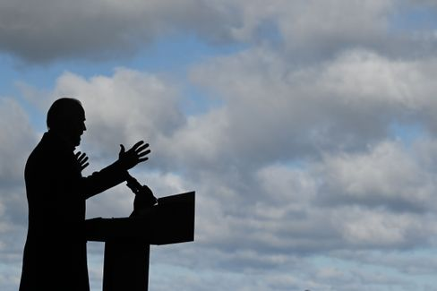

Candidate Biden

Photo: JIM WATSON / AFP

The Sunshine State [is the big prize for this choice.](https://www.spiegel.de/ausland/countdown-zur-us-wahl-aus-florida-die-mutter-aller-swing-states-a-3639c239-50d1-4fa0-b20c-47189d78722d) **If Biden gets Florida, it's probably hard for him to win.** If Trump wins Florida, he may not be through yet, but he has a more realistic chance of winning overall.

The advantage of Florida: There the counting of the postal ballots begins already weeks before the election day, unlike in Pennsylvania. **A reliable result on the night of the election is therefore to be expected.** Means: Biden can win without Florida. But with Florida, he would make it more complicated for Trump not to acknowledge a possible Biden victory.

During the day and during the election night, we will inform you extensively and comprehensively on SPIEGEL.de. For example, our U.S. correspondents Roland Nelles and Marc Pitzke deal with the possible **scenarios for the outcome of the election** - and address the role of Florida in detail.

That night, our reporters from the capital **Washington,** **Florida,** **Pennsylvania,** **Michigan** and **California** report.

**From 7 p.m. our live show starts.** We talk to experts, first-choices, artists like the US writer Jonathan Saffran Foer. **From 4.30 a.m. on Wednesday morning,** my colleagues Rachelle Pouplier and Britta Sandberg will welcome you to the early show with projections, assessments and many collegues and politicians. By the way, our location in the morning will become a live chat on Wednesday: WirLAGE authors talk about the consequences of this choice starting at 6 a.m.

* [Hatred, cultural struggle, discord: What remains of Trump - even if he has to leave](https://www.spiegel.de/ausland/donald-trump-was-von-ihm-bleibt-selbst-wenn-er-gehen-muss-a-00000000-0002-0001-0000-000173743533)

### SPIEGEL Climate Change Conference in the Livestream

And one more clue in your own matter: Today from 4 pm we stream on SPIEGEL.de our climate conference. Among other things, we question **CSU CEO Markus Söder** and Minister of Economic Affairs **Peter Altmaier** on climate policy, there are panels with business leaders such as **Lufthansa CEO Carsten Spohr,** scientists such as **Ottmar Edenhofer,** politicians such as **Green CEO Annalena Baerbock** and climate activists such as **Luisa Neubauer.** All information, schedules and guests can be found [here.](https://www.spiegel.de/klimakonferenz)

### Winner of the day...

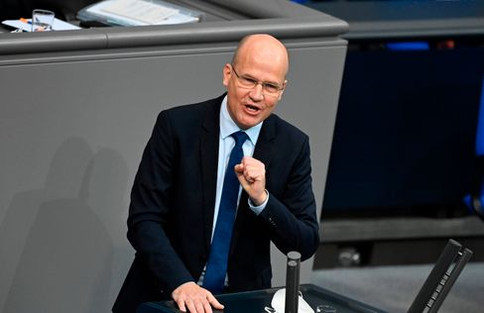

Head of Group Brinkhaus in the Bundestag

Photo: TOBIAS BLACK / AFP

It's**Ralph Brinkhaus.** Last week, the head of the Union Group defended the government's anti-Corona shutdown in a brilliant speech in the Bundestag ("The point is that we, as an open, democratic, plural society, prove that we also get to grips with this pandemic") and is now even being discussed as a **substitute candidate for the CDU presidency** and thus also the chancellor's candidacy.

In the party there are many personalities who are suitable for "highest top positions", "certainly also the group leader Ralph Brinkhaus belongs to it", [said Thuringia's CDU head Christian Hirte to the SPIEGEL.](https://www.spiegel.de/politik/deutschland/cdu-vorsitz-christian-hirte-bringt-ralph-brinkhaus-ins-spiel-a-668d1739-a6b7-410c-b616-c21336d8b331)

Now a shepherd does not make any candidates, but even the still-chairman [Annegret Kramp-Karrenbauer had recently warned in the SPIEGEL interview](https://www.spiegel.de/politik/deutschland/cdu-annegret-kramp-karrenbauer-ruft-friedrich-merz-und-armin-laschet-zur-ordnung-a-0bfacc78-98ee-4dcc-9f6a-2ba3721adb14) the quarreling candidate trio Merz-Laschet-Roettgen: "The more ruinous the competition is, the more some will perhaps ask themselves as a reflex to this discussion the question of other applicants."

Let's wait. At any rate, the Young Union today presents the **result of its member survey on the party presidency,** which JU leader Tilman Kuban considers binding on himself, but not on his association. So the winner would have a voice for sure.

### The latest news from the night

* **"We're still in the fight":** Top politicians have condemned the ongoing terrorist attack in Vienna and have pledged their support. [EU Council President Charles Michel called the act a cowardly act against life](https://www.spiegel.de/ausland/wien-politiker-bekunden-beileid-nach-terroranschlag-sind-nach-wie-vor-im-kampf-a-5a8bfd73-1e24-472c-ba5f-9dd9b4137b24)
* **Biden is ahead of Trump in the important Swing State Florida:** Florida could become one of the polling states - and there is a clear lead for Joe Biden. [Just recently he and Donald Trump had been right there.](https://www.spiegel.de/ausland/biden-liegt-im-wichtigen-swing-state-florida-vor-trump-a-bd0ddb89-8bd4-44ff-8220-be3c449c2300)
* **VW must call back 218,000 Jettas in the USA:** In the worst case, leakage of fuel could lead to a fire: [Due to defects on the Jetta Volkswagen orders large-scale vehicles to the workshops in the USA](https://www.spiegel.de/auto/vw-muss-in-den-usa-218-000-jetta-wegen-benzinlecks-zurueckrufen-a-66614d33-00da-430f-a70c-04728ef03447)