## The location in the morning

## Biden relies on America, Trump on the courts

By [Sebastian Fischer,](https://www.spiegel.de/impressum/autor-9c4e5259-0001-0003-0000-000000000166) Head of the SPIEGEL Capital Office

Dear reader, good morning,

Today we deal with the US election, the consequences of Trumpism, the Bundeswehr in the Corona crisis and Sahra Wagenknecht.

05.11.2020, 06.29 a.m.

### Only one State Still Missing Biden

Welcome to Day 2 after the U.S. elections. While Joe Biden is ahead of Trump at the *popular vote* with around 72 million votes, he **has broken the record of Barack Obama** - never before in US history did a presidential candidate win more votes than Biden did this year.

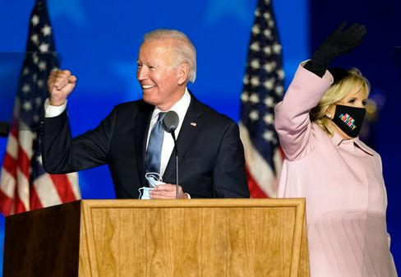

Candidate Biden, wife Jill Biden

Photo: Andrew Harnik / dpa

Just: As is well known, the total number of votes does not matter, nor is it clear who will be at the forefront of America in the future. **But you may not have to wait another day** until the last ballots in Pennsylvania are counted.

Because Biden is only missing one state to win - and that doesn't have to be Pennsylvania after the situation.

Voilà, **some numbers** for breakfast:

* If Biden's narrow lead in **Arizona** holds - and it can be assumed at this point - then the challenger currently has **264 votes** in the polling college. There's only 6 left for the majority. Trump currently comes to **214.**
* The South State of **Georgia** (16 votes) and **Nevada** in the West (6) could soon announce a winner. In Nevada, Biden is just ahead, in Georgia, Trump's lead melts - and the polls to be counted are in the trend for Biden.
* Then the big price: **Pennsylvania** (20), where Biden was born 77 years ago. If Trump wins Georgia, Nevada and North Carolina (15), then it would be 264 to 251 for Biden - and in Pennsylvania the election would decide, but perhaps only Friday. Trump is currently ahead with around 200,000 votes, but there are still hundreds of thousands of postal ballots missing, for example, from the Pittsburgh region, and they are, you know, most likely per Biden.
* [US 2020 election: Joe Biden needs another state](https://www.spiegel.de/ausland/us-wahl-2020-joe-biden-braucht-noch-einen-staat-zum-sieg-a-d4f3eb3e-e6cd-434d-b911-2542be743ad5)

### And Trump like that?

Since the president declared his victory against better knowledge on the night of the election, and he has already lost decisive states (Wisconsin, Michigan), he has been looking for **alternative ways to win** the election over the courts.

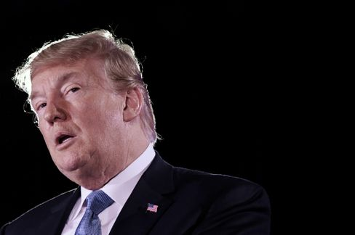

President Trump

Photo: OLIVIER DOULIERY/ AFP

Our US correspondent [Roland Nelles aptly comments:](https://www.spiegel.de/ausland/trumps-vorschnelle-siegeserklaerung-der-antidemokrat-a-37092f3f-7160-456b-905c-396c6b2ffb30) "All this seems like **the plot of a second-class autocrat** who needs a relapse position to prejudge a possible defeat. You ask yourself: What are you doing? Why can't the man just wait and win or lose in an honest way?"

Yeah, what are you doing?

In Georgia, for example, where he's running a tight lead, Trump sues for an enumeration stop. Reasons: According to an observer, **53 ballot papers arrived too late** in a municipality were added to the stack of electoral documents received in time. In Pennsylvania, Trump's people want to suspend the counting until their election observers supposedly get better access. In Wisconsin, Team Trump calls for a re-counting because of the narrow election outcome. And so on.

* [Do U.S. courts stop counting? "Trump's announcement is roaring"](https://www.spiegel.de/ausland/us-wahl-donald-trumps-ankuendigung-ist-getoese-der-yale-jurist-samuel-moyn-im-interview-a-4af39789-c210-4b07-88c6-d7acf00fe00c)

### What about Trumpism?

Whether Trump loses or not - the hatred and division he has sown in this country will continue to flourish. **For it is fertile soil.** Trump is only a symptom of the precarious situation in which the former leadership of the West is located.

If after four years with a racist and liar in the White House almost 70 million Americans give their voice to this person - what does that say about the state of the country? Again: **Trump won votes compared to 2016 - not lost.**

The publicist Paul Krugman noted that Biden always talks about the Americans being different from Trump and his policy ("that's not who we are"). But it must say: The majority of Americans were not like that - and Biden would perhaps be just five percentage points ahead of the overall votes at the end. **"It turns out,"** says Krugman,**"that many of us are like this."** Just like Trump.

* [Protocol of the choice of fate: America in a day that will change the world](https://www.spiegel.de/ausland/us-wahl-amerika-am-tag-der-die-welt-veraendern-wird-reportage-a-8ecaf565-6347-494b-99f5-3eba3f9717ed)

### Antiviral combat mission

Today, the Bundeswehr informs about its anti-Corona operation. Martin Schelleis, Lt. General of the Air Force with the military-prosaic title "National Territorial Commander", is responsible for the approximately 15,000 soldiers who can help in the domestic fight against Corona - if they are asked.

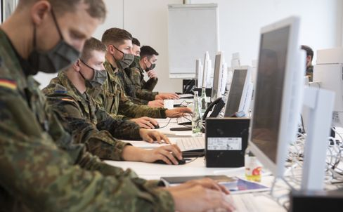

Soldiers help trace Corona infection chains in the Hanover region

Photo: Julian Stratenschulte / Julian Stratenschulte /picture alliance / dpa

In fact, the military is urgently needed. The Robert Koch Institute (RKI) has more than three dozen bottleneck reports from health services. Currently, according to the Ministry of Defense, 5350 soldiers are in action, helping in the follow-up of contacts on the offices or the Corona tests.

Most recently, even the **Berlin problem district Friedrichshain-Kreuzberg** has abandoned resistance to the use of the Bundeswehr. Since Wednesday, the District Superiors hit hard by the second wave (7-day incidence: 245). For weeks, the left and the green had prevented this. Now I want medics to take cuts.

### What does Sahra Wagenknecht do?

You can't really do it with her anymore, but you can't do it without her: The left and her political star Sahra Wagenknecht **have alienated themselves,** a year ago the 51-year-old resigned from the group presidency. Wagenknecht's central allegation paraphrases: **The left cares too much about urban hipsters and gender stars and too little about workers and unemployed people.**

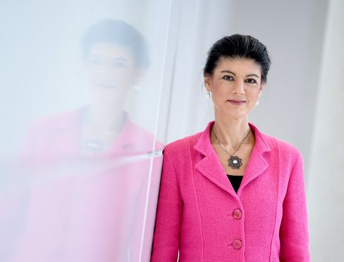

Left politician Wagenknecht

Photo: Britta Pedersen / dpa

Last weekend, her eternal opponent Katja Kipping should have been replaced as party leader. However, the party congress planned in Erfurt had to be postponed due to Corona. However, the designated new chairmen - Janine Wissler and Susanne Henning-Wellsow - are also not regarded as Wagenknecht buddies. So what do you do?

"What role can, should and does she want to play in a party in which hardly anyone can keep up with her popularity, but from which she obviously alienates herself?", my colleagues Kevin Hagen and Jonas Schaible ask today **in a** **profound piece about Sahra Wagenknecht** and her party, which I would like to recommend to you.

* [Left politician Wagenknecht: The Sahra Factor](https://www.spiegel.de/politik/deutschland/sahra-wagenknecht-und-die-linke-star-im-schatten-a-0a6d42d4-aa00-4e20-a82c-a85e4fca106e)

### Winner of the day ...

... is the CDU member **of** parliament **Elisabeth Motschmann.** As a member of the Foreign Affairs Committee, she clearly condemned Trump's attempts to stop a democratic election: "President Donald Trump's hasty declaration of victory is illegal and dangerous. **This is an ultimate attack on the core of democracy: the election."**

Her party friend and **CDU presidential candidate Friedrich Merz** behaves differently. The appeal to hold out is to be heard from him. But Motschmann is, of course, right. This is about the core of democracy. Without free choice, everything is nothing.

### The latest news from the night

* **"My short-term memory is over":** Michael J. Fox deals openly with his Parkinson's disease - now he has talked about recent health setbacks. [His memory had suffered greatly. But a hobby remains for him](https://www.spiegel.de/panorama/leute/michael-j-fox-schauspieler-spricht-ueber-verlust-von-kurzzeitgedaechtnis-a-dbf76c54-79c7-4721-83ca-7bb7385eff1c)
* **First full throttle, then slowness:** With three goals Borussia Dortmund has already decided the match at Club Bruges after half an hour. So the team could save energy - [it will need it on Saturday against FC Bayern](https://www.spiegel.de/sport/fussball/borussia-dortmund-siegt-in-der-champions-league-schnell-erledigt-kraft-gespart-a-fef85133-185d-451b-9713-700bb93f8831)
* **Children's door, tilting technique, feeding bowl for the dog:** Freight bikes are becoming more sophisticated - and more powerful. The segment is also booming because of the Corona pandemic. [Manufacturers offer many new models for 2021](https://www.spiegel.de/auto/fahrberichte/lastenrad-boom-die-cargobike-neuheiten-fuer-2021-a-b6a72088-1640-436a-8b7a-532f1f48f162)