## The location in the morning

## Why now speaks a lot for Biden

By [Sebastian Fischer,](https://www.spiegel.de/impressum/autor-9c4e5259-0001-0003-0000-000000000166) Head of the SPIEGEL Capital Office

Dear reader, good morning,

Today we are dealing with the (hopeful) finale of the decision between US President Donald Trump and challenger Joe Biden, the reluctance of the federal government and a virtual CDU party day.

06.11.2020, 05.38 a.m.

### Progress is a snail

Yeah, actually, they're still counting. And hour after hour, the race is getting worse. It's all about four states now: **Georgia, Pennsylvania, Arizona and Nevada.**

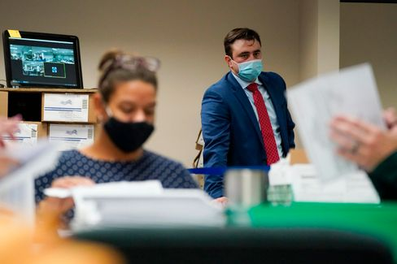

A Republican Election Observer at Counting in Pennsylvania

Photo: Mary Altaffer / AP

In Arizona (11 votes in the polling college) and Nevada (6) Joe **Biden** is **just ahead,** in Georgia (16) and Pennsylvania (20) he has caught up over the last hours, **the lead of the president melts** (Pennsylvania) or has **already melted (Georgia).**

Biden (so far 253 votes of 270 sure) now has **several ways to success,** Donald Trump (214) **only one.** And it's over **Pennsylvania.** There they counted the night, approaching the end, and Trump's former 10-percent point lead has fallen to below one percentage point.

Trump's legal attacks on the continuation of the enumeration **have so far remained unsuccessful.** It's still being counted.

* [Status of the censuses: This is how it stands in the key states](https://www.spiegel.de/ausland/us-wahl-stand-der-auszaehlungen-joe-biden-holt-in-mehreren-staaten-auf-a-d638279f-eee4-4a3d-9c9e-4ca0ef8b29d7)

### The Bizarre President, Part Two

While you were sleeping, after two days of camera abstinence Donald Trump spoke in the White House. It was **the continuation of his weird anti-democratic appearance on the night of the election.** "If you count the legal votes, I won loosely," he claimed. And more nonsense.

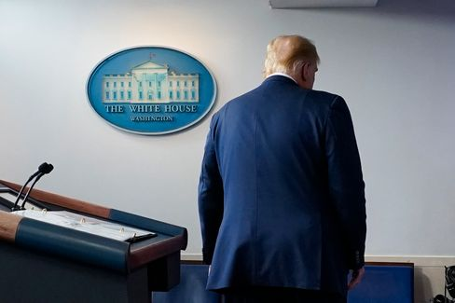

President Trump

Photo: Evan Vucci / AP

Trump seemed duller when he was lying this time than two days ago, tired and beaten off. **It was the words of an autocrat, but the sound of a loser.**

Presidential niece Mary Trump, who had published a book about her uncle before the election, commented: "That's what it looks like when a loser loses."

Biden, on the other hand, struggled a few hours before, together with his vice-president Kamala Harris, to make a most presidential appearance. Democracy is sometimes a bit chaotic, Biden said, **"sometimes it also needs a little patience."** But this patience had been rewarded in over 240 years US "with a system of government that engenders the envy of the world."

Well, not like that anymore. But we'll hold on.

* [US election: Trump once again blames fraud](https://www.spiegel.de/ausland/us-wahl-2020-donald-trump-behauptet-erneut-gewonnen-zu-haben-a-8dea65e4-4ab1-45c1-bacb-cf923bf05615)

### How do anti-democrats react?

Trump's lying appearance on the night of the election remained **unresponsive from the chancellor's office.** It can be assumed that this also remains so with his appearance from the last night.

Two days ago, Angela Merkel had her government spokesman Steffen Seibert alone tell her that the federal government had confidence in "the democratic tradition and the constitutional institutions" of America. As long as there is no end result, the government **follows "everything attentive",** but it does not comment.

The chancellor is expected to remain silent even now until the winner is established. Why get involved in skirmishes first?

Yeah, why not?

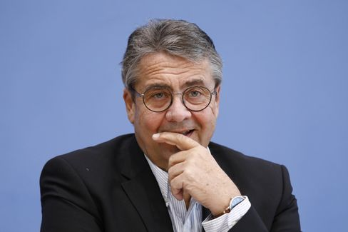

Former Minister of Foreign Affairs Gabriel

Photo: M. Popow / imago images/Metodi Popow

Criticism is now sparked by German restraint. Former SPD leader and former Foreign Minister **Sigmar Gabriel** demands a clear position on the US election from the Federal Government: "We should make it clear that the legitimacy of governments for us depends on **them accepting the basic principles of democracy,** and that is majority and minority," he said to the SPIEGEL.

The Federal Government is allowed to make a public statement. "That doesn't have to be combined with attacks on Donald Trump," said Gabriel, who is now head of the Atlantic Bridge, "but that we assume that all democracies feel bound to these principles **is a reasonable remark."**

* [US election: Sigmar Gabriel demands clear positioning of the Federal Government](https://www.spiegel.de/politik/us-wahl-sigmar-gabriel-verlangt-klare-positionierung-der-bundesregierung-a-9a6063ef-0b34-47a1-8111-b7a6a484b18d)

### Christian Digital Union

In the Christian Union, they would finally like to elect their new party leader. But because, first of all, the country is already **firmly under control of the Corona pandemic** again and the CDU did not have it so far with **digitalization,** it now has to be improvised. After all, a candidate for chancellor is soon needed. And how, please, should the CDU go into negotiations with the CSU if it doesn't even have a new chairman?

My colleagues Florian Gathmann and Veit Medick write today about the latest idea of the CDU: The delegates are to meet virtually for the **digital party congress** in January and **elect** the party leader and the rest of the board **online.** In the end, all election results would have to be confirmed again in a **written final vote,** i.e. by postal ballot.

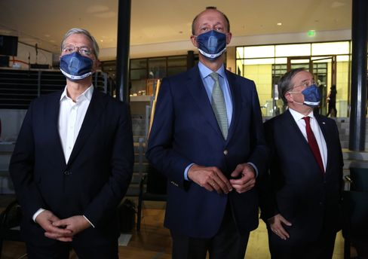

Candidate Röttgen, Merz. Lashet

Photo: Adam Berry / Getty Images

But now the crucial question: **Would that be legally safe?** After all, this is not about, let's say, the FDP chair. It's a position that could bring the holder to the Chancellery. The Union faction has asked the Ministry of the Interior for an assessment - and according to SPIEGEL information one is already sitting there on the matter. We'll keep our fingers crossed.

By the way: **The three CDU presidential candidates have a full program today.** Friedrich Merz presents his **book on the election campaign** via zoom conference (virtual!) : "New time. New Responsibility". It is presented by Christian Lindner (pardon, FDP boss is of course an important position). In the afternoon Merz and Rival Armin Laschet meet at the congress of the municipal political association of CDU and CSU (again virtual!), whose motto it can record with the Merz book title: "Designing structural change."

The CDU-Tag ends with a presentation round by **Merz, Laschet and competitor Norbert Röttgen at the Saxon Union** in Chemnitz - the party base is allowed to ask questions (of course: virtual).

* [Digital Party Congress: CDU wants clarification from the Ministry of the Interior for its presidential election](https://www.spiegel.de/politik/deutschland/cdu-parteitag-mit-wahl-des-vorsitzenden-innenministerium-soll-rechtssicherheit-bestaetigen-a-c7ffdaa5-9152-4a00-b5b9-b3ef959c25c3)

### Winner of the day...

...is **Mike Mohring.** The 48-year-old, who was replaced after the election debacle in 2019 and the no less debacle consequences than Thuringia's CDU boss, is given **a second political opportunity.**

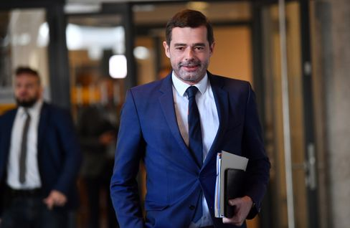

CDU politician Mohring (in March)

Photo: Martin Schutt/DPA

His CDU nominated him as **a Bundestag candidate** in one of the eight Thuringian constituencies, including Jena. Mohring beat the former member of the Bundestag Johannes Selle with 23 to 15 votes. According to SPIEGEL information, however, there are now considerations in the Selle camp to challenge the election.

Kind of familiar these days.

### The latest news from the night

* **More than 70 deaths from tropical storm "Eta":** Extreme rainfall has caused landslides and floods in Guatemala, Nicaragua, Costa Rica and Panama. [Dozens of people have already died, the number of victims could continue to rise](https://www.spiegel.de/panorama/gesellschaft/guatemala-nicaragua-costa-rica-und-panama-dutzende-tote-durch-tropensturm-eta-a-716dbe00-a2a2-408f-92f5-7dc7a9122e03)
* **Fingerprint obligation on ID card comes:** Two fingerprints, digital photos, an "X" on the passport for people who are not related to gender: [The Bundestag has decided on changes for identity cards and passports](https://www.spiegel.de/politik/deutschland/personalausweis-bundestag-beschliesst-aenderungen-fingerabdruck-pflicht-kommt-a-314b8525-51b0-4585-91e2-c45a5fe72bc6)
* **Barricaded in the Ministry:** Because of a Corona contact, Annegret Kramp-Karrenbauer went to quarantine at the beginning of the week. [But instead of being isolated at home, the Minister of Defense is sitting in her ministry. Can she do that?](https://www.spiegel.de/politik/deutschland/verbarrikadiert-im-ministerium-a-1113e0c0-0e47-4ede-8e8b-4d2fe9c0b0a6)