## The location in the morning

## Can Biden reunite the United States?

By [Sebastian Fischer,](https://www.spiegel.de/impressum/autor-9c4e5259-0001-0003-0000-000000000166) Head of the SPIEGEL Capital Office

Dear reader, good morning,

Today we deal with the likely winner of the US presidential election and his problems, with a broken party and an outsider who could become CDU chief.

07.11.2020, 07.28 a.m.

### How long do we have to wait...

...to start better times again? Welcome to Day 4 after the U.S. election night. The final winner is still not certain. It's still being counted. Every voice counts. At the same time, it is also clear: There is **hardly any realistic chance of a victory for incumbent Donald Trump.**

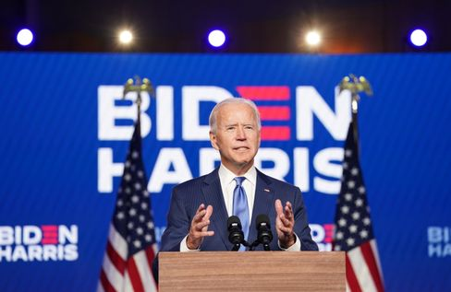

Candidate Biden at his appearance in Wilmington

Photo: KEVIN LAMARQUE / REUTERS

Last **night, Joe Biden appeared in public with Vice candidate Kamala Harris,** holding a kind of light version of an *Acceptance Speech,* with a handbrake attached.

Biden certainly gave up the victory and called his fellow countrymen to patience until really every voice had been counted. His performance was: a blessing. Well, well, well, well, well, well, well, well, well, well, well, well, well, well

What exactly do the figures say at the moment? **It stands 253 to 214 for Joe Biden** in the polling college, necessary for a victory is 270. The challenger is in **Nevada** (6 votes), **Arizona** (11) and **Pennsylvania** (20) with 20,000 to 30,000 votes each. In **Georgia** (16) Biden's lead is only a few thousand votes, so there will probably be a new count there in the end. But Biden would not be dependent on the result of the recounting in Georgia, even the other states would be enough for him if he were to fetch it.

**At Trump, despair has apparently grown in the last few hours.** The Anti-Democrat Council again and again conspiracy stories about the allegedly "stolen election" among its supporters, does not want to leave the White House. His son Donald Trump Junior had already recommended Daddy to **go to the "total war"** via Twitter.

In this context, read **our title story about Trump, the squatter.**

By the way, all attempts by Team Trump to take legal action against the counting of votes have so far **failed.** In his environment they will soon have to whisper it to him: Game Over.

* [Trump's dirty fight for the Oval Office: The squatter](https://www.spiegel.de/ausland/donald-trump-nach-der-us-wahl-der-hausbesetzer-a-00000000-0002-0001-0000-000173898741)

### What's coming?

This U.S. election was and is historical in so many dimensions.

* It is expected to **remove an anti-democrat and racist from office.**
* Challenger Joe Biden has won the *popular vote* with around 74 million votes and has **united as many votes as no candidate ever before** - also because of the very high turnout.
* However, Donald Trump is now in second place in this statistic. Almost half of the country is behind this man, **who was able to increase significantly compared to 2016.**
* It will probably make a traditional middle democrat a president who knew how to make **compromises with the Republicans** for decades. But is there still this Republican Party with which Joe Biden once made compromises?
* The Americans have voted Trump off, **but Trumpism will remain.** Read [here](https://www.spiegel.de/ausland/usa-nach-der-wahl-der-trumpismus-bleibt-auch-ohne-trump-a-00000000-0002-0001-0000-000173898740) the editorial of my colleague Mathieu von Rohr.

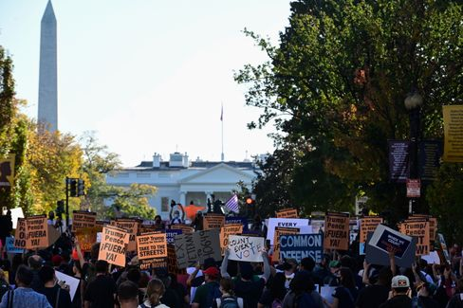

Protests in front of the White House after the U.S. election

Photo: ERIN SCOTT / REUTERS

So if it does, **it's a bittersweet victory for Joe Biden.** Before him lies the most difficult task of a president since the end of the Second World War. To restore the confidence of the international partners; to combat the Corona pandemic; to combat the economic crisis; to combat racism; to combat climate change.

Biden was Vice President in January 2009, when the brilliant winner Barack Obama passed away when he took over the country from his predecessor George W. Bush: Financial crisis, real estate crisis, car industry before collapse, terrorist threat, failed Iraq war.

But all this is nothing against all the challenges facing the 77-year-old Biden now. And Trump will remain **in the White House for about two and a half months** until the possible transfer of office in January. He may be a *lame duck* politically, but he still has all the power instruments of a president.

* [Fighting for the White House: Biden hopes to announce his victory on Saturday](https://www.spiegel.de/ausland/joe-biden-hofft-am-samstag-seinen-wahlsieg-zu-verkuenden-a-a96cea5e-4394-4091-8fa9-7c5d76a21ac6)

### What do the Republicans and their followers do?

Under Trump, the Republican Party has abandoned itself. In previous years, infiltrated by the right-wing radical tea party movement, she had already been shot ready for storm when Donald Trump came.

This party has become the **vehicle of an autocrat.** The Trump years were a character test for Lincoln's party - and it's messed up. Few upright Republicans like the former presidential candidate Mitt Romney have defended democracy and political decency. The vast majority of their elected representatives do not.

Now what? **We should not assume that the party is shaking and then emancipating itself from Trump.** The poison of Trumpism has leaked into this traditional party, with which Biden will find it difficult to reach compromises.

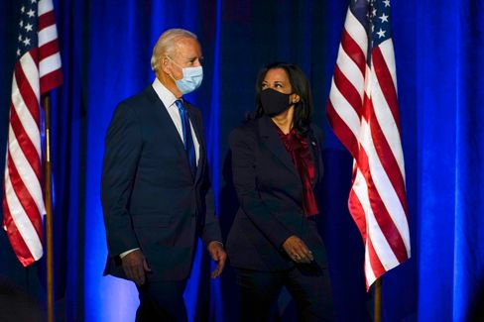

Candidates Biden, Harris

Photo: Carolyn Kaster / AP

Majority relations in the future Senate will be crucial, with a third of the total of 100 seats to be awarded in the election on Tuesday. **At the moment it's 48 to 48,** the Republicans are likely to win two more seats. There's two more left. And this is - of course - the two seats of the already contested Georgia (see above). Both will be decided in a final election in January. If it is 50:50, **the vote of the U.S. Vice President decides** at a stalemate in the Senate. And that in turn could be Kamala Harris.

And the voters? Or do you have to say better with a view to polarization: Trump fanbase? It will be **set on cold withdrawal** in the coming months. This can have unsightly consequences.

Biden and his vice president Kamala Harris will find little access to these people.

Should they even be looking for him? Yes, because **Trump voters are not the same as Trump voters.** There are the conspiracy narrators, the right-wing extremists: You don't integrate people like that, you fight them. But half the Americans aren't right-wing extremists. Countless have been led behind the spruce by Trump, the Republicans, the propaganda media.

Biden already appealed to these people during his recent appearance at night: **"We may be opponents, but we are not enemies. We're all Americans."** He would work as president just as hard for those who had not elected him. "We have to leave the anger and demonizations behind us," he said - it won't be easy.

* [Reward of shamelessness](https://www.spiegel.de/ausland/republikaner-nach-donald-trump-lohn-der-schamlosigkeit-a-04553b30-0efe-44fd-a0ff-cae8058bfb2b) [**-**](https://www.spiegel.de/ausland/republikaner-nach-donald-trump-lohn-der-schamlosigkeit-a-04553b30-0efe-44fd-a0ff-cae8058bfb2b) [The election result is not as catastrophic for the Republicans as it seems.](https://www.spiegel.de/ausland/republikaner-nach-donald-trump-lohn-der-schamlosigkeit-a-04553b30-0efe-44fd-a0ff-cae8058bfb2b)

### Is now Röttgen CDU boss?

During the election drama in the United States, one can see how a politician in Germany comes to the fore: Norbert Röttgen. The chairman of the Foreign Affairs Committee in the Bundestag is a candidate for the CDU presidency - **so far he was considered to be hopeless.**

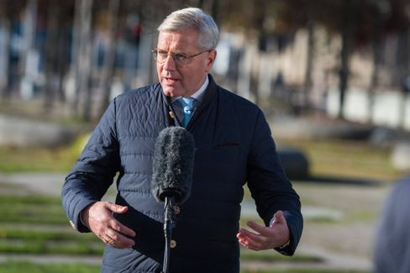

CDU politician Röttgen

Photo: Christian Spicker / imago images/Christian Spicker

But now his expertise is in demand, and his opponents **Friedrich Merz** and **Armin Laschet** recently waged an unappetising fight for the shift of the CDU Party Day in Corona times.

**Röttgen recognized his chance, gave the Compromiser** - and is already perceived by some as a candidate of compensation. My colleagues Florian Gathmann, Christoph Hickmann and Veit Medick describe the situation in this way: "The fact that Röttgen plays the conciliator at once, however, also goes **to** some on **the cookie** in the party. Many in the CDU still remember how often he gave the impression of being smarter than everyone else." He never spared power struggles. Years ago, he snatched away the precinct of a WG buddy.

And yet: Röttgen as party leader would **still have an attractive advantage** for many at the CDU base. He would be, writes the colleagues, probably the only Christian Democrat, who could leave the chancellor's candidacy to **the CSU boss Markus Söder,** who is popular with the CDU people, without loss of face.

* [CDU outsiders catch up: Can Norbert Röttgen become the leader of the party?](https://www.spiegel.de/politik/deutschland/cdu-kann-norbert-roettgen-etwas-doch-parteivorsitzender-werden-a-00000000-0002-0001-0000-000173898765)

### Winner of the day ...

... will be today (perhaps tomorrow) **Joe Biden** and **Kamala Harris.**

### The latest news from the night

* **Chief of Constitutional Protection suspended after attack in Vienna** : The terrorist attack in Vienna has human consequences: For the time being, the head of Vienna's constitutional protection has given up his position. [Austria's Interior Minister admits further failures of the authorities](https://www.spiegel.de/ausland/wien-verfassungsschutzchef-erich-zwettler-nach-terroranschlag-suspendiert-a-fb0f89ca-0cc3-4ce3-b5c5-d9a5698ec266)
* **Number of dead and missing by storm "Eta" rises to about 200** : In the case of landslides and floods caused by a tropical storm, more than a hundred people have died in Central America. [In Guatemala, an entire village was buried](https://www.spiegel.de/panorama/gesellschaft/eta-zahl-der-toten-und-vermissten-nach-tropensturm-in-zentralamerika-steigt-auf-170-a-de98effc-1635-4444-bb53-aadc293fc8e1)
* **Children's ponds in Lower Saxony hidden from the river - Suspect of manslaughter against mother** : A mother disappears from the hospital in Rotenburg with her four-year-old son. Hours later, the boy lies dead in the ramparts. [Now the prosecutor's office is investigating the 40-year-old](https://www.spiegel.de/panorama/justiz/rotenburg-in-niedersachsen-kinderleiche-aus-fluss-geborgen-totschlagsverdacht-gegen-mutter-a-0502b75d-8eb6-4717-8cbe-f9c06b709675)