## The location in the morning

## Trump's Days of Defiance

By [Dirk Kurbjuweit,](https://www.spiegel.de/impressum/autor-d6a694ab-0001-0003-0000-000000001319) author in the SPIEGEL capital office

Dear reader, good morning,

Today we deal with hard bandages in the USA, complaints against masks in Germany, the revolutionary Robert Blum and the salt shaker.

09.11.2020, 05.36 a.m.

### The Hour of Judges I

Losers can also do a lot of damage in a legal way. Donald **Trump** has taken this path. From now on, he wants his lawyers [to run more against the election results.](https://www.spiegel.de/ausland/us-wahl-2020-die-usa-zwischen-joe-biden-und-donald-trump-a-118fcb1b-ce70-4d78-9652-a24f433789f4) That is his right, even if there is no evidence so far that Trump, as he claims, has been deceived.

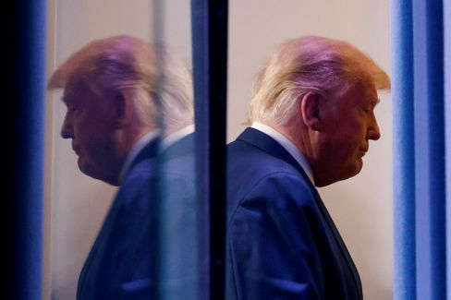

Donald Trump

Photo: CARLOS BARRIA / REUTERS

The question is whether you should make the most of your possibilities. Democracy researchers Steven Levitsky and Daniel Ziblatt have pointed out that democracies are also dependent on **"institutional failure":** "It's an act of intentional self-limitation - we don't fully exploit the power that is legally ours."

Trump's struggle may help his ego, although it seems more meagre with every day of defiance, but it hinders the transition, scratching the legitimacy and thus the power of the future president. Trump's approach contradicts the spirit of the Constitution by using it ruthlessly for his purposes. It's called constitutionalhardball, **constitutional struggle with hard bandages.** Levitsky and Ziblatt: "With every failing or failed democracy constitutionalhardball finds itself in abundance."

It has not been done, the struggle for US democracy continues. Now it's up to the judges.

* [Resistance to US election results: Trump's man for the rough](https://www.spiegel.de/ausland/richard-grenell-donald-trumps-mann-fuers-grobe-a-2bec8d33-7a8b-4ded-844d-e9bb7b00fdb7)

### The Hour of Judges II

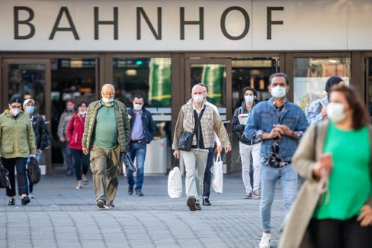

People with masks in Düsseldorf (April 2020)

Photo: Marcel Kusch/ DPA

A kind of "constitutionalhardball" exists these days also in Germany, with less drama though. Today, an administrative court is expected to decide whether the **masquerade obligation for the Düsseldorf city area** is permissible. Citizens challenge this edition with urgent requests.

There have recently been some judgments that have overturned political decisions in the fight against Corona, [the ban on accommodation in Baden-Württemberg](https://www.spiegel.de/politik/deutschland/corona-gericht-kippt-beherbergungsverbot-in-baden-wuerttemberg-a-7fd414c8-f59d-458d-9479-f1a4720e0761) or [the curfew for some Berlin hosts.](https://www.spiegel.de/politik/deutschland/corona-bestimmungen-gericht-kippt-berliner-sperrstunde-a-0c6b23db-f9c1-42b1-bba1-1c6b7ad85197) There will be more lawsuits, even more judgments. That is what the rule of law is for, and in doubt it also protects the interests of the individual against the majority. I will always defend this principle, but it would be appropriate for one or the other to avoid a complaint so that we can see whether the political decisions can help this country out of the crisis. It's not that bad wearing a mask.

Otherwise, it depends on the judges.

* [Simulation of pandemic progression: These are the scenarios for the Corona winter](https://www.spiegel.de/wissenschaft/medizin/corona-in-deutschland-das-sind-die-szenarien-fuer-den-winter-a-00000000-0002-0001-0000-000173898802)

### Death in the early morning

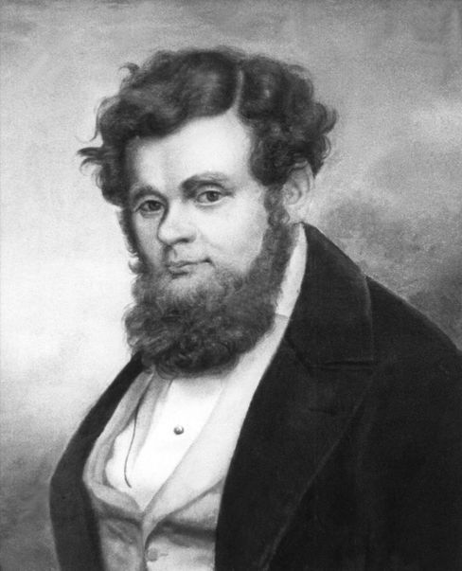

Robert Blum (undated archive image)

Photo: DPA

On November 9, **1848, Robert Blum** was awakened at five o'clock in the morning. At six o'clock, he stood in front of a firing squad. His last words are said to have been these: "I die for freedom, may the fatherland be mindful of me." Today this wish is finally to come true, at least a little. Federal President **Frank-Walter Steinmeier** will inaugurate the new **Robert-Blum-Saal** in Bellevue Castle, with art hanging on the walls of German democracy history.

Blum was one of the early German Democrats, born November 10, 1807 in Cologne. He learned the profession of the yellow caster, who made buckles or hinges from brass. Later he worked at the theatre in Leipzig, led the revolution of 1848 and moved as a member of the Paulskirchen Parliament in Frankfurt. Soon he went to Vienna because the revolution seemed to him more promising there, was arrested and executed. After that, the Germans forgot him. With the issue of democracy, they have been struggling for a long time.

All the more beautiful that the Federal President honors him from today with a hall in the castle, especially since November 9 also **stands for two other German revolutions,** that of 1918 and [that of autumn 1989 in the GDR.](https://www.spiegel.de/geschichte/9-november-1989-nacht-des-mauerfalls-wir-fluten-jetzt-a-1191238.html) And of course for the anti-Semitic atrocities that Germans have done, the 1938 Reichspogromnacht.

* [Freedom Fighter Blum: The Martyr of 1848](https://www.spiegel.de/wissenschaft/mensch/wiener-oktoberrevolution-1848-robert-blum-stirbt-als-freiheitskaempfer-a-972580.html)

### List of losses I: The salt shaker

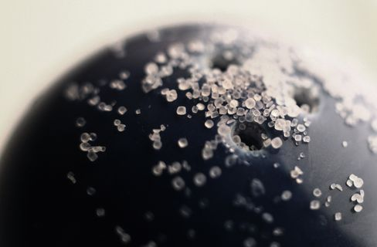

Anxiety of lubricating infections: The salt shaker has disappeared from many restaurants

Photo: Karl-Josef Hildenbrand/ dpa

From the writer **Judith Schalansky** there is a book entitled **"List of some losses".** I borrow these beautiful words and will **write** every day this week **about things or phenomena that have been lost to us in the pandemic.**

The salt shaker used to stand on every table in many restaurants. It wasn't the expensive restaurants, especially those with the stars. If Tim Raue in Berlin or the guest house Klaus Erfort in Saarbrücken were asked for a salt spreader, the cook would probably become obese (perhaps also the guest).

Salt spreaders were more like pizza Italians, Greeks or German corner. They were useful to cover the weaknesses of the kitchen, or helped the coarse palate to a sense of taste. On the other hand, salt is not exactly health-promoting, which is why the country's top health guru, the politician Karl Lauterbach, never consumes salt. Once when I was with him in the restaurant Facil (2 stars), he asked for saltless dishes, but then found out at the first course through discomfort that the cook had covered him with a pinch of salt, which almost led to the self-absorption of the cook.

Now the salt shakers have disappeared from many restaurants, out of fear of smear infections. [The alleged first German Corona outbreak](https://www.spiegel.de/wissenschaft/medizin/erster-corona-fall-in-deutschland-die-unglueckliche-reise-von-patientin-0-a-2096d364-dcd8-4ec8-98ca-7a8ca1d63524) at Webasto probably had to do with a salt spreader. If this loss causes all chefs to make more effort and we live healthier, the loss of the salt spreader is not really a loss.

### The latest news from the night

* **Joe Biden's first big battle:** 130,000 cases a day - Corona has the US firmly under control. How does Joe Biden want to tackle the crisis when he takes over the White House? [He is already presenting his task force](https://www.spiegel.de/ausland/joe-bidens-erste-grosse-schlacht-gewaehlter-us-praesident-gegen-coronavirus-a-83f72d92-0c42-4ee4-aeb8-46fcdca6da04)
* **"Up to 40 percent of the population are at risk":** The number of infections in Germany is increasing. [For Health Minister Jens Spahn, this is also related to the age structure - and the prosperity life](https://www.spiegel.de/wissenschaft/medizin/jens-spahn-sieht-bis-40-prozent-der-bevoelkerung-als-risikogruppe-fuer-corona-a-e60b80f4-19a2-47d3-b7de-1d37cac2dab8)
* **According to the report, Orbán threatens to veto the EU budget:** Anyone who dismantles the rule of law should soon receive less EU money - this does not appeal to Hungary, among other things. [According to a media report, head of government Viktor Orbán now becomes clear](https://www.spiegel.de/ausland/viktor-orban-droht-laut-bericht-mit-ungarns-veto-gegen-eu-haushalt-a-5dd6744d-cb08-4591-a052-80c8b3aec218)