Muscle Tonus Report

The following report is an analysis of the muscle load test performed at Plux on 26/09/2016.

The EMG electrodes were placed using the posterior superior iliac spine as an anatomical marker. Figure 1 shows the placement over the *multifidus* and the *erector spinae.*

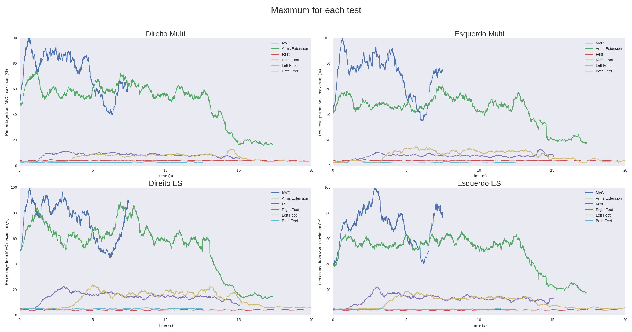

Figure 1 - Position of the EMG leads