Oblig 1

Ole Christian Moholth

## How to run

The game is a unity project, and all the variables are in the inspector.

To run, open the Physics folder as a unity project (or open the scene under Physics/Assets/Scenes).

$$F_{D}=\frac{1}{2}ρu^{2}C_{D}A$$

$$F_{D} is the drag force, which is by definition the force \\ component in the direction of the flow velocity. \\ ρ is mass density of the fluid. \\ u is the flow velocity relative to the object. \\ A is the reference area. \\ C_{D} is the drag coefficient-a dimensionless coefficient related to the objects geometry and \\ taking into account both skin friction and form drag$$

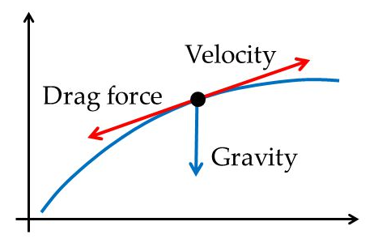

## Physics

### Drag

$$F_{D}=m\frac{∂v}{∂t}=\frac{1}{2}ρv^{2}C_{D}A$$

### Sum of forces

$$∑F=G+F_{D}$$

## Runge-kutta

Since the force acting upon the projectile depends on the velocity of the projectile relative to the surrounding fluid, the equations of motion given constant acceleration do not apply. Therefore we need a different approach to solving the problem.

The equation for drag links relates the velocity to it’s derivative, acceleration, so the problem is a differential equation.

Drag differential equation

$$m\frac{∂v}{∂t}=\frac{1}{2}ρv^{2}C_{D}A$$

There is no single approach to solving a differential equation, and we only need an approximate solution to the equation.

Using the method described in the book, fourth order runge-kutta (RK4), we can easily achieve a satisfactory result to this problem.

$$\frac{∂y}{∂t}=f\left(t,y\right), y\left(t_{0}\right)=y_{0}$$

$$y_{n+1}=y_{n}+\frac{h}{6}\left(k_{1}+2k_{2}+2k_{3}+k_{4}\right), \\ t_{n+1}=t_{n}+h$$

$$k_{1}=f\left(t_{n},y_{n}\right), \\ k_{2}=f\left(t_{n}+\frac{h}{2},y_{n}+\frac{h}{2}k_{1}\right), \\ k_{3}=f\left(t_{n}+\frac{h}{2},y_{n}+\frac{h}{2}k_{2}\right), \\ k_{4}=f\left(t_{n}+h,y_{n}+hk_{3}\right)$$

We need to calculate both the position and velocity of the projectile using RK4

$$\frac{∂x}{∂t}=v, \frac{∂v}{∂t}=a=g-\frac{ ρ{\left(v-v_{w}\right)}^{2}C_{D}A}{2m}$$

## Projectile

$$g=\left[\begin{aligned}0 \\ -9.81 \\ 0\end{aligned}\right]$$

Sum of the forces – Gravity, drag

$$∑F=G+F_{D} \\ a=\frac{∑F}{m}=\frac{G}{m}+\frac{F_{D}}{m}=g+\frac{F_{D}}{m} \\ F_{D}=-\frac{1}{2}ρ{\left(v-v_{w}\right)}^{2}C_{D}A$$

f(t, y) = dv/dt, dx/dt

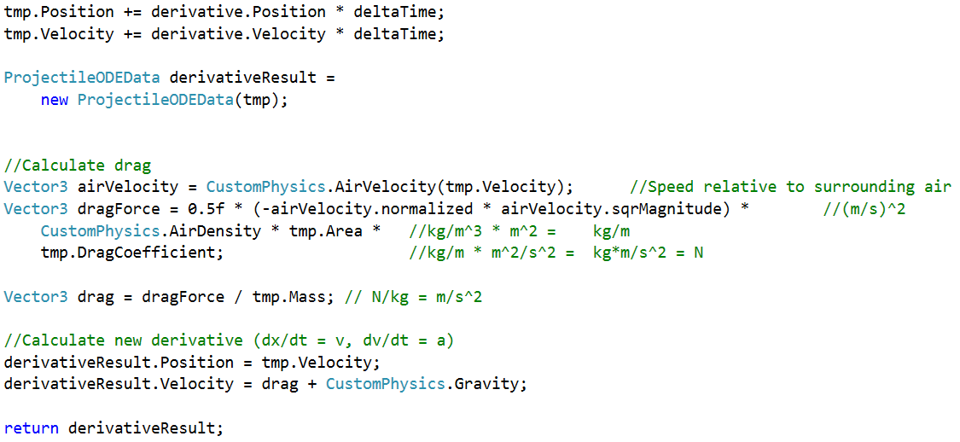



# References

Palmer, G. (2005). *Physics for Game Programmers.* Apress.