* **List of technologies and design pattern used :**
* **Technologies Used :**
  + **Tools :** Visual Studio 2012 , SQL server 2008
  + **Technology :**
    1. WCF
    2. LINQ to SQL
    3. MVC4
    4. . Net framework
    5. C#
    6. Java Script
    7. Jquery
    8. Angular JS
    9. Pdf Sharp
* **An overall activity diagram :**

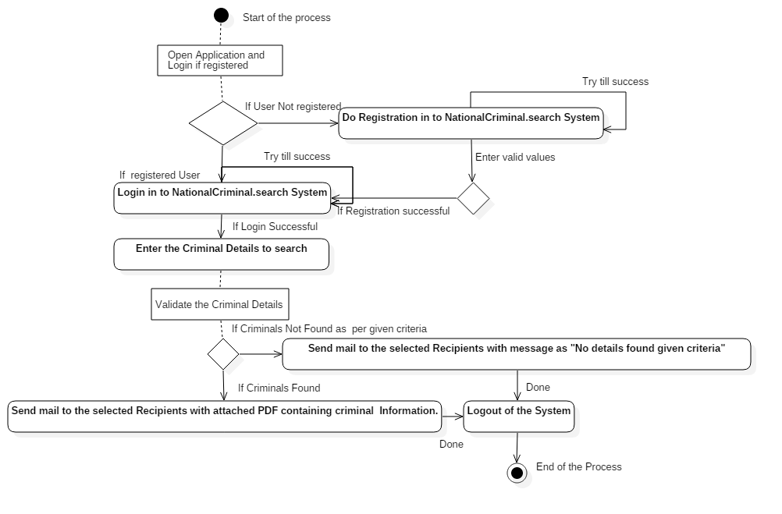

**Diagram1**.ActivityDiagram for Criminal Search

* **A sequence diagram for the search process :**

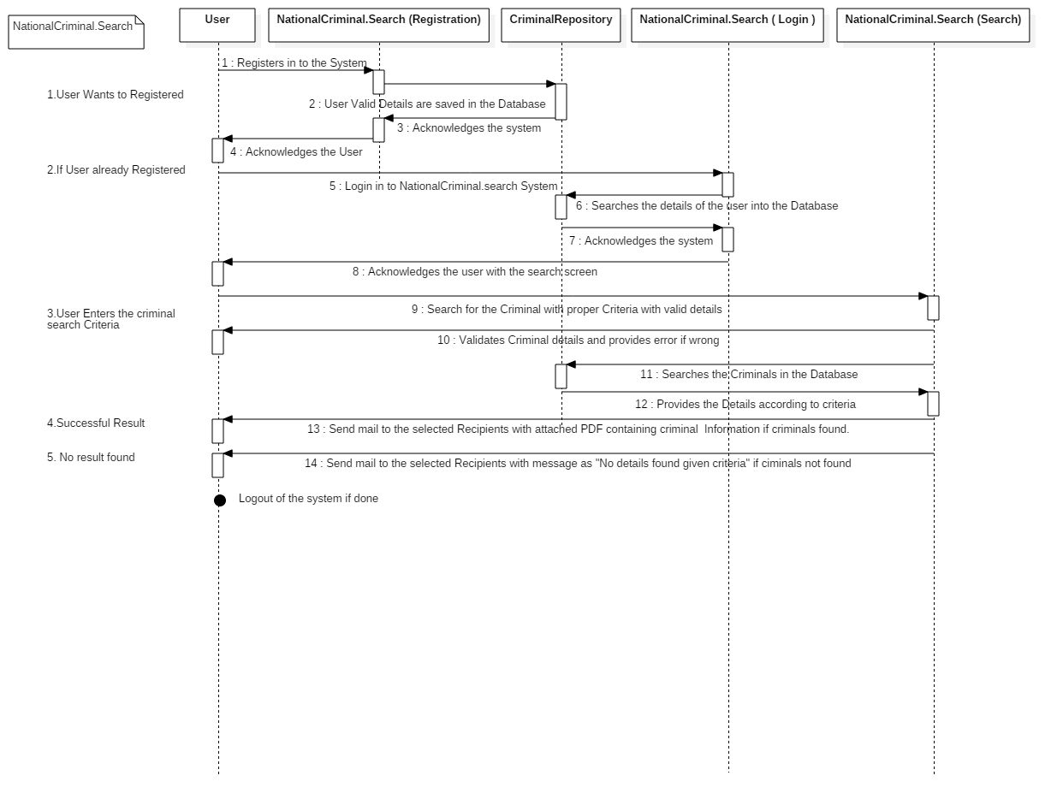

**Diagram2**.Sequence Diagram for Criminal Search