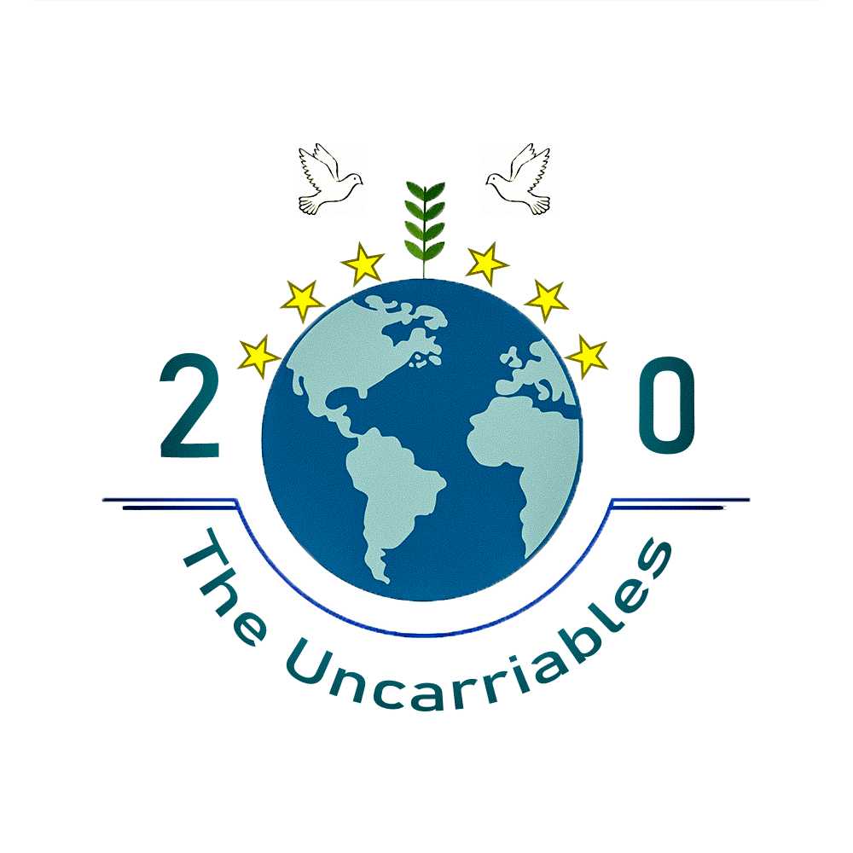

Table of Contents

1. TEchnical implementation 2

1.1 ROLES 2

1.2 Realization of the project 2

1.3 Used technologies 3

2. Information and Images copyright 4

2.1 Information 4

2.2 Images 7

3. description 9

1. TEchnical implementation
   1. ROLES

|  |  |
| --- | --- |
|  |  |
|  | Denislav Bratoevski (9B) – Scrum Trainer |
|  | Hakan Chandar (9V) – Front-End Developer |
|  | Alexander Baev (9V) – Designer |
|  | Ivailo Stoyanov (9B) – Back-End Developer |

* 1. Realization of the project

Our Scrum Trainer made the maps. The Designer and the Front-End developer made the website. The Back-End developer made the games. Sometimes we helped each out and “swapped” our roles. It was a wonderful and enjoyable journey. “We carried the uncarriable!”

* 1. Used technologies

|  |  |
| --- | --- |
|  | Used technologies |
|  | Teams - Communication |
|  | VS Code, Notepad++ - Coding |
|  | Word - Documentation and information |
|  | PowerPoint - Presentation |
|  | Excel – QA Documentation |
|  | Photoshop – Image editing |
|  | Amcharts – Charts and Diagrams |
|  | Leaflet - Maps |
|  | Font Awesome - Icons |
|  | HTML – Structure of the website |
|  | CSS – Style of the website |
|  | JavaScript – Games, Charts, Diagrams |

­­­

1. Information and Images copyright
   1. Information

|  |  |
| --- | --- |
|  | Used information with links |
|  | Stone Age  [WorldHistory.org](https://www.worldhistory.org/timeline/Stone_Age/) |
|  | Bronze Age  [WorldHistory.org](https://www.worldhistory.org/timeline/Bronze_Age/)  [ScientificAmerican.com](https://www.scientificamerican.com/article/when-the-first-farmers-arrived-in-europe-inequality-evolved/)  [Unesco.org](https://whc.unesco.org/en/list/393/)  [WorldHistory.org](https://www.worldhistory.org/Mycenaean_Civilization/) |
|  | Iron Age  [WorldHistory.org](https://www.worldhistory.org/timeline/Iron_Age/,%20https:/www.worldhistory.org/agora/) |
|  | Classical Antiquity  [SoftSchools.com](https://www.softschools.com/timelines/roman_empire/timeline_9/)  [SoftSchools.com](https://www.softschools.com/timelines/ancient_greece_timeline/80/) |
|  | Middle Ages  [SoftSchools.com](https://www.softschools.com/timelines/the_middle_ages_timeline/165/)  [Thoughtco.com](https://www.thoughtco.com/defining-the-middle-ages-part-6-1788883) |
|  | Renaissance Humanism  [WorldHistory.org](https://www.worldhistory.org/timeline/Renaissance_Humanism/)  [Wikipedia.org](https://en.wikipedia.org/wiki/The_Decameron)  [TimeToast.com](https://www.timetoast.com/timelines/humanism-d0818d6f-f0c1-46bd-8270-c1b02704de5b) |
|  | Protestant Reformation  [SoftSchools.com](https://www.softschools.com/timelines/protestant_reformation_timeline/218/) |
|  | European Renaissance  [WorldHistory.org](https://www.worldhistory.org/timeline/renaissance/)  [Britannica.com](https://www.britannica.com/summary/Renaissance-Timeline) |
|  | Enlightenment  [TimeToast.com](https://www.timetoast.com/timelines/enlightenment-s-major-events) |
|  | First Industrial Revolution  [SoftSchools.com](https://www.softschools.com/timelines/industrial_revolution_timeline/40/) |
|  | Revolutionary Period  [SoftSchools.com](https://www.softschools.com/timelines/revolutionary_war/timeline_11/) |
|  | Age of Imperialism  [TimeToast.com](https://www.timetoast.com/timelines/major-events-in-imperialism,)  [Wikipedia.org](https://en.wikipedia.org/wiki/Timeline_of_European_imperialism#1870%E2%80%931914) |
|  | Victorian Era  [SoftSchools.com](https://www.softschools.com/timelines/victorian_era_timeline/43/) |
|  | Second Industrial Revolution  [SoftSchools.com](https://www.softschools.com/timelines/industrial_revolution_timeline/40/) |
|  | World War 1  [SoftSchools.com](https://www.softschools.com/timelines/world_war_i/timeline_4/)  [Britannica.com](https://www.britannica.com/event/World-War-I/Killed-wounded-and-missing) |
|  | Great Depression  [SoftSchools.com](https://www.softschools.com/timelines/great_depression/timeline_13/) |
|  | World War 2  [SoftSchools.com](https://www.softschools.com/timelines/world_war_ii_timeline/120/)  [Britannica.com](https://www.britannica.com/event/World-War-II/Costs-of-the-war) |
|  | Contemporary Period  [Hispantic.com](https://history.hispantic.com/timeline/timeline-of-contemporary-period/)  [TimeToast.com](https://www.timetoast.com/timelines/major-historical-events-of-the-contemporary-period)  [Wikipedia.org](https://en.wikipedia.org/wiki/Germany)  [Britannica.com](https://www.britannica.com/topic/Berlin-Wall) |
|  | Troposphere  [Britannica.com](https://www.britannica.com/science/troposphere) |
|  | Stratosphere  [Britannica.com](https://www.britannica.com/science/stratosphere) |
|  | Mesosphere  [Britannica.com](https://www.britannica.com/science/mesosphere) |
|  | Thermosphere  [Britannica.com](https://www.britannica.com/science/thermosphere) |
|  | Exosphere - [Britannica.com](https://www.britannica.com/science/exosphere) |
|  | Space – [Britannica.com](https://www.britannica.com/science/space-physics-and-metaphysics) |
|  | Country flags – [Proballers.com](https://www.proballers.com/) |
|  | Austria  [Planetware.com](https://www.planetware.com/tourist-attractions/austria-a.htm)  [StiftAdmont.at](https://www.stiftadmont.at/en/library)  [Wien.info](https://www.wien.info/en/sightseeing/sights/hundertwasser-house-vienna-348464) |
|  | Bulgaria  [Wikipedia.org](https://en.wikipedia.org/wiki/Melnik,_Bulgaria)  [Britannica.com](https://www.britannica.com/place/Rila)  [Wikipedia.org](https://en.wikipedia.org/wiki/Central_Balkan_National_Park)  [Wikipedia.org](https://en.wikipedia.org/wiki/Tsarevets_(fortress))  [Unesco.org](https://whc.unesco.org/en/list/219/)  [CapeKaliakra.com](https://www.capekaliakra.com/) |
|  | Belgium  [Planetware.com](https://www.planetware.com/tourist-attractions/belgium-b.htm) |
|  | Croatia  [Planetware.com](https://www.planetware.com/tourist-attractions/croatia-hr.htm)  [Britannica.com](https://www.britannica.com/place/Istria) |
|  | Cyprus  [Planetware.com](https://www.planetware.com/tourist-attractions/cyprus-cy.htm) |
|  | Czech Republic  [Wikipedia.org](https://en.wikipedia.org/wiki/Mill_Colonnade)  [Planetware.com](https://www.planetware.com/tourist-attractions/czech-republic-cz.htm) |
|  | Denmark  [Planetware.com](https://www.planetware.com/tourist-attractions/denmark-dk.htm) |
|  | Estonia  [Planetware.com](https://www.planetware.com/estonia/top-rated-attractions-things-to-do-in-estonia-ee-1-2.htm)  [VisitEstonia.com](https://www.visitestonia.com/en/where-to-go/tallinn/tallinn-old-town) |
| F | Finland  [Planetware.com](https://www.planetware.com/tourist-attractions/finland-sf.htm) |
|  | France  [Planetware.com](https://www.planetware.com/tourist-attractions/france-f.htm)  [Wikipedia.org](https://en.wikipedia.org/wiki/Carcassonne) |
| G | Germany  [Planetware.com](https://www.planetware.com/tourist-attractions/germany-d.htm) |
| G | Greece  [Planetware.com](https://www.planetware.com/tourist-attractions/greece-gr.htm) |
|  | Hungary  [Planetware.com](https://www.planetware.com/tourist-attractions/hungary-h.htm) |
|  | Ireland  [Planetware.com](https://www.planetware.com/tourist-attractions/ireland-irl.htm) |
|  | Italy  [Planetware.com](https://www.planetware.com/tourist-attractions/italy-i.htm) |
|  | Latvia  [TheCrazyTourist.com](https://www.thecrazytourist.com/15-best-places-visit-latvia/)  [Wikipedia.org](https://en.wikipedia.org/wiki/C%C4%93sis_Castle)  [Wikipedia.org](https://en.wikipedia.org/wiki/Turaida_Castle)  [Latvia.Travel](https://www.latvia.travel/en/city/jurmala-8)  [Liepaja.Travel](https://liepaja.travel/en/see-and-do/the-beach/) |
|  | Lithuania  [Wikipedia.org](https://en.wikipedia.org/wiki/Trakai)  [Wikipedia.org](https://en.wikipedia.org/wiki/Vilnius_Old_Town,%20https:/www.lb.lt/en/money-museum-1)  [Wikipedia.org](https://en.wikipedia.org/wiki/Museum_of_Occupations_and_Freedom_Fights)  [Lithuania.Travel](https://www.lithuania.travel/en/place/the-devils-museum)  [Wikipedia.org](https://en.wikipedia.org/wiki/Hill_of_Crosses) |
| L | Luxembourg  [Planetware.com](https://www.planetware.com/tourist-attractions/luxembourg-l.htm) |
|  | Malta  [Wikipedia.org](https://en.wikipedia.org/wiki/Mdina_Gate)  [Planetware.com](https://www.planetware.com/tourist-attractions/malta-m.htm) |
|  | Netherlands  [Wikipedia.org](https://en.wikipedia.org/wiki/Canals_of_Amsterdam)  [Planetware.com](https://www.planetware.com/tourist-attractions/netherlands-nl.htm) |
|  | Poland  [Wikipedia.org](https://en.wikipedia.org/wiki/Auschwitz-Birkenau_State_Museum)  [Planetware.com](https://www.planetware.com/poland/top-rated-tourist-attractions-in-poland-pl-1-3.htm) |
|  | Portugal  [Planetware.com](https://www.planetware.com/tourist-attractions/portugal-p.htm)  [EuropeanWaterfalls.com](https://www.europeanwaterfalls.com/waterfalls/cascata-do-arado/) |
|  | Romania  [Wikipedia.org](https://en.wikipedia.org/wiki/Corvin_Castle)  [Britannica.com](https://www.britannica.com/place/Transylvanian-Alps)  [PoianaBrasov.com](https://www.poianabrasov.com/)  [Unesco.org](https://whc.unesco.org/en/list/588/)  [RomaniaTourism.com](https://romaniatourism.com/monasteries/sucevita-monastery.html)  [Wikipedia.org](https://en.wikipedia.org/wiki/Saint_Parascheva_Church,_Poienile_Izei) |
|  | Slovakia  [Wikipedia.org](https://en.wikipedia.org/wiki/Bansk%C3%A1_%C5%A0tiavnica)  [Planetware,com](https://www.planetware.com/slovakia/top-rated-things-to-do-in-slovakia-slo-1-2.htm)  [Unesco.org](https://whc.unesco.org/en/list/973/)  [Unesco.org](https://whc.unesco.org/en/list/622/) |
|  | Slovenia  [Wikipedia.org](https://en.wikipedia.org/wiki/Lipica,_Se%C5%BEana)  [Wikipedia.org](https://en.wikipedia.org/wiki/Postojna_Cave)  [Wikipedia.org](https://en.wikipedia.org/wiki/Predjama_Castle)  [InspiRock.com](https://www.inspirock.com/slovenia/idrija/anthonys-shaft-mining-museum-a1134192593)  [Kraji.eu](https://kraji.eu/slovenija/vrhnika_cerkev_sv_trojice/eng) |
|  | Spain  [Planetware.com](https://www.planetware.com/tourist-attractions/spain-e.htm) |
| S | Sweden  [Planetware.com](https://www.planetware.com/tourist-attractions/sweden-s.htm) |

### Images

Images are taken from Pexels, Pixabay, Unsplash, Wikimedia Commons and Flickr. The first 3 websites contain royalty free images (no copyright). Whereas in Wikimedia Commons and Flickr there is with and without copyright. Images that are in the [Public Domain](https://creativecommons.org/publicdomain/mark/1.0/deed.en) are without copyright.

|  |  |
| --- | --- |
| № | Images with CC Attribution-ShareAlike [2.0](https://creativecommons.org/licenses/by-sa/2.0/deed.en) , [3.0](https://creativecommons.org/licenses/by-sa/3.0/deed.en) and [4.0](https://creativecommons.org/licenses/by-sa/4.0/deed.en) licence with a link |
| 1 | [classicalEra7](https://search.openverse.engineering/image/96ec5763-8d7a-4d33-9414-d406d5150d9a) |
| 2 | [earlyMiddleAges3](https://www.flickr.com/photos/8259447@N06/31841056400/in/photolist-QvFJK3-PRh3f2-QvFP9y-dvH6yi-99mqwj-2bWoFsk-99ihog-8cpL1D-5r2mzo-4wyGwv-agFrb9-2mXY9mW-24YDutt-6w9FBt-5o7uzF-5obGV5-5obHWS-dSB2wf-53HBKB-CA7jX4-qNXQ6N-LWYMU-awmE87-7y6jdT-8gkB2B-22RA2kG-cxr21S-eFmwbS-4adJwP-nxBDqH-85vuNj-FJP7u5-oMNsCa-4hjy39-6EUtcp-4zXmR2-HxjMUw-9GEuoM-7bNaLf-bpgDcb-cxr2fm-9GEtfP-9GE5za-9GHnrd-9GGUso-bpgDed-bgZ9MZ-9GHkmb-GLKst8-bkSi2E) |
| 3 | [earlyMiddleAges5](https://commons.wikimedia.org/wiki/File:Statue_of_King_Alfred_at_Alfred_University.jpg) |
| 4 | [lateMiddleAges1](https://commons.wikimedia.org/wiki/File:Hundred_years_war_collage.jpg) |
| 5 | [renaissanceHumanism2](https://commons.wikimedia.org/wiki/File:Francesco_Petrarca2.jpg) |
| 6 | [renaissanceHumanism4](https://commons.wikimedia.org/wiki/File:Certaldo_Giovanni_Boccacio.jpg) |
| 7 | [renaissanceHumanism5](https://commons.wikimedia.org/wiki/File:Thomas_More_Utopia_November_1518_Erasmvs_Roterodamvs_(The_Folger_Shakespeare_Library).jpg) |
| 8 | [protestantReformation1](https://commons.wikimedia.org/wiki/File:95Thesen.jpg) |
| 9 | [protestantReformation6](https://commons.wikimedia.org/wiki/File:The_Story_of_Mankind_-_The_Thirty_Years_War.png) |
| 10 | [enlightenment1](https://commons.wikimedia.org/wiki/File:Peter_the_great_20180625_1.jpg) |
| 11 | [enlightenment7](https://commons.wikimedia.org/wiki/File:The_Estate_General.jpg) |
| 12 | [highMiddleAges4](https://commons.wikimedia.org/wiki/File:Magna_Carta_(Faversham)_9279.JPG) |
| 13 | [lateMiddleAges3](https://commons.wikimedia.org/wiki/File:Joan_of_Arc_statue_(Washington,_D.C.)_04.JPG) - [GNU Free Documentation License, version 1.2](https://commons.wikimedia.org/wiki/Commons:GNU_Free_Documentation_License,_version_1.2) |
| 14 | [firstIndustrialRevolution1](https://commons.wikimedia.org/wiki/File:Krupp_0-8-0T_Industrial_steam_engine_(No_1751).jpg) |
| 15 | [firstIndustrialRevolution2](https://commons.wikimedia.org/wiki/File:Spinning_Jenny_Helmshore_6108.JPG) |
| 16 | [firstIndustrialRevolution3](https://commons.wikimedia.org/wiki/File:Watts_Campbell_-Corliss-_Steam_Engine_-_18528327905.jpg) |
| 17 | [firstIndustrialRevolution5](https://commons.wikimedia.org/wiki/File:Automatic_Telegraph_Reciever.jpg) |
| 18 | [revolutionaryPeriod3](https://commons.wikimedia.org/wiki/File:Revolutionary_War_artillery_on_display_at_Yorktown_Battlefield_image_12.jpg) |
| 19 | [revolutionaryPeriod5](https://commons.wikimedia.org/wiki/File:Having_laid_down_his_sword,_statue_of_General_George_Washington_praying,_old_capital_building,_Olympia,_Washington,_USA.jpg) |
| 20 | [ageOfImperialism4](https://commons.wikimedia.org/wiki/File:Wikimedia_Conference_2011_Berlin_(210).JPG) |
| 21 | [ageOfImperialism6](https://commons.wikimedia.org/wiki/File:Russo-Japanese_War;_Japanese_ambulance_men_at_work_on_a_batt_Wellcome_V0015654.jpg) |
| 22 | [ageOfImperialism7](https://commons.wikimedia.org/wiki/File:Panama_Canal_Trip_1994_01.jpg) |
| 23 | [victorianEra2](https://commons.wikimedia.org/wiki/File:Alexandrina_Victoria_-_Bronze_-_ACCN_83-1-5_-_Government_Museum_-_Mathura_2013-02-24_6662.JPG) |
| 24 | [victorianEra3](https://commons.wikimedia.org/wiki/File:Memorial_to_the_Irish_Potato_Famine,_St_Lukes,_Liverpool_(2).JPG) |
| 25 | [victorianEra7](https://commons.wikimedia.org/wiki/File:Prince_Albert.jpg) |
| 26 | [secondIndustrialRevolution1](https://commons.wikimedia.org/wiki/File:VIEW_WEST,_BESSEMER_ENGINE._-_McKenna-Jojo_Air_Lease,_Kane_Field,_Kane,_McKean_County,_PA_HAER_PA,42-KAN.V,1-4.tif) – [NPS Copyright Policy](https://www.nps.gov/aboutus/disclaimer.htm) |
| 27 | [secondIndustrialRevolution2](https://commons.wikimedia.org/wiki/File:The_monument_to_Alfred_Nobel_at_the_memorial_park_Alfred_Nobel_Planet.jpg) |
| 28 | [secondIndustrialRevolution8](https://commons.wikimedia.org/wiki/File:Ford_Model_T_BW_2018-07-15_13-17-15.jpg) |
| 29 | [greatDepression3](https://commons.wikimedia.org/wiki/File:Franklin_D._Roosevelt_-_NH_19.tiff) |
| 30 | [worldWar2-3](https://commons.wikimedia.org/wiki/File:USS_Yorktown_during_the_Battle_of_Midway_(34966921235).jpg) |
| 31 | [contemporaryPeriod2](https://commons.wikimedia.org/wiki/File:West_and_East_Germans_at_the_Brandenburg_Gate_in_1989.jpg) |
| 32 | [contemporaryPeriod8](https://commons.wikimedia.org/wiki/File:Twin_Towers_Smoking.jpg) |
| 33 | [compass](https://www.flaticon.com/free-icon/compass_869156?term=compass&page=1&position=8&page=1&position=8&related_id=869156&origin=search) - Flaticon |
| 34 | [fortress](https://www.flaticon.com/premium-icon/fortress_1821818) - Flaticon |
| 35 | [gps](https://www.flaticon.com/free-icon/gps_608732) - Flaticon |
| 36 | [greek-temple](https://www.flaticon.com/premium-icon/greek-temple_1821763) - Flaticon |
| 37 | [helmet](https://www.flaticon.com/premium-icon/helmet_1401706?related_id=1401706&origin=search) - Flaticon |
| 38 | [knight](https://www.flaticon.com/premium-icon/knight_2706827) - Flaticon |
| 39 | [map](https://www.flaticon.com/premium-icon/map_924123) - Flaticon |
| 40 | [mountain](https://www.flaticon.com/free-icon/mountain_4289222) - Flaticon |
| 41 | [parchment](https://www.flaticon.com/premium-icon/parchment_2682065) - Flaticon |
| 42 | [plasts](https://www.flaticon.com/premium-icon/geography_2161280?related_id=2161280&origin=search) - Flaticon |
| 43 | [ship](https://www.flaticon.com/premium-icon/ship_1821825) - Flaticon |
| 44 | [sun](https://www.flaticon.com/free-icon/sun_2994302) - Flaticon |

## **description**

Our website has 3 things you can choose from: History, Geography and Games.

When you go to History main page you can choose from 20 historical eras. By choosing one you go to a timeline of important events during that period.

When you go to Geography main page you can choose a country from all countries in the European Union. By choosing one you go to a map and a diagram. The map of that country shows its biggest cities, protected areas, and popular tourist attractions. The diagram shows the country’s population from 1900 per decades.

When you go to the Games main page you can choose from 4 games: Memory Cards, Astronaut, Country Guess and Quiz. In memory cards there are cards that you should match with the corresponding image. In Astronaut you try to go to the farthest in the atmosphere so you can get more information about its spheres. In Country Guess you are challenged to show you skills about flags and countries capital. And finally in the Quiz you are asked questions about History and Geography, which information can be found in our website.

1. **Conclusion**

So far, we are happy with our project. But we think there are a few things we can do better on the website. Such as the number of countries. We would like to have information about all the countries in the world. Also, we would like to use SQL for the forms in the websites.