学号________________ 密级________________

**东北大学本科毕业论文**

Design and implementation of Educational Administration System in Elementary and Secondary Schools Based on J2EE

学 院 名 称：东北大学软件学院

专 业 名 称：软件工程（国际（英语））

学 生 姓 名：李远识

指 导 教 师：张明卫 副教授

吴洪涛 工程师

**2021 年 5 月**

Design and implementation of Educational Administration System in Elementary and Secondary Schools Based on J2EE

|  |  |  |
| --- | --- | --- |
| 作者姓名： | 李远识 | |
| 校内指导教师： | 张明卫 | 副教授 |
| 校外指导教师： | 吴洪涛 | 工程师 |
| 单位名称： | 软件学院 | |
| 专业名称： | 软件工程（国际（英语）） | |

东 北 大 学

2021年5月

Design and implementation of Educational Administration System in Elementary and Secondary Schools Based on J2EE

by Li Yuanshi

|  |  |  |
| --- | --- | --- |
| Supervisor: | Associate  Professor | Zhang Mingwei |
| Associate Supervisor: | Engineer | Wu Hongtao |

Northeastern University

June 2021

**郑 重 声 明**

本人呈交的学位论文，是在导师的指导下，独立进行研究工作所取得的成果，所有数据、图片资料真实可靠。尽我所知，除文中已经注明引用的内容外，本学位论文的研究成果不包含他人享有著作权的内容。对本论文所涉及的研究工作做出贡献的其他个人和集体，均已在文中以明确的方式标明。本学位论文的知识产权归属于培养单位。

本人签名： 日期：

摘 要

毕业设计（论文）是学生在校学习的最后阶段，是培养学生综合运用所学知识，发现、提出、分析和解决实际问题，锻炼实践能力的重要环节，是对学生实际工作能力的系统训练和考察过程。毕业设计（论文）是学生在教师指导下，对所从事工作和取得成果的完整表述，是学生毕业及学位资格认定的重要依据。论文的撰写是学生基本能力训练的过程，应当符合国家及有关行业（部门）指定的有关标准，符合汉语语言规范。为加强对此项工作的指导，严格把关，依据中华人民共和国《科学技术报告、学位论文和学术论文的编写格式》和东北大学论文格式制定此规范，本规范专为我院本科毕业设计（论文）撰写打印时使用。

本文主要介绍本科毕业设计（论文）的排版及打印规范，关于论文的撰写原则及内容指导请参考《本科毕业设计（论文）的撰写规范》一文。学位论文主要部分由前头部分、主体部分和结尾部分组成。前头部分主要包括：封面、中文题名页、英文题名页、郑重声明、中文摘要、英文摘要、目录。主体部分主要包括：绪论、正文、总结及展望。结尾部分包括：参考文献、致谢、附录（限必要时添加）。

希望通过本文的阐述，使同学们能够了解掌握东北大学软件学院本科毕业设计（论文）的排版及打印规范，并认真执行。

**关键词：**本科毕业设计；论文排版；论文打印；页面布局；段落

**ABSTRACT**

In recent years, with the rapid development of software and hardware technology, all aspects of people's life gradually integrate with information technology. School management is also moving towards unification, standardization and informatization. The improvement of school educational administration system is also the most important in the process of information standardization. Although the structure of educational administration website system in Colleges and universities is gradually improved, the educational administration information in the compulsory education stage of primary and secondary schools is still in the primary stage of development. Compared with many developed countries, the development of information system in primary and secondary schools is in the primary stage and lacks a perfect and mature system. Therefore, it is urgent to develop a set of compatible and widely applicable educational administration management platform in primary and secondary schools.

**Key words:**

Contents

摘 要 II

ABSTRACT III

I.　 Introduction 1

1.1 Introduction to development background 1

1.2 Research values 2

1.3 Research status 3

II.　 Related technologies 5

2.1 封面 5

2.1.1 论文题目 5

2.1.2 学生信息 5

2.1.3 论文封面日期 5

2.2 中英文题名页 5

2.2.1 题目 5

2.2.2 姓名 6

2.2.3 学校与日期 6

2.3 郑重声明 6

2.4 中英文摘要 6

2.4.1 摘要标题 6

2.4.2 摘要内容 6

2.4.3 关键词 6

2.5 目录 7

2.5.1 目录 7

2.5.2 索引条目 7

III. 正文部分 8

3.1 各级标题 8

3.2 正文 8

3.3 图 8

3.4 表 9

3.5 程序代码 10

3.6 公式 10

3.7 注释 11

3.8 引文标示 11

IV. 结尾部分 13

4.1 参考文献 13

4.2 参考文献格式 13

4.3 参考文献举例 14

参考文献 15

致 谢 16

1. **Introduction**

Compulsory education is an important educational process that all Chinese citizens need to participate in at this stage. Due to the large population base in China, educational administration is a huge project. The work of educational administration in primary and secondary schools has high repeatability and heavy workload. Based on the educational administration work of various schools, the development of educational administration information system suitable for primary and secondary schools supported by high information technology can provide a good information environment for the teaching work of primary and secondary schools.

## **Introduction to development background**

With the continuous expansion of the population base, the number of people receiving compulsory education is gradually increasing, and the number of institutions carrying out compulsory education is also gradually increasing. According to the data of the seventh national census on May 11, 2021, China's total population is 141.17 million. Among them, the population aged 0-14 is 253.38 million, accounting for 17.95%. According to relevant data, in 2020, the number of students in compulsory education will reach 156 million, and the number of schools in compulsory education will be 210,800. There are 52,800 junior high schools in China, with 16.321 million students enrolled and 49.1409 million students enrolled. There are 3.8607 million full-time teachers in junior middle schools. There are 158,000 primary schools. Primary schools enrolled 18.0809 million students and 107.2535 million students. There are 6.4342 million full-time teachers in primary schools. Table 1-1 shows the number of primary and secondary school students in 2015-2020.

**Table 1.1 The number of primary and secondary school students in 2015-2020**

|  |  |  |  |
| --- | --- | --- | --- |
| Year | Pupils | Junior students | Total |
| 2015 | 86,930,000 | 43,120,000 | 130,050,000 |
| 2016 | 99,130,000 | 43,290,000 | 142,420,000 |
| 2017 | 100,940,000 | 44,420,000 | 145,360,000 |
| 2018 | 103,390,000 | 46,530,000 | 149,920,000 |
| 2019 | 105,610,000 | 48,270,000 | 153,880,000 |
| 2020 | 107,250,000 | 49,140,000 | 156,390,000 |

According to this table, in the six years of compulsory education, the number of students in school increased by about 20% from 130 million in 2015 to 156 million in 2020. With the growth of the number of students year by year, the teaching staff is also growing, and the task of each teacher and school staff is getting bigger and bigger. With the existing teachers and educational resources, it is a challenge for compulsory education to ensure the orderly teaching work.

The school's educational administration work is generally presided over by the educational administration office, and the level of teaching work is closely related to the development of daily educational administration work. With the same number of classrooms and teachers, the scale of teaching management is gradually expanding and showing a trend of repetition. Educational administration involves student status management, examination results management, curriculum management and other aspects, covering many similar contents[1]. Take the middle school where I used to work as an example. There are less than ten staff in the academic affairs office, who are responsible for the teaching of about 3,000 or 4,000 teachers and students. Different people perform their own duties. However, with the expansion of the number of students, the workload of each staff member is greatly increased. Only when the quality of educational administration is guaranteed, can the teaching quality of teachers and the learning effect of students be guaranteed. Therefore, the teaching based on educational administration has been recognized by more and more regional schools.

In order to do a good job of educational administration in primary and secondary schools, in addition to increasing the staff of the educational administration office, we can also improve the efficiency of educational administration by using of information technology[2]. Due to the influence of factors such as establishment assessment, it is difficult to implement the method of adding personnel. The use of information technology can realize the systematic management of educational administration information in a real sense and achieve the goal of paperless teaching. It can greatly reduce the duplication of labor, improve the efficiency of educational administration, improve the level of teaching[3].

With the development of software and hardware and the popularization of information technology, many primary and secondary schools have computer and other electronic equipment, and built the intranet. At the same time, they have launched the open official website and WeChat small program platform. Both parents and teachers can visit the school website through mobile phones and iPads to learn about students' learning. Based on this kind of network equipment construction, many primary and secondary schools have the foundation to deploy educational administration management system[4].

Through visiting several primary and secondary schools in Tangshan, Hebei Province, it is found that due to the lack of informatization of educational administration system, there are many problems, such as low efficiency of teaching office, difficult development of educational administration, etc., which bring difficulties to the further improvement of teaching quality. The problems are as follows.

1. The efficiency of teaching task is low

This problem is reflected in many aspects. In the process of handling various affairs, all levels need to approve documents. For example, teachers need to print class and grade transcripts, and they need to submit the transcripts to the Academic Affairs Office for approval. The academic affairs office can only provide transcripts to teachers after consulting materials and stamping approval. These redundant services and procedures greatly increase the complexity of educational work, so it is necessary for information system to assist paperless office.

1. Lack of teaching summary and analysis ability

This is clearly reflected in each quiz and mid-term final exam. For example, after getting the report card, teachers only have simple ranking and average score information, and other information needs to be analyzed one by one. This greatly reduces the office efficiency of teachers and adds a lot of tasks to teachers. However, if we combine today's hot machine learning and deep learning algorithm, cluster analysis of student performance, and provide some reference for teachers and parents, then the teaching work will be significantly improved.

1. Unable to respond to different circumstance in time

During the investigation, we found that the staff of the Academic Affairs Office generally reflected some common problems. When the accidental events such as students' suspension and transfer in and out occur, the existing system is very troublesome to deal with, or there are no effective response measures at all. These aspects show that the current backward educational administration system in primary and secondary schools is difficult to deal with emergencies, so we need a set of perfect educational administration management system, which can still effectively deal with and continue to use when these problems occur.

In light of above-mentioned problems, this thesis gives a proper solution to most primary and secondary schools which could be easily moved.

## **Research values**

Due to the low level of informatization of educational administration management system in the research area at the present stage, and the difference is very large, so the development of a B/S mode of educational administration management system has the following three significance:

1. Reduce the workload of teachers and educational staff

In the daily work of educational administration, many businesses are repetitive or do not need human operation. For example, the work of student score entry, ranking and analysis can be automatically completed by the educational administration software system, without the need for teachers or educational administration staff to check one by one. Through the informatization of educational administration system, we can greatly save the cost of human resources, reduce the duplication of work, and reduce the workload of personnel.

1. Ensure the teaching work in order

The intelligent educational administration management system is the core of the school to carry out various teaching tasks. The quality of educational administration ensures the orderly progress of student work, logistics work and administrative work. Therefore, the informatization of educational administration system is of great research value.

1. Meet the needs of work and help other work in order

In daily teaching life, there will always be a series of emergencies. For example, teachers ask for leave, take holidays, make up classes and other special circumstances, if it is necessary to allocate resources manually, it is not only inefficient, but also likely to make mistakes. If we use a reasonable algorithm to achieve the transfer of teachers, then the efficiency of problem processing will be greatly improved, and the normal education and teaching work can be maintained.

## **Research status**

Western developed countries such as the United States, Britain and Canada have the advantages of advanced science and technology and early technology development. After entering the 21st century, they have established a relatively mature educational administration system. Through consulting the research materials of educational administration system at home and abroad, the paper summarizes and compares the development of educational administration system at home and abroad, and finds out the following two advantages of educational administration system in developed countries.

1. High degree of fit of new technology

Many foreign educational administration systems can be combined with high technology. As we all know, there have been unprecedented breakthroughs and progress in the fields of smart phones, data mining and machine learning. Some foreign primary and secondary schools have applied this kind of high technology to the development and application of educational administration information system. Combined with the existing good school network foundation, realize the specific function for each student in different situations. Take California, for example, where I visited. The primary schools in the whole state are connected to the Internet. Parents can download the corresponding app to pay attention to their children's academic performance or listen to school news push. This is a good reflection of the school's educational management system and the integration of new technologies.

1. High degree of automation and informatization

With the rapid development of machine learning, artificial intelligence, neural network and other fields, this kind of algorithm can be used to optimize educational administration, teaching information arrangement, student performance analysis and other aspects. Relying on the results of flexible business process processing and intelligent processing, foreign schools apply these research and technology to the educational administration system, which greatly improves the automation and informatization of the system[5]. For example, many artificial intelligence algorithms can be used in automatic course scheduling[6], and the method of information processing in the Internet of things can also be used for reference[7].

With the gradual improvement of domestic primary and secondary school network, and the improvement of Internet technology, the development of domestic compulsory education stage educational information management platform has a good environment. The function is gradually changing from single to complex, and the scope of application is gradually changing from inside to outside.

The educational administration management system based on Web application development belongs to the popular application development direction, whether computer or smart phone, as long as there is a network place, you can log in and use this kind of application at any time. With a browser, you can open the website for operation anytime and anywhere. And in today's environment, WeChat small program end can also be used as the research and development direction, open the ssmall program, teachers and parents can carry out comprehensive supervision and education on children, realize online communication, sending and receiving information and other functions.

Based on the research results at home and abroad, combined with the actual situation of primary and secondary schools in Tangshan, Hebei Province, the paper designs and develops an applied software system for the primary and secondary school education business, and applies the machine learning algorithm to improve the efficiency of educational administration.

## **Research contents**

This article will design and develop a teaching management information system of primary and secondary schools based on B / S mode and separation of front and back end according to the teaching management situation of some primary and secondary schools in Tangshan, Hebei Province. The main research and development contents are as follows:

1. requirement analysis procedure

Requirement analysis is one of the important links in software development. The requirement analysis process needs to obtain the user requirements. This paper makes full investigation on the management of teaching in primary and secondary schools, combs the business module process, divides the function module, realizes the detailed analysis of the function module, and the demand documents in the production and development process.

1. database design and implementation

According to the requirement documents, complete the conceptual model design and physical model design of the database, and complete the data dictionary.

1. system design

In this paper, through the research and analysis of the development mode of front-end and back-end separation mode, the back-end distinguishes the logic of controller layer, service layer and Dao layer. The front end pays attention to the combination of structure layer (HTML), presentation layer (CSS) and behavior layer (JavaScript). Distinguish the functions of each layer, and carry out separate development at the same time.

1. system functional implementation

This part analyzes the interface and code of each function.

1. system test

In the testing process, JUnit and other tools are used to test the function and performance of the system. The results will also be tested in this part.

Through the above-mentioned series of processes, gradually complete the realization of supporting the educational administration management information system of primary and secondary schools.

## **Organizational structure of this thesis**

Chapter one: Introduction. This paper introduces the development background, research significance, research status at home and abroad, research content, including the organizational structure of the paper.

Chapter two: Related technologies. This paper introduces the development environment, expounds the technology of front-end and back-end separation development and server mount technology.

Chapter three: Requirement analysis. This paper analyzes the demand of educational administration in primary and secondary schools, and constructs the system demand analysis model (physical model and conceptual model).

Chapter four: System design. Including database design (design table structure to meet business storage requirements) and software system architecturedesign.

Chapter five: System implementation. Realize the content of system requirement analysis, improve system security, information management and data mining.

Chapter six: System test. Write test cases, use test tools to test the performance and function of educational administration system.

Chapter seven: Summary and Prospect. This paper summarizes the research and development work, and looks forward to the next research and optimization content.

1. **Related technologies**

## **The theoretical basis of applied algorithm**

When analyzing the influencing factors of students' test scores, the optimized K-Means clustering method(p-K-Means) is used to further mine the students' scores.

* + 1. **Traditional K-Means**

The traditional K-means method randomly selects the number of clusters and cluster points, then calculates the set distance between data points and cluster points, and then repeatedly calculates until the algorithm converges.

For primary and secondary school students' performance analysis, the traditional K-means method will have some disadvantages. First, the number of clusters needs to be specified artificially. Without experience, it is difficult to determine how many factors are related to students' performance. Secondly, the method is highly dependent on cluster points, and it is easy to fall into local optimum, which may reduce the number of factors affecting students' performance. Finally, when the data points are scattered and the noise is large, the result will be greatly affected. To sum up, we need to use the improved p-k-means method to solve these problems.

* + 1. **Optimal p-K-Means method**

In order to better illustrate the p-K-Means algorithm, some definitions are proposed.

**Definition 1:** let and are two different data objects, they are all in dimension, and their geometric distance are as follows:

**Definition 2:** let the geometric distance from data object ( dimension) to set (data set of the sample points) are:

**,**

**Definition 3:** For the data object and data object in the collection, if the clustering of data objects *m* to two data objects and reaches the farthest, the following conditions are established:

**Definition 4:** The arithmetic mean in set is calculated as follows:

The following steps are the p-K-Means method:

Step 1: Input cluster data and data set and cluster number K

Step 2: Calculate the distance between two data objects, find the largest distance *d* and two points C1 and C2 with the largest geometric distance.

Step 3: Virtually delete all points from the set (do not participate in the next search and add flag bits).

Step 4: Take C1 and C1 as the initial basic clustering centers, search C3 from the set to maximize the distance between C3 and C1 and C2 (C3 satisfies the conditions in definition 1).

Step 5: Compare and judge whether the number of cluster centers is equal to the input k value. If it is less than K, repeat step 3 and step 4 (until the cluster is clustered), When the number of cluster centers is equal to K value, the following steps are performed.

Step 6: Calculate the distance from all points to the cluster center, and find the nearest cluster.

Step 7: Calculate the center of gravity of each cluster and move the cluster center.

Step 8: If the algorithm does not converge, repeat steps 5 and 6. If the algorithm converges, end the algorithm and output results.

Figure 2.1 gives the process of p-K-Means algorithm.

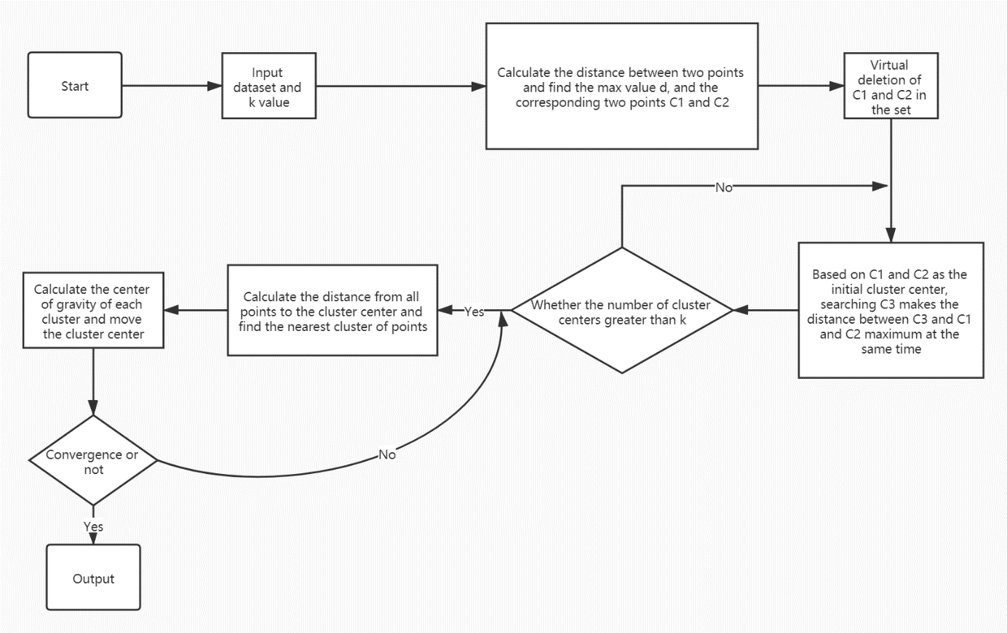

**Figure 2.1 p-K-Means algorithm process[8]**

The improved p-K-Means algorithm solves the problem that the traditional K-Means algorithm relies too much on the initialization of the cluster center, so it is suitable for the clustering analysis of students' performance.

## **System development mode**

* + 1. **Object-oriented development pattern**

Generally, software development has two modes: object-oriented and process oriented. The core of object-oriented is object. Object is a variety of things that people want to study. It can be specific things in daily life, but also some abstract rules, plans and so on. Objects are abstracted into classes. Modularization of complicated steps is object-oriented. The core of modularization is the whole thing, which is to decompose the things that constitute the problem into various objects. The purpose of establishing the object is not to complete a certain step, but to describe the behavior of a certain thing in the whole step of solving the problem[9].

Object oriented development is a progress of the concept of process-oriented development. For web applications, the use of object-oriented development can greatly improve work efficiency and reduce workload, so the use of object-oriented development mode.

The integration of object-oriented development pattern into the development process is embodied in object-oriented analysis (OOA), object-oriented design (OOD) and object-oriented programming (OOP). The advantage of object-oriented development pattern can be listed as the following three points:

1. High development efficiency

Using the object-oriented development method, we can abstract the real things and map the real things directly to the development objects, which is like the human thinking process. At the same time, because the object-oriented development method can achieve code reuse through inheritance or combination, it can greatly improve the efficiency of software development.

1. Ensure the robustness of the software

It is because of the high importance of object-oriented development method, in the development process can reuse the existing and long-term tested code in related fields, so it naturally plays a good role in promoting the robustness of software.

1. Ensure the high maintainability of the software

Due to the object-oriented development method, the readability of the code is very good. At the same time, the object-oriented design pattern also makes the code structure clearer and easier to maintain.

* + 1. **Separation of frontend and backend**

In the application mode of frontend and backend separation, the backend only returns the data required by the frontend, does not render HTML pages, and no longer controls the effect of the frontend. What effect the user sees and how the data requested from the backend is loaded into the frontend are all decided by the frontend. The backend only needs to provide a set of logic to provide data to the outside, And the coupling degree between the frontend and the backend is relatively low. In this mode, we usually make each view of the backend development an interface, or API, and the frontend can add, delete, modify and query data through the access interface.

The advantage of front-end and back-end separation is to improve work efficiency, make the division of labor clearer, and improve the local performance of the system. In the follow-up process, the code can be better reused and easy to maintain. The business platform is not limited to web applications, but may develop WeChat applets or other types of development, such as embedded development. Therefore, using the development mode of front-end and back-end separation can greatly reduce the workload and make the educational administration system easier to migrate.

## **Development tools and environment**

1. **Development tools and technologies**
2. Database.

Navicat. Navicat is a set of fast, reliable and cheap database management tools, designed to simplify database management and reduce system management costs. Built with an intuitive graphical user interface, Navicat provides a secure and simple way to create, organize, access, and share information. Navicat Premium enables you to simply and quickly transfer data between various database systems, or to transfer a plain text file in a specified SQL format and encoding. This simplifies the process of migrating data from one server to another. Batch jobs from different databases can also be scheduled and run at a specified time.

1. Backend.

MyBatis. MyBatis is an excellent persistence layer framework, which encapsulates JDBC. It supports customized SQL, stored procedures, and advanced mapping. MyBatis avoids almost all JDBC code and manual setting of parameters and obtaining result sets. MyBatis can use simple XML or annotations to configure and map native information, and map interfaces and Java POJOs (plain ordinary Java objects) to records in the database.

Spring framework (Spring boot, Spring MVC, Spring cloud). In a sense, Spring framework belongs to the upgraded version of J2EE framework, which has all the characteristics of J2EE and simplifies the development process. JavaBean is used to replace the cumbersome EJB. In recent years, with the development of Spring project, excellent derivatives such as Spring boot auto configuration tool and Spring could distributed framework are born.

Spring Boot is designed based on Spring 4.0, which not only inherits the original excellent features of Spring framework, but also simplifies the whole construction and development process of Spring application by simplifying configuration. Spring Boot can be used to create independent Spring applications, and executable JARs and WARs can be created based on its Maven or Gradle plugins; At the same time, embedded Tomcat and other servlet containers; Automatic configuration of "starter" project object model (POMS) to simplify Maven configuration; Absolutely no code generation, no XML configuration, making the code simple.

1. Frontend.

Vue framework (Vue-CLI, Vue Router, Vue Loader). Vue is a progressive JavaScript framework for building user interfaces. Unlike other large frameworks, Vue is designed to be applied layer by layer from the bottom up. Vue's core library only focuses on visual layers, which is not only easy to use, but also easy to integrate with third-party libraries or existing projects. On the other hand, when combined with modern tool chain and various supporting class libraries, Vue can also provide drivers for complex single page applications (SPA).

1. Server.

Apache Tomcat server. Tomcat server is a free open-source web application server. It is a lightweight application server. It is widely used in small and medium-sized systems and not many concurrent users. It is the first choice for developing and debugging JSP programs. Tomcat is an extension of Apache server, and its ability to handle dynamic HTML is much better than Apache. In addition, Tomcat server is also a servlet and JSP container, and independent servlet container is the default mode of Tomcat.

1. **Development environment**

JDK 8, MySQL Ver 8.0.20, Node.js V14.3.0, Spring boot 2.4.5, Spring cloud 2020.0.2, Vue CLI 4.4.1, Apache Tomcat 9.0.36.

## **Summary**

This chapter introduces how to select the appropriate development mode, determine the object-oriented development mode, and adopt the development strategy of separating the front and back end. By using of framework and plugins to reduce the amount of code, increase code reusability, reduce project development costs, enhance maintainability, and greatly shorten the development cycle.

1. **Requirement Analysis of System**

The educational administration of primary and secondary schools is related to every teacher and student. The analysis and feedback of students' performance is of great significance for parents and teachers to help students improve. Therefore, it is necessary to reasonably analyze the current demand of educational administration management, expand the reasonable demand according to the existing business, and establish the demand analysis model.

## **Method and process of requirement analysis**

The educational tasks of primary and secondary schools vary from school to school, but they are almost the same. In order to meet the teaching plan designated by the Ministry of education for primary and secondary schools, the following ways are adopted to analyze and investigate the needs of the educational administration system of primary and secondary schools.

1. Questionnaire survey.

In the educational administration work of primary and secondary schools, participants and contacts are not only the educational administration staff, but also teachers and students. Therefore, some questions are designed for different user groups to ask them what requirements they have for the educational administration information system.

1. Consult literature and documents.

School business should be in line with the national government's rules and regulations, and should be written in the relevant documents. Therefore, in addition to the entity literature, we can also access the documents related to educational administration business on the Internet. Analyze the work of different staff and build a complete business process.

1. Brainstorming.

In the process of needs analysis, we need the assistance of the school, and the teacher representatives and other department representatives put forward suggestions. Through the demand connection between the participants, we can guide each other to get deeper demand. Using the mode of brainstorming, we can make a more comprehensive demand analysis of the educational administration management system.

In a word, the requirement result must be complete, consistent and reliable, and can be realized by using the existing technical methods.

## **Business requirement analysis**

Business needs analysis in this case refers to the analysis of the needs put forward by some primary and secondary schools or Municipal Education Bureau in Tangshan, Hebei Province. In the interview survey, we learned the following needs. Through questionnaire survey, and document consulting, we know that the requirements of the school for the information educational administration management system are generally as follows, which can be divided into functional requirements and non-functional requirements.

1. **Functional requirement analysis**

Including student information management, staff list management, class curriculum management, examination results management and message notice. Figure 3.1 illustrate the functional business requirement.

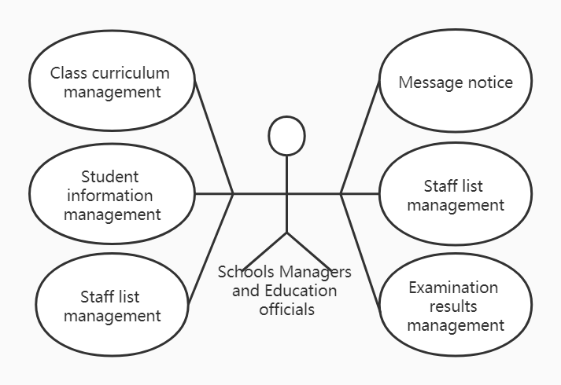

**Figure 3.1 Use Case of functional business requirement**

These businesses are the classic educational management needs of primary and secondary schools. These contents are proposed by the government and schools for students to enjoy good compulsory education and reduce the workload of teaching staff, which has analytical significance and value.

The requirement of students' information management is mainly in response to the requirement of "one person, one student status" of the Ministry of education.

Staff list and class management are mainly aimed at the allocation of teachers and other resources for daily teaching activities.

The requirement of examination result management is to input students' grades and save files.

Message notice part is to release of school notice rapidly and improve office efficiency.

1. **Non-functional requirement analysis**

Education departments and schools first proposed that the system should have good security and be able to keep all kinds of data for a long time. And the system can have good applicability, for all primary and secondary schools can meet the needs of their daily educational work. The education department hopes to develop the information-based educational administration management system with quality and quantity guaranteed, and at the same time to reduce various costs as much as possible. Finally, the school hopes that the new system is easy to operate, and can let the teaching staff know and master the basic business operation process as soon as possible.

Schools and municipal education departments put forward many non-functional requirements for the educational administration system, mainly focusing on the security, reliability and ease of use of the educational administration system. The main responsibility of educational administration management system is to assist teaching staff to complete teaching tasks smoothly and efficiently. Therefore, the realization of these non-functional requirements should be considered in the selection of final system requirements.

## **User requirement**

1. **Modeling and analysis of user functional requirements (Use case analysis)**

User requirements describe the goals of users, that is, the tasks that users require the system to accomplish. Firstly, the user type of the system is defined, and then the user needs are obtained by questionnaire, field research, literature review and brainstorming. According to the requirements of the users, the system users can be divided into administrators, educational administrators, teachers and parents. Analyze each type of user requirements and create use case model. Figure 3.2 is the use case of the user requirement.

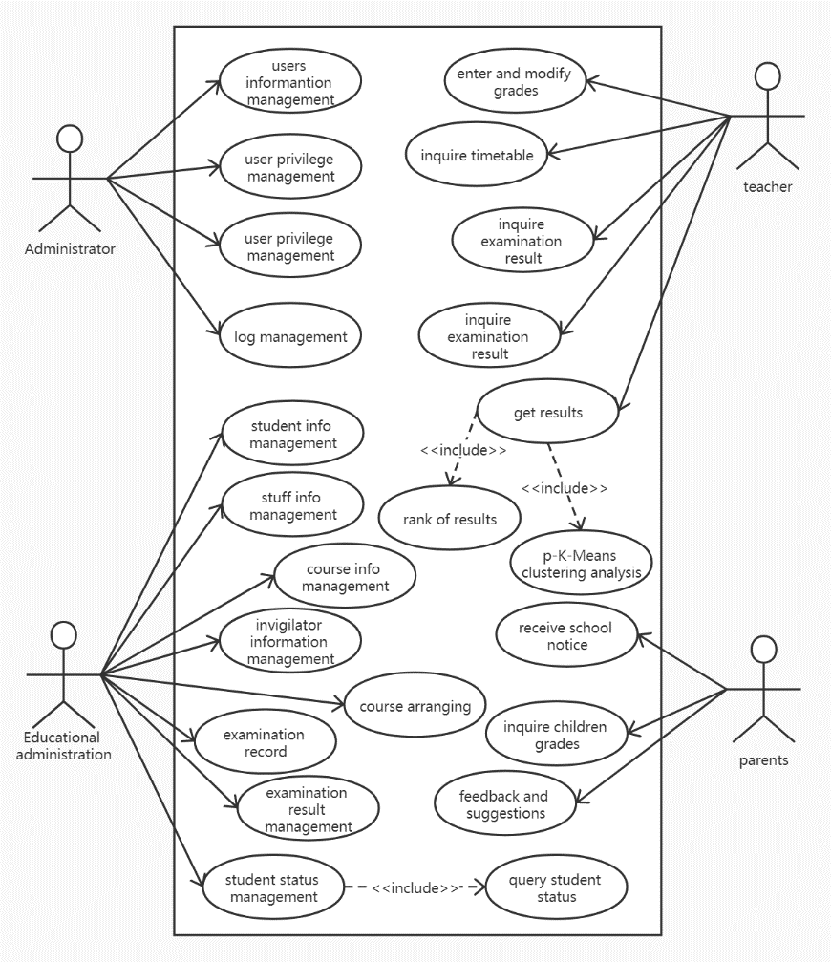

**Figure 3.2 User requirement analysis model (use case diagram)**

Administrator is the abstraction of the administrator of the school network center (the one who has highest access to the system). The functional user requirements of Administrator are user information management, user privilege management, user privilege management, log management and so on.

Educational administration is the abstract of educational administrators who are responsible for the daily educational affairs of a school. The functional user requirements of Administrator are student info management, stuff info management, course info management, invigilator information management, course arranging, examination record, examination result management, student status management, etc.

Teachers represent all the teachers in the school, including the head teacher, other teachers and life teachers. The user requirements of teachers are entering and modifying grades, inquiring timetable, inquiring examination result, inquiring examination result, getting results (rank of results and p-K-Means clustering analysis) and so on.

Parents have the following user requirements including inquiring children’s grades, feedback and suggestions and receive school notice, etc.

1. **Non-functional user requirement analysis**

For system administrators, the system needs to be safe, reliable and have good performance (reflected in throughput and response time).

For educational administrators, the non-functional requirement of the system is to have strong fault tolerance and ease of use (easy to learn and operate).

For teachers and parents, the system needs to be easy to operate and the best beautiful interface, message reception should be timely, and the system should be real-time.

## **Functional requirement**

Functional requirements specify the software functions that developers must implement in the product. Users use these functions to complete tasks and meet business requirements. Functional requirements analysis is an important part in the process of software development, which is generally divided into two parts: summary analysis and detailed analysis[10].

1. **Brief analysis of system functional requirements**

System function requirement summary analysis is to determine the overall function and realization goal of educational administration information system from the aspects of system requirement, business requirement and user requirement. According to the function summary analysis, the educational administration management system is divided into six modules, namely privilege management module, student information management module, staff information management module, course and class management module, examination and result management module and parents function module.

Privilege management module belongs to the internet manager of the schools. This module is the key that could ensure all the modules and functions works well.

Student information management module. Students’ status, class and other information will be handled in this module.

Staff information management module. This part deals with staff’s name, position, salary and other related information. Employee’s transfer is also completed in this module.

Course and class management module. The services handled by this module are course arrangement, the formulation of term schedule and classes information, etc.

Examination and result management module. The examination and result analysis module has complex functions, mainly composed of score entry and modification, p-K-Means clustering analysis evaluation and invigilation arrangement.

Parents function module. The system provides parents with the functions of receiving information, querying children's test scores and feedback.

1. **Detailed analysis of system functional requirements**

According to the summary requirements analysis, the module content is divided, and the specific functional requirements within each module are analyzed.

1. Detailed requirement analysis of privilege management module.

The super administrations have the highest privilege to get the access to the privilege management module. Figure 3.4 shows the detailed functions of this module.

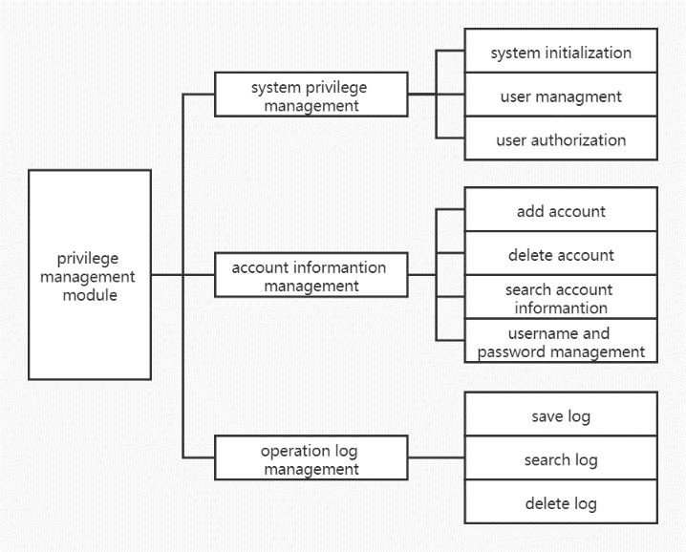

**Figure 3.4 Detailed functional analysis of privilege management module**

System privilege management have the function of initializing system, managing users and authorizing different users.

Account information management sub-module operate user account information. Username, password and private keys that are protect the account safety are all manipulated by this module.

Operation log module is important to the whole system, because the daily logs have vital influences on the system. In this part, logs could be saved deleted and sought.

1. Detailed requirement analysis of student information management module.

This module mainly operates students’ status. Figure 3.5 shows the sub-module and sub-functions of this module.

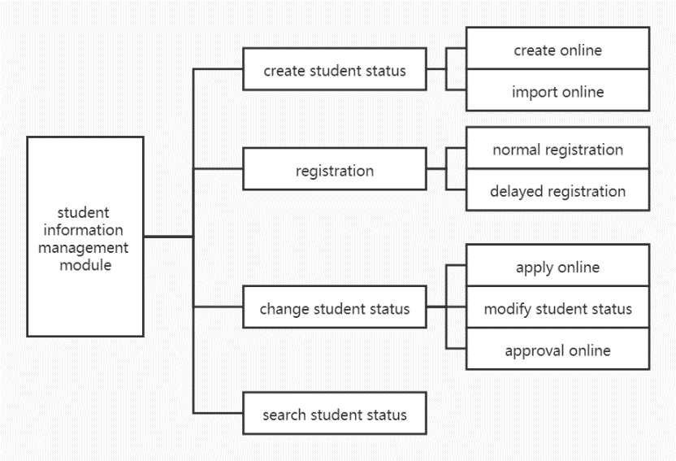

**Figure 3.5 Detailed functional analysis of student information management module**

Create student status module have the function of creating student status and import existed status.

Registration function allows user to do two different kinds of registration (normal and delayed).

Change student status will be used when new students come or old students leave, and their status would be changed. Users apply the change request and approval online. The students’ status can be searched in this part.

1. Detailed requirement analysis of staff information management module.

This module controls the operation of the staff information in the school. This module have four main function that are add, delete, search and modify the information of the teachers.

1. Detailed requirement analysis of course and class management module.

Courses and classes information are all manipulated by this module. Figure 3.6 shows the detailed functional requirement.

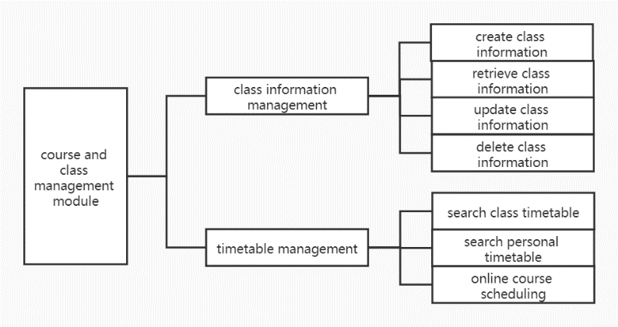

**Figure 3.6 Detailed functional analysis of course and class management module**

Class information sub-module include creating, retrieving, updating and deleting related operations. Timetable management have three functions that are searching class/personal timetable and scheduling.

1. Detailed requirement analysis of examination and result management module.

Examination and result management module are composed by two parts. Figure 3.7 clearly shows the detailed requirement analysis.

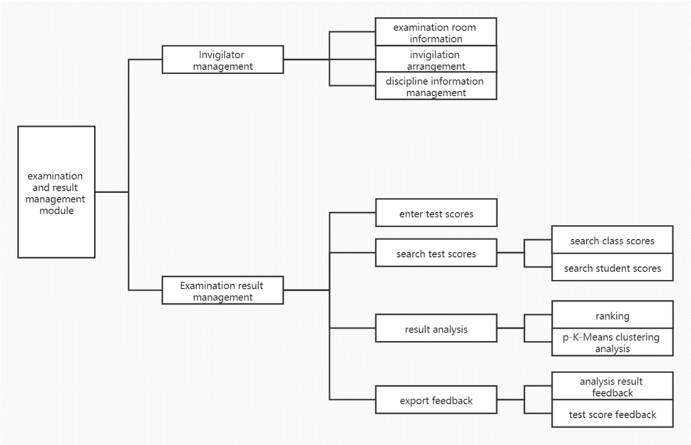

**Figure 3.7 Detailed functional analysis of examination and result management module.**

Invigilator management sub-module have three sub-parts that are examination room information, invigilation arrangement and discipline information management. These parts help record each test situation and prepare for the next examination.

Examination result management is one of the most important part of this educational administration system. Entering, modifying and searching the test scores are the most foundational requirements for the system. Result analysis function use machine learning algorithm p-K-Means method to get the feedback.

When the user get the test analysis result automatically, they can export the results by the export feedback module.

1. Detailed requirement analysis of parents function module.

There are three main functions in the parent function module: receiving school notification messages (including performance feedback and general notification), querying students' scores and suggesting feedback (opinions directly return to the Academic Affairs Office).

## **Business process analysis**

The system mainly has two business processes, the course scheduling business process and the examination result analysis business process, then analyzes them respectively.

1. **Course scheduling business process analysis**

First, we need to make it clear that each teacher is responsible for the subject this semester, and this part is initiated and submitted by teachers. After receiving the information, the Academic Affairs Office checks the information and arranges the courses after confirming all the information is correct. The system automatically checks whether there is a conflict, and reallocates if there is a conflict. After no conflict, the curriculum is issued in the educational affairs system and provided to teachers for reference. Figure 3.8 is the business flow chart of course scheduling.

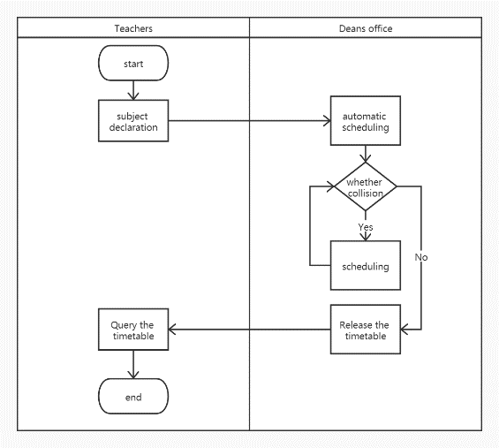

**Figure 3.8 The business flow chart of course scheduling**

1. **Examination result analysis business process**

The test score process involves all types of users. First, when the students have finished the test and the teacher has finished marking the test paper, the head teacher sorts out the student score table and uploads it to the system. The office of educational administration carries out the operation and sends the results to the analysis platform (calling API). In the analysis platform, the data is firstly cleaned by preprocessing, and if the processing fails, the data is reprocessed. If the processing is completed, the p-K-Means algorithm is used to generate the analysis results, and feedback to the educational administration system. Teachers can generate their own student development report after finding the results from the educational administration system, and decide whether to feed back to parents or users. Figure 3.9 is the flow chart of examination result analysis business process.

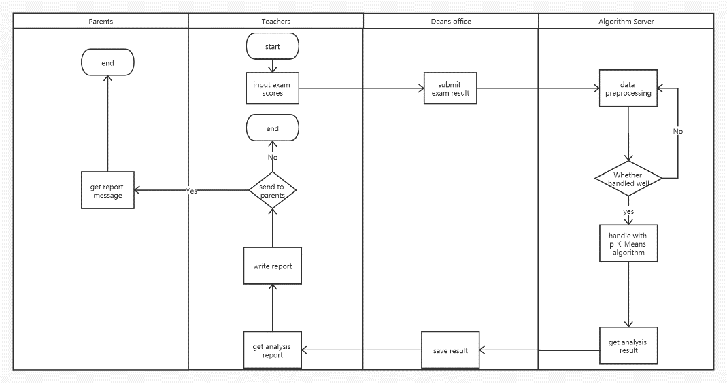

**Figure 3.9 The flow chart of examination result analysis business process**

The p-K-Means algorithm are encapsulated on a server. It provides service by an API. By calling the API, a formal examination result could be analyzed.

## **Summary**

According to the international standardization, the system needs analysis in many aspects. According to the analysis and research results, the system is divided into six functional modules: authority management, student information management and so on. Detailed analysis of the specific functions of each module and the process cooperation between modules, build a process model. Users are divided into four categories: teachers, parents, etcs. According to these users, use case model is constructed. Requirement analysis documents were created according to the standard requirements.

1. **System design**

System design also includes structured design method and object-oriented design method[11]. In this paper, object-oriented design combined with structured design method is used to show the database design, and backend design, etc.

Database design mainly through the establishment of ER model, and then integrated into the form of database table design and development. The overall development of the front and back end of the system needs to follow the principle from simple to complex. First, determine the development architecture, and then discuss the design patterns and various frameworks. After that, the content of each module is designed.

In the detailed design part, the design concepts and principles of different functions of each functional module are shown in detail through the use of sequence diagram and database table.

## **Database design**

Database design is the first step of software development. By designing a good database model, the system can meet the requirements of data storage. Relying on the standardized process of database, the ER model, relational model and finally the table are established.

1. **Building ER model**

Combined with the structured method, the ER model is established by modules.

1. Privilege management module ER models

By analyzing the authority management module, the entity and attribute are found, and the corresponding ER model is constructed. Figure 3.10 is the ER model of privilege management module.

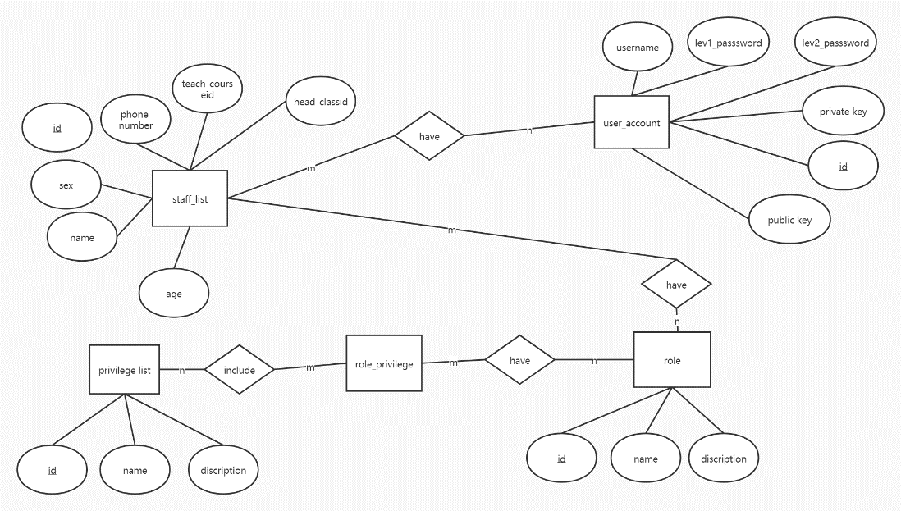

**Figure 3.10 The ER model of privilege management module.**

The privilege list records the different kinds of privileges that could be authorized such as super admin, admin and teachers, etc. A role entity has recorded the different users who have used this system and it also record the only identifier, name and description of the roles.

Then the staff list has recorded all the teacher and other employees in the school. It has so many attributes like id, name, sex, phone number and so on. Different people could have so many roles, for example a member of the academic affairs office could be a math teacher in some small schools, so the relation is multiple to multiple.

The user_account entity records the account information to all the users. For example, username and the password would be the key to login the system. For future safety, the system will be considered to use ASE-256 to encrypt, so the private key value could be used in this field. A staff could have many accounts, a teacher may also be a parent of the student.

1. Student information management module ER models

Student have so many constrains, so we contribute the studentfiles, student_status and school entities to design the ER model of student information management module. Figure 3.11 shows the ER model.

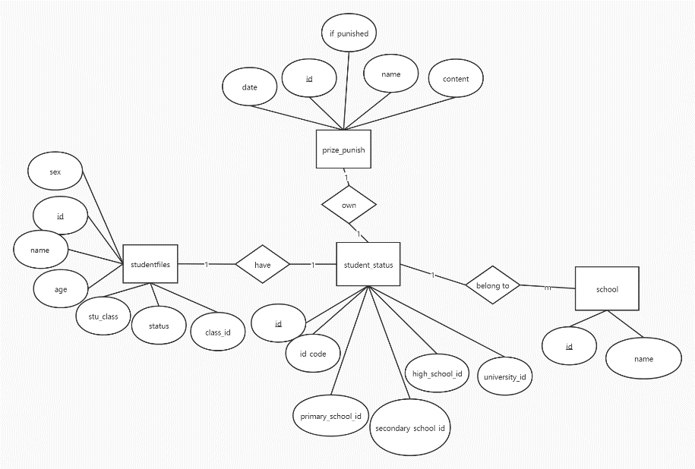

**Figure 3.11 The ER model of student information management module**

The current basic information of each student is represented by entity studentfiles. It has recorded student name, sex, age, class and some other attributes. This entity corresponds to the students’ status entity. According to the government’s requirement, a student could only have one status and a status’ code so that the relation between entity studentfile and student_status is one to one.

The student status entity records the school students went to in their life, and keeps the unique student status number of each person. The schools’ ids are stored in this entity and a school entity that corresponds to the student_status entity. The school entity recorded the id and school name that have certified by the Ministry of education.

Prize_punish entity records the rewards or punishments received by each student at any stage of the school. It has some attributes like id, name, content, date and whether in punished status. The name and content describe the type of prize or the punishment. After being punished, student need to ask for the school to change the punishment state to return to the normal state. Everyone's school status corresponds to the only punishment and reward status, so the relationship between prize_punish and student_status is one-to-one.

1. Staff information management module ER models

The staff in school are generally divided into two categories, one is teachers, the other is personnel without teaching tasks. They all belong to the user of the system and are stored in the entity user_account. The teacher’s information is mainly stored in the teacher entity. The ER model are as follows. Figure 3.12 is the ER diagram.

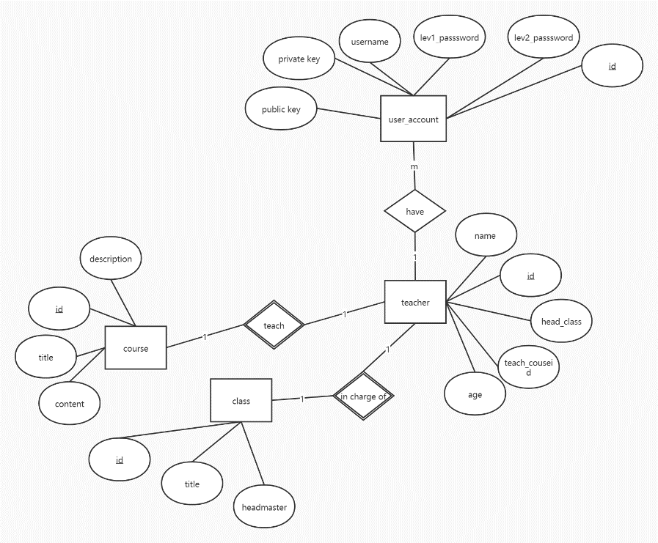

**Figure 3.12 The ER model of staff information management**

Teachers belong to user groups. A teacher can use multiple identities. He can be both a teacher and a member of the academic affairs office so that the relationship between teacher and user_account is one-to-multiple. The entity teacher records the id, name, age, sex, head_class and teach_courseid. The attribute head_class shows that which class is the teacher in charge of. The teach_courseid illustrate that which subject will the teacher teach in the next term.

Entity course has four attributes and they are id, title, content and description. This entity records all the course types in the school. Every teacher teaches one kind of courses at least. The relation between teacher and course is a weak relation one-to-one (weak relation is to illustrate that courses must be taught by a teacher).

Entity class have three attributes that are id, title and headmaster. A class must be in charged by a teacher at least so that the relation between teacher and class is weak relation one-to-one.

1. Course and class management module ER models

Course information are stored in the entity course and class information are recorded in the entity class. Scheduled timetable creates the relationship between course, class and teacher entity. Figure 3.13 gives the ER model between them.

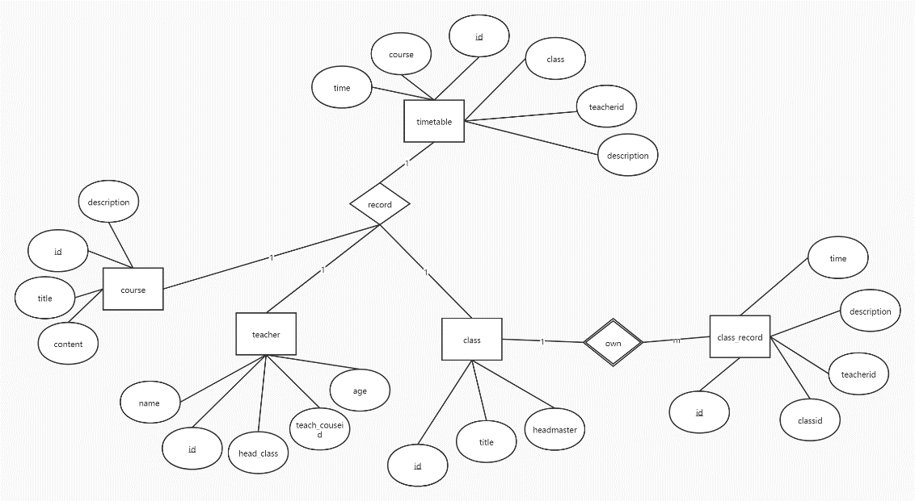

**Figure 3.13 The ER model of course and class management module**

The timetable is automatically generated by the system after arranging classes, which records the id, class, course, teacherid, time and description. The id is the identifier of each entity of the timetable. Class records the corresponding class and the attribute course is the course type. The relationship between time table and class and course are both one-to-one.

Entity teacher’s id are recorded as an attribute of timetable, because a teacher could only teach a course at one time. The relation between teacher and timetable are one to one.

After finishing the class, the teacher should have finished an evaluation of the class. This information can be represented as the entity class_record. The entity class_record have five attributes and they are id, classid, teacherid, time and description. The teacher has the choice to do the evaluation or not so that the relationship between class and class_record is one-to-multiple.

1. Examination and result management module ER models

The exam_arrange entity records six attributes. Classid corresponds to which classroom will the examination take place. Invigilator_id is chosen from the entity teacher, because the invigilators must be the teachers. Subject records the current test subject. The figure 3.14 is the ER model of examination and result management module.

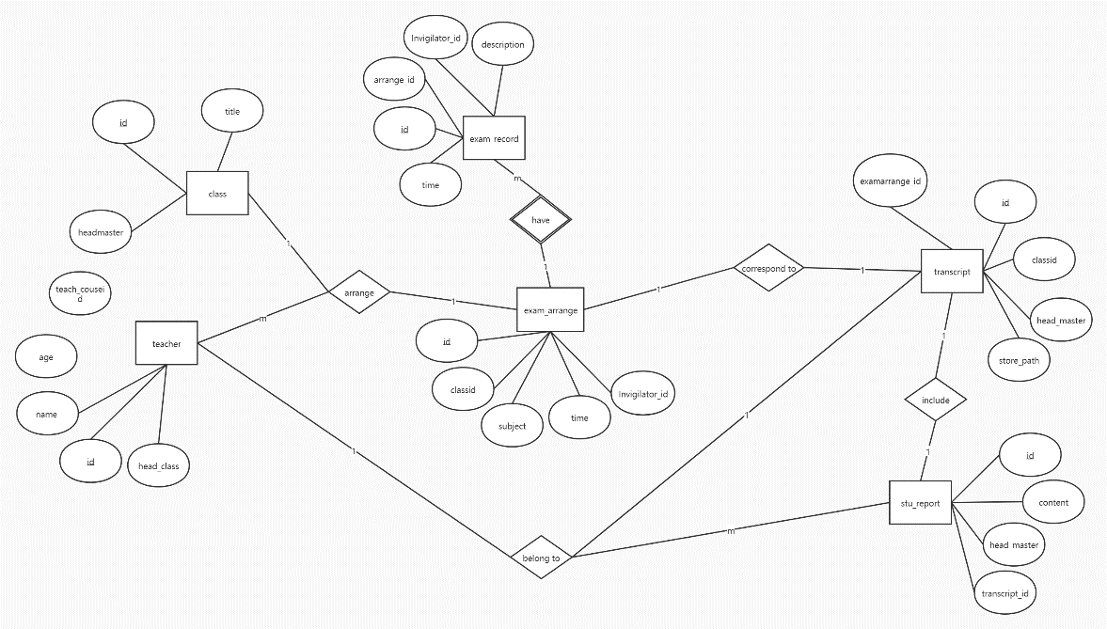

**Figure 3.14 ER model of examination and result management module**

An examination is arranged in a class, so the relationship between exam_arrange and class is one to one. The number of invigilators of an exam was decided by the school and they could only be chosen from the teachers so that the relation between entity exam_arrange and entity teacher is one to multiple.

The information of an exam is totally represented as entity exam_arrange and entity exam_record. The entity exam_record has five attributes and they are id, arrange_id, invigilator_id, time and description. The arrange_id correspond to the entity exam_arrange. There may be multiple test records in an exam, so the relationship between exam_arrange and exam_report is one to multiple.

When the exam finish, the score analysis will be done. The score is recorded as the entity transcript. It has five attributes and they are id, classid, head_master, store_path and examarrange_id. Classid stands for the class corresponding to the transcript, and head_master is the head teacher of the corresponding class. Store_path stands for the local path to save the report card (used to retrieve the transcript), and examarrange_id stands for the examination arrangement record information. Because a test corresponds to a transcript, the relationship between entity transcript and entity exam_arrange is one to one. The class transcript of an examination only belongs to the head teacher of the class, therefore the relation between an entity transcript and teacher is also one to one.

The score analysis platform returns report of the score based on p-K-Means algorithm and others. The report is represented by the entity stu_report. It includes id, content, head_master and transcript_id. A report includes a transcript of one examination so that the relationship of them is one to one. The attribute head_master is the head teacher of the student and a teacher could have many reports of the students, therefore the relationship of report and head_master is multiple to one.

1. Parents function module ER models

The parent is one of the user groups, and the parent entity is represented by parent_acct. Figure 3.15 shows ER model of parents function module.

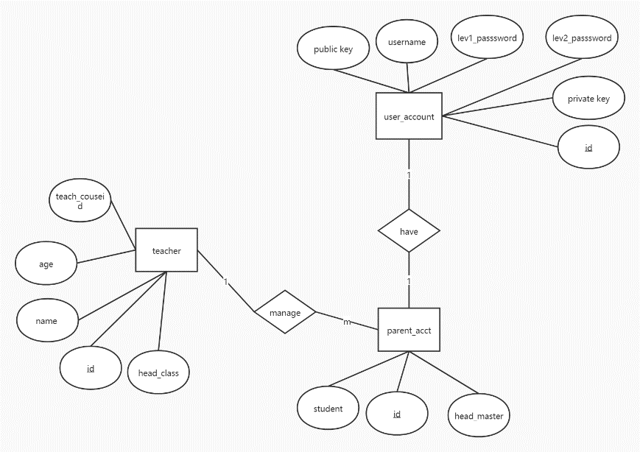

**Figure 3.15 ER model of parents function module**

The entity parent_acct has three attributes and they are id, student and head_master. A parent could have many children and a head master manage many parents of the students. The relation between teacher and parent_acct is one to multiple.

A parent could only have one account in the system, so the relationship between parent_acct and user_ account is one to one.

1. **ER to relation**

After the completion of the system database ER model, analyze each entity and the relationship between them. The ER model is mapped to a relational model using normalization standards. Figure 3.16 shows the mapping of the system from ER model to relational model.

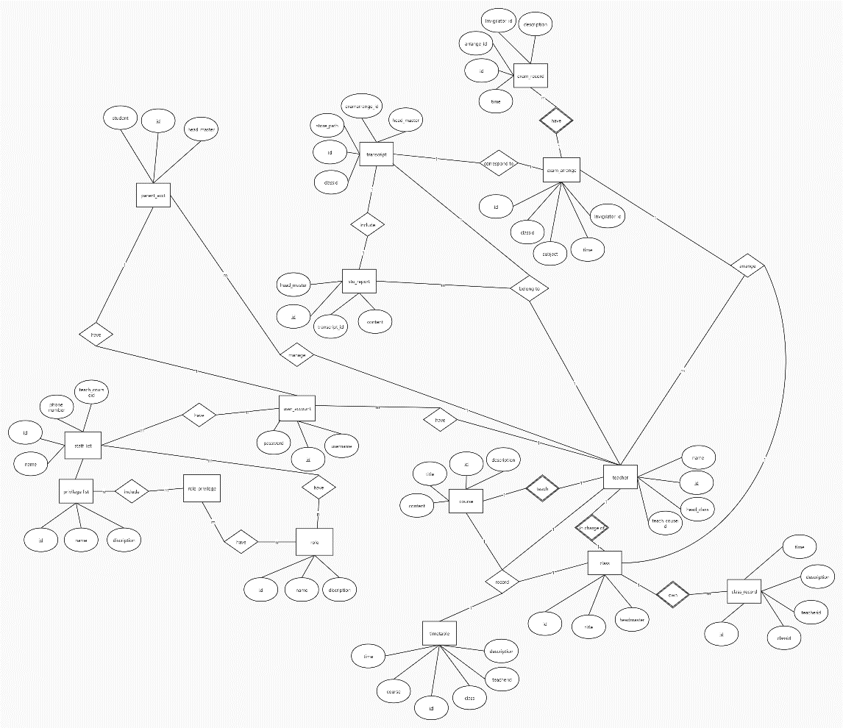

**Figure 3.16 Relational model of educational administration system**

According to the established relational model, analysis and optimization are carried out, and then database table building operation is carried out.

1. **Create table**

After getting the database relational model, write SQL statements to create the database.

According to the relationship model, the teacher table is constructed by SQL statement. The code is as follows.

CREATE TABLE `teacher`

(

`id` int NOT NULL,

`name` varchar(255) NULL DEFAULT NULL,

`age` int NULL DEFAULT NULL,

`sex` varchar(2) NULL DEFAULT NULL,

`head_classid` int NULL DEFAULT NULL,

`teach_courseid` int NULL DEFAULT NULL,

PRIMARY KEY (`id`) USING BTREE,

INDEX `head_classid`(`head_classid`) USING BTREE,

INDEX `teach_courseid`(`teach_courseid`) USING BTREE,

CONSTRAINT `teacher_ibfk_1` FOREIGN KEY (`head_classid`) REFERENCES `class` (`id`) ON DELETE RESTRICT ON UPDATE RESTRICT,

CONSTRAINT `teacher_ibfk_2` FOREIGN KEY (`teach_courseid`) REFERENCES `course` (`id`) ON DELETE RESTRICT ON UPDATE RESTRICT

)

SET FOREIGN_KEY_CHECKS = 1;

Table student_status record the status of the students including their primary and secondary schools, etc. The code to build this table using SQL statements is as follows.

CREATE TABLE `student_status`

(

`id` int NOT NULL,

`id_code` varchar(255) NOT NULL,

`primary_school_id` int NULL DEFAULT NULL,

`secondary_school_id` int NULL DEFAULT NULL,

`high_school_id` int NULL DEFAULT NULL,

`university_id` int NULL DEFAULT NULL,

PRIMARY KEY (`id`) USING BTREE,

INDEX `primary_school_id`(`primary_school_id`) USING BTREE,

INDEX `secondary_school_id`(`secondary_school_id`) USING BTREE,

INDEX `high_school_id`(`high_school_id`) USING BTREE,

INDEX `university_id`(`university_id`) USING BTREE,

CONSTRAINT `student_status_ibfk_1` FOREIGN KEY (`primary_school_id`) REFERENCES `school` (`id`) ON DELETE RESTRICT ON UPDATE RESTRICT,

CONSTRAINT `student_status_ibfk_2` FOREIGN KEY (`secondary_school_id`) REFERENCES `school` (`id`) ON DELETE RESTRICT ON UPDATE RESTRICT,

CONSTRAINT `student_status_ibfk_3` FOREIGN KEY (`high_school_id`) REFERENCES `school` (`id`) ON DELETE RESTRICT ON UPDATE RESTRICT,

CONSTRAINT `student_status_ibfk_4` FOREIGN KEY (`university_id`) REFERENCES `school` (`id`) ON DELETE RESTRICT ON UPDATE RESTRICT

)

SET FOREIGN_KEY_CHECKS = 1;

Table timetable record all the course schedules of the school, the SQL of creating this table is as follows.

CREATE TABLE `timetable`

(

`id` int NOT NULL,

`class` int NULL DEFAULT NULL,

`course` int NULL DEFAULT NULL,

`teacherid` int NULL DEFAULT NULL,

`time` datetime NULL DEFAULT NULL,

`description` varchar(255) NULL DEFAULT NULL,

PRIMARY KEY (`id`) USING BTREE,

INDEX `class`(`class`) USING BTREE,

INDEX `course`(`course`) USING BTREE,

INDEX `teacherid`(`teacherid`) USING BTREE,

CONSTRAINT `timetable_ibfk_1` FOREIGN KEY (`class`) REFERENCES `class` (`id`) ON DELETE RESTRICT ON UPDATE RESTRICT,

CONSTRAINT `timetable_ibfk_2` FOREIGN KEY (`course`) REFERENCES `course` (`id`) ON DELETE RESTRICT ON UPDATE RESTRICT,

CONSTRAINT `timetable_ibfk_3` FOREIGN KEY (`teacherid`) REFERENCES `teacher` (`id`) ON DELETE RESTRICT ON UPDATE RESTRICT

)

SET FOREIGN_KEY_CHECKS = 1;

Table exam_arrange records the exam class, subject and time, etc. The SQL of creating table exam_arrange are as follows.

CREATE TABLE `exam_arrange` (

`id` int NOT NULL,

`classid` int NULL DEFAULT NULL,

`subject` varchar(255) NULL DEFAULT NULL,

`time` datetime NULL DEFAULT NULL,

`invigilator_id` int NULL DEFAULT NULL,

PRIMARY KEY (`id`) USING BTREE,

INDEX `classid`(`classid`) USING BTREE,

INDEX `subject`(`subject`) USING BTREE,

INDEX `invigilator_id`(`invigilator_id`) USING BTREE,

CONSTRAINT `exam_arrange_ibfk_1` FOREIGN KEY (`classid`) REFERENCES `class` (`id`) ON DELETE RESTRICT ON UPDATE RESTRICT,

CONSTRAINT `exam_arrange_ibfk_2` FOREIGN KEY (`subject`) REFERENCES `course` (`title`) ON DELETE RESTRICT ON UPDATE RESTRICT,

CONSTRAINT `exam_arrange_ibfk_3` FOREIGN KEY (`invigilator_id`) REFERENCES `user_account` (`uid`) ON DELETE RESTRICT ON UPDATE RESTRICT

)

SET FOREIGN_KEY_CHECKS = 1;

Table stu_report record the information of students’ examination result and analysis result. By analyzing the relation model, the SQL of creating table stu_report are as follows.

CREATE TABLE `stu_report`

(

`id` int NOT NULL,

`head_master` int NULL DEFAULT NULL,

`transcript_id` int NULL DEFAULT NULL,

`content` varchar(255) CHARACTER SET utf8mb4 COLLATE utf8mb4_0900_ai_ci NULL DEFAULT NULL,

`time` datetime NULL DEFAULT NULL,

PRIMARY KEY (`id`) USING BTREE,

INDEX `head_master`(`head_master`) USING BTREE,

INDEX `transcript_id`(`transcript_id`) USING BTREE,

CONSTRAINT `stu_report_ibfk_1` FOREIGN KEY (`head_master`) REFERENCES `teacher` (`id`) ON DELETE RESTRICT ON UPDATE RESTRICT,

CONSTRAINT `stu_report_ibfk_2` FOREIGN KEY (`transcript_id`) REFERENCES `transcript` (`id`) ON DELETE RESTRICT ON UPDATE RESTRICT

)

SET FOREIGN_KEY_CHECKS = 1;

Firstly, the ER model is constructed through analysis, and the ER model is transformed into a relational model by using standardized method. Finally, according to the relational model, SQL statements are used to complete the creation of the database table.

## **System design**

1. **General design of system**
2. **System architecture design**

The design of this system adopts B/S (browse and server) mode. B/S architecture is a change or improvement of C/S (client and server) mode. The advantage of this architecture is that it can separate the front-end and back-end business logic, and implement most of the business logic in the back-end of the system. The front-end or browser only needs to implement simple business logic.

The system uses MVC design model for development, and relies on SpringMVC framework for function and level division. The frontend controller is the DispatcherServlet interface implementation class, the mapping processor is the HandlerMapping interface implementation class, the view parser is the ViewResolver interface implementation class, and the page Controller is the controller interface implementation class. Spring Boot, a component of Spring framework, is used to simplify the configuration and code of SpringMVC framework.

The hierarchical business functions of spring framework can be divided into DAO layer, entity layer, mapper layer, service layer and controller layer.

DAO layer, also called persistence layer, mainly interacts with database. Dao layer is mainly to do the work of data persistence layer, mainly to interact with the database. In this case, MyBatis technology was used to achieve the interaction between the back end of the system and the database through data persistence.

Entity layer is the entity class in the backend project, typically it corresponds to the tables in the database.

The Service layer controls the business. The Service layer is mainly responsible for the logical application design of business modules. Like the DAO layer, the interface is designed first, then the class to be implemented is created, and then the association of its implementation is configured in the configuration file. Then the interface can be called in the Service layer to handle the business logic application. Encapsulating the business logic of the Service layer facilitates the independence and reuse of the business logic.

The controller layer is responsible for the control of the specific business module process. The controller layer mainly calls the interface in the service layer to control the specific business process. The control configuration also needs to be carried out in the configuration file.

The frontend uses Vue.js framework for development. Vue.js integrates the advantages of various frameworks and has multiple component libraries for supporting use. The more famous ones are element UI, iView UI and Vux UI.

1. **Design of overall function module of the system**

According to the functional requirements analysis, the system is divided into six functional modules. They are privilege management module, student information management module, staff information management module, course and class management module, examination and result management module, parents function module. Figure 4.1 is the overall function module of the system.

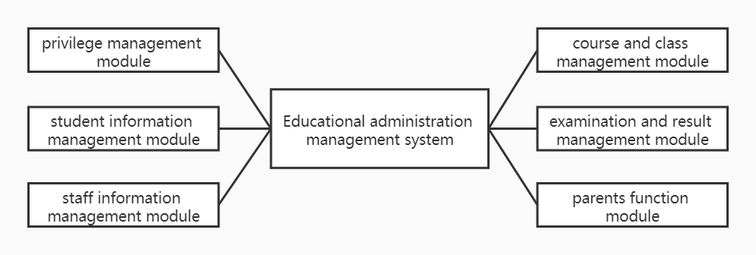

**Figure 4.1 overall function module of the system**

According to the function is divided into six modules, the following are detailed design of each functional module.

1. **Detail design of system**
2. **Detail design of privilege management module**

First, the authority management module is an important part of maintaining the normal operation of the system module. The module realizes the functions of user authorization, account information management, operation log and so on. According to the division of module functions, draw the class diagram as shown in Figure 4.2.

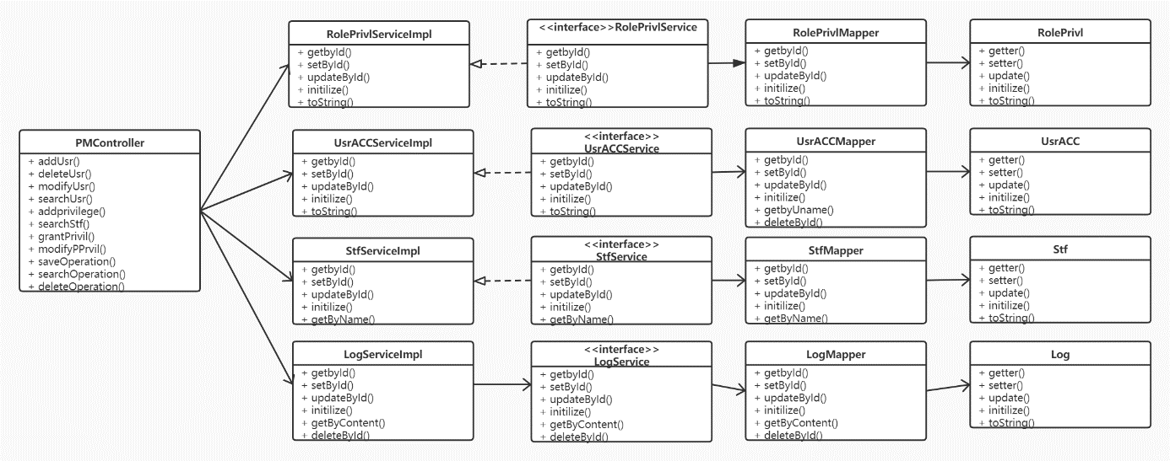

**Figure 4.2 Class diagram of privilege management module**

The controller layer services includes adding, deleting, updating, searching user information, adding privilege to the users, searching staff information, granting privileges and operating logs. The related entities includes RolePrivl, UsrACC, Stf and Log which are corresponding to the related tables in the database.

Taking the new user given permission as an example, the sequence diagram is shown in figure 4.3.

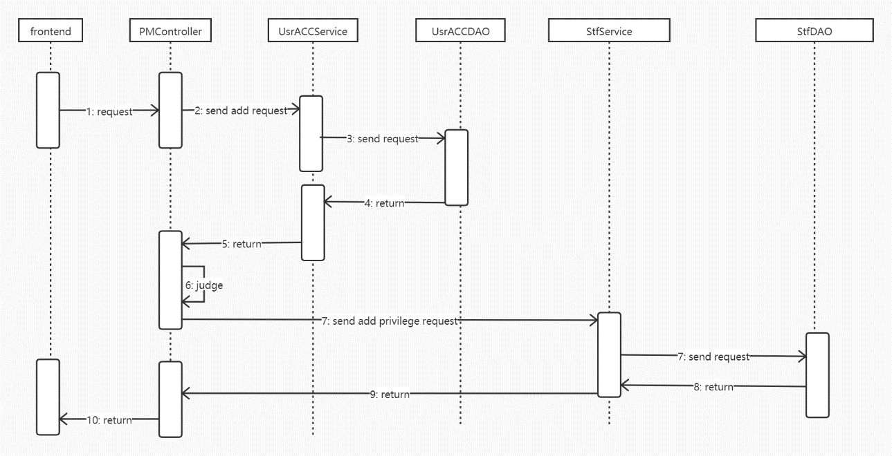

**Figure 4.3 Flow chart of adding a new user and grant privilege to his/her**

The process of adding users and granting permissions is that the front end first sends a request to the PMController class, then sends a request to the UsrAccService, and finally arrives at the UsrAccDAO layer to interact with the database. After the operation is completed, continue to return to PMController for judgment. If the condition allows (adding users normally), send information to StfService to continue to inform StfDAO to interact with the database, and finally return the result to the front end.

When the operating successfully, the front end will pop up a message to show the user that the work flow is success.

1. **Detail design of student information management module**

There are four entities involved in the function modules of student information and student status management, which are StuFile, StuStatus, School and PP. StuFile is the entity of table studentfile in the database. StuStatus is the entity of table student_status in the database. School is the entity of table school in the database. PP is the entity of table prize_punish in the database. According to the module function division, the generated class diagram is shown in Figure 4.4.

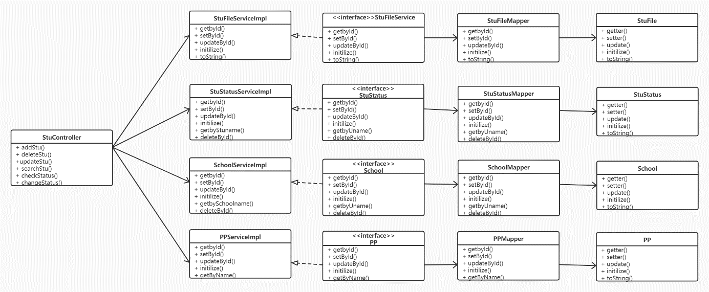

**Figure 4.4 Class diagram of student information management module**

The StuController includes adding, deleting, updating and searching the student information, and also checking the state of the students’ status and changing the student status.

Taking adding a new student’s status as an example, the sequence chart is shown as figure 4.5.

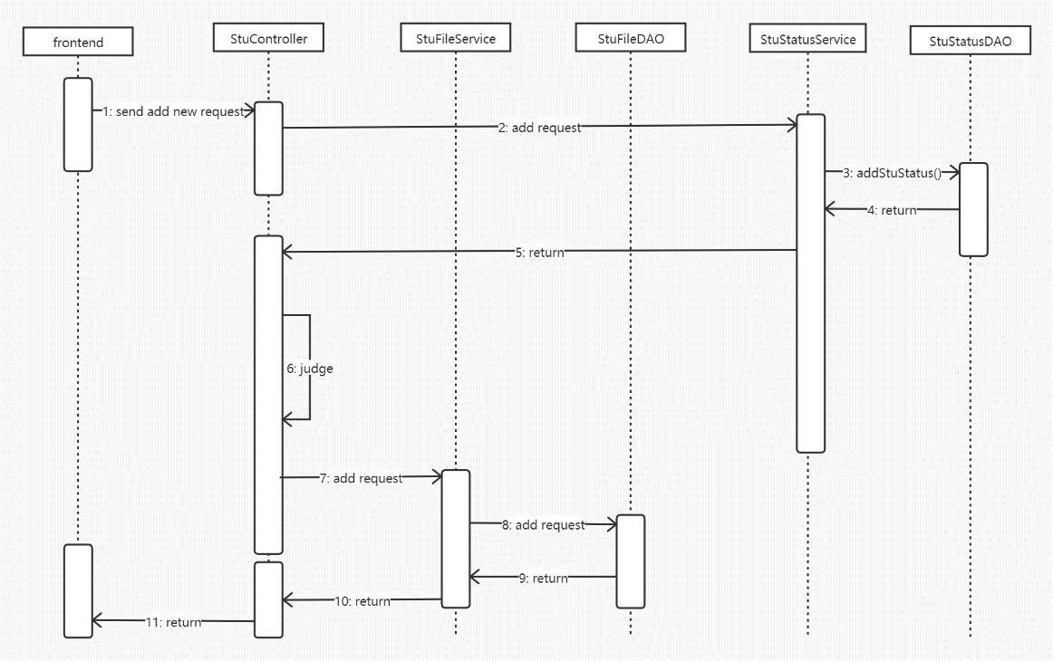

**Figure 4.5 Flow chart of add a new student’s information**

When the front end sends a request to add student information, the StuController class first receives the data. Then notify StuStatusService, call its addsStu() method, transfer the data to StuStatusDAO class, interact with the database, and return the result to StuController class.

Then the StuController class judges internally, and if the student registration is successful, the student information is registered. First, the information is sent to the StuFileService class, then the addNew () method is called to transmit the information to the StuFileDAO class to interact with the database. Finally, the result is returned to the StuController class and sent to the front end.

1. **Detail design of staff information management module**

Staff information management module is mainly to manage staff information. The related class diagram is shown in Figure 4.6.

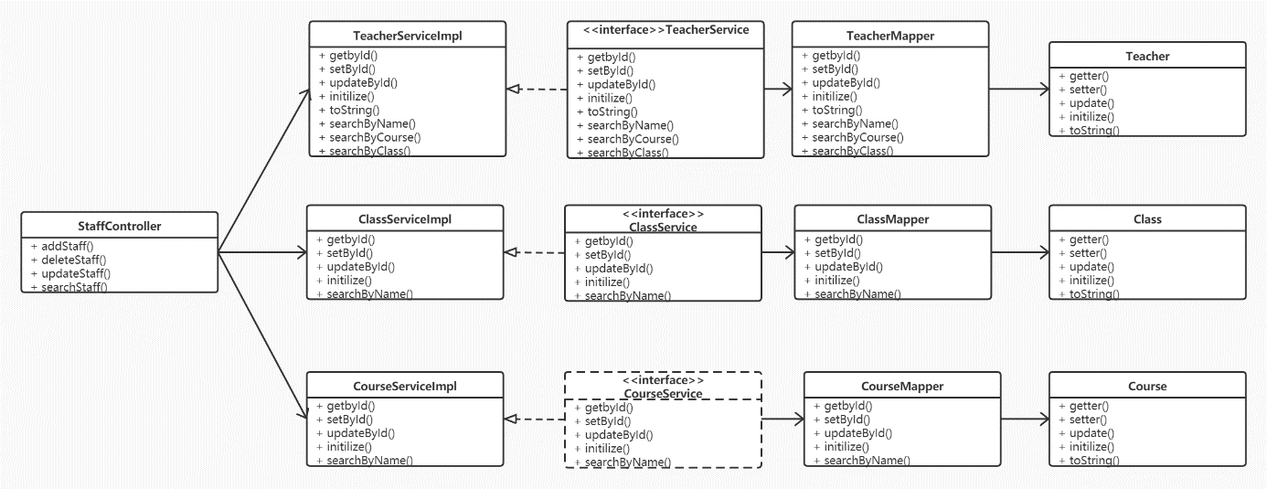

**Figure 4.6 Class diagram of staff information management module**

The entities involved in this module are teacher, class and course. They all have the basic function of adding, deleting, updating and searching.

1. **Detail design of course and class management module**

The entities involved in this part are TT, course and class. TT is the timetable. The class diagram is shown as figure 4.7.

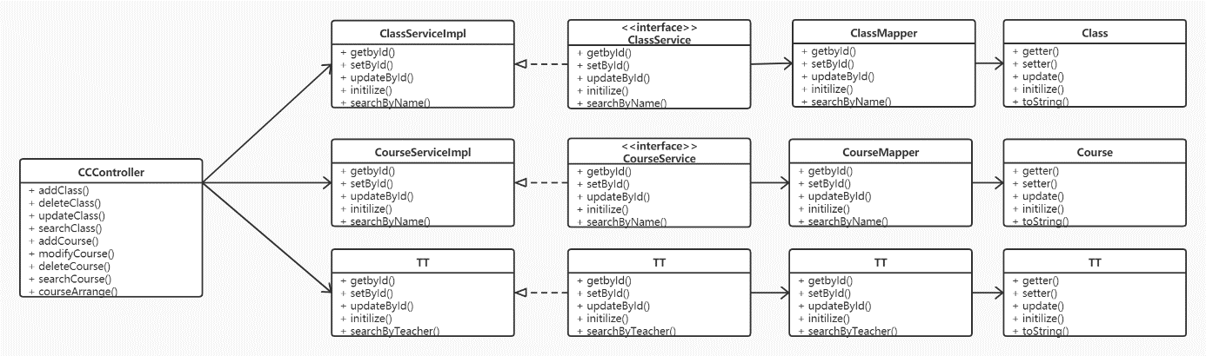

**Figure 4.7 Class diagram of course and class management module**

The functions of CCController class are adding, deleting, updating searching class and course. The most important core function of this controller class is course arrangement. Figure 4.8 shows the course scheduling process.

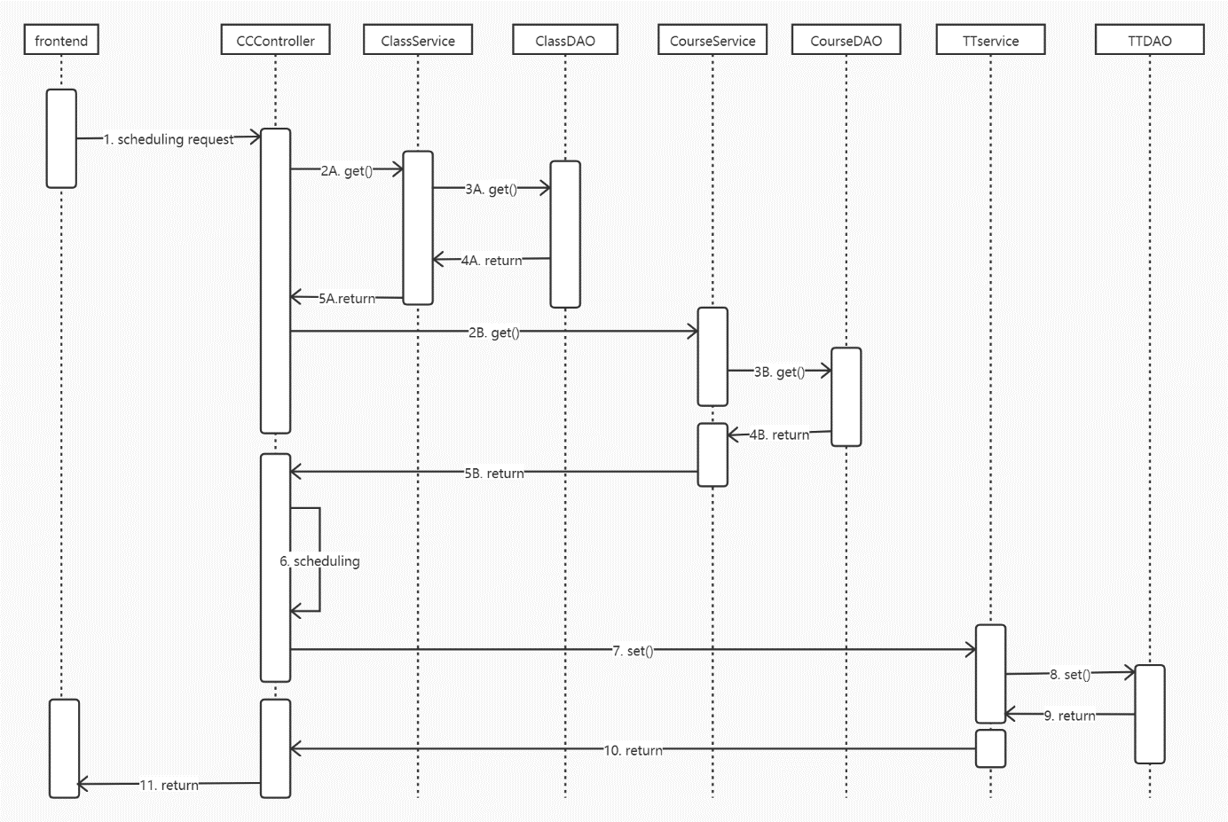

**Figure 4.8 Flow chart of course arrangement**

First, the front end sends the back end scheduling request, and the CCController class accepts the request. Then send information to ClassService and CourseService at the same time to request all class and course type information. When the CCController class receives the return information, it arranges classes.

After the course scheduling is finished, the result of course scheduling is sent to TTService, and then the information is transferred to TTDAO layer to interact with the database. Finally, the result is returned to the CCController class, and a message is sent to the front end.

1. **Detail design of examination and result management module**

The entities include ExamArrange, ExamRecord, Transcript and StuReport. The class diagram is shown as figure 4.9.

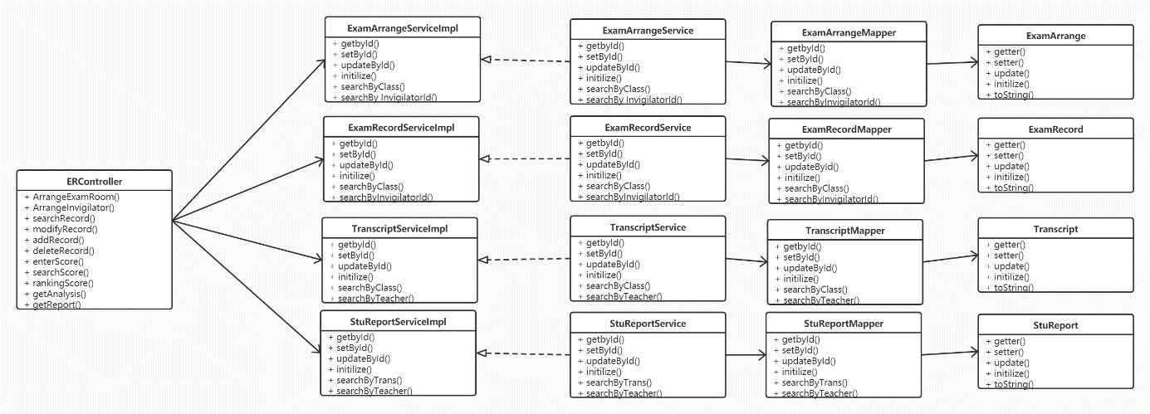

**Figure 4.9 Class diagram of examination and result management module**

The function of ERController includes arrange each examination room and invigilator, adding, deleting, modifying and searching scores. Ranking and analyzing score are also be done in this module. It can also generate a report by using this part.

Score analyzing flow chart is shown by figure 4.10.

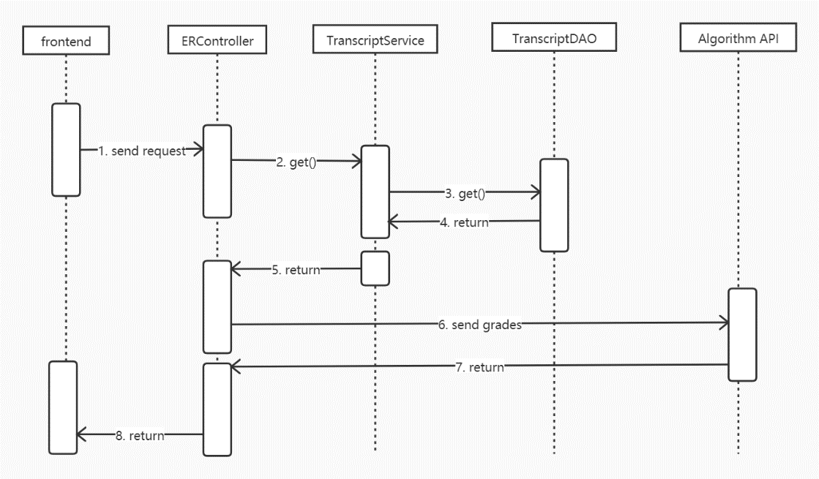

**Figure 4.10 Flow chart of score analyzing**

First, the front-end sends the requirement of generating performance analysis to the back-end, the ERController class receives the signal, and then sends the get() request to the TranscriptService. After that, the information is sent to the TranscriptDAO layer to interact with the database, request to the corresponding report card, and the data is returned to the ERController layer. Then, the report card is sent to the algorithm API by ERController, and the analysis result is returned to ERController class. Finally, the front end receives the analysis result.

1. **Detail design of parents function module**

Parents' information is stored in form parents and the user information is recorded in the table user_account, which includes the functions of receiving information, making suggestions and receiving children's performance reports. The main work of parents is to focus on the development of WeChat apps in the future.

## **Analysis algorithm design**

The algorithm analysis is completed by a specific API, and the design flow chart is as follows.

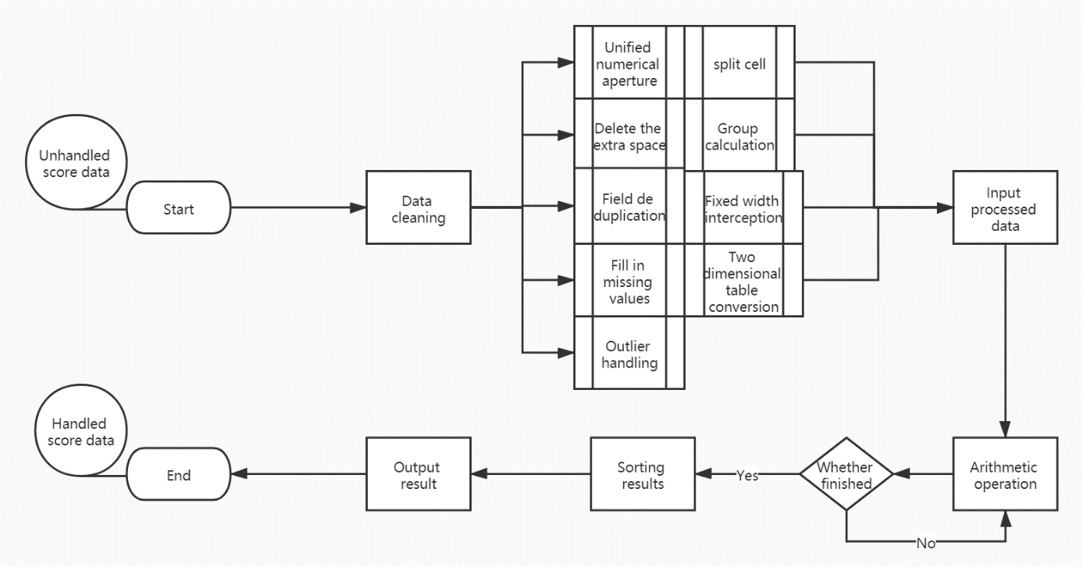

**Figure 4.11 Score analysis flow chart**

The back end sends data and requests to the performance analysis API. At the beginning of processing performance data, the results to be analyzed and processed may have noise, so we use common data cleaning methods (such as using regression or maximum likelihood estimation to fill in the vacancy value, using the average value instead of outliers, etc.) to process the data to be analyzed, and then use algorithms and corresponding models for analysis. After the analysis, the system judges whether the processing is completed. If the processing is successful, the data will be output, and the results and analysis results will be packaged and returned to the back end.

## **Summary**

This part completes the process of database modeling design and implementation. The ER model is established by analyzing the requirements, the ER diagram is transformed into a relational model, and the database table is established by using SQL. The traditional structural design pattern combined with object-oriented design pattern is used to divide the function of the system from outline to detail, and the class diagram and sequence diagram are used to explain and explain each part in detail. Finally, the flow chart is used to explain and design the algorithm API.

参考文献

[1] Sun Qi. Design and implementation of university educational administration information system based on Network [J]. Chinese Science and technology information, 2010(09):140-141.

[2] Han Xiuzhi, Cao Yuan. Design and application of higher vocational educational administration management information system based on ASP.NET development tool of modern information technology [J]. Guangxi Light Industry, 2010,26(10):83-86.

[3] Zhang Jianxue, Dai Min. Design and implementation of educational administration information system based on Network [J]. Journal of Civil Aviation Flight University of China, 2010, 021(005):35-37.

[4] Wang Qinhui, Sun HongRui, Li Chao. Design of university educational administration management information system based on. NET [J]. Digital technology and Application, 2010, 000(003):63-64.

[5] Li Xiaoming, Xu Qinglin. Design and Implementation of Teaching Management System Based on J2EE. Computer and Modernization, 2007.

[6] Bin Yang. Application of artificial intelligence algorithm in school course scheduling system [J]. Digital technology and Application, 2015, 000(010):144-145.

[7] Xinhui Wang. Research on Application of student management system based on Internet of things technology [J]. Electronic world, 2020.

[8] Chuanyu Zang, Yong Shen, Yuhao Zhang, et.al. Research on K-Means Algorithm Analysis and Improvement [J]. Computer science and Application, 2016, 6(9):14.

[9] Yafei Liu, Ao Yu, Xiaotian Qi. Analysis of the basic characteristics of case-based process oriented and object-oriented [J]. Science and technology information, 2020,18(08):3+5.

[10] Yu Yang. Research on requirement analysis of engineering project[J]. Computer generation, 2021(01):51-53.

[11] Yini Wang. Discussion on the design method of computer software [J]. Online guide · Online education, 2012, 000(014):130.

致 谢

应以简短的文字对题目与论文撰写过程中曾直接给予帮助的人员(例如指导教师、答疑教师及其他人员)表示自已的谢意 ，这不仅是一种礼貌，也是对他人劳动的尊重，是治学者应有的思想作风。对整个毕业设计（论文）进行总体性、概括性总结，表达出设计（论文）的思路、学习收获、对未来进一步学习的设想。