NP-DEMO-3: Ethanol and Sniff Phase-Locking — Methods & QC Report
Task ID: NP-DEMO-3
Contract: 02_contract/contract_v001.yaml (status: confirmatory)
Intended audience: lab + QC reviewers
Companion document: see the separate Results report for statistical outcomes. This document covers signal processing, inclusion/exclusion, and QC only.

Question
What signal was recorded, what was measured, and what was asked:
Olfactory-bulb single-unit spike times were recorded with Neuropixels probes across 6 sessions in one animal, together with a raw sniff-sensor signal (SNF, not the LFP) and a raw ethanol-trace signal (ETH), both sampled at the LabView acquisition rate (LV_Fs, approximately 125 Hz) on the same clock as the spike times. For each recording, sniff cycles and instantaneous sniff phase were detected from SNF, ethanol-contact periods were detected from ETH, and each spike was assigned the sniff phase and ethanol/control condition label of the moment it occurred. This report documents the detection and inclusion pipeline that produced the per-unit and per-experiment phase-locking (mean resultant length, MRL) quantities used for the confirmatory statistical tests reported separately.
Methods
Sniff-phase detection (SNF). Sniff onsets and instantaneous sniff phase were computed from the raw SNF signal via compute_sniff_phase(D, threshold_std=-0.5). This threshold is a validated, pinned kernel default and was not altered for this analysis (per contract assumption; changing it requires human sign-off).
Ethanol-contact detection (ETH). Ethanol-contact periods were detected via the new detect_eth_contact(D, eth_threshold=0.05) function: the mean of the entire ETH time series for the experiment was subtracted first (no windowing or per-epoch subtraction), and the mean-subtracted trace was then thresholded — samples strictly above threshold were labeled "ethanol present," samples at or below threshold were labeled "control." n_trials for each experiment is the count of discrete contiguous runs of mean-subtracted-ETH samples strictly above threshold. This is an identical, fixed rule applied to all six sessions with no per-experiment adjustment, and it is a new algorithm distinct from (and not a reuse of) the existing threshold_eth.py kernel (which uses a different floor-clip rule).
Spike-phase assignment and valid-sniff gate. Each spike was assigned its sniff phase via compute_spike_phase. A spike was retained for downstream analysis only if its assigned phase field spike_SNF_PH was non-negative (i.e., it fell within a valid, detected sniff cycle). Spikes with a negative spike_SNF_PH (non-sniffing periods or signal noise) were excluded from all locking statistics; every excluded interval was logged (see Discarded-Sections below), never silently dropped.
Unit inclusion criteria. A unit was included only if its overall firing rate was at or above 0.1 Hz and it had at least 50 valid-sniff spikes combined across the ethanol and control conditions. For the top-five example-unit figure specifically, an additional criterion required more than 500 spikes per unit per condition (this stricter criterion applies only to selection of the illustrative examples, not to the population statistics).
Session list. 6 sessions, all from one animal, located under C:\Projects\Repos\Neuropixels\DATA: 2021-11-01, 2021-11-03, 2021-12-15, 2022-05-17, 2022-06-24, 2022-09-14. The 2022-09-14 session is multi-shank and required _fix_ks_dir() within load_experiment_data to locate its Kilosort output subdirectory one level deeper than the default location. Session 2021-11-03 was included in full: detect_eth_contact determined from the data that usable control periods exist for this session (per prior open-decision resolution), so it was retained in all downstream statistics.
MRL (mean resultant length) formula. For each included unit, and separately for the ethanol condition and the control condition, the mean resultant length of the valid-sniff spike phases was computed as the magnitude of the mean unit vector on the circle: MRL = the absolute value of the average of exp(i·phase) over all valid spikes in that condition, where phase is the sniff-cycle phase of each valid spike. A condition-agnostic MRL (pooling valid-sniff spikes across both conditions) was also computed per unit, used only to select the globally strongest/weakest phase-locking examples for QC (not one pair per experiment).
No causal claims are made in this document about ethanol’s effect on phase-locking; this section describes measurement and processing steps only.
QC-Counts
Per-experiment counts, computed from RESULT-sniff-qc (never typed by hand):
Experiment | n_sniffs | n_neurons | n_trials | Duration (min) | % usable sniff
2021-11-01 | 10949 | 232 | 2501 | 48.77 | 95.98
2021-11-03 | 9087 | 429 | 491 | 49.82 | 84.31
2021-12-15 | 7005 | 236 | 1180 | 48.61 | 62.00
2022-05-17 | 9422 | 109 | 1048 | 49.04 | 93.47
2022-06-24 | 9169 | 287 | 557 | 48.40 | 95.97
2022-09-14 | 3852 | 310 | 187 | 17.99 | 98.95

n_trials per experiment (contiguous above-threshold ethanol-contact runs, from RESULT-eth-mask) is cross-checked against the table above and agrees exactly: 2501, 491, 1180, 1048, 557, 187.
Discarded-Sections
Every discarded SNF section (non-sniffing periods and short/noise segments) was logged with its experiment, start time, end time, and reason — no silent discards. Summing all logged intervals in RESULT-discard-log across the six experiments gives:
n_intervals total (discarded SNF sections) = 1742.
Reasoning: each discarded interval is tagged with one of two reasons — non-sniffing (periods with no detected sniff cycle, e.g., long gaps or grooming) or noise/short (very brief or artifactual candidate intervals below the reliable-detection floor of the sniff-phase kernel). Discarded intervals occur throughout all six sessions and account for the complement of the pct_usable_sniff_time values reported in QC-Counts above — e.g., the comparatively low usable-time fraction for 2021-12-15 (62.00%) reflects a session with a larger share of short/noise-flagged intervals than the other five sessions.
The full, unabridged discarded-section log (experiment, start_s, end_s, reason for all 1742 intervals) is provided in the Appendix and is not reproduced in full here.
Figures
FIG-DEMO3-QC-SNIFF — "Methods: per-experiment sniffing and ethanol-contact examples." One two-panel block per experiment (SNF_z top panel with the sniff-onset threshold_std red dashed line; mean-subtracted ETH bottom panel with the ethanol-contact threshold red dashed line), on a shared time axis, captioned with n_sniffs, n_neurons, n_trials, duration_min, and pct_usable_sniff_time per experiment. Source results: RESULT-eth-mask, RESULT-sniff-qc, RESULT-discard-log.
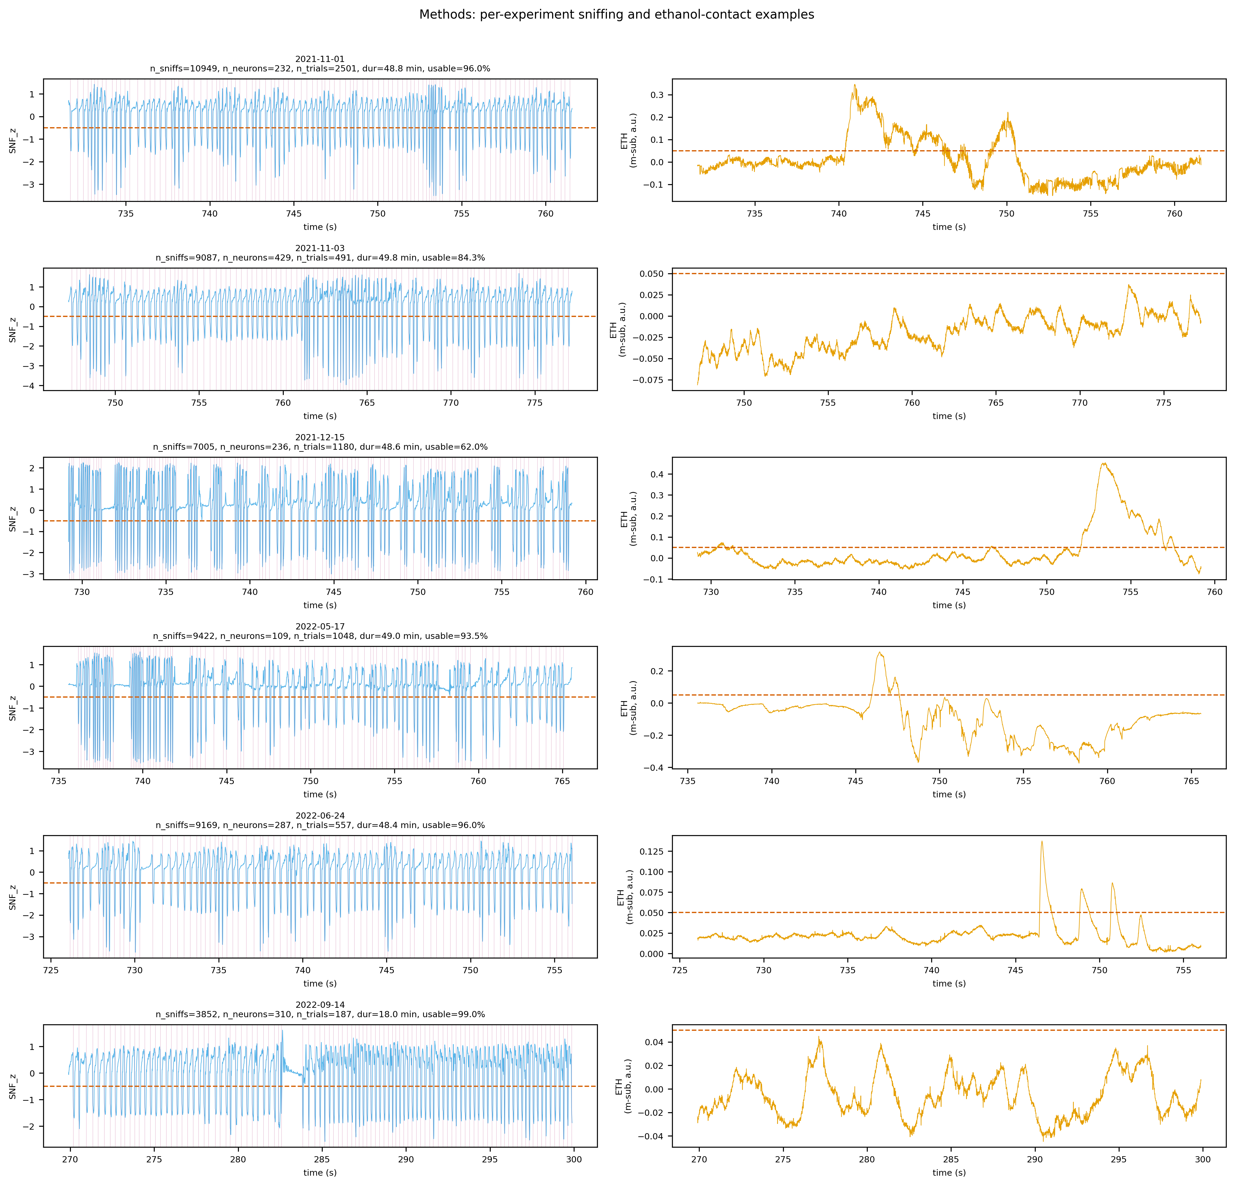
FIG-DEMO3-QC-SNIFF. Per-experiment sniffing (SNF_z) and ethanol-contact (mean-subtracted ETH) examples with detection thresholds.
FIG-DEMO3-QC-PSTH — "Methods: sniff-locked PSTH examples (strongest and weakest phase-locking units)." Sniff-locked PSTHs for the single globally strongest and single globally weakest condition-agnostic-MRL unit (selected across all experiments combined, not one pair per experiment), each labeled with its experiment/session date and MRL_cond_agnostic. Source results: RESULT-mrl-per-unit.
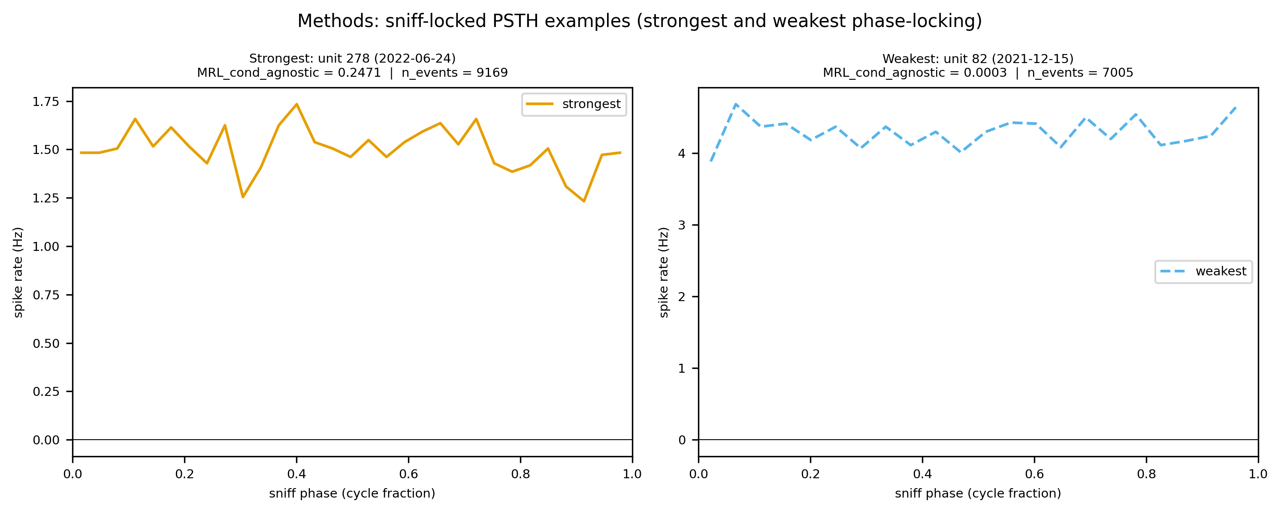
FIG-DEMO3-QC-PSTH. Sniff-locked PSTHs for the globally strongest and weakest condition-agnostic-MRL units.
Limitations
- The animal-level paired Wilcoxon test (reported in the companion Results document) has an experiment count that is statistically underpowered to detect anything but a very large, highly consistent effect; a non-significant result at this sample size does not establish absence of an effect.
- Sniff-phase detection is threshold-based (compute_sniff_phase, pinned kernel default); it is not a model-based or adaptive detector, and its false-positive/false-negative sniff-onset calls are bounded by this single fixed threshold across all sessions and animals.
- Ethanol-contact detection is also threshold-based (detect_eth_contact, entire-trace mean-subtraction, fixed threshold, identical for all six sessions); it does not adapt to session-specific baseline drift beyond the single mean-subtraction step, and the same fixed rule is applied regardless of any per-session differences in ETH sensor coupling or noise floor.
- No MATLAB reference implementation exists for detect_eth_contact; its fixture was established from the first validated implementation run after code review and manual inspection, rather than from an independent reference pipeline.
Appendix
Full discarded-section log (experiment, start_s, end_s, reason) — see RESULT-discard-log (1742 entries total, one row per discarded interval, per experiment).

