NP-DEMO-3: Ethanol and Sniff Phase-Locking — Results Report
Contract: 02_contract/contract_v001.yaml (status: confirmatory)
Intended audience: lab + demo
Companion document: see the separate Methods/QC report (NP-DEMO-3_ethanol_sniff_phase_locking_METHODS.docx) for signal-processing methods, per-experiment QC counts, and the full discarded-section log. Counts and discards are not duplicated here.

Question
Does ethanol contact modulate olfactory-bulb (OB) neuron sniff-phase-locking? Specifically: does the mean resultant length (MRL) of OB single-unit spike phase relative to the sniff cycle differ between ethanol-contact and control periods, at the animal/experiment level and at the individual-unit population level?
Methods-Summary
Sniff phase was detected from the raw sniff sensor (SNF) signal and ethanol-contact periods were detected from the mean-subtracted ethanol trace (ETH), per experiment, using fixed, pinned thresholds applied identically across all sessions; each spike was assigned a sniff phase and a condition label (ethanol vs. control), and only spikes falling within valid, detected sniff cycles were retained. Units were included only if they met a minimum firing-rate and minimum valid-spike-count criterion. Per included unit, MRL was computed separately for the ethanol and control conditions. Two pre-specified, confirmatory tests were then run: an animal-level paired Wilcoxon signed-rank test on each experiment’s mean per-unit MRL (ethanol vs. control), and a unit-level linear mixed-effects model (MRL as a function of condition, with a random intercept for animal/experiment). Full signal-processing detail, per-experiment QC counts, and the complete discarded-section log are in the companion Methods/QC report.
Results — Animal-Level
This is the pre-registered, primary confirmatory test. A paired, exact, two-sided Wilcoxon signed-rank test compared each experiment’s mean per-unit MRL under ethanol versus control (6 experiments, one paired observation per experiment):
- Test statistic (W): 5.0
- Exact p-value: 0.3125
- Matched-pairs rank-biserial r: 0.5238
- n = 6 experiments
Because the exact p-value (0.3125) is above the conventional significance threshold, the null hypothesis of no ethanol effect on mean per-unit MRL at the experiment level cannot be rejected. This is the primary, animal-level result of this analysis.
Direction of the (non-significant) shift: examining RESULT-mrl-per-experiment, 5 of 6 experiments showed a numerically higher mean per-unit MRL under ethanol than under control.
Experiment | Mean MRL, control | Mean MRL, ethanol
2021-11-01 | 0.0127 | 0.0312
2021-11-03 | 0.0176 | 0.0521
2021-12-15 | 0.0170 | 0.0442
2022-05-17 | 0.0778 | 0.0318
2022-06-24 | 0.0459 | 0.0666
2022-09-14 | 0.0261 | 0.1016

With only 6 paired observations, this consistent numerical direction is suggestive but the test is not powered to confirm it statistically; see Limitations.
Results — Unit-Level
This is a secondary, exploratory-power (not primary) test. A linear mixed-effects model was fit to the per-unit MRL values, with condition (ethanol vs. control) as a fixed effect and a random intercept for animal/experiment (formula: MRL ~ condition_code):
- n_units = 1601
- n_experiments = 6
- Condition fixed-effect p-value (Wald z, REML): 1.43 × 10⁻⁶⁰
- Standardized fixed-effect estimate (effect size): 0.5803
The condition fixed effect is statistically significant at this unit-level sample size. This unit-level result is secondary to, and does not override, the non-significant animal-level Wilcoxon result above. With 1601 units nested within only 6 experiments, the large unit-level N confers high statistical power to detect even small, consistent shifts in per-unit MRL; a significant condition effect in this model reflects such small, consistent unit-level shifts and should not be interpreted as establishing a population-level (animal-level) ethanol effect, nor as causal evidence that ethanol contact changes phase-locking — the random-intercept term corrects for non-independence of units within the same animal, but the fundamental animal-level replication count (matching the Wilcoxon test above) remains the same regardless of how many units are recorded per animal.
Examples
The five units with the largest absolute change in phase-locking (|MRL_ethanol − MRL_control|) across all included units, drawn only from experiments/units meeting the stricter (more than 500 spikes per unit per condition) inclusion rule used for this illustrative figure, ranked from largest to smallest delta_MRL:
Unit ID | Experiment | delta_MRL | MRL, ethanol | MRL, control
278 | 2022-06-24 | 0.2633 | 0.0196 | 0.2829
259 | 2021-11-03 | 0.1784 | 0.1807 | 0.0023
148 | 2022-06-24 | 0.1614 | 0.0295 | 0.1909
103 | 2022-05-17 | 0.1612 | 0.0135 | 0.1747
141 | 2021-11-03 | 0.1588 | 0.1767 | 0.0179

These five units are illustrative extremes (largest observed shifts), not a random or representative sample; they are shown to give the reader a concrete sense of what the largest per-unit shifts look like and should not be used to characterize the typical unit. See FIG-DEMO3-EXAMPLES for sniff-locked PSTHs (ethanol + control overlaid) and probe-location maps for each of these five units.
Figures
FIG-DEMO3-RESULTS-ANIMAL — "Results: experiment-level MRL comparison (ethanol vs control)." Paired per-experiment points plus the summary statistic; states n_experiments, exact p, and rank-biserial r from RESULT-wilcoxon. Source results: RESULT-mrl-per-experiment, RESULT-wilcoxon.
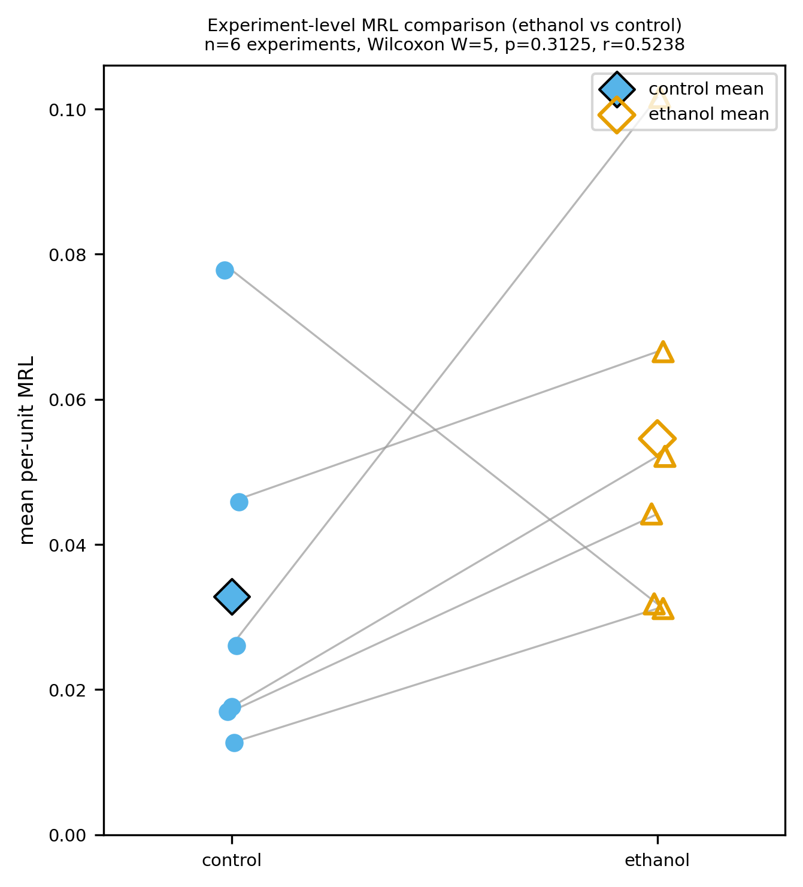
FIG-DEMO3-RESULTS-ANIMAL. Experiment-level paired MRL comparison (ethanol vs control); W = 5.0, exact p = 0.3125, rank-biserial r = 0.5238, n = 6.
FIG-DEMO3-RESULTS-UNIT — "Results: unit-level MRL comparison (LME, ethanol vs control)." Per-unit points (raw data, not summary-only) plus the LME condition fixed effect; states n_units, n_experiments, exact p, and standardized fixed-effect estimate from RESULT-lme. Source results: RESULT-mrl-per-unit, RESULT-lme.
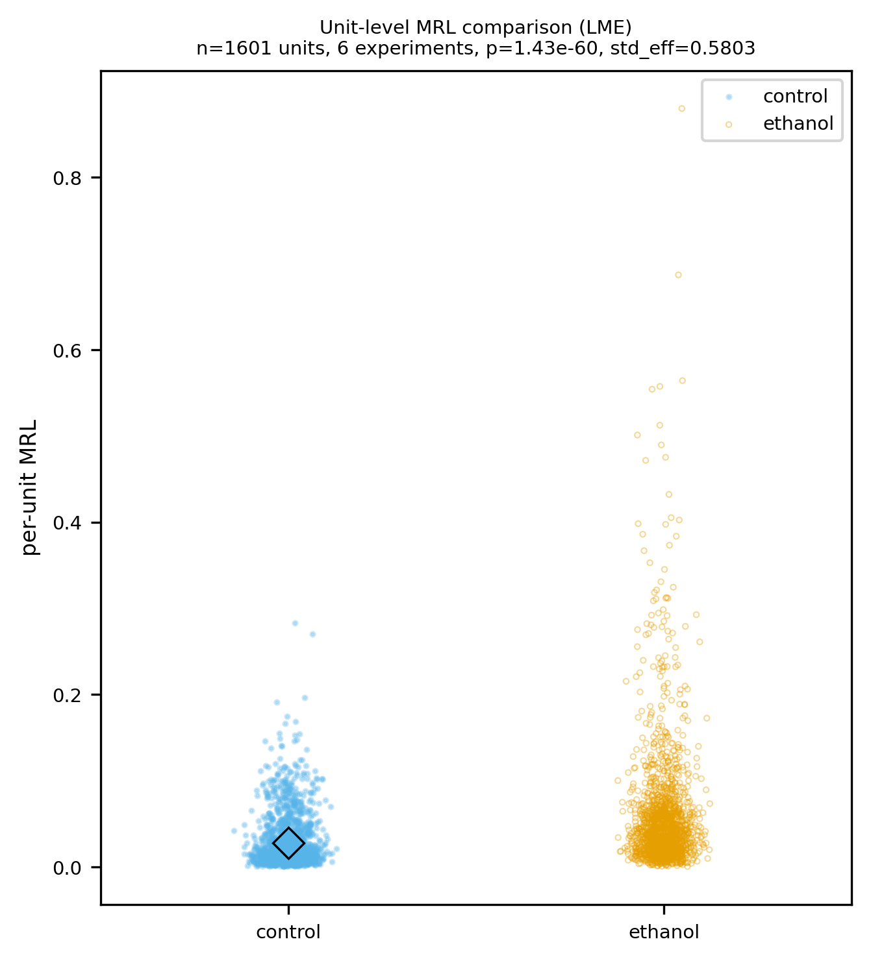
FIG-DEMO3-RESULTS-UNIT. Unit-level MRL comparison (LME); n_units = 1601, n_experiments = 6, p = 1.43 × 10⁻⁶⁰, standardized effect = 0.5803.
FIG-DEMO3-EXAMPLES — "Results: top-five units by |delta_MRL| — sniff-locked PSTHs and probe maps." One row per example unit: sniff-locked PSTH (ethanol + control overlaid) and full probe-location layout with the target unit highlighted. Source results: RESULT-examples-top5, RESULT-mrl-per-unit.
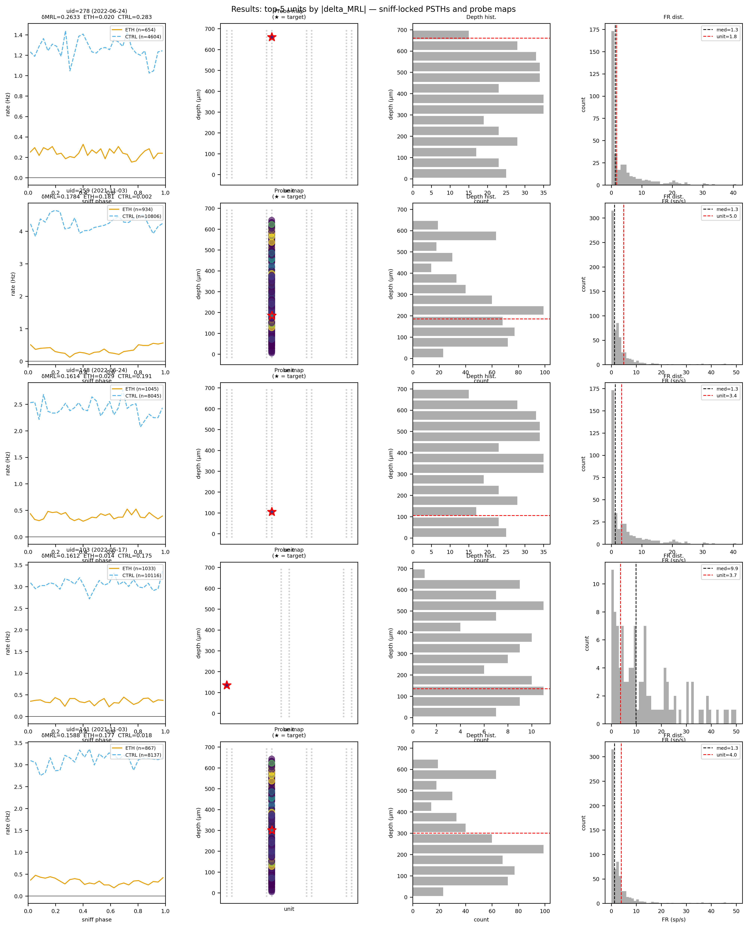
FIG-DEMO3-EXAMPLES. Top-five units by |delta_MRL|: sniff-locked PSTHs (ethanol + control overlaid) and probe-location maps.
Limitations
- The primary, animal-level Wilcoxon test has only 6 experiments as its sample size, which is underpowered to detect anything short of a very large and highly consistent ethanol effect; the non-significant result here means an effect at this level cannot be confirmed, not that no effect exists.
- The unit-level LME’s statistical significance is driven substantially by its much larger sample size (1601 units versus a handful of experiments); a significant unit-level condition effect does not by itself establish a population/animal-level effect, and should be read alongside — not instead of — the primary Wilcoxon result.
- This is an observational, within-animal comparison of ethanol-contact versus control sniff periods, not a randomized or counterbalanced intervention; the design supports description of association between condition and phase-locking but does not support a causal attribution of any observed shift to ethanol exposure per se, as opposed to other factors that co-vary with ethanol-contact periods (e.g., behavioral state, sniffing pattern changes, or time-in-session).
- The top-five example units (Examples section) are selected as the most extreme observed shifts and are not representative of the broader unit population; they illustrate range, not central tendency.

