NP-PAPER OB Depth-Coherence Study: Results Report
Deliverable B per contract_v001.yaml reports[role=results_report]. Reporting rules for this document require exact counts, exact p-values, and effect sizes, and require exploratory (non-causal) framing for the depth-dependence question while the coherence computation itself is a confirmatory replication of a published method.

Results
Across olfactory-bulb depth, this analysis asks two questions: which recording depth best aligns the local field potential to sniffing (the strongest theta-band, coherence between LFP and the sniff signal, the measure of alignment used by Rafilson and colleagues' twenty twenty-four paper, Figure one), and whether the strength of that alignment varies systematically with depth. The unit of analysis is the animal (5 animals across 6 recording sessions; one animal, NP8, contributed two sessions, which were averaged per depth into a single animal-level observation before any cross-session aggregation or statistical test below, so that animal is not double-counted).
Central and most important finding: the coherence computation itself faithfully implements the published confirmatory method (the same multitaper windowing, the same circular-shift null with at least 1000 shifts at a fixed pinned seed (5489), the same 95th-percentile significance threshold). Applying that method to this dataset, unlike Rafilson and colleagues' twenty twenty-four paper, no depth in any session reached significance by the paper's own headline measure: the peak-theta-coherence percentile against its own circular-shift null. Across all 30 session-by-depth cells, the single highest such percentile observed was 90.4 (out of a 95% significance threshold) -- never reaching significance. A small fraction of individual theta-band frequencies did exceed the per-frequency null in some sessions (Table one, "Sig. theta fraction," up to 19.5 percent of the theta band in the largest case), consistent with weak or chance-level coupling at isolated frequencies rather than a robust, band-wide alignment. This is reported here plainly and is not softened: by the paper's own headline significance test, this dataset does not replicate its alignment finding at any depth.

Per-Depth Theta Coherence
Table one (rendered programmatically from the frozen per-session-by-depth coherence-reduction result object) reports, for every session and every depth, the mean theta coherence (primary measure), peak theta coherence and its frequency, the fraction of the theta band exceeding the null threshold, and the peak-coherence null percentile -- thirty rows in total (six sessions by five depths), each an unmodified frozen-file value.
Table two summarizes the grand mean, plus/minus standard error of the mean, theta coherence at each depth, averaged across 5 animals (this animal-level analysis, RESULT-GRANDMEAN, is DIFFERENT input to the depth statistics below than the raw 6-session table one above, since the two sessions from one animal were first averaged into a single animal-level value per depth):
- Depth A: mean 0.0243, SEM 0.0039
- Depth B: mean 0.0250, SEM 0.0025
- Depth C: mean 0.0260, SEM 0.0023
- Depth D: mean 0.0256, SEM 0.0022
- Depth E: mean 0.0265, SEM 0.0022
All five depths show similarly small mean theta coherence (on the order of a few hundredths), consistent with the null finding above: no depth's grand mean is anywhere near a range that would itself be flagged significant against the null.
Session | Depth | Channel | Ycoord (um) | Mean theta coh | Peak theta coh | Peak freq (Hz) | Sig. theta fraction | Peak null percentile
11-01-2021 | A | 0 | -15 | 0.0215 | 0.0475 | 11.00 | 2.4% | 76.7
11-01-2021 | B | 24 | 165 | 0.0198 | 0.0371 | 9.50 | 0.0% | 33.1
11-01-2021 | C | 46 | 330 | 0.0288 | 0.0454 | 8.25 | 17.1% | 69.0
11-01-2021 | D | 118 | 510 | 0.0287 | 0.0471 | 8.25 | 19.5% | 75.9
11-01-2021 | E | 142 | 690 | 0.0273 | 0.0456 | 8.25 | 14.6% | 71.4
11-03-2021 | A | 0 | -15 | 0.0240 | 0.0410 | 4.25 | 0.0% | 34.2
11-03-2021 | B | 24 | 165 | 0.0232 | 0.0450 | 8.00 | 7.3% | 62.5
11-03-2021 | C | 46 | 330 | 0.0260 | 0.0485 | 6.25 | 17.1% | 70.5
11-03-2021 | D | 118 | 510 | 0.0273 | 0.0470 | 4.00 | 14.6% | 65.9
11-03-2021 | E | 142 | 690 | 0.0278 | 0.0510 | 6.25 | 17.1% | 79.3
12-15-2021 | A | 0 | -15 | 0.0335 | 0.0739 | 2.00 | 17.1% | 72.7
12-15-2021 | B | 24 | 165 | 0.0272 | 0.0825 | 6.50 | 4.9% | 87.3
12-15-2021 | C | 46 | 330 | 0.0266 | 0.0853 | 6.50 | 4.9% | 89.8
12-15-2021 | D | 118 | 510 | 0.0265 | 0.0863 | 6.50 | 4.9% | 90.4
12-15-2021 | E | 142 | 690 | 0.0261 | 0.0858 | 6.50 | 4.9% | 90.1
5-17-2022 | A | 0 | -15 | 0.0240 | 0.0508 | 10.00 | 0.0% | 15.2
5-17-2022 | B | 24 | 165 | 0.0237 | 0.0513 | 4.50 | 0.0% | 16.4
5-17-2022 | C | 46 | 330 | 0.0245 | 0.0481 | 4.50 | 0.0% | 10.3
5-17-2022 | D | 118 | 510 | 0.0231 | 0.0577 | 3.75 | 0.0% | 34.7
5-17-2022 | E | 142 | 690 | 0.0298 | 0.0730 | 9.75 | 7.3% | 79.0
06-24-2022 | A | 0 | -15 | 0.0108 | 0.0215 | 9.75 | 0.0% | 0.2
06-24-2022 | B | 24 | 165 | 0.0193 | 0.0486 | 6.50 | 4.9% | 88.6
06-24-2022 | C | 46 | 330 | 0.0186 | 0.0456 | 6.50 | 4.9% | 82.3
06-24-2022 | D | 118 | 510 | 0.0185 | 0.0402 | 6.50 | 7.3% | 60.4
06-24-2022 | E | 142 | 690 | 0.0184 | 0.0437 | 6.50 | 7.3% | 76.1
09-14-2022 | A | 0 | -15 | 0.0308 | 0.0803 | 5.00 | 7.3% | 89.5
09-14-2022 | B | 24 | 165 | 0.0334 | 0.0811 | 5.00 | 12.2% | 89.6
09-14-2022 | C | 46 | 330 | 0.0331 | 0.0773 | 5.00 | 9.8% | 86.1
09-14-2022 | D | 118 | 510 | 0.0317 | 0.0724 | 5.00 | 9.8% | 78.1
09-14-2022 | E | 141 | 690 | 0.0306 | 0.0705 | 5.00 | 7.3% | 74.1

Depth | Grand mean theta coh | SEM | n animals
A | 0.0243 | 0.0039 | 5
B | 0.0250 | 0.0025 | 5
C | 0.0260 | 0.0023 | 5
D | 0.0256 | 0.0022 | 5
E | 0.0265 | 0.0022 | 5

Best Depth
Per animal, the best depth is the one of the five with the highest mean theta coherence for that animal (Table three, rendered from the frozen per-animal-best-depth result object):
- NP8: best depth 4 (mean theta coherence 0.0280)
- Np10: best depth 1 (mean theta coherence 0.0335)
- NP12: best depth 5 (mean theta coherence 0.0298)
- NP15: best depth 2 (mean theta coherence 0.0193)
- NP22: best depth 2 (mean theta coherence 0.0334)
Overall, ranking the five depths by their grand-mean theta coherence across animals, the top-ranked depth is 5 (grand mean 0.0265), with the full ranking (highest to lowest) 5 > 3 > 4 > 2 > 1. Consistency across animals is limited: depth 5, the overall top-ranked depth, was each individual animal's own best depth in only 1 of 5 animals -- i.e. a plurality winner rather than a robust, consistent one. Per-ordinal consistency counts across all five depths: depth A won in 1 of 5 animals; depth B in 2; depth C in 0; depth D in 1; depth E in 1. Because the omnibus depth test below is not significant, no post-hoc comparison of the overall-best depth against the others was performed (an uncontracted post-hoc comparison would itself be prohibited here).
Animal | Session(s) | Best depth | Mean theta coh (best depth)
NP8 | 11-01-2021, 11-03-2021 | D | 0.0280
Np10 | 12-15-2021 | A | 0.0335
NP12 | 5-17-2022 | E | 0.0298
NP15 | 06-24-2022 | B | 0.0193
NP22 | 09-14-2022 | B | 0.0334
OVERALL (grand mean rank) | - | E | 0.0265

Per-ordinal consistency counts (number of animals for which each depth was that animal's own best depth): Depth A = 1, Depth B = 2, Depth C = 0, Depth D = 1, Depth E = 1 (out of 5 animals total).

Does Alignment Vary by Depth
Two repeated-measures tests were run on the 5-animal by five-depth table of mean theta coherence, treating animal as the repeated-measures block: a linear mixed-effects model (depth as a fixed categorical effect, animal as a random intercept, tested by likelihood-ratio test against the intercept-only model) as the primary test, and a Friedman test (distribution-free, across the five depths with animals as blocks) as a confirmatory test.
Linear mixed-effects likelihood-ratio test: chi-square 1.822, degrees of freedom 4, exact p 0.768. Effect size: range of the estimated marginal depth means 0.0022; intraclass correlation 0.747. MixedLM raised 2 convergence-related warning(s) fitting the 5-animal x 5-depth (n=25) table: The MLE may be on the boundary of the parameter space.; The MLE may be on the boundary of the parameter space.. Reported per coordinator instruction, not hidden -- interpret the LMM chi-square/p alongside the (convergence-warning-free) Friedman result.
Friedman test: statistic 1.760, degrees of freedom 4, exact p 0.780; Kendall's W (effect size) 0.088.
Neither test reached significance at the pinned alpha threshold (alpha = 0.05): the omnibus depth effect was not statistically significant by either the mixed-effects likelihood-ratio test or the Friedman test. Consistent with the pre-specified reporting rule for this exploratory question, no Holm-corrected post-hoc pairwise comparisons were run, since they were contracted to occur only if the omnibus test were significant. We therefore characterize this depth-dependence question descriptively (which depth had the highest observed grand-mean coherence, and how consistent that ranking was across animals, above) without concluding that recording depth determines, causes, or systematically changes theta-band LFP-sniff alignment in this dataset -- the observed depth differences are small relative to their between-animal variability and are not statistically distinguishable from chance across animals.
Test | Statistic | df | Exact p | Effect size
Linear mixed-effects LRT | 1.822 | 4 | 0.768 | marginal-mean range=0.0022; ICC=0.747
Friedman | 1.760 | 4 | 0.780 | Kendall's W=0.088

Omnibus result: not statistically significant by either test (posthoc pairwise comparisons were therefore not run, per the pre-specified reporting rule). The mixed-effects convergence note is reported inline above with the LMM statistics, not repeated here.

Figures

Figure one (FIG-PAPER1-PSD)
Figure 1B analogue: LFP power spectral density overlaid across the five depths (grand mean plus/minus SEM across 5 animals), with theta, beta, and gamma bands marked and depth ordinals A through E (tip to surface) legended. The power (y) axis is shown on a logarithmic scale.
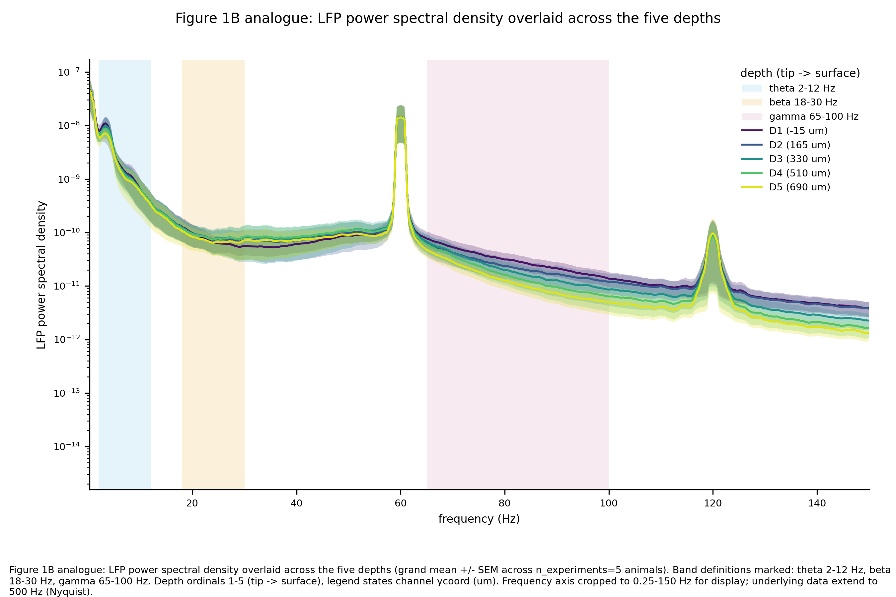

Figure two (FIG-PAPER1-COH)
Figure 1C-bottom / 1E analogue (key figure): the LFP-sniff coherence spectrum for each of the five depths (grand mean plus/minus SEM across 5 animals), with the 95th-percentile (n>=1000 shifts, seed 5489) circular-shift null threshold drawn as a red dotted line and the theta band shaded. This figure shows directly that every depth's observed coherence sits below its own null threshold across the theta band -- the same null result summarized above (maximum peak-coherence percentile 90.4, out of a 95% significance threshold, across all 30 session-by-depth cells).
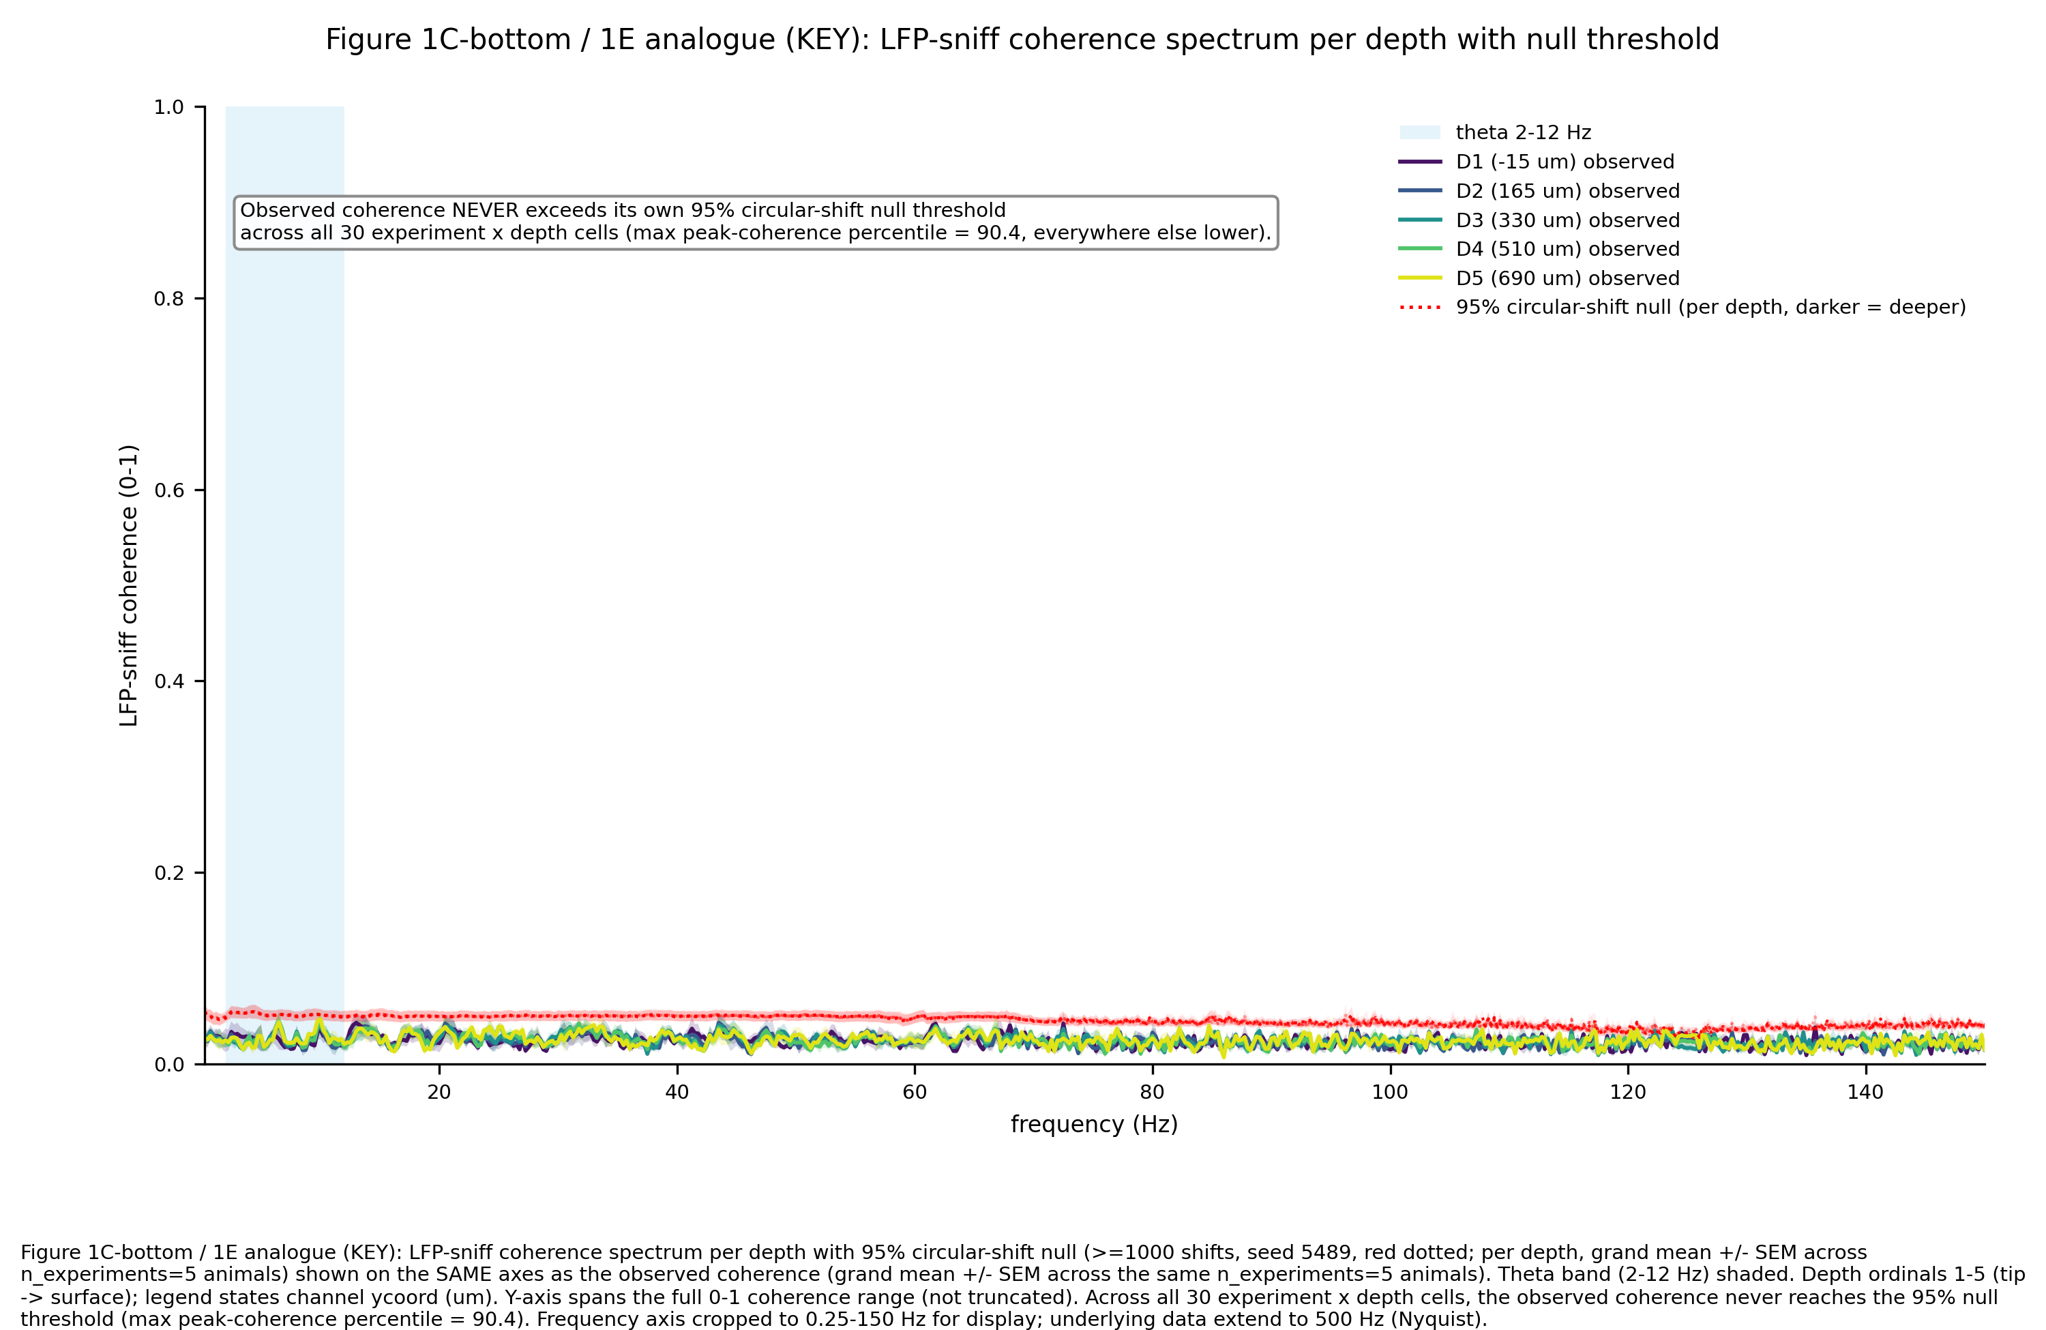

Figure three (FIG-PAPER1-DEPTH-SUMMARY)
Headline figure: sniff-alignment strength (mean theta coherence) as a function of depth (ycoord and ordinal, tip to surface), with per-animal points plus grand mean plus/minus SEM, and the best-aligned depth marked. Annotated with the omnibus test results (linear mixed-effects likelihood- ratio chi-square 1.822, degrees of freedom 4, exact p 0.768; Friedman statistic 1.760, degrees of freedom 4, exact p 0.780, Kendall's W 0.088) and identifying the depth with the highest observed grand-mean coherence (depth 5, the individual best depth for 1 of 5 animals). A companion panel shows the significant-theta fraction by depth. No significance stars are shown, consistent with the non-significant omnibus result; this figure and its caption are framed as an exploratory characterization, not a causal claim about depth.
