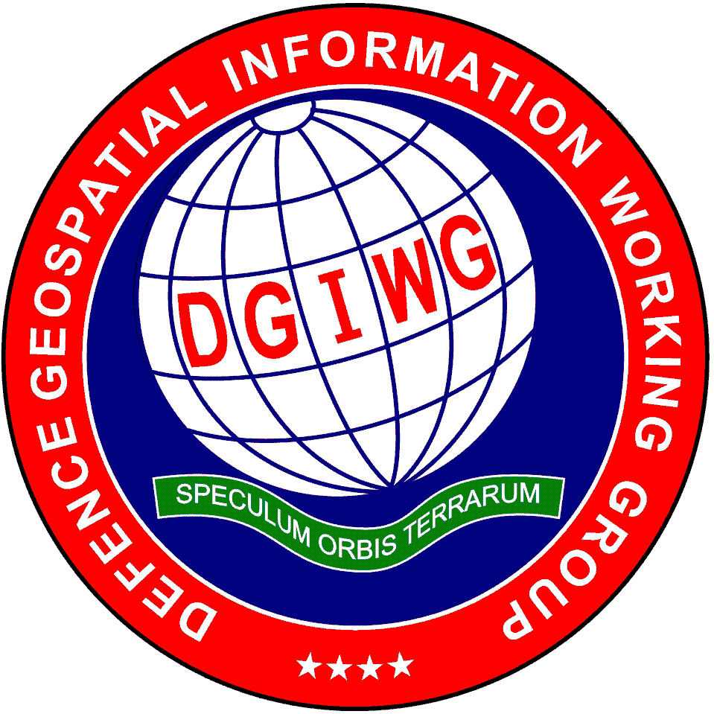

DGIWG GitHub report

| **Document type:** | **Technical Report** |
| --- | --- |
| Document date: | 5th February 2020 |
| Edition number: | 0.2.1 |
| Responsible Party: | DGIWG |
| Editor : | Dimitri Sarafinof |
| Audience: | DGIWG participants and associates |
| Abstract: | This document describes the GitHub experimentation ran by DGIWG WSTP about using GitHub tools within the DGIWG specific standardization process. |
| Copyright: | © Copyright DGIWG, some rights reserved - (CC) (By:) Attribution You are free: - to copy, distribute, display, and perform/execute the work - to make derivative works - to make commercial use of the work Under the following conditions: - (By:) Attribution. You must give the original author (DGIWG) credit. - For any reuse or distribution, you must make clear to others the license terms of this work. Any of these conditions can be waived if you get permission from the copyright holder DGIWG. Your fair use and other rights are in no way affected by the above. This is a human-readable summary of the Legal Code (the full license is available from Creative Commons <<http://creativecommons.org/licenses/by/2.0/> >). |

Table of Contents

1. Introduction

1.1. Context

1.2. Aim

2. Experimentation description

2.1. GitHub setup

2.2. Tutorial

2.3. Document template

2.4. Standard development

2.5. Conclusion

2.6. And what about GitLab ?

3. Feedback

3.1. Advantages

3.2. Some identified issues

3.3. Possible way forward

3.4. Things to be checked

3.5. Recommendations and way forward

Appendix A: DGIWG workflow for standard development (proposal)

Appendix B: DGIWG GitHub how to

*Working with GitHub : DGIWG how to*

Introduction to GitHub

Required tools

Working on an existing repository

Pulling changes from your fork

Working on a new project

GitHub Flow

1. Introduction

1.1. Context

OGC is using GitHub tools for developing standards and testbeds reports. This process has several advantages:

* a unique gold copy of the document (and other resources like schemas)
* version control of the resources
* focus on the content and not on the look of the document (also avoid errors in references, text styles, numbering …​)
* easy contribution and merge of the comments/contributions with full traceability

From asciidoc text format (.adoc), PDFs or HTMLs can be generated quite easily for document publication (with recommended tools).

*PS: the NGA also develops its own profiles on Github (*[*https://github.com/ngageoint/*](https://github.com/ngageoint/)*).*

1.2. Aim

DGIWG management team agreed on a one year experiment period for the P5-05 project (Web Processing Services). A DGIWG experimentation has then been run in 2019 to investigate use of GitHub tools for helping the process development of DGIWG standards.

2. Experimentation description

2.1. GitHub setup

DGIWG organization has been created on GitHub website <https://github.com/DGIWG/>. This allows creation of open repositories for DGIWG projects. For the DGIWG experiment, the DGIWG WPS profile development has been run under <https://github.com/DGIWG/P5.05-WPS>.

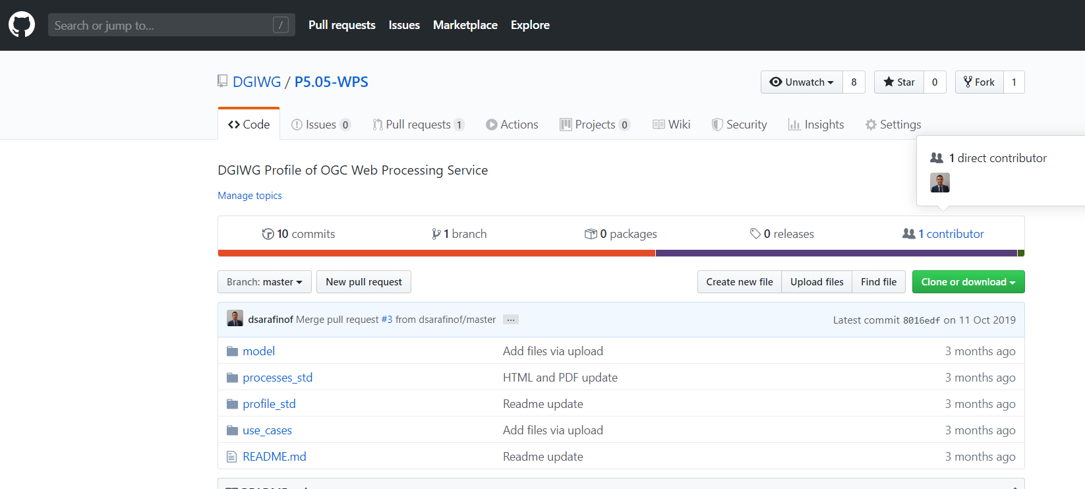

**Figure 1. DGIWG P5.05-WPS repository**

|  |  |
| --- | --- |
|  | the GitHub experiment has been run on a voluntary base; usual contributions/comments to the document have also been accepted during the process. |

2.2. Tutorial

A Git/GitHub tutorial has been created to be presented to the DGIWG WSTP experts and more globally to DGIWG members during side sessions and DGIWG TP plenary <https://portal.dgiwg.org/files/?artifact_id=69392>.

A test repository (sandbox) has been created to help volunteers to play with it before contributing to the project (<https://github.com/DGIWG/sandbox>). A "step by step" GitHub document has also been created for this purpose (see Annex A); it also describes required and recommended tools to be used (such as Atom text editor, useful plugins, Asciidoctor …​)

2.3. Document template

A first draft of the DGIWG template document has been generated for GitHub testing purposes <https://github.com/DGIWG/Management/tree/master/Templates>. This template provides an empty DGIWG standard document (AsciiDoc format) with same structure and look and feel as the current DGIWG word template for DGIWG standards.

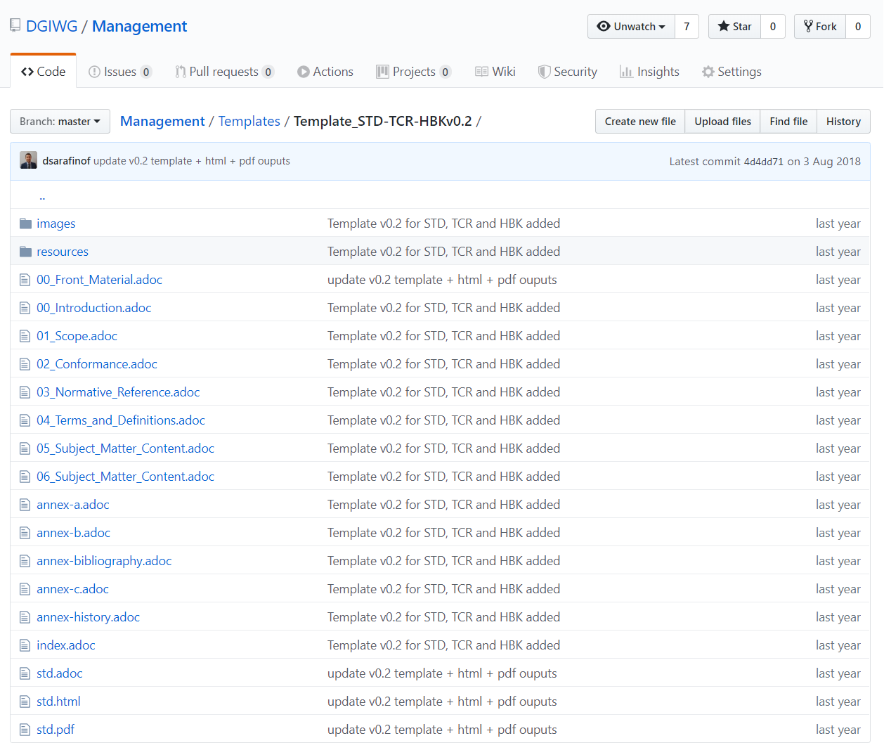

**Figure 2. DGIWG AsciiDoc standard template**

2.4. Standard development

The P5.05 group has setup a dedicated repository <https://github.com/DGIWG/P5.05-WPS> which contains two main subfolders for:

* a profile of WPS 2.0
* geospatial processes description (intervisibility, line of sight, routing, …​).

Contributions (with text editor Atom) have been made on each expert clone of the repository before submitting pull request to the DGIWG repository. See workflow and tutorial in the [_annex_a].

|  |  |
| --- | --- |
|  | Atom is a text editor that let experts edit the text locally on their computer (see figure below) |

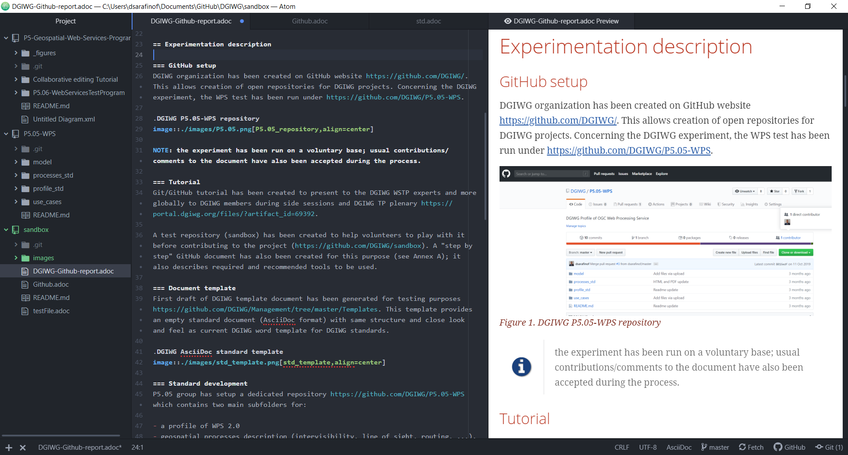

**Figure 3. Edition of documents with Atom text editor and document preview**

Local editions are submitted by experts on the DGIWG GitHub (pull request mechanism); differences are highlighted and easy to discuss (see figure below).

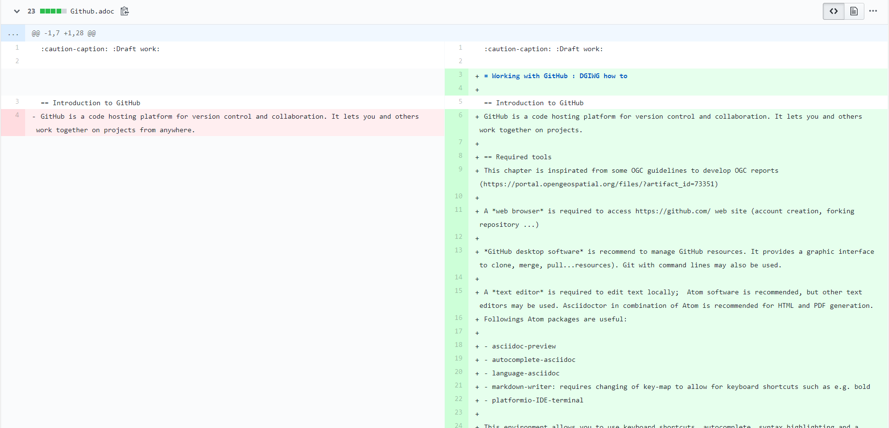

**Figure 4. GitHub comparison during the pull request process**

Each of these two documents follows the previous defined template. Command lines allow easy generation of PDF or HTML documents (draft documents have been generated to allow easier reading and commenting). This also can be done with a plugin of the Atom editor.

**HTML generation from an AsciiDoc document with a command line**

asciidoctor -r asciidoctor-bibtex -a linkcss -a stylesheet=dgiwg.css -a stylesdir=resources/stylesheets std.adoc

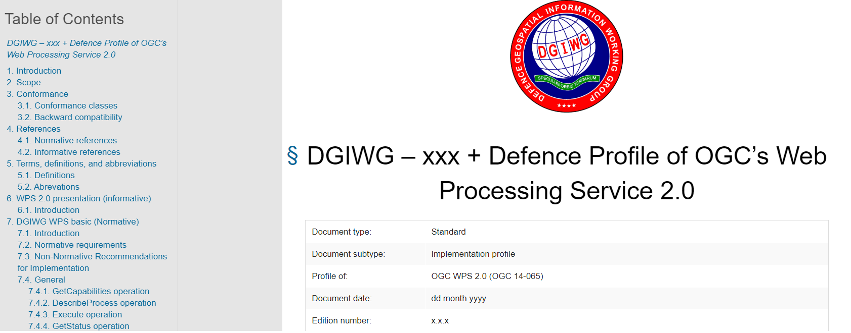

**Figure 5. DGIWG HTML rendering from the current draft template**

2.5. Conclusion

**The process used by P5.05 team for developing standard works. This allows use of new technologies and also more classic contributions (via Word).**

2.6. And what about GitLab ?

GitLab is another Git-based repository, offering more or less the same functionalities as GitHub. One of the main differences is that GitLab private repositories are free (public repositories are charged), whereas GitHub offers the opposite (public is free, private is charged). OGC has then investigated the use of GitLab and now (announced the 14th of January 2020) offers its own flavor on <https://gitlab.ogc.org/>. OGC procedure is simple, "**Private Repos = GitLab / Public Repos = GitHub**". the process development is the same. DGIWG P5 has also created the DGIWG organization under GitLab, but has not investigated its usability yet.

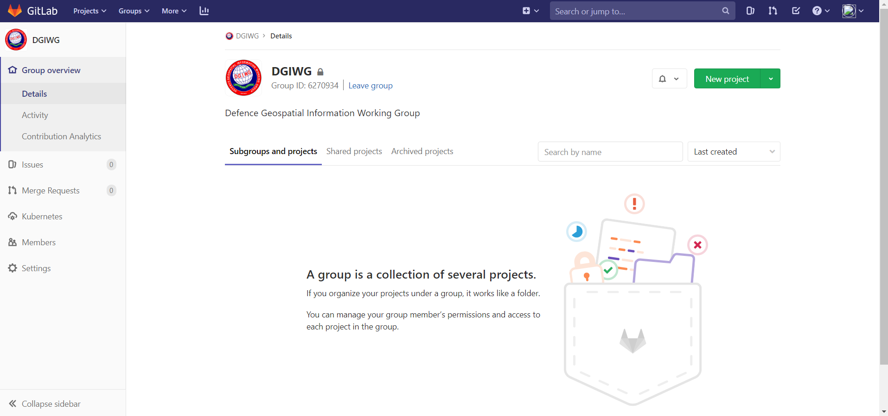

**Figure 6. DGIWG Group created under GitLab**

3. Feedback

3.1. Advantages

1. publicly available and free tools allow **easy offline editing and contributions** between meetings
2. **merging contributions is an easy step** and is managed by github.com web site (pull requests). Differences (additions, deletions…​) are highlighted, discussions during meetings or teleconferences becomes easier.
3. **including/referencing external resources** (like XML schemas) is much easier
4. **managing references, tables and images is much easier** (at least it is automatic based on a simple syntax and no error is introduced by exchanging a word document between people which use different Office versions or different language settings). NOTE: the final editing part of a DGIWG standard for publication as Word or PDF document is a demanding task (that even with most carefulness may lead to mistakes or erroneous references in published DGIWG documents).
5. using the **same technology and workflow as OGC** may also be an advantage for DGIWG when profiling OGC standards. This is especially of interest for Web services and upcoming OGC APIs profiles, but can also be an advantage for nations aiming at developing national profiles based upon DGIWG standards.
6. **becoming friendly** with the tools and the DGIWG proposed workflow requires **only a few hours.**

3.2. Some identified issues

The proposal to use GitHub and contribute to a collaborative approach to developing DGIWG profiles and Standards, it is assumed that:

1. the user has access to the Open Internet both to GitHub and GitHub download App plugin sites from a Military Network.
2. the Network the user is working on does not have any JavaScript (transactional) restrictions.
3. the User has Administrate Rights to install on their respective computer.
4. the User does not have any restrictions of items such as the ‘Command Line Interface’.
5. the Military network can interact with the GitHub/Lab and Local Machine Repo.

|  |  |
| --- | --- |
|  | These issues have been identified by GBR. Full analysis can be found in the document ["Using GitHub on Defence Military Networks"](https://portal.dgiwg.org/files/?artifact_id=70084). |

3.3. Possible way forward

Moving directly to a full GitHub process for developing DGIWG standards does not seems to be the better path now. Generating Word versions of the a.doc documents for people having no access to GitHub has been experienced for writing this report (and for P5.05). Word file may be generated easily from the HTML version. This allows then commenting and contributing from all experts (comments done via Word have to be re-inserted into the adoc file on GitHub by someone having access to it).

3.4. Things to be checked

1. Tools installation (see [_annex_b])
2. Access to <https://github.com/> (only for specific tasks)

3.5. Recommendations and way forward

1. **Continue P5.05 experiment** and finalize it with GitHub tools
2. **Start investigation of GitLab** in line with OGC process
3. **Finalize DGIGW documents template in asciidoc** (+ CSS)
4. **Review all resources** to support using GitHub/GitLab for DGIWG
5. **Extend experiment to other DGIWG panel(s)** (volunteers ?) to gather wider feedback
6. **Setup management rights** on <https://github.com/DGIWG/>

Appendix A: DGIWG workflow for standard development (proposal)

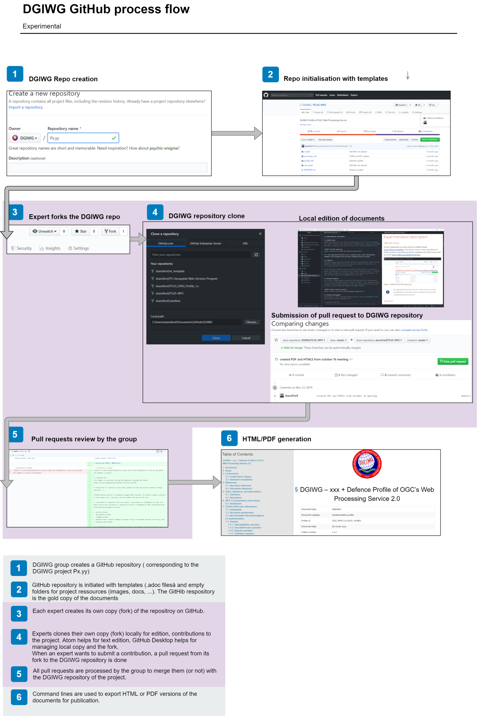

**Figure 7. DGIWG simple flow for standard development under GitHub**

Appendix B: DGIWG GitHub how to

Working with GitHub : DGIWG how to

4. Introduction to GitHub

GitHub is a code hosting platform for version control and collaboration. It lets you and others work together on projects.

5. Required tools

This chapter is inspirited from some OGC guidelines to develop OGC reports (<https://portal.opengeospatial.org/files/?artifact_id=73351>)

A **web browser** is required to access <https://github.com/> web site (account creation, forking repository …​)

*Online editing*

Online editing of asciidoc document is possible, directly with a web browser. This solution does not offer advance functionalities (visual preview, spellcheck…​) that are available offline with dedicated tools.

*Offline editing*

**GitHub desktop software** is recommended to manage GitHub resources. It provides a graphic interface to clone, merge, pull…​resources).

|  |  |
| --- | --- |
|  | Git command lines may also be used (without any graphic interface) to manage resources. |

A **text editor** is required to edit text locally (offline); Atom software is recommended, but other text editors may be used. Asciidoctor in combination of Atom is recommended for HTML and PDF generation. Followings Atom packages are useful:

* asciidoc-preview
* autocomplete-asciidoc
* language-asciidoc
* markdown-writer: requires changing of key-map to allow for keyboard shortcuts such as e.g. bold
* platformio-IDE-terminal

This environment allows you to use keyboard shortcuts, autocomplete, syntax highlighting and a rendered preview for asciidoc; and provides you an terminal window within the editor to convert your asciidoc to html and pdf

Although GitHub can be used anonymously, a GitHub user account is required to interact with the platform and to be able to fork repositories. GitHub is free for public repositories.

6. Working on an existing repository

This first use case is useful when you want to collaborate to an existing project. That is the case for the DGIWG activity. In this case, the workflow is

* Go to the DGIWG project/repository you want to work on (for example <https://github.com/DGIWG/sandbox>)
* Fork the project to your account, so you have your own version.
* Clone on your machine your version of the repository (your fork that looks like <https://github.com/yourNames/sandbox>). This may be done with [GitHub desktop tool](https://desktop.GitHub.com/).

⇒ this will create a copy of your repository on you local hard drive.

* Edit file locally (for example with Atom editor tool, check "Recommended AsciiDoc Environment" on <https://portal.opengeospatial.org/files/?artifact_id=73351> for installing the tool and related plugins)
* Save file locally (still with the text editor)
* Commit locally (for example with GitHub desktop)
* Push to Fork (for example with GitHub desktop)

⇒ this will push your local changes to your own fork of the repository (<https://github.com/yourName/sandbox>)

7. Pulling changes from your fork

* create a new pull request (from your own fork on GitHub.com, for example <https://github.com/yourName/sandbox>)

⇒ this pull request has then to be discussed and accepted by admin of the DGIWG repo (<https://github.com/DGIWG/sandbox>)

* once your pull request has been accepted by the DGIWG repo, you just need to synchronize your fork again with it by (with GitHub desktop for example)
  + comparing your local copy to the DGIWG branch <https://github.com/DGIWG/sandbox>)
  + make a merge (this will update your local clone of your own repository), then your local Copy = the DGIWG online repo (<https://github.com/DGIWG/sandbox>)
  + push it to the origin (this will update your online copy <https://github.com/yourName/sandbox>), then <https://github.com/yourName/sandbox> = <https://github.com/DGIWG/sandbox>

8. Working on a new project

How to create a new project? The easiest is to use the GitHub UI to create a new project and then clone it. You can also use the command line (more info [here](https://help.github.com/en/github/importing-your-projects-to-github/adding-an-existing-project-to-github-using-the-command-line)).

9. GitHub Flow

[GitHub Flow](http://1.bp.blogspot.com/-n8gwrM5Bf04/UfosDLuuDUI/AAAAAAAAKwg/2aE3V0NDk-g/s1600/git-and-GitHub-workflow.png)

Last updated 2020-02-05 17:42:02 +0100