AuraDB Knowledge Graph Report

Data set: https://github.com/ArithaRTU/KMS_Dataset
Schema:
StudyProgram
|
HAS_COURSE
|
StudyCourse
|
HAS_TOPIC
|
CourseTopic
Imported Data:
- StudyProgram
- StudyCourse
- CourseTopic
Relationship:
- HAS_TOPIC
Queries:
1.
MATCH (p:StudyProgram)
RETURN p.program_id, p.title
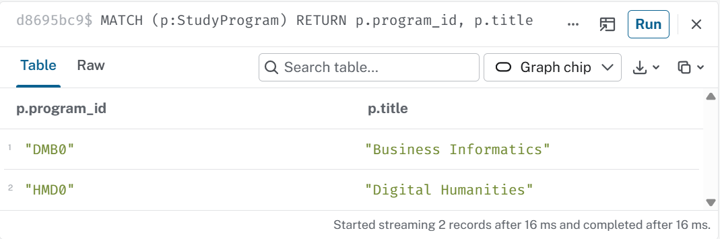
2.
MATCH (c:StudyCourse)
RETURN c.title
LIMIT 10
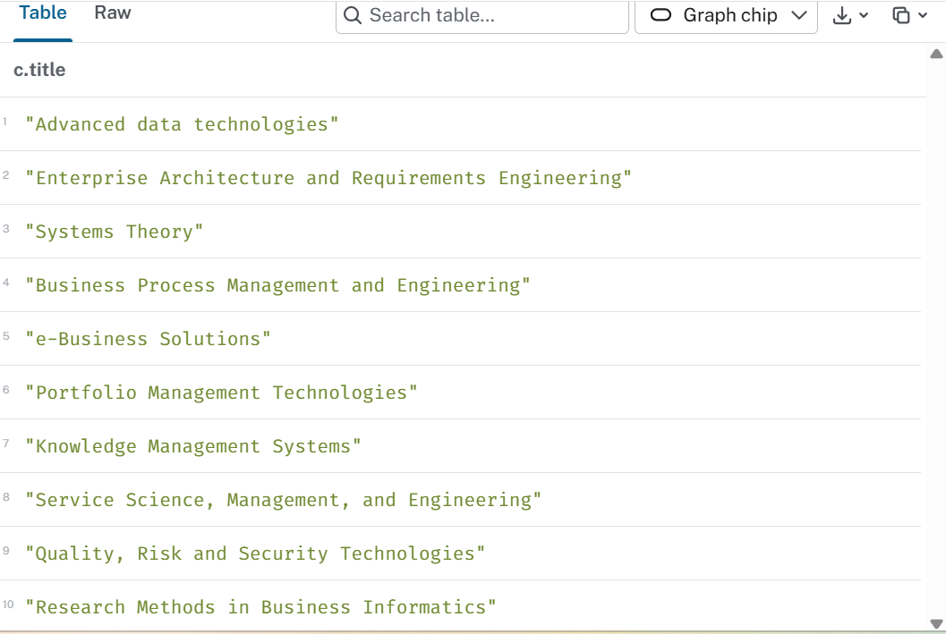
3.
MATCH (c:StudyCourse)-[:HAS_TOPIC]->(t:CourseTopic)
RETURN DISTINCT c.title, t.title
LIMIT 6
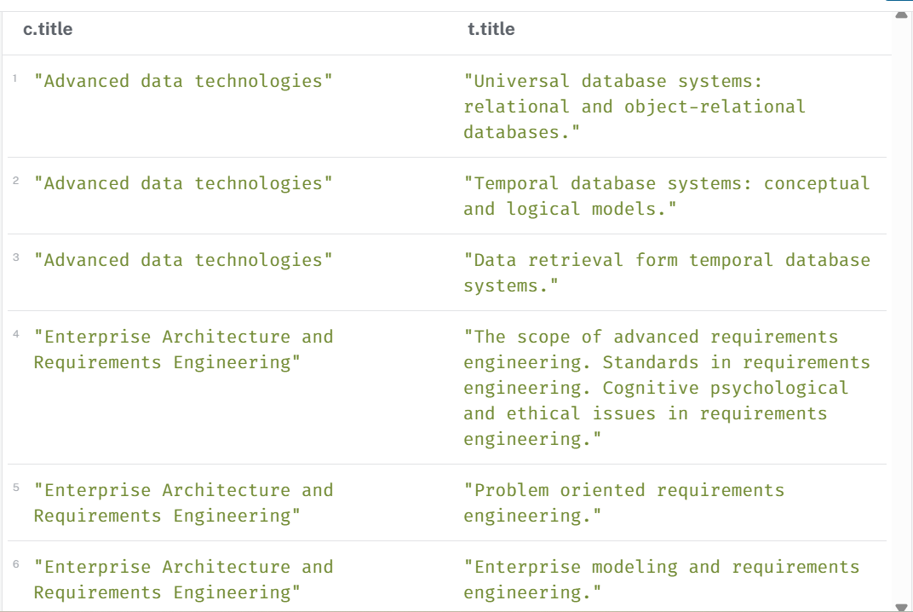
4.
MATCH p=(c:StudyCourse)-[:HAS_TOPIC]->(t:CourseTopic)
RETURN DISTINCT p
LIMIT 8
