BUSINESS REQUIREMENT DOCUMENT

Mines Administration System

Department of Geology and Mines (DGM)
Ministry of Energy and Natural Resources (MoENR)

Version 3.0
Mar 28, 2025

Background 10
Objectives 10
Stakeholders 10
Scope of work 10
1. Exploration Permit 12
1.1. Process Flow 12
1.2. Applicant 12
1.2.1. Input FORM EP-1 (APPLICATION FOR EXPLORATION PERMIT) 12
1.2.2. Business Flow for Applicant/Leasee 15
1.3. MPCD Officer 16
1.3.1. Input Field for MPCD Officer 16
1.3.2. Business logic for MPCD Officer 17
1.4. Geologist 18
1.4.1. Input Field for Geologist 18
1.4.2. Business logic for Geologist 19
2. LC/Invoice Upload 21
2.1. Process flow 21
2.2. Applicant 21
2.2.1 Input Field for Applicant 21
12.2.2 Business Logic for Applicant 22
2.3. Regional Coordinator 22
2.3.1 Input Field for Regional Coordinator 22
2.3.2 Business Logic for Regional Coordinator 23
3. Quarrying Lease 24
3.1. Process Flow 24
3.2. Applicant 25
3.2.1. Input FORM A (Application of Quarrying Lease) 25
3.2.2. Business logic for Applicant/Leasee 28
3.3. MPCD Officer 29
3.3.1. Input Field for MPCD focal 29
3.3.2. Business logic for MPCD Officer 30
3.4. Geologist 31
3.4.1. Input field for Geologist 31
3.4.2. Business logic for Geologist 32
3.5. Mining Engineer, MD 33
3.5.1. Input field for Mining Engineer 33
3.5.2. Business logic for Mining Engineer 34
3.6. Mining Chief 36
3.6.1. Input Field for Mining Chief 36
3.6.2. Business Logic for Mining Chief 36
3.7. Director, DGM 36
3.7.1. Input field for Director 36
3.7.2. Business logic for Director 36
4. Mining Lease 38
4.1. Process Flow 38
4.2. Applicant 39
4.2.1. Input FORM A (Application of Mining Lease) 39
4.2.2. Business logic for Applicant/Leasee 41
4.3. MPCD Officer 42
4.3.1. Input Field for MPCD focal 42
4.3.2. Business logic for MPCD Officer 43
4.4. Geologist 44
4.4.1. Input field for Geologist 44
4.4.2. Business logic for Geologist 45
4.5. Mining Engineer, MD 46
4.5.1. Input field for Mining Engineer 46
4.5.2. Business logic for Mining Engineer 48
4.6. Mining Chief 49
4.6.1. Input Field for Mining Chief 49
4.6.2. Business Logic for Mining Chief 49
4.7. Director, DGM 49
4.7.1. Input field for Director 49
4.7.2. Business logic for Director 50
5. Renewal of Lease 51
5.1. Process Flow 51
5.2. Applicant 51
5.2.1. Input FORM F (Application for Renewal of Mining Lease) 51
5.2.2. Business Logic for Applicant/Leasee 53
5.3. Mining Engineer, MD 54
5.3.1. Input field for Mining Division 54
5.3.2. Business logic for Mining Engineer 56
5.4. Geologist 57
5.4.1. Input field for Geologist 57
5.4.2. Business logic for Geologist 58
5.5. Chief, MD 58
5.5.1. Input field for Chief, MD 58
5.5.2. Business logic for Chief, MD 59
5.6. Director, DGM 60
5.6.1. Input field for Director 60
5.6.2. Business logic for Director 60
6. Renewal of Environment Clearance (EC) 62
6.1. Process Flow 62
6.2. Applicant 62
6.2.1. Input Field for Applicant 62
6.2.2. Business Logic for Applicant 64
6.3. Regional Coordinator 64
6.3.1. Input Field for RC 64
6.3.2. Business Logic for RC 65
6.4. MPCD Officer 65
6.4.1. Input Field For MPCD 65
6.4.2. Business Logic for MPCD 67
6.5. Mining Engineer, MD 67
6.5.1. Input Field for ME, MD 67
6.5.2. Business Logic for ME, MD 68
6.6. Mining Inspector (MI) 69
6.6.1. Input Field for MI 69
6.6.2. Business Logic for MI 70
7. Magazine Plan 71
7.1. Process Flow 71
7.2. Applicant 71
7.2.1. Input Form for Applicant 71
7.2.2. Business Logic for Promoter/Applicant 72
7.3. Mining Engineer, MD 72
7.3.1. Input Form for Mining Engineer 72
7.3.2. Business Logic for Mining Engineer 73
7.4. Department of Law and Order Focal 73
7.4.1. Input Form for DLO Focal 73
7.4.2. Business Logic for DLO Focal 74
8. Explosive Requisition 75
8.1. Process Flow 75
8.2. Applicant 75
8.2.1. Input field for applicant 75
8.2.2. Business Logic for Applicant 76
8.3. Regional Coordinator/Mining Inspector 76
8.3.1. Input field for Regional Coordinator/Mining Inspector 76
8.3.2. Business logic for Regional Coordinator/Mining Inspector 77
8.4. Mining Engineer 78
8.4.1. Input field for Mining Engineer 78
8.4.2. Business Logic for Mining Engineer 78
8.5. Department of Law and Order focal 79
8.5.1. Input field for Department of Law and Order focal 79
8.5.2. Business Logic for Department of Law and Order focal 79
9. Royalty 80
9.1. Process Flow 80
9.2. Promoter 80
9.2.1. Input Field for Promoter 80
9.2.2. Business Logic for Promoter 80
10. Mine Transport Permit 81
10.2. Applicant 81
10.2.1. Input Field for Applicant 81
10.2.2. Business Logic for Applicant 83
10.3. RC/MI 84
10.3.1. Input Field for RC 84
10.3.2. Business Logic for RC 85
11. Stockyard Transport Permit 86
11.1. Process Flow 86
11.2. Applicant 86
11.2.1. Input field for Applicant 86
11.2.2. Business logic 88
11.3. Regional Coordinator 88
11.3.1. Input Field for Regional Coordinator/MI 88
11.3.2. Business Logic for RC/MI 89
12. Stock Lifting Transport Permit 90
12.1. Process Flow 90
12.2. Applicant 92
12.3. Regional Coordinator (RC)
13. Surface Collection TP 94
13.1. Process Flow 94
13.2. Applicant/Promoter 94
15.2.2 Business Logic for Applicants 96
13.3. Regional Coordinator (RC) 98
14. Rural Transport Permit 99
14.1. Process Flow 99
14.2. Applicant/Promoter 99
16.2.2 Business Logic for Applicant 99
14.3. Regional Coordinator (RC/MI) 100
14.3.1. Input Field for RC/MI 100
15. Promoter Annual Report 101
15.1. Process flow 101
15.2. Promoter 101
15.2.1. Input Form E (Annual Report on Operation of the Mine) 101
15.2.2. Business Logic for Promoter 110
16. Promoter Bi-Annual Reporting 111
16.1. Process flow 111
16.2. Promoter 111
16.2.1. Input Form D (Bi-annual Report on Operation of the Mine) 111
16.2.2. Business Logic for Promoter 117
17. Accident Reporting 118
17.1. Process Flow 118
17.2. Promoter 118
17.2.1. Input Form I (Notice of Accident) 118
17.2.2. Business Logic for Promoter 119
17.3. RC/MI 120
17.3.1. Input field for RC/MI 120
17.3.2. Business logic for RC/MI 120
17.4. Director 121
17.4.1. Input field for Director 121
17.4.2. Business logic for Director 121
18. Temporary Closure 122
18.1. Process Flow 122
18.2. Promoter 122
18.2.1. Input field for Promoter 122
18.2.2. Business logic for Promoter 123
18.3. Regional Coordinator 123
18.3.1. Input field for RC 123
18.3.2. Business logic for RC 124
18.4. Mining Inspector 124
18.4.1. Input field for MI 124
18.4.2. Business logic for MI 125
19. Termination 126
19.1. Process Flow 126
19.2. Chief, Mining Division 126
19.2.1. Input Field for Chief, MD 126
19.2.2. Business Logic for Chief, MD 127
19.3. CMS Head, MTC 127
19.3.1. Input field for CMS Head, MTC 127
19.3.2. Business logic for CMS Head, MTC 128
19.4. Promoter 128
19.4.1. Input field for Promoter 128
19.4.2. Business logic for Promoter 129
20. Immediate suspension 130
20.1. Process Flow 130
20.2. RC/ME 130
20.2.1. Input field for RC/ME 130
20.2.2. Business logic for RC/ME
20.3. Promoter 131
20.3.1. Input field for Promoter 131
20.3.2. Business logic for Promoter
20.4. Mining Inspector 132
20.4.1. Input field for MI 132
20.4.2. Business logic for MI
21. Mine Restoration 134
21.1. Process Flow 134
21.2. Promoter 134
21.2.1. Input Field for Promoter 134
21.2.2. Input Field for progress report 135
21.2.3. Input Field for Mine Restoration Completion Report 135
21.2.4. Business Logic for Promoter
21.3. Mining Engineer, Mining Division 138
21.3.1. Input field for Mining Engineer, Mining Division 138
21.3.2. Business logic for Mining Engineer, Mining Division 139
21.4. Regional Coordinator/Mining Inspector 139
21.4.1. Input field for RC/MI 139
21.4.2. Business logic for RC/MI 140
22. Surface collection (minerals, Sand, Stone and Boulders) 140
22.1. Process Flow 140
22.2. Promoter 141
22.2.1. Input Field for Promoter 141
22.2.2. Business Logic for Promoter 144
22.3. MPCD Officer 145
22.3.1. Input field for MPCD Officer 145
22.3.2. Business logic for MPCD Officer 147
22.4. Mining Engineer, MD 148
22.4.1. Input field for Mining Engineer, Mining Division 148
22.4.2. Business logic for Mining Engineer, Mining Division 150
23. Stock Lifting 151
23.1. Process Flow 151
23.2. Promoter 151
23.2.1. Input field for Promoter 151
23.2.2. Business logic for Promoter 152
23.3. MPCD Officer 152
23.3.1. Input field for MPCD Officer 152
23.3.2. Business logic for MPCD Officer 154
23.4. RC/MI 155
23.4.1. Input field for RC/MI 155
23.4.2. Business logic for RC/MI 156
23.5. Mining Engineer, MD 156
23.5.1. Input field for Mining Engineer, MD 156
23.5.2. Business logic for Mining Engineer, MD 157
24. Rural Permit 159
24.1. Process Flow 159
24.2. Promoter 159
24.2.1. Input field for Promoter 159
24.3. Regional Coordinator 160
24.4. Mines Inspector 160
25. Auction of surface collection (Minerals & stone and boulders) 161
25.1. Process Flow 161
25.2. MPCD Focal 161
25.2.1. Input field for MPCD 161
25.2.2. Business logic for MPCD 163
25.3. Promoter 164
25.3.1. Input field for Promoter 164
25.3.2. Business logic for Promoter 164
25.4. Mining Engineer, MD 164
25.4.1. Input field for Mining Engineer, MD 164
25.4.2. Business logic for Mining Engineer, MD 165
26. Renewal for SC for State-owned company 166
26.1. Process Flow 166
26.2. Promoter 166
26.2.1. Input field for Promoter 166
26.2.2. Business logic for Promoter 168
26.3. MPCD Focal 168
26.3.1. Input field for MPCD Focal 168
26.3.2. Business logic for MPCD Focal 169
26.4. Mining Engineer, MD 170
26.4.1. Input Field for Mining Engineer, MD 170
26.4.2. Business Logic for Mining Engineer, MD 171
27. Exploration GeoPhysics 172
27.1. Process Flow 177
28. Geology Survey Division Services 178
28.1. Geological mapping 178
28.2. Mineral Prospecting 178
28.3. Mineral exploration 178
28.4. Study of construction material 178
28.5. Mineral and rock sampling 178
28.6. Geological core logging 178
28.7. Chemical Laboratory Analytical Services 178
28.8. Survey and GIS 178
28.9. Drilling 178
28.10. Sample Transport Clearance 178
28.11. Others(Specify) 178
28.12. Process flow 184
29. Sample Transport Clearance 185
29.1. Process Flow 185
30. Manual Entry of Mining, Quarrying, surface collection and stock lifting. 186
30.1. Process flow 186
30.2. MPCD/MD focal 186
30.2.1. Input fields for MPCD / MD focal 186
30.2.2. Business Logic for MPCD / MD focal 187
30.3. Chief,MD 187
30.4. Promoter 187
30.5. Director 187
31. Data Requirements 188
32. Data and User Management 189
32.1. User Authentication and Authorization: 189
32.2. System Administration: 189
32.3. User Management 190
32.4. Role Management 191
32.5. Permission Management 191
32.6. Map User Role 191
32.7. Map Role Permission 192
32.8. Master Data Management: 192
32.9. Data Integrity and Security for Digital Archival System 192
32.10. Reporting and Analytics: 193
32.11. Dashboard 194

System Name: Mines Administration System

Background
The current MAS system is a mixed-mode service(part online and part offline) and some services are not functioning. Therefore, the proposed system will aim to provide end-to-end MAS service, thereby enhancing the efficiency in the service delivery.

Objectives
The objective of undertaking this project are as follows:
- To update the system processes with the current practice.
- Reduce face to face interaction
- Improve service delivery for applicants
- Centralized data management
- Ease of use for service providers
- Inventory for Mining data
- Enhanced decision-making
- Ensure real-time updates
- Improve overall transparency
- Minimize the issue of non-compliance

Stakeholders
The following are the stake holders involved in the services that are discussed in this report:
- Department of Geology and Mines
- Department of Environment and Climate Change
- National Land Commission
- Department of Law and Order
- Dzongkhag Administration
- Department of Forest and Park Services
- Applicants

Scope of work
- Redevelopment of Existing MAS
  - Migration to Latest Technology Stack:
    - Rebuild the Mineral Administration System (MAS) using a modern technology stack (e.g., Spring Boot, Angular/React, PostgreSQL).
    - Enhance system scalability, security, and maintainability.
    - Ensure compatibility with mobile and web platforms for ease of access.
- Digitization of DGM Services
  - End-to-End Digital Transformation:
    - Automate all DGM services, including quarry lease processes, mineral license applications, and royalty management.
    - Implement self-service portals for citizens and businesses.
    - Develop a user-friendly interface.
- Integration with External Systems
  - Key System Integrations:
    - Seamless integration with:
      - G2C Portal: Business license and company registration systems.
      - NSW: For streamlined import/export processes.
      - BIRMS Payment Gateway: Enable payment processing and validation.
      - BoB Dollar Rate API: Automate exchange rate updates for international transactions.
      - Real-time data exchange with NLCS, DECC, and other relevant agencies.
- NDI Level I & II Integration
  - Digital Identity and Signing:
    - Implement National Digital Identity (NDI) Level I & II authentication for secure user verification.
    - Introduce digital signature functionality for key transactions and approvals, ensuring legal validity and traceability.
- Environmental Clearance (EC) Service
  - Streamlined EC Application:
    - Develop an integrated Environmental Clearance module.
    - Enable tracking of EC applications, compliance, and renewals.
    - Automate workflows with DECC and ensure regulatory adherence.
- Advanced Record-Keeping and Reporting
  - Centralized Record Management:
    - Implement a centralized digital repository for all DGM records.
    - Ensure secure, role-based access for stakeholders.
  - Reporting Dashboards:
    - Develop an advanced dashboard for DGM officials to track TAT, application status, and compliance monitoring.
    - Include features like drill-down reports, graphical analytics, and export capabilities.
- Real-Time Status and TAT Monitoring
  - Application Status Updates:
    - Enable applicants to view real-time status updates for all service requests.
    - Include estimated turnaround time (TAT) for each stage of the process.
  - Proactive Notifications:
    - Provide automated SMS/email notifications for status changes and required actions.
- End-to-End Implementation of DGM Services
  - Comprehensive Coverage:
    - Redevelop and digitize all services under DGM.

Exploration Permit

Process Flow
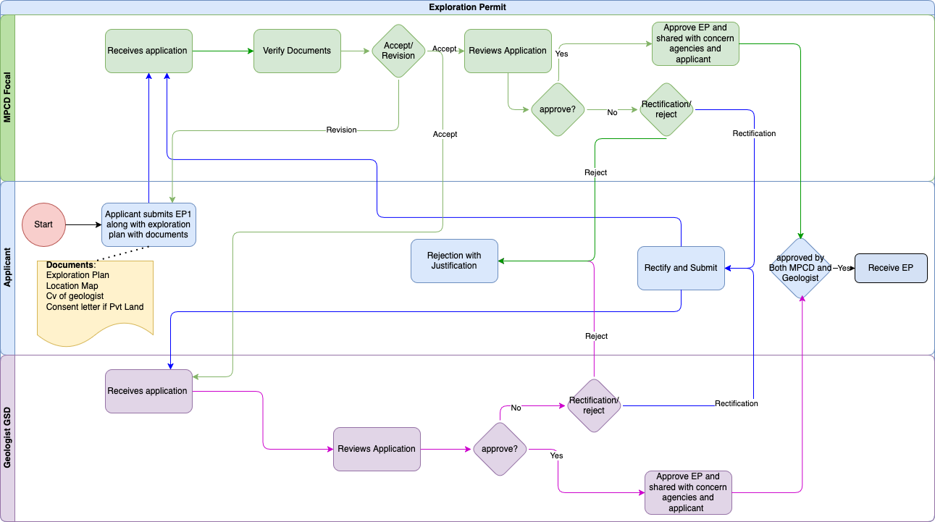

Applicant

Input FORM EP-1 (APPLICATION FOR EXPLORATION PERMIT)
Field Name | Input Type | Validation | Remarks
a. INDIVIDUALS
CID | Auto | Pull from DCRC(for integration)/NDI should be implemented
Mobile Phone | Auto | Pull from DCRC
Email ID | Auto | Pull from DCRC
b. LICENSED FIRMS OR COMPANY
License No. | Auto | Pull from IBLS
Mobile No | Auto | Pull from IBLS
Email ID* | Auto | Pull from IBLS
Save as Draft | Button
Next | Button
SHORT DESCRIPTION OF THE PROPOSED EXPLORATION ACTIVITY
Mineral(s) of interest | Select | Pull from Master
Proposed duration | Text
Source of Finance | Radio Button | Loan /Equity
Technical competence  & experience | Text |  | Optional
Workforce requirement  & recruitment | Text |  | Optional
Land ownership
SRF(acres) | Number
Private(acres) | Number
Total(acres) | Auto | SRF+Private
Save as Draft | button
Next | button
LOCATION OF THE PROPOSED EXPLORATION ACTIVITY
Place | Text
Dungkhag | Select | Pull from Master
Dzongkhag | Select | Pull from Master
Gewog | Select | Pull from Master
Nearest Village | Select | Pull from masters
Attachments
Description of exploration activity(Exploration Proposal) | File | Less than 1MB | Description of area, exploration plan and value addition proposal.
Curriculum Vitae (CV) | File | Less than 1MB | Include certificates of the qualified professionals with a  minimum of Bachelor’s Degree in Geology, and other relevant disciplines OR  persons with a minimum of at least five years of field experience in mineral  exploration validated by relevant authority, to be engaged in the exploration  activity.
Consent letter | File | Less than 1MB | The written consent letter from the private landowner is required if: i. the proposed area falls within private registered lands  ii. the private land falls within 200m radial distance from the proposed  exploration boundary.
Location Map | File | Less than 2MB | KMZ/KML Map
Save as Draft | Button
Submit | Button

Business Flow for Applicant/Leasee

Business Rule
BR No. | Business Rule
 | Users (individuals or companies) authenticate/log in through National Digital Identity (NDI).
 | The system checks eligibility criteria such as valid Tax clearance certificates, security clearance and the number of mining leases in the same household or same company.
 | Only if the above conditions are met, the applicant can proceed next with the application process.
Users submit an EP-1 application and exploration proposal along with the required documents detailed below
- CV
- Value addition
- Consent letters if the area is on private land
- KMZ of the Area proposed
 | Users can revise and resubmit their application as many times as needed based on the feedback provided by the MPCD focal. The resubmission cycle will continue until the application meets the satisfaction of the MPCD focal. Each submission and corresponding review must be tracked, and the application cannot advance to the next stage without approval from the MPCD focal.
 | Users can revise and resubmit their application as many times as needed based on the feedback provided by the Geologist. The resubmission cycle will continue until the application meets the satisfaction of the Geologist. Each submission and corresponding review must be tracked, and the application cannot advance to the next stage without approval from the Geologist/Chief.
 | The user receives an Exploration Permit (EP-2) through the system
 | When the validity of the EP is finished the System will automatically cancel the EP.

Functional Requirement
FR No. | Functional Requirement
 | Integration with NDI for authentication.
 | Dashboard for applicants showing the tasks/applications with status
 | Integration with the DCRC system for household information to check for the number of operational mining leases in the same household. The maximum allowed number is 2.
 | Integration with the Tax system for validating tax clearance certificate
 | Integration with security clearance system, RBP for Security clearance validation
 | Integration with SMS gateway for sending notifications to users at every stage
 | Integration with Esakor system to validate private land
 | Integration with IBLS to check for the number of operational mining leases in the same company. The maximum allowed number is 2.
 | Integration with BIRMS payment gateway for paying application fee
 | The input forms should be properly categorised, with a "Save as Draft" option available in each section.
 | Option to track application status.
 | Option to edit the application when it is in the draft phase.
 | Integration with SMS gateway for sending notifications to users at every stage
 | After obtaining an Exploration Permit, there should be an option to proceed with a mining lease.
 | The system sends an automated reminder to the applicant before the deadline for submitting progress reports.
 | The system captures the initial application, SMS notification, application revision (if any), exploration proposal submission, and timestamp for reporting.

MPCD Officer

Input Field for MPCD Officer
Field Name | Input Type | Validation | Remarks
View details | Button |  | Views the exploration application documents
Accept | Button |  | Accepts if documents are complete
Request for Revision | Button |  | Requests for revision if documents are missing
Approve | Button |  | Approves the exploration application
Comments/Remarks | Text field | Not required
Request for Revision | Button |  | Submits the comments, remarks and prompts the applicant to resubmit the application with Revision
Comments/Remarks | Text field | Required
Reject | Button |  | This closes the loop
Comments/Remarks | Text field | Required

Business logic for MPCD Officer

Business Rule
BR No. | Business Rule
 | Option to log in as an agency user.
 | MPCD chief/ Focals can re-assign the task to another MPCD focal if he/she is busy/on leave.
 | The MPCD focal Officer receives the submitted application and documents.
 | The MPCD focal has to verify the completion of forms and documents before reviewing the proposal. can view the Documents in PDF format.
 | If the application is incomplete, the focal will forward the application with the remarks (for revision).The application will proceed to the next stage only after the focal verifies and approves the revisions.
 | If the application is accepted by the MPCD focal, only then the MPCD focal and the Geologist are permitted to review it.
 | If additional information is required, the focal will forward only the specific sections of the application (input fields or documents) that need further details or changes, along with remarks outlining the necessary updates. The application will proceed to the next stage only after the focal verifies and approves the revisions.
 | If the application is approved by the MPCD, the system will check if the geologist has also approved the exploration application, If approved by both then the Exploration permit will be issued.

Functional Requirement
FR No. | Functional Requirement
 | The system will automatically assign the application to the MPCD focal based on their current workload.
 | The system should have provisions for the chief to assign the system assigned task to another focal if he is of the opinion.
 | The system should be configurable to assign MPCD and GSD focals simultaneously (parallel workflow).
 | Email and system notifications will be sent to the assigned MPCD focal upon assignment of the application.
 | The dashboard for MPCD focal shall display a list of tasks along with their current status. The tasks should be organised by priority and deadline to facilitate efficient management. The dashboard must provide real-time updates on task status, allowing the focal to track progress.
 | Users should be able to filter tasks by status (e.g., pending, in progress, completed) for better visibility.
 | The dashboard should also include visual indicators (e.g., colour codes) to represent different task statuses at a glance.
The system shall provide an option for the focal to review the application form and associated documents before submission.
focal must be able to view all input fields and uploaded documents in a read-only format (downloadable) for verification purposes.
The review option should allow the focal to navigate through each section of the application seamlessly.
A summary of the application, including key information and document names, should be displayed during the review process.
The workload assessment will be determined by predefined metrics, such as the number of pending applications or tasks assigned to each MPCD focal.
The assignment process should ensure that applications are evenly distributed to optimise efficiency and reduce bottlenecks.
 | Integration with Gmail to send email notifications.
 | Option for resubmissions or additional information requests with an option to write remarks.
 | The system captures the application assigned, reassignment, SMS notification and approved (EP) timestamp for TAT calculation and reporting

Geologist

Input Field for Geologist
Field Name | Input Type | Validation | Remarks
View details | Button |  | Views the whole exploration application
Approve | Button |  | Approves the exploration application
Comments/Remarks | Text field | Not required
Request for Revision | Button |  | Submits the comments, remarks and prompts the applicant to resubmit the application with rectification
Comments/Remarks | Text field | Required
Reject | Button |  | This closes the loop
Comments/Remarks | Text field | Required

Business logic for Geologist

Business Rule
BR No. | Business Rule
 | Option to log in as an agency user.
 | The chief geologist/Geologist can re-assign the task to another Geologist if he/she is busy/on leave.
 | The Geologist reviews the submitted Exploration Plan.
 | If additional information is required, the focal will forward only the specific sections of the application (input fields or documents) that need further details or changes, along with remarks outlining the necessary updates. The application will proceed to the next stage only after the focal verifies and approves the revisions.
 | After the focal approves the application , the system will check if the MPCD focal has also been approved. If both approved, then the EP will be sent to the applicant.

Functional Requirement
FR No. | Functional Requirement
 | The system will automatically assign the application to the Geologist based on their current workload.
 | The system should be configurable to assign MPCD and GSD focals simultaneously (parallel workflow).
 | Email and system notifications will be sent to the assigned Geologist upon assignment of the application.
 | The dashboard for Geologists shall display a list of tasks along with their current status. The tasks should be organised by priority and deadline to facilitate efficient management. The dashboard must provide real-time updates on task status, allowing Geologists to track progress.
 | Users should be able to filter tasks by status (e.g., pending, in progress, completed) for better visibility.
 | The dashboard should also include visual indicators (e.g., colour codes) to represent different task statuses at a glance.
The system shall provide an option for the focal to review the application form and associated documents before submission.
focal must be able to view all input fields and uploaded documents in a read-only format for verification purposes.
The review option should allow the focal to navigate through each section of the application seamlessly.
A summary of the application, including key information and document names, should be displayed during the review process.
The workload assessment will be determined by predefined metrics, such as the number of pending applications or tasks assigned to each Geologist.
The assignment process should ensure that applications are evenly distributed to optimise efficiency and reduce bottlenecks.
 | Integration with Gmail to send email notifications.
 | Option for resubmissions or additional information requests with an option to write remarks.
 | The system captures the application assigned, reassignment, SMS notification and approved (exploration permit) timestamp for TAT calculation and reporting

2. LC/Invoice Upload

2.1. Process flow
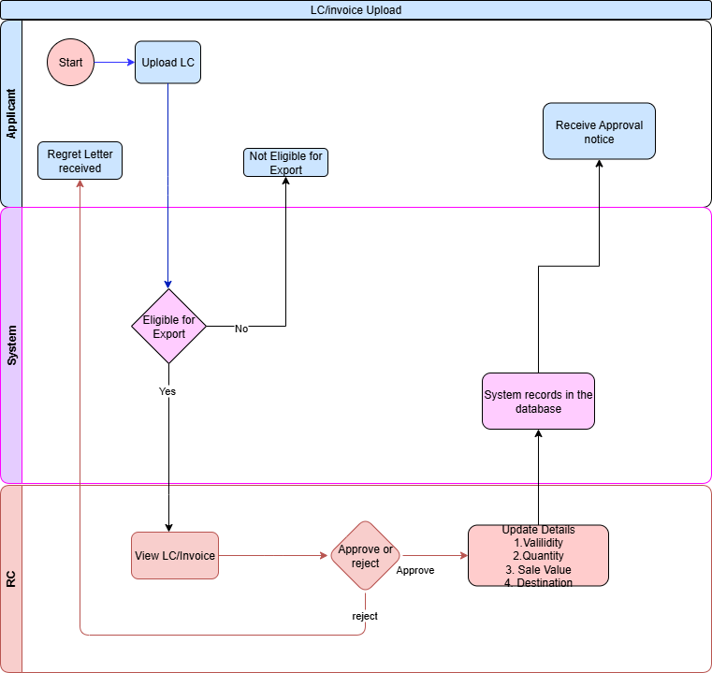

2.2. Applicant

2.2.1 Input Field for Applicant

Field Name | Input Type | Validation | Remarks
Upload LC/Invoice | File | Less than 1 MB | Upload LC for Approval
View Approved LC/Invoices | Button |  | Views the list of approved LCs/Invoices

12.2.2 Business Logic for Applicant

Business Rule
BR No. | Business Rule
Br-1 | The promoter/applicant will login as a user.
Br-2 | The promoter/applicant will then go to TP services Tab and select “Upload LC/Invoice”
Br-3 | If the LC/Invoice is approved/Rejected then the promoter/applicant will receive a notice

Functional Requirement
FR No. | Functional Requirement
FR-1 | System to automatically check if eligible for export from surface collection/Stock lifting/Mines and quarries based on export eligibility logic.
FR-2 | System to keep real time track of LC/Invoice balances.

2.3. Regional Coordinator

2.3.1 Input Field for Regional Coordinator

Field Name | Input Type | Validation | Remarks
View LC/Invoice | Button |  | View the submitted LC/Invoice.
Reject LC | Button
Comments/Remarks | Text | Required | Send remarks for rejection
Validity | Date
Quantity | Number
Rate/MT | Currency |  | This rate will be used for calculation of applicable royalty.
Update LC/Invoice details | Button
Approve LC/Invoice | Button |  | Approve LC/Invoice

2.3.2 Business Logic for Regional Coordinator

Business Rule
BR No. | Business Rule
BR -1 | The RC/MI will login as agency user
BR-2 | For new LC/Invoice, the RC/MI will go to the Transport Permit Services>>LC/Invoice
BR-3 | The RC will check the LC/Invoice and then update the details :  Destination, Quantity, Validity, Sale Value,etc

Functional Requirement
FR No. | Functional Requirement
FR-1 | System to keep track of LC/Invoice Quantity.

Quarrying Lease

Process Flow
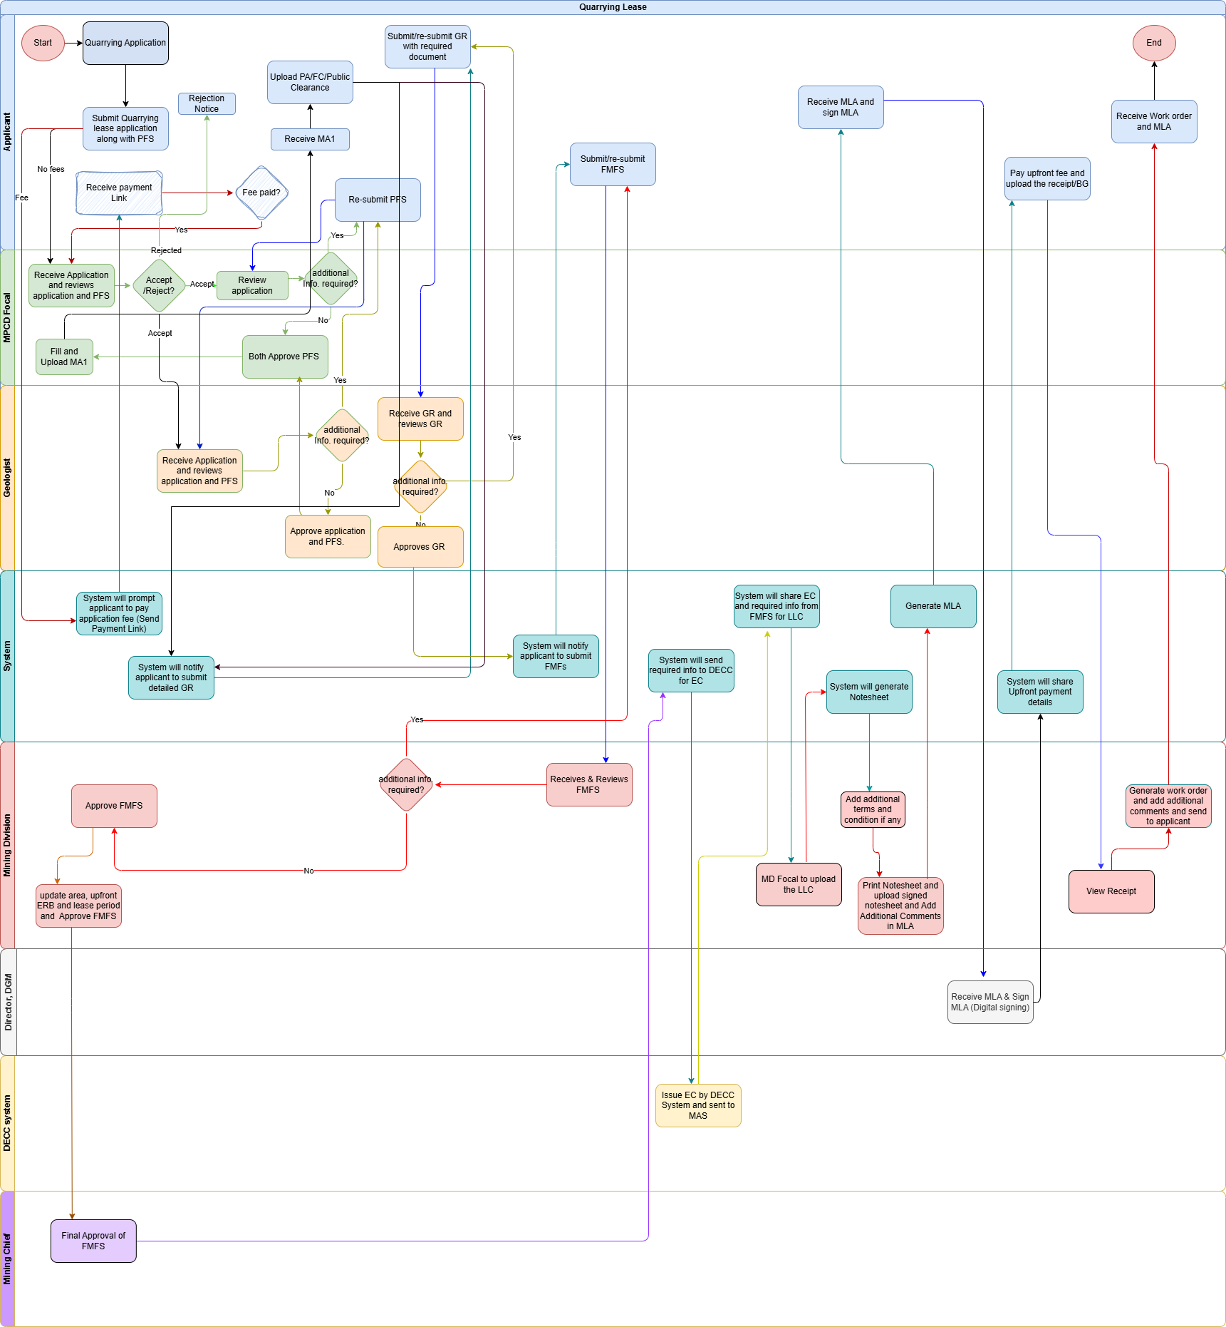

Applicant

Input FORM A (Application of Quarrying Lease)
Field Name | Input Type | Validation | Remarks
a. INDIVIDUALS
CID | Auto | Pull from DCRC(for integration)/NDI should be implemented
Name | Auto | Pull from DCRC
Mobile Phone | Auto | Pull from DCRC
Email ID | Auto | Pull from DCRC
Postal Address | Text |  | Optional
Telephone No | Varchar |  | Optional
b. LICENSED FIRMS OR COMPANY
License No. | Auto | Pull from IBLS
Mobile No | Auto | Pull from IBLS
Email ID | Auto | Pull from IBLS
SHORT DESCRIPTION OF THE PROPOSED MINING ACTIVITY
Type of Mines | Select | Pull from Master
Type of minerals/products | Select | Pull from Master
Required investment | Integer
Source of Finance | Radio Button | Loan / equity
Technical competence  & experience | Text |  | Optional
Workforce requirement  & recruitment | Text
Proposed lease period* | Date
Land ownership
SRF(acres)* | number
Private(acres)* | number
Total(arces)* | Auto | SRF+Private
LOCATION OF THE PROPOSED MINING ACTIVITY
Place* | Text
Dungkhag* | Select | Pull from Master
Dzongkhag* | Select | Pull from Master
Gewog* | Select | Pull from Master
Nearest Village* | Select | Pull from masters
Attachments
Location map with proposed boundary* | File | Less than 2 mb | KMZ / KML file
Description of financial capability with evidences* | File | Less than 1 mb | PDF
Exploration report (Mandatory for captive mines) | File | Less than 5 mb | PDF
Consent letter | File | Less than 1 mb | The written consent letter from the private landowner is required if: i. the proposed area falls within private registered lands  ii. the private land falls within 200m radial distance from the proposed  exploration boundary.
Geological Report | File | Less than 5 mb | PDF
FMFS | file | 5 mb | PDF
Save Draft | Button
Submit | Button

Business logic for Applicant/Leasee

Business Rule
BR No. | Business Rule
 | Users (individuals or companies) authenticate/log in through National Digital Identity (NDI).
 | The system checks eligibility criteria such as valid Tax clearance certificates, security clearance and the number of mining leases in the same household or same company.
 | Only if the above conditions are met, the applicant can proceed next with the application process.
Users submit a Quarrying lease application and Pre Feasibility Study (PFS) along with the required documents detailed below
- Financial statements
- Location Map
- Consent letters if the area is on private land
The system should support both functionalities:
- It can progress directly to the next stage, bypassing the fee payment step.
- It can follow the fee payment process before proceeding.
If fee payment is imposed, an SMS notification will be sent to the user regarding the application fee payment. The application cannot move to the next stage unless the payment process is completed.
 | Users can revise and resubmit their application as many times as needed based on the feedback provided by the MPCD focal. The resubmission cycle will continue until the application meets the satisfaction of the MPCD focal. Each submission and corresponding review must be tracked, and the application cannot advance to the next stage without approval from the MPCD focal.
 | Users can revise and resubmit their GR as many times as needed based on the feedback provided by the Geologist. The resubmission cycle will continue until the application meets the satisfaction of the Geologist. Each submission and corresponding review must be tracked, and the application cannot advance to the next stage without approval from the concerned geologist.
 | Users submits the FMFS as pdf.
 | Users can revise and resubmit their FMFS as many times as needed based on the feedback provided by the ME. The resubmission cycle will continue until the application meets the satisfaction of the ME. Each submission and corresponding review must be tracked, and the application cannot advance to the next stage without approval from the Concerned Mining engineer of the Mining Division..
 | Users will accept the terms and conditions and digitally sign MLA.
 | Users will pay the upfront payment through the payment link.
 | The user receives a work order and the MLA.

Functional Requirement
FR No. | Functional Requirement
 | Integration with NDI for authentication.
 | Dashboard for applicants showing the tasks/applications with status
 | Integration with the DCRC system for household information to check for the number of operational mining leases in the same household. The maximum allowed number is 2.
 | Integration with the Tax system for validating tax clearance certificate
 | Integration with security clearance system, RBP for Security clearance validation
 | Integration with SMS gateway for sending notifications to users at every stage
 | Integration with Esakor system to validate private land
 | Integration with IBLS to check for the number of operational mining leases in the same company. The maximum allowed number is 2.
 | Integration with BIRMS payment gateway for paying application fee
 | Deadline enforcement with automatic application cancellation if deadlines are missed.
 | The input forms should be properly categorised, with a "Save as Draft" option available in each section.
 | Option to track application status.
 | Option to edit the application when it is in the draft phase.
 | Integration with SMS gateway for sending notifications to users at every stage
 | The system captures the initial application, SMS notification, application revision (if any), PFS submission, GR submission, FMFS submission and MLA signing timestamp for reporting.
 | Receives SMS notification to submit Geological report, FMFS, PFS, Payment link etc..
 | Upon signing MLA by the director, system will send payment link for upfront amount (ERB)
 | Once the Upfront amount is paid, the system will generate a work order and send it to the applicant.

MPCD Officer

Input Field for MPCD focal
Field Name | Input Type | Validation | Remarks
View details | Button |  | Views the whole Quarrying application.
Accept Application | Button |  | Accepts the Quarrying application
Request for Revision | Button |  | Submits the comments, remarks and prompts the applicant to resubmit the application or pfs with rectification
Comments/Remarks* | Text |  | Any remarks
Reject | Button |  | This closes the loop
Comments/Remarks* | Text |  | Any remarks
Approve | Button |  | Approves the application and PFS
Comments/Remarks | Text |  | Any remarks
Upload PA* | PDF attachment |  | Field to upload the PA as a PDF.

Business logic for MPCD Officer

Business Rule
BR No. | Business Rule
 | The system will automatically assign the application to the MPCD focal based on their current workload.
 | Email and system notifications will be sent to the assigned MPCD focal upon assignment of the application.
 | MPCD focal/ Chief can re-assign the task to another MPCD focal if he/she is busy/on leave.
 | The MPCD focal Officer reviews the submitted documents and PFS.
 | The MPCD focal can directly reject an application and will send the reasons for the rejection.
 | IF the MPCD focal accepts the application then the process moves forward.
 | If additional information is required, the focal will send a remark which describes what portions needs to be changed. The application will proceed to the next stage only after the focal verifies and approves the revisions.
 | If the application is approved, the MPCD focal will then upload the PA.
 | After PA, the system will send a notification (SMS and system) to the applicant to submit a detailed geological report (GR) with the deadline.

Functional Requirement
FR No. | Functional Requirement
 | Option to log in as an agency user.
 | The dashboard for MPCD focal shall display a list of tasks along with their current status. The tasks should be organised by priority and deadline to facilitate efficient management. The dashboard must provide real-time updates on task status, allowing MPCD to track progress.
 | Users should be able to filter tasks by status (e.g., pending, in progress, completed) for better visibility.
 | The dashboard should also include visual indicators (e.g., colour codes) to represent different task statuses at a glance.
The system shall provide an option for the focal to review the application form and associated documents before submission.
focal must be able to view all input fields and uploaded documents in a read-only format for verification purposes.
The review option should allow the focal to navigate through each section of the application seamlessly.
A summary of the application, including key information and document names, should be displayed during the review process.
 | The MPCD focal should have option to download the PFS.
The workload assessment will be determined by predefined metrics, such as the number of pending applications or tasks assigned to each MPCD focal.
The assignment process should ensure that applications are evenly distributed to optimize efficiency and reduce bottlenecks.
 | Integration with Gmail to send email notifications.
 | Option for resubmissions or additional information requests with an option to write remarks.
 | Workflow to handle MTC decision-making and updates.
 | The system captures the application assigned, reassignment, SMS notification and approved (for PFS and PA) timestamp for TAT calculation and reporting

Geologist

Input field for Geologist
Field Name | Input Type | Validation | Remarks
PFS Review
View details | Button |  | Views the whole Quarrying application with PFS.
Request for Revision | Button |  | Submits the comments, remarks and prompts the applicant to resubmit the application or pfs with rectification
Comments/Remarks* | Text |  | Any remarks
Reject | Button |  | This closes the loop
Comments/Remarks* | Text |  | Any remarks
Approve | Button |  | Approves the application and PFS
Comments/Remarks | Text |  | Any remarks
Geological Report Riview
View details | Button |  | Views the whole GR.
Request for Revision | Button |  | Submits the comments, remarks and prompts the applicant to resubmit the GR with rectification
Comments/Remarks* | Text |  | Any remarks
Reject | Button |  | This closes the loop
Comments/Remarks* | Text |  | Any remarks
Approve | Button |  | Approves the GR
Comments/Remarks | Text |  | Any remarks

Business logic for Geologist

Business Rule
BR No. | Business Rule
 | The system will automatically assign the GR report to the Geologist based on their current workload.
 | Email and system notifications will be sent to the assigned Geologist upon assignment of the application.
 | The geologist/Chief Geologist can re-assign the task to another Geologist if he/she is busy/on leave.
 | The Geologist reviews the submitted Geological report.
 | If additional information is required, the focal will forward only the sections that need further details or changes, along with remarks outlining the necessary updates. The application will proceed to the next stage only after the focal verifies and approves the revisions.

Functional Requirement
FR No. | Functional Requirement
 | Option to log in as an agency user.
 | The dashboard for Geologists shall display a list of tasks along with their current status. The tasks should be organised by priority and deadline to facilitate efficient management. The dashboard must provide real-time updates on task status, allowing Geologists to track progress.
 | Users should be able to filter tasks by status (e.g., pending, in progress, completed) for better visibility.
 | The dashboard should also include visual indicators (e.g., colour codes) to represent different task statuses at a glance.
The system shall provide an option for the focal to review the application form and associated documents before submission.
focal must be able to view all input fields and uploaded documents in a read-only format for verification purposes.
The review option should allow the focal to navigate through each section of the application seamlessly.
A summary of the application, including key information and document names, should be displayed during the review process.
The workload assessment will be determined by predefined metrics, such as the number of pending applications or tasks assigned to each Geologist.
The assignment process should ensure that applications are evenly distributed to optimise efficiency and reduce bottlenecks.
 | Integration with Gmail to send email notifications.
 | The Geologist should have the provision to download the GR.
 | Option for resubmissions or additional information requests with an option to write remarks.
 | The system captures the application assigned, reassignment, SMS notification and approved (for GR) timestamp for TAT calculation and reporting.

Mining Engineer, MD

Input field for Mining Engineer
Field Name | Input Type | Validation | Remarks
View Details | Button |  | Views the whole FMFS.
Request for Revision | Button |  | Submits the comments, remarks and prompts the applicant to resubmit the FMFS with rectification.
Comments/Remarks* | Text field | Required | This text box will take in the remarks either for rejection or for rectification.
Update details
Area | Number |  | Approved Area
Upfront ERB | Currency |  | Approved ERB
Lease Period | Date |  | Approved
Mineral/Material | Select |  | Approved
Approve | Button |  | Approves the FMFS.
Comments/ Remarks | Text field
Land Lease Certificate
Upload LLC | Button |  | Displays page to upload LCC
LLC | File
Upload | Button |  | Upload the LLC.
Notesheet and MLA
Download/Print | Button |  | The MD focal can Download or print the system generated notesheet.
Upload Notesheet | Button |  | Displays page to upload Notesheet
Notesheet | File |  | Upload file
Upload | Button |  | The MD focal to upload the Signed notesheet.
Generate MLA | Button |  | System will generate MLA
Edit MLA | Button |  | The MD focal can edit the MLA
Submit MLA | Button

Business logic for Mining Engineer

Business Rule
BR No. | Business Rule
 | The system will automatically assign the FMFS application to the Mining Engineer (ME) based on their current workload.
 | Email and system notifications will be sent to the assigned ME upon the assignment of the application.
 | The ME/Chief can re-assign the task to another ME if he/she is busy/on leave.
 | The ME reviews the submitted FMFS Report.
 | If additional information is required, the focal will forward only the remarks the necessary updates. The application will proceed to the next stage only after the focal verifies and approves the revisions.
 | The ME will upload the Land Lease Certificate ( LLC) when he obtains it from the DLC.
 | Once the EC and Land Lease Certificate (LLC) are obtained, a note sheet is generated, signed by the Minister, Secretary and Director, and uploaded to the system .
 | The MD focal can generate the MLA and can edit if necessary before sending for signing. proceed for Mine Lease Agreement Signing (MLA).

Functional Requirement
FR No. | Functional Requirement
 | Option to log in as an agency user.
 | The dashboard for ME shall display a list of tasks and their current status. The tasks should be organised by priority and deadline to facilitate efficient management. The dashboard must provide real-time updates on task status, allowing ME to track progress.
 | The ME should be able to filter tasks by status (e.g., pending, in progress, completed) for better visibility.
 | The dashboard should also include visual indicators (e.g., colour codes) to represent different task statuses at a glance.
The system shall provide an option for the focal to review the application form and associated documents before submission.
focal must be able to view all input fields and uploaded documents in a read-only format for verification purposes.
The review option should allow the focal to navigate through each section of the application seamlessly.
A summary of the application, including key information and document names, should be displayed during the review process.
The workload assessment will be determined by predefined metrics, such as the number of pending applications or tasks assigned to each Geologist.
The assignment process should ensure that applications are evenly distributed to optimise efficiency and reduce bottlenecks.
 | Integration with Gmail to send email notifications.
 | Option for resubmissions or additional information requests with an option to write remarks.
After FMFS approval by chief MD, the system sends the necessary information( Approved FMFS) to the DECC system and applies for an Environmental Clearance (EC).
EC must be obtained before the lease process proceeds.
Integration with DECC system.
 | After EC approval, the system will send the approved EC and FMFS to the Mining Focal. The Mining Focal will then upload the LLC
 | The System will send MLA to the applicant for signing.
 | Lease agreement generation and digital signature integration.
 | Note sheet template generation and approval workflows.
 | The system issues work orders/approval after payment is made.
 | The system captures the application assigned, reassignment, SMS notification and approved (for FMFS and EC) timestamp for TAT calculation and reporting

Mining Chief

Input Field for Mining Chief

Field Name | Input Type | Validation | Remarks
View FMFS | Button |  | Views the whole FMFS.
Approve FMFS | Button |  | Will Approve the FMFS.
Comments/Remarks | Text field

Business Logic for Mining Chief

Business Rule
BR No. | Business Rule
 | The Mining Chief will receive FMFS from the Mining Focal for the final approval.
 | The Mining Chief approves the FMFS and then only the process can move forward.

Director, DGM

Input field for Director
Field Name | Input Type | Validation | Remarks
View MLA Details | Button |  | Views the whole MLA .
Approve and Sign | Button |  | Will E-sign the MLA.

Business logic for Director

Business Rule
BR No. | Business Rule
 | The Director DGM receives MLA and digitally signs MLA

Functional Requirement
FR No. | Functional Requirement
 | Option to log in as an agency user.
 | The Dashboard for the Director shall display all sorts of reports and tasks in graphical representation as well as in report format.
 | The dashboard for Director shall display a list of tasks for MLA signing. The tasks should be organised by priority and deadline to facilitate efficient management.
 | Users should be able to filter tasks by status (e.g., pending, in progress, completed) for better visibility.
The system shall provide an option for the Director to review the application form and associated documents before submission.
The Director must be able to view all input fields and uploaded documents in a read-only format for verification purposes.
 | system to send email notifications.

Mining Lease

Process Flow
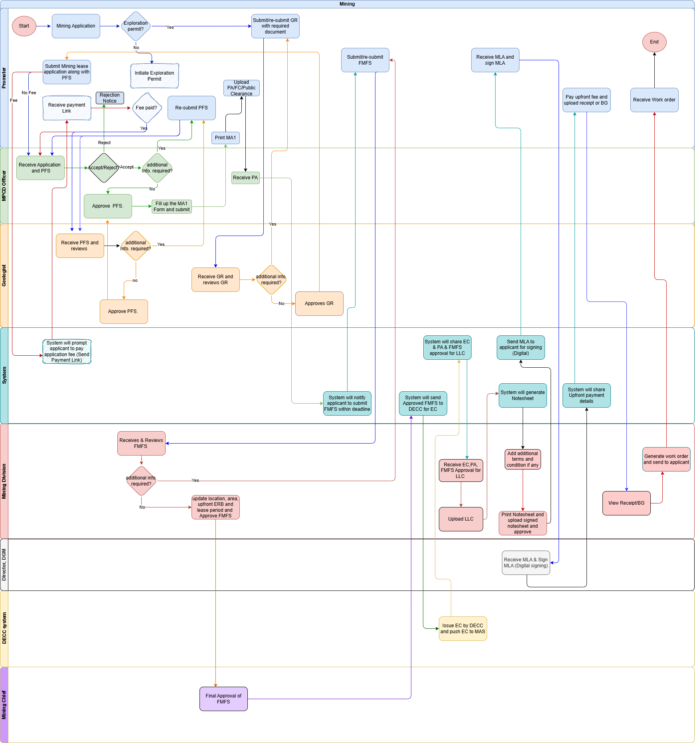

Applicant

Input FORM A (Application of Mining Lease)
Field Name | Input Type | Validation | Remarks
a. INDIVIDUALS
CID* | Auto | Pull from DCRC(for integration)/NDI should be implemented
Name | Auto | Pull from DCRC
Mobile Phone* | Number
Email ID | email
b. LICENSED FIRMS OR COMPANY
License No.* | Auto | Pull from IBLS/G2C
Mobile No* | Number | Pull from IBLS/G2C
Email ID | email
SHORT DESCRIPTION OF THE PROPOSED MINING ACTIVITY
Type of Mines | Select | Pull from Master
Type of minerals/products* | Select | Pull from Master
Required investment | Integer
Source of Finance | Radio Button | Loan / equity
Technical competence  & experience | File |  | Optional
Workforce requirement  & recruitment | Text
Proposed lease period* | Text
Land ownership
SRF(acres)* | number
Private(acres)* | number
Total(arces)* | Auto | SRF+Private
LOCATION OF THE PROPOSED MINING ACTIVITY
Place* | Text
Dzongkhag* | Select | Pull from Master
Gewog* | Select | Pull from Master
Nearest Village* | Select | Pull from masters
Attachments
Location map with proposed boundary* | File |  | KMZ/KML
Description of financial capability with evidences* | File
Exploration report (Mandatory for captive mines) | File
Consent letter | File |  | The written consent letter from the private landowner is required if: i. the proposed area falls within private registered lands  ii. the private land falls within 200m radial distance from the proposed  exploration boundary.
Save Draft | Button
Submit | Button

Business logic for Applicant/Leasee

Business Rule
BR No. | Business Rule
 | Users (individuals or companies) authenticate/log in through National Digital Identity (NDI).
 | The systems asks if the applicant has an exploration permit for the same.If not then the system will initiate the exploration permit process.If the applicant selects “yes” then the system will prompt the applicant to upload the GR. Then the process continues in the same mining process.
 | Users can revise and resubmit their GR as many times as needed based on the feedback provided by the Geologist. The resubmission cycle will continue until the application meets the satisfaction of the Geologist. Each submission and corresponding review must be tracked, and the application cannot advance to the next stage without approval from the concerned geologist.
Users submit mining lease application and Pre Feasibility Study (PFS) along with the required documents detailed below
- Financial statements
- Location Map
- Consent letters if the area is on private land
The system should support both functionalities:
- It can progress directly to the next stage, bypassing the fee payment step.
- It can follow the fee payment process before proceeding.
If fee payment is imposed, an SMS notification will be sent to the user regarding the application fee payment. The application cannot move to the next stage unless the payment process is completed.
 | Users can revise and resubmit their application as many times as needed based on the feedback provided by the MPCD focal. The resubmission cycle will continue until the application meets the satisfaction of the MPCD focal. Each submission and corresponding review must be tracked, and the application cannot advance to the next stage without approval from the MPCD focal.
 | Users submits the FMFS as pdf
 | Users can revise and resubmit their FMFS as many times as needed based on the feedback provided by the ME. The resubmission cycle will continue until the application meets the satisfaction of the ME. Each submission and corresponding review must be tracked, and the application cannot advance to the next stage without approval from the Concerned Mining engineer of the Mining Division..
 | Users will accept the terms and conditions and digitally sign MLA.
 | Users will pay the upfront payment through the payment link.
 | The user receives a work order and the MLA.

Functional Requirement
FR No. | Functional Requirement
 | Integration with NDI for authentication.
 | Dashboard for applicants showing the tasks/applications with status
 | Integration with BIRMS payment gateway for paying application fee
 | Deadline enforcement with automatic application cancellation if deadlines are missed.
 | The input forms should be properly categorised, with a "Save as Draft" option available in each section.
 | Option to track application status.
 | Option to edit the application when it is in the draft phase.
 | Integration with SMS gateway for sending notifications to users at every stage
 | The system captures the initial application, SMS notification, application revision (if any), PFS submission, GR submission, FMFS submission and MLA signing timestamp for reporting.
 | Receives SMS notification to submit Geological report, FMFS, PFS, Payment link etc..
 | Upon signing MLA by the director, system will send payment link for upfront amount (ERB)
 | Once the Upfront amount is paid, the system will send the payment receipt to the Mining focal and also generate a work order and send it to applicant.

MPCD Officer

Input Field for MPCD focal
Field Name | Input Type | Validation | Remarks
View details | Button |  | Views the whole Quarrying application.
Comments/Remarks* | Text field | Required | This text box will take in the remarks either for rejection or for rectification
Request for Revision | Button |  | Submits the comments, remarks and prompts the applicant to resubmit the application or pfs with rectification
Reject | Button |  | This closes the loop
Comments/Remarks* | Text field | Required
Approve | Button |  | Approves the application and PFS
Comments/Remarks | Text field | Not Required
Upload PA | PDF attachment |  | Field to upload the PA as a PDF.
Submit | Button |  | Submits PA

Business logic for MPCD Officer

Business Rule
BR No. | Business Rule
 | The system will automatically assign the application to the MPCD focal based on their current workload.
 | Email and system notifications will be sent to the assigned MPCD focal upon assignment of the application.
 | MPCD focal/chief can re-assign the task to another MPCD focal if he/she is busy/on leave.
 | The MPCD focal Officer reviews the submitted documents and PFS.
 | The MPCD focal can directly reject an application and will send the reasons for the rejection.
 | IF the MPCD focal accepts the application then the process moves forward.
 | If additional information is required, the focal will send a remark which describes what portions needs to be changed. The application will proceed to the next stage only after the focal verifies and approves the revisions.
 | If the application is approved, the MPCD focal will then upload the PA.
 | After PA, the system will send a notification (SMS and system) to the applicant to submit a detailed FMFS with the deadline.

Functional Requirement
FR No. | Functional Requirement
 | Option to log in as an agency user.
 | The dashboard for MPCD focal shall display a list of tasks along with their current status. The tasks should be organised by priority and deadline to facilitate efficient management. The dashboard must provide real-time updates on task status, allowing MPCD to track progress.
 | Users should be able to filter tasks by status (e.g., pending, in progress, completed) for better visibility.
 | The dashboard should also include visual indicators (e.g., colour codes) to represent different task statuses at a glance.
The system shall provide an option for the focal to review the application form and associated documents before submission.
focal must be able to view all input fields and uploaded documents in a read-only format for verification purposes.
The review option should allow the focal to navigate through each section of the application seamlessly.
A summary of the application, including key information and document names, should be displayed during the review process.
 | The MPCD focal should have option to download the PFS.
The workload assessment will be determined by predefined metrics, such as the number of pending applications or tasks assigned to each MPCD focal.
The assignment process should ensure that applications are evenly distributed to optimise efficiency and reduce bottlenecks.
 | Integration with Gmail to send email notifications.
 | Option for resubmissions or additional information requests with an option to write remarks.
 | Workflow to handle MTC decision-making and updates.
 | The system captures the application assigned, reassignment, SMS notification and approved (for PFS and PA) timestamp for TAT calculation and reporting

Geologist

Input field for Geologist

Field Name | Input Type | Validation | Remarks
PFS Report
View Details | Button |  | Views the whole Quarrying application and the PFS
Comments/Remarks* | Text field | Required | This text box will take in the remarks either for rejection or for rectification
Request for Revision | Button |  | Submits the comments, remarks and prompts the applicant to resubmit the application with rectification.
Approve | Button |  | Approves the PFS
Comments/Remarks | Text field | Required
Review Geological Report
View GR | Button |  | Views the GR
Request for Revision | Button |  | Submits the comments, remarks and prompts the applicant to resubmit the GR with rectification.
Comments/remarks* | Text field | Required
Approve GR | Button |  | Approves the GR.
Comments/remarks | Text Field

Business logic for Geologist

Business Rule
BR No. | Business Rule
 | The system will automatically assign the GR report to the Geologist based on their current workload.
 | Email and system notifications will be sent to the assigned Geologist upon assignment of the application.
 | The geologist/Chief can re-assign the task to another Geologist if he/she is busy/on leave.
 | The Geologist reviews the submitted Geological report.
 | If additional information is required, the focal will forward only the sections that need further details or changes, along with remarks outlining the necessary updates. The application will proceed to the next stage only after the focal verifies and approves the revisions.
 | The Geologist reviews the submitted Application and PFS.
 | If additional information is required, the focal will forward only the sections that need further details or changes, along with remarks outlining the necessary updates. The application will proceed to the next stage only after the focal verifies and approves the revisions.

Functional Requirement
FR No. | Functional Requirement
 | Option to log in as an agency user.
 | The dashboard for Geologists shall display a list of tasks along with their current status. The tasks should be organised by priority and deadline to facilitate efficient management. The dashboard must provide real-time updates on task status, allowing Geologists to track progress.
 | Users should be able to filter tasks by status (e.g., pending, in progress, completed) for better visibility.
 | The dashboard should also include visual indicators (e.g., colour codes) to represent different task statuses at a glance.
The system shall provide an option for the focal to review the application form and associated documents before submission.
focal must be able to view all input fields and uploaded documents in a read-only format for verification purposes.
The review option should allow the focal to navigate through each section of the application seamlessly.
A summary of the application, including key information and document names, should be displayed during the review process.
The workload assessment will be determined by predefined metrics, such as the number of pending applications or tasks assigned to each Geologist.
The assignment process should ensure that applications are evenly distributed to optimise efficiency and reduce bottlenecks.
 | Integration with Gmail to send email notifications.
 | The Geologist should have the provision to download the GR.
 | Option for resubmissions or additional information requests with an option to write remarks.
 | The system captures the application assigned, reassignment, SMS notification and approved (for GR) timestamp for TAT calculation and reporting.

Mining Engineer, MD

Input field for Mining Engineer
Field Name | Input Type | Validation | Remarks
View Details | Button |  | Views the whole FMFS.
Request for Revision | Button |  | Submits the comments, remarks and prompts the applicant to resubmit the FMFS with rectification.
Comments/Remarks* | Text field | Required | This text box will take in the remarks either for rejection or for rectification.
Update details
Area | Number |  | Approved Area
Upfront ERB | Currency |  | Approved ERB
Lease Period | Date |  | Approved
Mineral/Material | Select |  | Approved
Approve | Button |  | Approves the FMFS.
Comments/ Remarks | Text field
Land Lease Certificate
Upload LLC | Button |  | Displays page to upload LCC
LLC | File
Upload | Button |  | Upload the LLC.
Notesheet and MLA
Download/Print | Button |  | The MD focal can Download or print the system generated notesheet.
Upload Notesheet | Button |  | Displays page to upload Notesheet
Notesheet | File |  | Upload file
Upload | Button |  | The MD focal to upload the Signed notesheet.
Generate MLA | Button |  | System will generate MLA
Edit MLA | Button |  | The MD focal can edit the MLA
Submit MLA | Button

Business logic for Mining Engineer

Business Rule
BR No. | Business Rule
 | The system will automatically assign the FMFS application to the Mining Engineer (ME) based on their current workload.
 | Email and system notifications will be sent to the assigned ME upon the assignment of the application.
 | The ME/Chief can re-assign the task to another ME if he/she is busy/on leave.
 | The ME reviews the submitted FMFS Report.
 | If additional information is required, the focal will forward only the remarks and the necessary updates. The application will proceed to the next stage only after the focal verifies and approves the revisions.
 | The ME will upload the Land Lease Certificate ( LLC) when he obtains it from the DLC.
 | Once the EC and Land Lease Certificate (LLC) are obtained, a note sheet is generated, signed by the Minister, Secretary and Director, and uploaded to the system and proceed for Mine Lease Agreement Signing (MLA).
 | The SMS will be sent to a user for the payment of the ERB.

Functional Requirement
FR No. | Functional Requirement
 | Option to log in as an agency user.
 | The dashboard for ME shall display a list of tasks and their current status. The tasks should be organised by priority and deadline to facilitate efficient management. The dashboard must provide real-time updates on task status, allowing ME to track progress.
 | The ME should be able to filter tasks by status (e.g., pending, in progress, completed) for better visibility.
 | The dashboard should also include visual indicators (e.g., colour codes) to represent different task statuses at a glance.
The system shall provide an option for the focal to review the application form and associated documents before submission.
focal must be able to view all input fields and uploaded documents in a read-only format for verification purposes.
The review option should allow the focal to navigate through each section of the application seamlessly.
A summary of the application, including key information and document names, should be displayed during the review process.
The workload assessment will be determined by predefined metrics, such as the number of pending applications or tasks assigned to each Geologist.
The assignment process should ensure that applications are evenly distributed to optimise efficiency and reduce bottlenecks.
 | Integration with Gmail to send email notifications.
 | Option for resubmissions or additional information requests with an option to write remarks.
After FMFS approval, the system sends the necessary information to the DECC system and applies for an Environmental Clearance (EC).
EC must be obtained before the lease process proceeds.
Integration with DECC system.
After EC approval, the system will pull EC and send EC along with FMFS to NLCS for a Land Lease Certificate (LLC).
Integration with the NLCS system.
 | The System will send MLA to the applicant for signing.
 | Lease agreement generation and digital signature integration.
 | Note sheet template generation and approval workflows.
 | The system issues work orders/approval after payment is made.
 | The system captures the application assigned, reassignment, SMS notification and approved (for FMFS and EC) timestamp for TAT calculation and reporting

Mining Chief

Input Field for Mining Chief
Field Name | Input Type | Validation | Remarks
View FMFS | Button |  | Views the whole FMFS.
Approve FMFS | Button |  | Will Approve the FMFS.
Comments/Remarks | Text field

Business Logic for Mining Chief

Business Rule
BR No. | Business Rule
 | The Mining Chief will receive FMFS from the Mining Focal for the final approval.
 | The Mining Chief approves the FMFS and then only the process can move forward.

Director, DGM

Input field for Director
Field Name | Input Type | Validation | Remarks
Check MLA Details | Button |  | Views the whole MLA .
Approve and Sign the MLA | Button |  | Will E-sign the MLA.

Business logic for Director

Business Rule
BR No. | Business Rule
 | The Director DGM receives MLA and digitally signs MLA

Functional Requirement
FR No. | Functional Requirement
 | Option to log in as an agency user.
 | The Dashboard for the Director shall display all sorts of reports and tasks in graphical representation as well as in report format.
 | The dashboard for Director shall display a list of tasks for MLA signing. The tasks should be organised by priority and deadline to facilitate efficient management.
 | Users should be able to filter tasks by status (e.g., pending, in progress, completed) for better visibility.
The system shall provide an option for the Director to review the application form and associated documents before submission.
The Director must be able to view all input fields and uploaded documents in a read-only format for verification purposes.
 | system to send email notifications.

Renewal of Lease

Process Flow
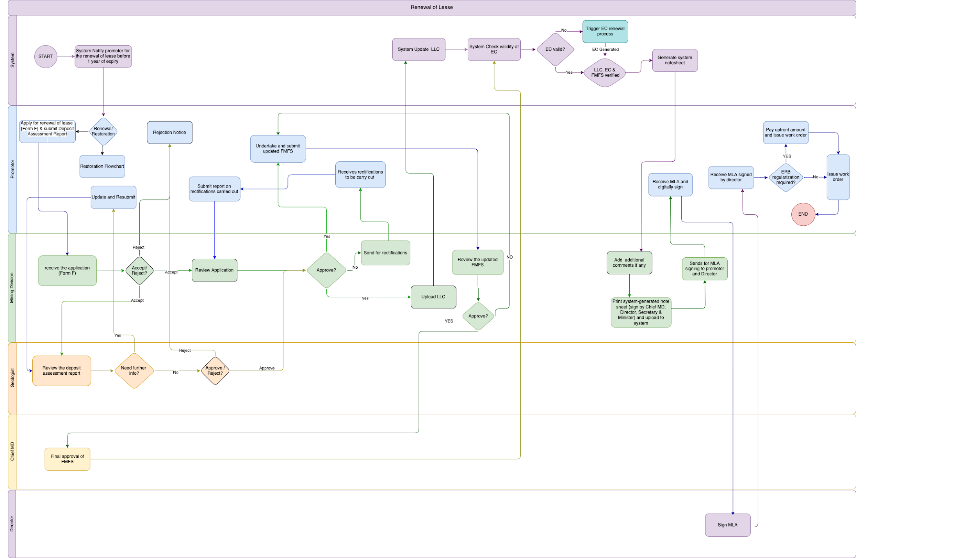

Applicant

Input FORM F (Application for Renewal of Mining Lease)
Field Name | Input Type | Validation | Remarks
a. Applicant details
Lessee | Auto | Pulled from DB
Mobile Phone | Auto/Number | Pulled from DB | Can edit/Update number
Email ID | Auto/email | Pulled from DB | Can edit/Update Email Id
Postal Address | Auto | Pulled from DB
Telephone No | Auto | Pulled from DB
SHORT DESCRIPTION OF THE MINE LEASE
Name of the Mine | Auto | Pull from DB
Duration | Auto | Pull from DB
Expiry Date | Auto | Pull from DB
Proposed lease renewal period | Auto | Pull from DB
Mineral use | Auto | Pull from DB
LOCATION OF THE MINE
Place | Auto | Pull from DB
Nearest Village | Auto | Pull from DB
Gewog | Auto | Pull from DB
Dungkhag | Auto | Pull from DB
Dzongkhag | Auto | Pull from DB
Deposit Assessment Report | File | BLOB
Declaration | Checkbox |  | I hereby declare that the information provided herewith are true to the best of my knowledge and in the event of false or misleading information, I shall be liable for any action under the Mines and Minerals Management Act and Regulations thereof.
Save Draft | Button
Submit | Button

Business Logic for Applicant/Leasee

Business Rule
BR No. | Business Rule
 | Promoter (individuals or companies) authenticate/log in through National Digital Identity (NDI).
 | The applicant will initiate the renewal process 1 year before the lease expiry.
Applicants with a performance score below average are not eligible for mining lease renewal.
All renewal applications require valid tax clearance and a Deposit Assessment Report.
 | The system will automatically validate the performance score and check the validity of the Tax Clearance Certificate. The promoter can proceed to submit the application only if these eligibility criteria are successfully met.
 | Applicants must submit application Form F and Deposit Assessment Report for renewal.
 | The system will automatically assign the application to the Mining Engineer and the DAR (Development Approval Request) to the Geologist.
 | Users can revise and resubmit their application as many times as needed based on the feedback provided by the ME focal. The resubmission cycle will continue until the application meets the satisfaction of the ME focal. Each submission and corresponding review must be tracked, and the application cannot advance to the next stage without approval from the MPCD focal.
 | Users can revise and resubmit their DRA as many times as needed based on the feedback provided by the Geologist. The resubmission cycle will continue until the application meets the satisfaction of the Geologist. Each submission and corresponding review must be tracked, and the application cannot advance to the next stage without approval.
 | Users fill out the FMFS form and submit it.
 | Users can revise and resubmit their FMFS as many times as needed based on the feedback provided by the ME. The resubmission cycle will continue until the application meets the satisfaction of the ME. Each submission and corresponding review must be tracked, and the application cannot advance to the next stage without approval from the Chief, MD.
 | Users will accept the terms and conditions and digitally sign MLA.
 | Users will pay the upfront payment through the payment link.
 | The system will issue a work order to the user once the payment is successfully cleared.

Functional Requirement
FR No. | Functional Requirement
 | Integration with NDI for authentication.
 | Dashboard for applicants showing the tasks/applications with status
 | Integration with BIRMS payment gateway for paying application fee
 | Notify applicants one year before lease expiry with instructions for the renewal process.
 | Provide an interface for applicants to submit Form F along with the required documents.
 | The system will retrieve the promoter's performance score from the database and verify if it meets the predefined eligibility threshold (score should be above average). If the score falls below the average, an error message will be displayed, preventing further progress.
 | The system will validate the promoter's Tax Clearance Certificate by integrating with the RAMIS system to ensure it is valid on the application date. If the certificate is invalid or expired, the user will receive a error message. Eligibility confirmation will depend on meeting both the Tax Clearance and performance score criteria.
 | Deadline enforcement with automatic application cancellation if deadlines are missed.
 | The input forms should be properly categorised, with a "Save as Draft" option available in each section.
 | Option to track application status.
 | Option to edit the application when it is in the draft phase.
 | Integration with SMS gateway for sending notifications to users at every stage
 | The system captures the initial application, SMS notification, application revision (if any), DRA submission, FMFS submission and MLA signing timestamp for reporting.
 | The system will retrieve the applicant's digital signature from their profile if it was uploaded during onboarding; otherwise, it will prompt the applicant to upload their digital signature after acquiring lease approval and before proceeding to the next stage of the application.
Generate note sheets and support offline signing by stakeholders.
Enable digital signing of the MLA by both the applicant and the Director.
 | Receives SMS notification to submit DAR report, FMFS, Payment link etc..
Check for outstanding 2013 upfront payments or ERB regularization.
Facilitate payment processing and proceed to work order issuance based on payment status.
 | Once the Upfront amount is paid, the system will generate a work order and send it to applicant.

Mining Engineer, MD

Input field for Mining Division

Field Name | Input Type | Validation | Remarks
Review Lease renewal | Button |  | Opens and checks the whole renewal application.
Accept renewal | Button |  | Accepts the renewal application.
Reject application | Button |  | Rejects the application with remarks.
Remarks | Text Field |  | The remarks to either accept or reject.
Approve application | Button |  | Approves the Renewal application
Send comments | Text field |  | Send the comments for rectification of renewal application.
Upload LLC |  |  | For the MD focal to upload the LLC.
Review FMFS | Button |  | Views the FMFS
Comments FMFS | Button |  | Send the comments for rectification of FMFS.
Approve FMFS | Button |  | Approves FMFS.
Print Notesheet | Button |  | Prints System generated notesheet
Upload Notesheet | Button |  | Uploads signed notesheet.
Send MLA for signing | Button |  | Sends MLA for signing.

Business logic for Mining Engineer

Business Rule
BR No. | Business Rule
 | The system will automatically assign the application to the Mining Engineer (ME) based on their current workload.
 | Email and system notifications will be sent to the assigned ME upon the assignment of the application.
 | The ME can re-assign the task to another ME if he/she is busy/on leave.
 | The ME reviews the submitted application Report.
 | The ME can directly reject a renewal application.
 | If additional information is required, the focal will forward only the specific sections of the application (input fields or documents) that need further details or changes, along with remarks outlining the necessary updates. The application will proceed to the next stage only after the focal verifies and approves the revisions.
 | Once the application and DAR are approved, the MD focal will upload the LLC. The Process can continue even if the LLC is not uploaded.
 | ME will review the updated FMFS report. If additional information is required, the ME will forward only the relevant sections of the application (input fields or documents) that need further details or changes, along with remarks specifying the necessary updates. The application will proceed to the next stage only after the focal point verifies and approves the revisions.
 | Once the FMFS is accepted by the ME, the updated FMFS will be submitted to the Chief, MD for final approval.
 | Once the Environmental Clearance (EC), updated FMFS, and Land Lease Certificate (LLC) are obtained, the system will automatically generate the notesheet. The Mining Engineer (ME) will print the notesheet, have it signed by the Chief, Director, Secretary, and Minister, then upload the signed notesheet to the system. Subsequently, the system will proceed with the Mining Lease Agreement (MLA) process by sending the MLA to the Director and the Promoter for signing.
ME will verify whether the 2013 upfront amount and ERB regularization are required:
- If required, prompt payment before issuing the work order.
- If not required, proceed with the work order issuance.

Functional Requirement
FR No. | Functional Requirement
 | Option to log in as an agency user.
 | The dashboard for ME shall display a list of tasks and their current status. The tasks should be organised by priority and deadline to facilitate efficient management. The dashboard must provide real-time updates on task status, allowing ME to track progress.
 | The ME should be able to filter tasks by status (e.g., pending, in progress, completed) for better visibility.
 | The dashboard should also include visual indicators (e.g., colour codes) to represent different task statuses at a glance.
The system shall provide an option for the focal to review the application form and associated documents before submission.
focal must be able to view all input fields and uploaded documents in a read-only format for verification purposes.
The review option should allow the focal to navigate through each section of the application seamlessly.
A summary of the application, including key information and document names, should be displayed during the review process.
The workload assessment will be determined by predefined metrics, such as the number of pending applications or tasks assigned to each ME.
The assignment process should ensure that applications are evenly distributed to optimise efficiency and reduce bottlenecks.
 | Integration with Gmail to send email notifications.
 | Option for resubmissions or additional information requests with an option to write remarks.
 | The System will send MLA to the applicant for signing.
 | Lease agreement generation and digital signature integration.
 | Note sheet template generation and approval workflows.
 | The system issues work orders/approval after payment is made.
 | The system captures the application assigned, reassignment, SMS notification and approved (for FMFS and EC) timestamp for TAT calculation and reporting

Geologist

Input field for Geologist

Field Name | Input Type | Validation | Remarks
Review Deposit reassessment report | Button |  | Opens and checks the whole Reassessment report.
Send comments | Button/text field |  | Sends comments for rectification and resubmission of Reassessment report.
Approve | Button |  | Approves the Reassessment report.

Business logic for Geologist

Business Rule
BR No. | Business Rule
 | The system will automatically assign the Deposit Assessment Report (DAR) to the Geologist (ME) based on their current workload.
 | Email and system notifications will be sent to the assigned Geologist upon the assignment of the application.
 | The Geologist/Chief can re-assign the task to another Geologist if he/she is busy/on leave.
 | The Geologist reviews the submitted DAR.
 | If additional information is required, the focal will forward only the specific sections of the application (input fields or documents) that need further details or changes, along with remarks outlining the necessary updates. The application will proceed to the next stage only after the focal verifies and approves the revisions.
 | The geologist will review and approve the DAR and the process moves forward.

Functional Requirement
FR No. | Functional Requirement
 | Option to log in as an agency user.
 | The dashboard for GSD head and Focal Geologists shall display a list of tasks along with their current status. The tasks should be organised by priority and deadline to facilitate efficient management. The dashboard must provide real-time updates on task status, allowing Geologists to track progress.
 | Users should be able to filter tasks by status (e.g., pending, in progress, completed) for better visibility.
 | The dashboard should also include visual indicators (e.g., colour codes) to represent different task statuses at a glance.
The system shall provide an option for the focal to review the application form and associated documents before submission.
focal must be able to view all input fields and uploaded documents in a read-only format for verification purposes.
The review option should allow the focal to navigate through each section of the application seamlessly.
A summary of the application, including key information and document names, should be displayed during the review process.
The workload assessment will be determined by predefined metrics, such as the number of pending applications or tasks assigned to each Geologist.
The assignment process should ensure that applications are evenly distributed to optimise efficiency and reduce bottlenecks.
 | Integration with Gmail to send email notifications.
 | Option for resubmissions or additional information requests with an option to write remarks.
 | The system captures the application assigned, reassignment, SMS notification and approved (for DAR) timestamp for TAT calculation and reporting

Chief, MD

Input field for Chief, MD
Field Name | Input Type | Validation | Remarks
Review Lease renewal | Button |  | Opens and checks the whole renewal application.
Approve FMFS | Button |  | Approve FMFS

Business logic for Chief, MD

Business Rule
BR No. | Business Rule
 | The chief receives the updated and accepted FMFS.
 | The chief reviews the submitted FMFS with recommendations/remarks by focal ME.
 | If additional information is required, the Chief will forward only the specific sections of the application (input fields or documents) that need further details or changes, along with remarks outlining the necessary updates. The application will proceed to the next stage only after the Chief verifies and approves the revisions.
 | The Chief reviews and provides final endorsement after the FMFS is verified.
After FMFS approval, the system sends the necessary information to the DECC system and applies for an Environmental Clearance (EC).
EC must be obtained before the lease process proceeds.

Functional Requirement
FR No. | Functional Requirement
 | Option to log in as an agency user.
 | The dashboard for GSD headChief Geologists shall display a list of tasks for approval. The tasks should be organised by priority and deadline to facilitate efficient management.
 | Users should be able to filter tasks by status (e.g., pending, in progress, completed) for better visibility.
The system shall provide an option for the GSD headChief to review the application form and associated documents before submission.
The chief must be able to view all input fields and uploaded documents in a read-only format for verification purposes.
The review option should allow the Focal to navigate through each section of the application seamlessly.
A summary of the application, including key information and document names, should be displayed during the review process.
 | system to send email notifications.
 | Option for resubmissions or additional information requests with an option to write remarks.
 | The system captures the application, revision and approval timestamp for TAT calculation and reporting
After FMFS approval, the system sends the necessary information to the DECC system and applies for an Environmental Clearance (EC).
EC must be obtained before the lease process proceeds.
Integration with DECC system.
 | After EC approval, the system will pull EC and send EC along with FMFS to MD focal for a Land Lease Certificate (LLC).

Director, DGM

Input field for Director

Field Name | Input Type | Validation | Remarks
Check MLA Details | Button |  | Views the whole MLA .
Approve and Sign the MLA | Button |  | Will E-sign the MLA.

Business logic for Director

Business Rule
BR No. | Business Rule
 | The Director DGM receives MLA and digitally signs MLA

Functional Requirement
FR No. | Functional Requirement
 | Option to log in as an agency user.
 | The Dashboard for the Director shall display all sorts of reports and tasks in graphical representation as well as in report format.
 | The dashboard for Director shall display a list of tasks for MLA signing. The tasks should be organised by priority and deadline to facilitate efficient management.
 | Users should be able to filter tasks by status (e.g., pending, in progress, completed) for better visibility.
The system shall provide an option for the Director to review the application form and associated documents before submission.
The Director must be able to view all input fields and uploaded documents in a read-only format for verification purposes.
 | system to send email notifications.

Renewal of Environment Clearance (EC)

Process Flow

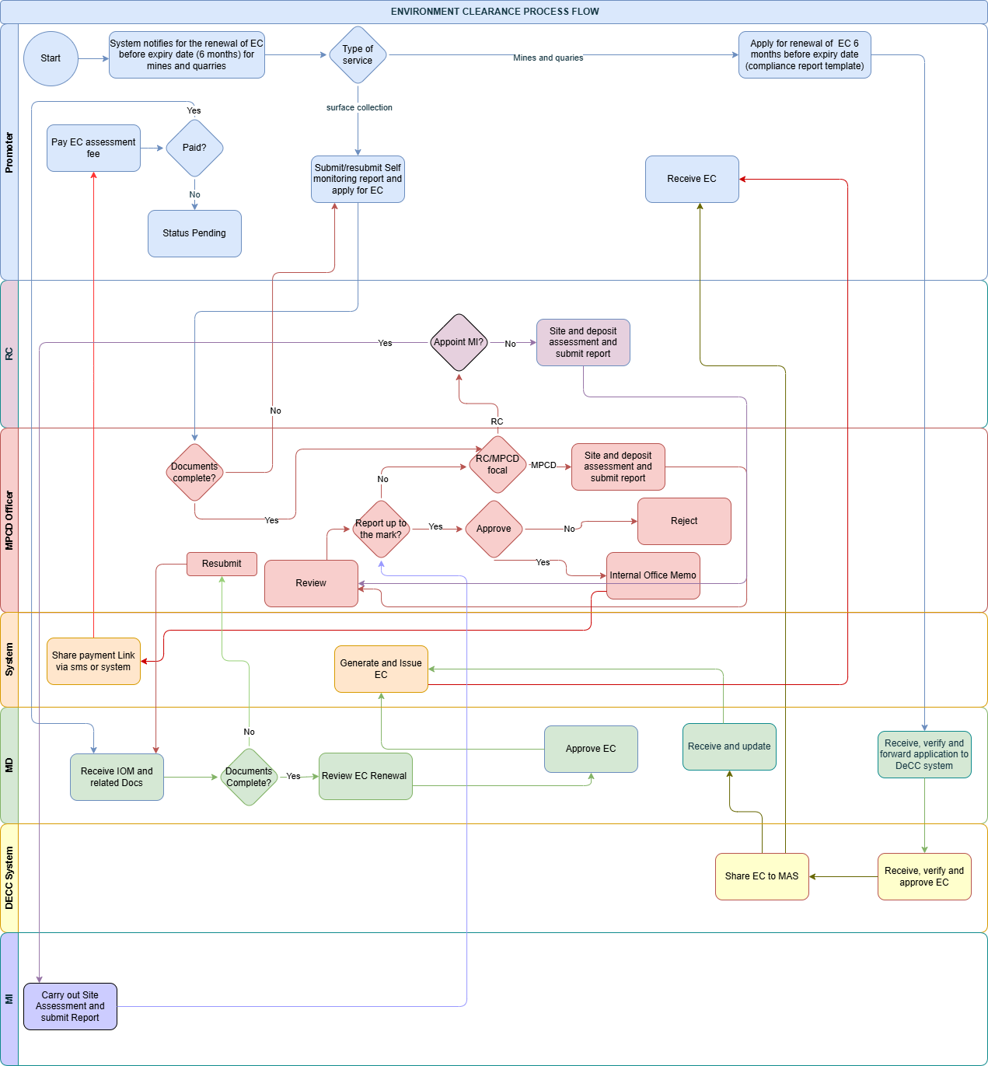

Applicant

Input Field for Applicant
Field Name | Input Type | Validation | Remarks
Type of Service | DropDown |  | The dropdown will have two options, Surface collection EC and Mine EC
Location | Text
Area | Text
File Upload | File |  | To Upload Previous EC
Submit Self Monitoring Report | File
Pay EC Fee | Button |  | Will prompt payment through BIRMS
View EC | Button |  | Will view the EC received
Print EC | Button |  | To print/Download the EC

Business Logic for Applicant
BR No. | Business Rule
 | Promoters (individuals or companies) authenticate/log in through National Digital Identity (NDI).
 | The applicant will initiate the renewal process 6 months before the expiry of EC.
 | The applicant will select a type of Services (Surface collection or Mines and quarries).
If the applicant selects "Mines and Quarries," the renewal application will be routed to the Mining Division (MD) focal for review.
The applicant must submit a compliance monitoring report as part of the process.
 | The system will automatically assign the application to the MD focal, who will review and forward it to the Department of Environment and Climate Change (DECC) through the system.
Once the Environmental Clearance (EC) is renewed, the DECC system will share the EC status and area details with the Mines Administration System (MAS).
The promoter will be notified of the updated EC status in the MAS.
If the applicant selects "Surface collection," the renewal application will be routed to the MPCD focal for review.
The applicant must submit a Self monitoring report as part of the process.
 | If additional documents are required, the applicant will be notified and will have the option to submit the necessary documents as many times as needed.
 | The applicant will receive a payment link immediately after the application is approved by the MPCD focal. If the payment is not completed, the application will remain in a pending status and will not proceed to the subsequent stages.
 | The applicant will receive the renewed Environmental Clearance (EC) once it is approved by the MD focal. The applicant will then have the option to generate, download, or print the EC.

Functional Requirement
FR No. | Functional Requirement
 | Integration with NDI for authentication.
 | Dashboard for applicants showing the tasks/applications with status
 | Integration with BIRMS payment gateway for paying application fee
 | System to notify applicants 6 months before EC expiry with instructions for the renewal process.
 | Integration with DECC system for EC process for Mines and Quaries.
 | Provide an interface for applicants to submit application along with the required documents.
 | Deadline enforcement with automatic application cancellation if deadlines are missed.
 | The input forms should be properly categorised, with a "Save as Draft" option available in each section.
 | Option to track application status.
 | Option to edit the application when it is in the draft phase.
 | Integration with SMS gateway for sending notifications to users at every stage
 | The system captures the initial application, SMS notification and application revision (if any) timestamp for reporting.
 | System to generate EC once it is approved by the concerned focals

Regional Coordinator

Input Field for RC
Field Name | Input Type | Validation | Remarks
Assign MI | Button
MI | Select | Pull from masters
assign | Button |  | Assigns MI
Review application | Button |  | Will view the whole Doc submitted for EC renewal.
Attach Site Report | File Upload
Submit Report | Button |  | Submits the report

Business Logic for RC

BR No. | Business Rule
The RC will conduct the site and deposit assessment and submit the report to the MPCD focal.
Or Assign MI to conduct the site and deposit assessment and submit the report to the MPCD focal.

Functional Requirement
FR No. | Functional Requirement
 | Option to log in as an agency user.
 | The dashboard for RC shall display a list of tasks and their current status. The tasks should be organised by priority and deadline to facilitate efficient management. The dashboard must provide real-time updates on task status, allowing MI to track progress.
 | The MI should be able to filter tasks by status (e.g., pending, in progress, completed) for better visibility.
 | The dashboard should also include visual indicators (e.g., colour codes) to represent different task statuses at a glance.
The system shall provide an option for the focal to review the application form and associated documents before submission.
focal must be able to view all input fields and uploaded documents in a read-only format for verification purposes.
The review option should allow the focal to navigate through each section of the application seamlessly.
A summary of the application, including key information and document names, should be displayed during the review process.

MPCD Officer

Input Field For MPCD
Field Name | Input Type | Validation | Remarks
EC renewal application | Button |  | Will view the whole Doc submitted for EC renewal.
Attach Site Report | File Upload
Submit Report | Button |  | Submits the report
Approve Application | Button |  | Will approve the EC renewal application
Additional Remarks | Text Field |  | Any additional remarks
View IOM | Button |  | Will check the system generated IOM
Submit IOM | Button |  | Will submit the IOM to the MD

Business Logic for MPCD

Business Rule
BR No. | Business Rule
 | When the applicant selects "Surface Collection" and submits the application, it will be forwarded to the MPCD focal for review.
 | The system will automatically assign the application to the MPCD focal based on their current workload.
 | Email and system notifications will be sent to the assigned MPCD focal upon assignment of the application.
 | MPCD focal/chief can re-assign the task to another MPCD focal if he/she is busy/on leave.
 | The MPCD focal will verify whether all required documents have been submitted. If any documents are missing, the focal will return the application to the applicant for resubmission.
 | If all required documents are submitted, the MPCD focal will either conduct the site and deposit assessment themselves and submit the report, or assign an RC to carry out the site and deposit assessment.
 | The MPCD focal will review the site and deposit assessment report submitted by either the RC or the MPCD focal.
 | If additional information is required, the focal will provide a remark detailing the specific portions that need to be revised or updated.
 | The MPCD focal will then decide whether to approve or reject the report. If the report is rejected, the applicant will be notified along with the justification for the rejection.
 | If the MPCD focal approves the assessment report for EC renewal, the system will generate an internal office memo and send a payment link to the applicant.

Functional Requirement
FR No. | Functional Requirement
 | Option to log in as an agency user.
 | The dashboard for MPCD focal shall display a list of tasks along with their current status. The tasks should be organised by priority and deadline to facilitate efficient management. The dashboard must provide real-time updates on task status, allowing MPCD to track progress.
 | Users should be able to filter tasks by status (e.g., pending, in progress, completed) for better visibility.
 | The dashboard should also include visual indicators (e.g., colour codes) to represent different task statuses at a glance.
The system shall provide an option for the focal to review the application form and associated documents before submission.
focal must be able to view all input fields and uploaded documents in a read-only format for verification purposes.
The review option should allow the focal to navigate through each section of the application seamlessly.
A summary of the application, including key information and document names, should be displayed during the review process.
The workload assessment will be determined by predefined metrics, such as the number of pending applications or tasks assigned to each MPCD focal.
The assignment process should ensure that applications are evenly distributed to optimise efficiency and reduce bottlenecks.
Integration with Gmail to send email notifications.
Integration with SMS for payment notification.
 | Option for resubmissions or additional information requests with an option to write remarks.
 | The system captures the application assigned, reassignment, SMS notification and approved timestamp for TAT calculation and reporting

Mining Engineer, MD

Input Field for ME, MD
Field Name | Input Type | Validation | Remarks
EC renewal application | Button |  | Will view the whole Doc submitted for EC renewal.
View IOM | Button |  | Will view the IOM
View Fee Receipt | Button |  | View the EC renewal Fee receipt
Approve EC | Button |  | Approve EC
View EC Surface collection | Button |  | View System generated EC
Forward EC Application | Button |  | Forward EC to DECC for processing EC
View EC | Button |  | View EC received from DECC

Business Logic for ME, MD

Business Rule
BR No. | Business Rule
 | If the EC renewal application is for Mines and Quarries, the application along with a compliance monitoring report will be automatically assigned to the Mining Engineer (ME), MD based on their current workload. Email and system notifications will be sent to the assigned ME upon the assignment of the application.
 | The ME/Chief MD can re-assign the task to another ME if he/she is busy/on leave.
 | The ME reviews the submitted application and forwards the application to DECC through the DECC system.
 | Once the DECC renews the EC, the EC status and area details will be updated in the MAS through an API.
 | For the EC renewal application for Surface Collection, the IOM and relevant documents will be automatically assigned to the Mining Engineer (ME), MD based on their current workload, once the applicant pays the EC assessment fee. Both email and system notifications will be sent to the assigned ME upon the application assignment.
 | The ME will verify whether all required documents have been submitted. If any documents are missing, the focal will return the application to the applicant for resubmission.
 | If all required documents are submitted, the ME review and approve the EC.

Functional Requirement
FR No. | Functional Requirement
 | Option to log in as an agency user.
 | The dashboard for ME shall display a list of tasks and their current status. The tasks should be organised by priority and deadline to facilitate efficient management. The dashboard must provide real-time updates on task status, allowing ME to track progress.
 | The ME should be able to filter tasks by status (e.g., pending, in progress, completed) for better visibility.
 | The dashboard should also include visual indicators (e.g., colour codes) to represent different task statuses at a glance.
The system shall provide an option for the focal to review the application form and associated documents before submission.
focal must be able to view all input fields and uploaded documents in a read-only format for verification purposes.
The review option should allow the focal to navigate through each section of the application seamlessly.
A summary of the application, including key information and document names, should be displayed during the review process.
The workload assessment will be determined by predefined metrics, such as the number of pending applications or tasks assigned to each ME.
The assignment process should ensure that applications are evenly distributed to optimize efficiency and reduce bottlenecks.
Integration with Gmail to send email notifications.
Integration with SMS gateway for SMS notifications.
 | Option for resubmissions or additional information/Documents requests with an option to write remarks.
 | The system must integrate with the DECC system to share EC status and area details for "Mines and Quarries" services.
 | The system captures the application assigned, reassignment, SMS notification and approved timestamp for TAT calculation and reporting

Mining Inspector (MI)

Input Field for MI
Field Name | Input Type | Validation | Remarks
View Remarks | Button |  | Will view the remarks given by RC for EC renewal.
Attach Report | File Upload |  | Attach the site report
Submit Report | Button |  | Submit report

Business Logic for MI

Business Rule
BR No. | Business Rule
 | The MI will conduct the site and deposit assessment and submit the report to the MPCD focal.

Functional Requirement
FR No. | Functional Requirement
 | Option to log in as an agency user.
 | The dashboard for MI shall display a list of tasks and their current status. The tasks should be organised by priority and deadline to facilitate efficient management. The dashboard must provide real-time updates on task status, allowing MI to track progress.
 | The MI should be able to filter tasks by status (e.g., pending, in progress, completed) for better visibility.
 | The dashboard should also include visual indicators (e.g., colour codes) to represent different task statuses at a glance.
The system shall provide an option for the focal to review the application form and associated documents before submission.
focal must be able to view all input fields and uploaded documents in a read-only format for verification purposes.
The review option should allow the focal to navigate through each section of the application seamlessly.
A summary of the application, including key information and document names, should be displayed during the review process.

Magazine Plan

Process Flow
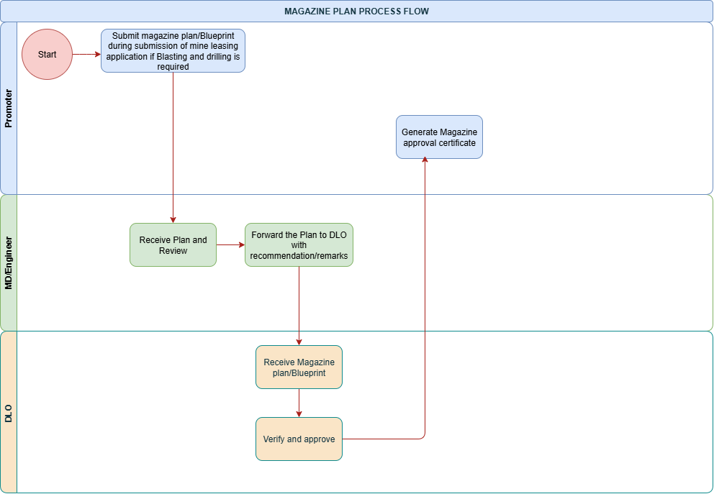

Applicant

Input Form for Applicant
Field Name | Input Type | Validation | Remarks
Upload Magazine Plan | File Upload |  | File Upload for Magazine plan
View/Download Magazine Approval | Button |  | View The magazine approval/Download

Business Logic for Promoter/Applicant

Business Rule
BR No. | Business Rule
 | Users (individuals or companies) authenticate/log in through National Digital Identity (NDI).
 | Applicants must submit a magazine plan or blueprint during the mine leasing application if drilling and blasting are required.
 | Applicants are required to pay any applicable royalties before the magazine approval certificate can be generated. If the payment is pending, the approval status remains "pending."
 | Applicants should be notified of any additional requirements or issues found in their submission. They should also be informed when the payment link is generated.

Functional Requirement
FR No. | Functional Requirement
 | Integration with NDI for authentication.
 | The system shall allow the applicant to submit an explosive requisition form with data validation to ensure all required fields are filled out correctly before submission.
 | Applicants should be able to check the real-time status of their submission, with details on whether it’s under review, if additional information is required, or if it’s approved.
 | Integration with DLO system to generate magazine approval certificate

Mining Engineer, MD

Input Form for Mining Engineer
Field Name | Input Type | Validation | Remarks
View Magazine Plan | Button |  | Views the whole Magazine plan.
Remarks | Text Field |  | The remarks to either accept or reject.
Forward plan to DLO | Button |  | Will forward Magazine plan to DLO.

Business Logic for Mining Engineer

Business Rule
BR No. | Business Rule
 | Option to log in as an agency user.
 | The Mine Engineer shall review the submitted magazine plan/blueprint to ensure it complies with regulatory and safety standards before forwarding it for final approval.
 | After verifying, the Mine Engineer must forward approved plan with a recommendation to the DLO for final verification and approval.

Functional Requirement
FR No. | Functional Requirement
 | Integration with NDI for authentication.
 | The Mine Engineer’s dashboard should provide an overview of all incoming magazine plan submissions, showing their status (e.g., "Pending Review," "Awaiting Resubmission," "Forwarded to DLO") and due dates.
 | The system should allow the Mine Engineer to access and open magazine plan submissions uploaded by promoters.
 | The Mine Engineer should have the option to review each magazine plan and add comments or recommendations.
 | Upon approval, the system shall allow the Mine Engineer to forward the plan, along with their recommendation and any additional notes, to the DLO system for final verification and approval.
 | The system shall send automated notifications to the Mine Engineer when a new plan is submitted by the promoter.

Department of Law and Order Focal

Input Form for DLO Focal
Field Name | Input Type | Validation | Remarks
View Magazine Plan | Button |  | Views the whole Magazine plan.
Remarks | Text Field |  | The remarks to either accept or send for rectification.
Approve Magazine Plan | Button |  | Approves the magazine plan
Send comments | Button |  | Send the remarks for rectification and probe the applicant to resubmit the plan

Business Logic for DLO Focal

Business Rule
BR No. | Business Rule
 | Option to log in as an agency user.
 | The DLO must verify that all required royalties or fees are paid before issuing an approval certificate. No plan shall be approved without payment confirmation.
 | Once all requirements are met, the DLO is responsible for generating and issuing an approval certificate to the applicant.

Functional Requirement
FR No. | Functional Requirement
 | Integration with NDI for authentication.
 | The system shall allow the DLO to receive a plan forwarded from the Mine Engineer, along with recommendations and any supporting documentation.
 | The system shall provide the DLO with the ability to verify that the applicant has paid the necessary royalty or fee. This verification step should prevent approval if the payment is pending.
 | Upon approval, the system shall automatically generate an approval certificate and share with the MAS system.
 | The dashboard should include search and filter options, allowing the DLO to find applications based on promoter name, status, or submission date.

Explosive Requisition

Process Flow
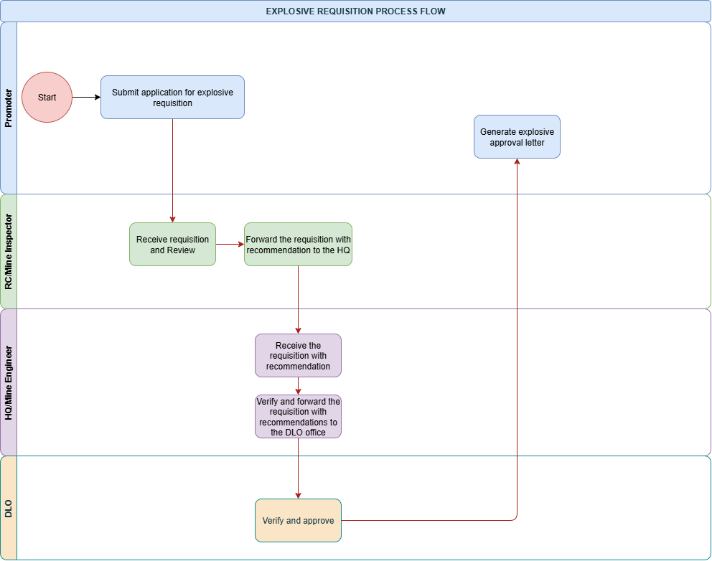

Applicant

Input field for applicant
Field Name | Input Type | Validation | Remarks
Blaster | Auto | Pulled from DB
Type | Auto | Pulled from DB
Specification | Auto | Pulled from DB
Required Quantity | Number
Remarks | Text | Not required
Download Recommendation | Button |  | View and download the explosive requisition recommendation given by DGM.

Business Logic for Applicant

Business Rule
BR No. | Business Rule
 | Users (individuals or companies) authenticate/log in through National Digital Identity (NDI).
 | The applicant must submit a fully completed and accurate explosive requisition form through the system.
 | The applicant is responsible for monitoring the status of their requisition.
 | Upon approval, they must promptly complete the required royalty payment to proceed with obtaining the explosive approval letter.
 | Once notified, the applicant must complete the royalty payment by the deadline to avoid delays in approval processing. Otherwise the status will remain as pending.

Functional Requirement
FR No. | Functional Requirement
 | Integration with NDI for authentication.
 | The system shall allow the applicant to submit an explosive requisition form with data validation to ensure all required fields are filled out correctly before submission.
 | The system shall provide the applicant with a real-time status tracker, allowing them to view the current stage of their requisition.
 | The system shall send automated notifications to the applicant at key stages.
 | Integrate with the DLO system and send a secure payment link to the applicant once DLO approval is granted.
 | Upon confirmation of the royalty payment, the system shall automatically generate an explosive approval letter.
 | The applicant should be able to download or view this approval letter directly from the system.

Regional Coordinator/Mining Inspector

Input field for Regional Coordinator/Mining Inspector

Field Name | Input Type | Validation | Remarks
View Requisition | Button |  | Views the requisition form.
Recommendation/remarks | Text Field |  | The remarks to send the recommendation for explosive requisition.
Forward Requisition with Recommendation | Button |  | Forward the requisition to HQ/MD

Business logic for Regional Coordinator/Mining Inspector

Business Rule
BR No. | Business Rule
 | Option to log in as an agency user.
 | The RC/MI must receive and review the application for explosive requisition submitted by the promoter promptly upon submission.
 | The MI/RC must verify that the applicant complies with all applicable legal, safety, and environmental standards for handling and using explosives.
 | If a requisition is incomplete or non-compliant, the MI/RC should request additional information from the applicant
 | Upon verification, forward the application to the Mining Engineer with recommendation.

Functional Requirement
FR No. | Functional Requirement
 | Option to log in as an agency user.
 | The system shall allow the MI/RC to access and view the details of each explosive requisition, including uploaded documents and applicant information.
 | The system shall allow the MI/RC to request additional information from the applicant when needed. This request should generate a notification to the applicant and enable them to respond directly in the system.
 | The system shall enable the MI/RC to record their recommendation and add any comments or feedback on the requisition.
 | After review, the system shall allow the MI/RC to forward the requisition to HQ, including their recommendation and any additional notes.
 | The system shall send automated notifications to the MI/RC when new requisitions are submitted and require review.

Mining Engineer

Input field for Mining Engineer

Field Name | Input Type | Validation | Remarks
View Requisition | Button |  | Views the requisition request with the recommendation from MI/RC.
Recommendation/remarks | Text Field |  | The remarks to send the recommendation for explosive requisition.
Forward Requisition Recommendation | Button |  | Forward the requisition to DLO and also send a copy to the applicant.

Business Logic for Mining Engineer

Business Rule
BR No. | Business Rule
 | Option to log in as an agency user.
 | The Mine Engineer must review all explosive requisition applications received from the Regional/Mine Inspector to ensure they meet all regulatory and safety requirements.
 | After verifying compliance, the Mine Engineer must forward each approved requisition with a recommendation to the DLO for final verification and approval.

Functional Requirement
FR No. | Functional Requirement
 | Integration with NDI for authentication.
 | The system shall allow the Mine Engineer to access and view details of all requisitions submitted by the Regional/Mine Inspector
 | The system should allow the RC/MI to log inspection activities, attach supporting documents.
 | Upon approval, the system shall allow the Mine Engineer to forward the requisition, along with their recommendation and any additional notes, to the DLO system for final verification and approval.
 | The system shall send automated notifications to the Mine Engineer when a new requisition is submitted by the Regional/Mine Inspector.

Department of Law and Order focal

Input field for Department of Law and Order focal
Field Name | Input Type | Validation | Remarks
View Requisition | Button |  | Views the requisition form with recommendation from DGM/HQ.
Remarks | Text Field |  | The remarks to either accept or send the requisition for rectification.
Approve Requisition |  |  | Approves the requisition.
Send comments |  |  | Send the remarks for rectification and probe the applicant to resubmit the requisition.

Business Logic for Department of Law and Order focal

Business Rule
BR No. | Business Rule
 | Option to log in as an agency user.
 | The DLO must verify that all required royalties or fees are paid before approving the requisition. No requisition shall be approved without payment confirmation.
 | Once all requirements are met, the DLO is responsible for generating and issuing the official explosive approval letter to the applicant.

Functional Requirement
FR No. | Functional Requirement
 | Integration with NDI for authentication.
 | The system shall allow the DLO to receive explosive requisition requests forwarded from the Mine Engineer, along with recommendations and any supporting documentation.
 | The system shall provide the DLO with the ability to verify that the applicant has paid the necessary royalty or fee. This verification step should prevent approval if the payment is pending.
 | Upon approval, the system shall automatically generate an official explosive approval letter and share with the MAS system.

Add Royalty

Process Flow
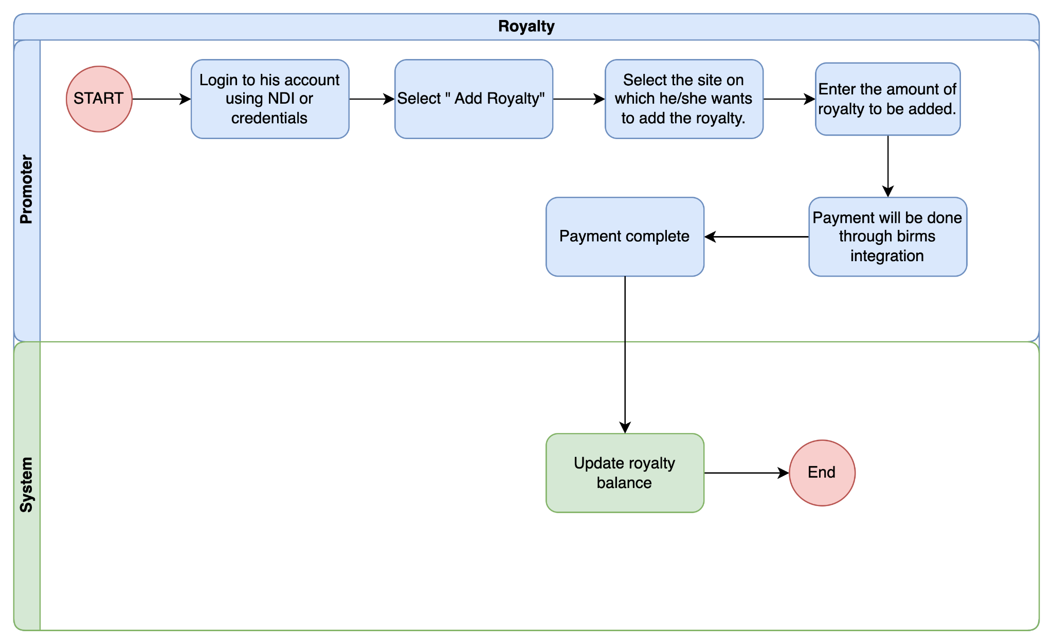

Promoter

Input Field for Promoter
Field Name | Input Type | Validation | Remarks
Site | Select | Pull from Masters | Selects the site on which promoter wants to add the royalty.
Amount | Number |  | Enter the royalty amount
Add Royalty | Button |  | Redirects to the BIRMS

Business Logic for Promoter

Business Rule
BR No. | Business Rule
 | There will be an option to log in as an agency user.
 | The promoter can add royalty to a specific site.
 | Once the promoter enters the royalty amount and submits it, they will be redirected to the BIRMS interface to complete the payment process.
 | After the payment process in BIRMS is successfully completed, the royalty will be added to the site.

Mine Transport Permit
  - Process Flow

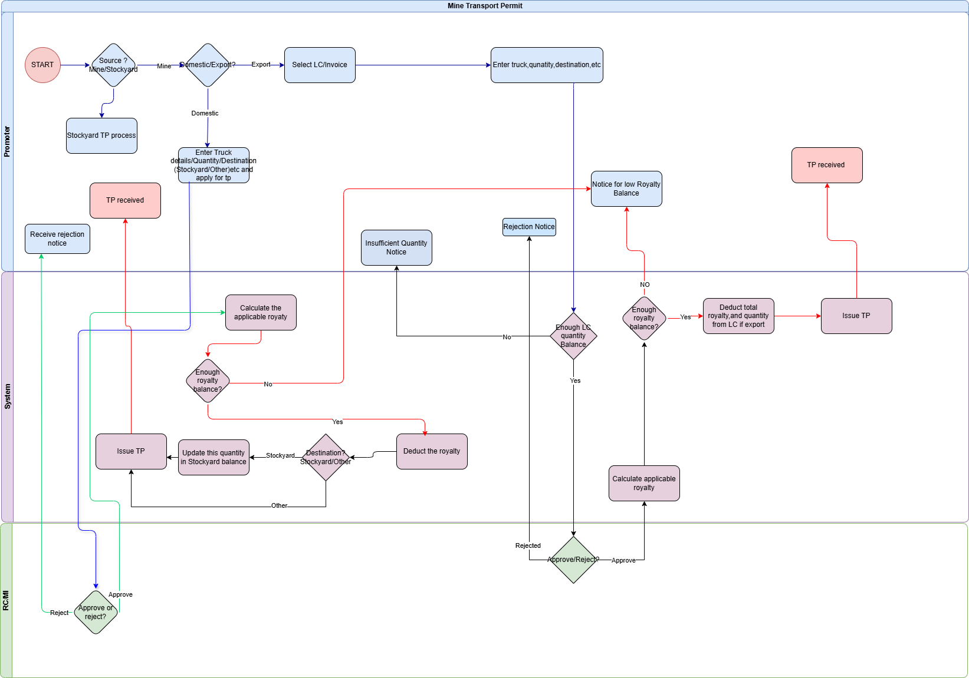

Applicant

Input Field for Applicant

Field Name | Input Type | Validation | Remarks
Source | Select | Pull from Masters | Selects the source of the material promoter.
Destination | Select | Pull from master | Select whether the destination is Export or Domestic and if domestic , then whether to stockyard or directy to customers.
Domestic TP
Destination | Select | Pull from master | Select transport to stockyard or other
Transport details | Varchar |  | Enter truck/Quantity/Etc details
Calculate royalty | Button |  | Calculate the applicable Royalty
Submit | Button |  | Submits the TP application
View TP | Button |  | The applicant can view the TP and download option as well.
Export TP
Select LC/Invoice | Select |  | The promoter will select the LC/Invoice to export on .
Transport details | Varchar |  | The promoter will enter the transport details.
Weight Slip | File | Less than 1 MB | The promoter will upload the weight slip file.
Calculate Royalty | Button |  | The promoter will click this button and will calculate the applicable royalty.
Submit | Button |  | Submit TP application.
View TP | Button |  | Will view the system generated TP and option to download.

Business Logic for Applicant

Business Rule
BR No. | Business Rule
BR -1 | The promoter/applicant will login to their MAS account
BR-2 | Then go to the TP services Tab and select the “source” as “Mines and Quaries”
BR-3 | When the source is chosen, then the applicant will have to choose whether Export or Domestic transport
BR-4 | For Domestic destination, the applicant will then choose whether the destination is stockyard or Other.
 | Domestic
BR-5 | For domestic destination, the applicant will then enter all the required details and submit the application.
BR-6 | If the application is approved and there is enough royalty balance then the applicant will receive the Transport Permit
 | Export
BR-7 | When the destination is selected as “Export” the applicant shall select LC/Invoice on which the export is to be done.
BR-8 | When the LC/Invoice is selected, then the applicant must enter the transport details and submit
BR-9 | If the application is approved and there is enough royalty balance then the applicant will receive the Transport Permit else will receive a rejection notice.

Functional Requirement
FR No. | Functional Requirement
FR-1 | System to automatically update the Quantity transported to the stockyard incase of destination stockyard. The system should understand that all destination to stockyard shall updated the quantity under the stockyard balance.
FR-2 | System to automatically check the royalty balance and send notice if there is not enough royalty balance
FR-3 | System to keep track of the quantity transported from each LC/Invoice and prevent any TP application from that LC/Invoice incase of insufficient or exhausted transport quantity balance for that LC. Also the system should check the LC/Invoice validity and prevent any TP application incase the validity is expired.
FR-4 | System to automatically calculate the applicable royalty.
FR-5 | System to automatically deduct the applicable royalty from the balance royalty when the TP is approved by the MI/RC.
FR-6 | Provision for the applicant to check all the approved TPs based on different sorting methods ( material type, date,etc)

RC/MI

Input Field for RC

Field Name | Input Type | Validation | Remarks
Domestic
View | Button |  | It will show the TP application.
Approve | Button |  | Approves the TP application
Comments/Remarks | Text |  | Send remarks for approval (optional)
Reject | Button |  | Rejects the TP application.
Comments/Remarks | Text | Required | Send remarks for rejection
Export
View LC/Invoice | Button |  | View the submitted LC/Invoice.
View | Button |  | View the whole TP application details.
Reject TP | Button |  | Rejects TP application
Comments/Remarks | Text |  | Send remarks for rejection
Approve TP | Button |  | Approves TP application
Comments/Remarks | Text |  | Send remarks for rejection (Optional)

Business Logic for RC

Business Rule
BR No. | Business Rule
BR -1 | The RC/MI will login as agency user
BR-2 | Any new Transport Permit applicant will be shown under the “Transport Permit Service” Tab
BR-3 | Domestic Transport Permit
BR-4 | The RC/MI will check the transport permit details and if everything is correct, they will approve the Transport Permit or else reject with remarks.
BR-5 | Export Transport Permit
BR-8 | For export Transport permit approvals the RC/MI will go to the Transport Permit services>>Export Transport Permit>>TP and check for new applications and approve or reject the applications with remarks

Functional Requirement
FR No. | Functional Requirement
FR-1 | System to automatically update the Quantity transported to the stockyard incase of destination stockyard
FR-2 | System to keep track of transported quantity from each site
FR-3 | Provisions for agency users to check the dispatch records and royalty balances for any site
FR-4 | Provision to search any transport permit either by date, source, Transport Permit No,etc
FR-5 | Provision to download Transport reports, royalty reports for site for inspectors or region as a whole for RC
FR-6 | System to prevent double counting of dispatched quantities.

Stockyard Transport Permit

Process Flow
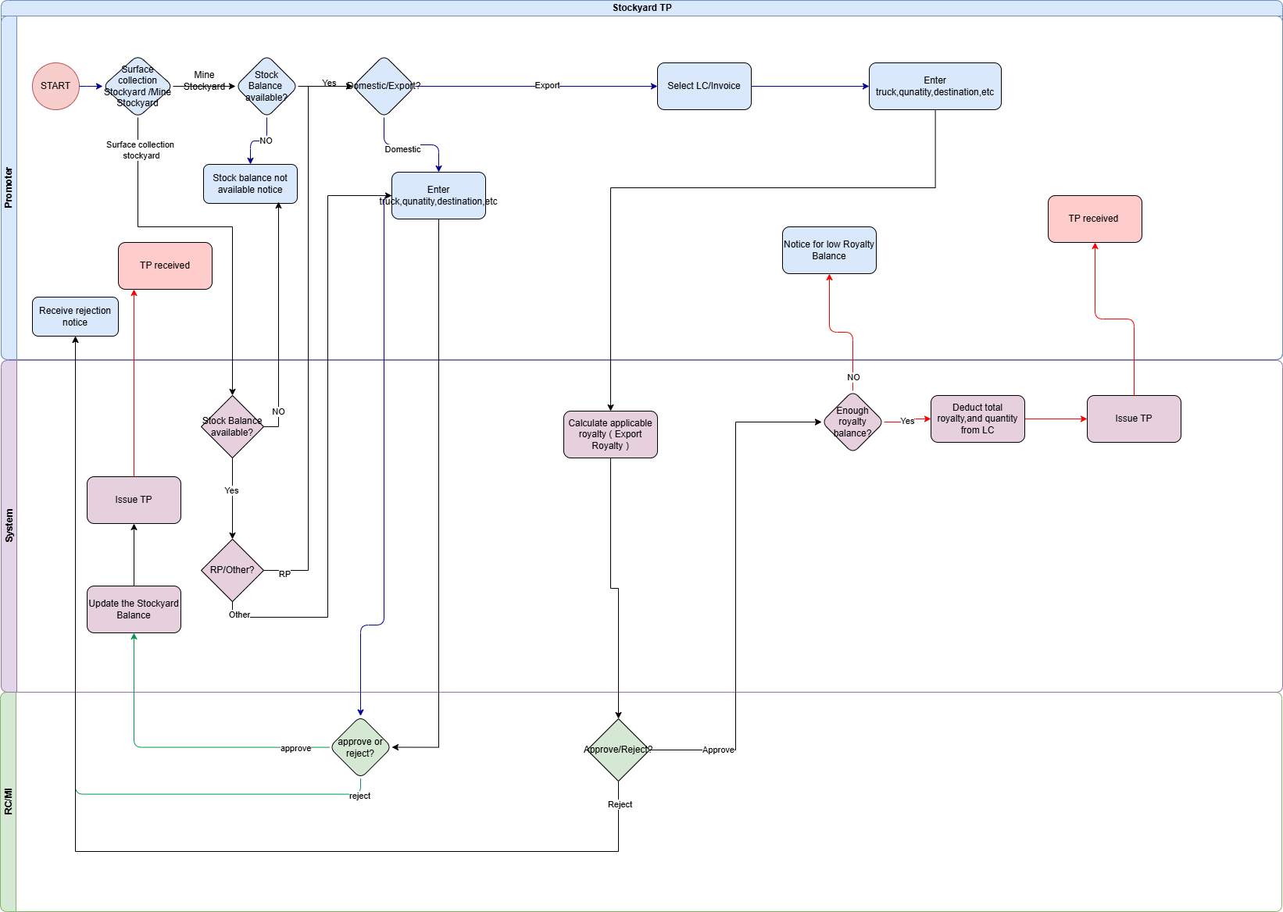

Applicant

Input field for Applicant

Field Name | Input Type | Validation | Remarks
Source | Select | Pull from Masters | Selects the source of the material promoter.
Destination | Select | Pull from master | Select whether the destination is Export or Domestic and if domestic , then whether to stockyard or directy to customers.
Domestic TP
Destination | Select | Pull from master | Select transport to stockyard or other
Transport details | Varchar |  | Enter truck/Quantity/Etc details
Calculate royalty | Button |  | Calculate the applicable Royalty
Submit | Button |  | Submits the TP application
View TP | Button |  | The applicant can view the TP
Export TP
Select LC/Invoice | Select |  | The promoter will select whether they want to export on the existing LC/Invoice or export on a new LC/Invoice
Transport details | Varchar |  | The promoter will enter the transport details including the name of the exporter.
Upload weight Slip | File | Less than 1 MB | The promoter will upload the weight slip.
Calculate Royalty | Button |  | The promoter will click this button and the applicable royalty.
Submit | Button |  | Submit TP application.
View TP | Button |  | Will view the system generated TP and option to download as well.

Business logic

Business Rule
BR No. | Business Rule
BR -1 | The promoter/applicant will login to their MAS account
BR-2 | Then go to the TP services Tab and select the “source” as “Stockyard”
BR-3 | When the source is chosen, then the applicant will have to choose whether Export or Domestic transport
 | Domestic
BR-5 | For domestic transport, the applicant will then enter all the required details and submit the application.
BR-6 | If the application is approved and there is enough royalty balance then the applicant will receive the Transport Permit
 | Export
BR-7 | When the destination is selected as “Export” the applicant shall select LC/Invoice to export on.
BR-8 | When the LC/Invoice is selected, then the applicant must enter the details and submit
BR-9 | If the application is approved and there is enough royalty balance then the applicant will receive the Transport Permit

Functional Requirement
FR No. | Functional Requirement
FR-1 | System to automatically check the royalty balance and send notice if there is not enough royalty balance
FR-2 | System to keep track of the quantity transported from each LC/Invoice and prevent any TP application from that LC/Invoice incase of insufficient or exhausted transport quantity balance for that LC. Also the system should prevent TP application from an expired LC/Invoice
FR-3 | System to automatically calculate the applicable royalty.
FR-4 | Provision for the applicant to check all the approved TPs based on different sorting methods ( material type, date,etc)

Regional Coordinator

Input Field for Regional Coordinator/MI

Field Name | Input Type | Validation | Remarks
Domestic
View | Button |  | It will show the TP application.
Approve | Button |  | Approves the TP application
Comments/Remarks | Text |  | Send remarks for approval (optional)
Reject | Button |  | Rejects the TP application.
Comments/Remarks | Text | Required | Send remarks for rejection
Export
View LC/Invoice | Button |  | View the LC/Invoice on which the export is done.
View | Button |  | View the whole TP application details
Reject TP | Button |  | Rejects TP application
Comments/Remarks | Text |  | Send remarks for rejection
Approve TP | Button |  | Approves TP application
Comments/Remarks | Text |  | Send remarks for rejection (Optional)

Business Logic for RC/MI

Business Rule
BR No. | Business Rule
BR -1 | The RC/MI will login as agency user
BR-2 | Any new Transport Permit applicant will be shown under the “Transport Permit Service” Tab
 | Domestic Transport Permit
BR-4 | The RC/MI will check the transport permit details and if everything is correct, they will approve the Transport Permit or else reject with remarks.
 | Export Transport Permit
BR-5 | For export Transport permit approvals the RC/MI will go to the Transport Permit services>>Export Transport Permit>>TP and check for new applications and approve or reject the applications with remarks

Functional Requirement
FR No. | Functional Requirement
FR-1 | System to keep track of transported quantity from each site
Fr-2 | Provision to search any transport permit either by date, source, Transport Permit No,etc
FR-3 | Provision to download Transport reports, royalty reports for site for inspectors or region as a whole for RC

Stock Lifting Transport Permit

Process Flow
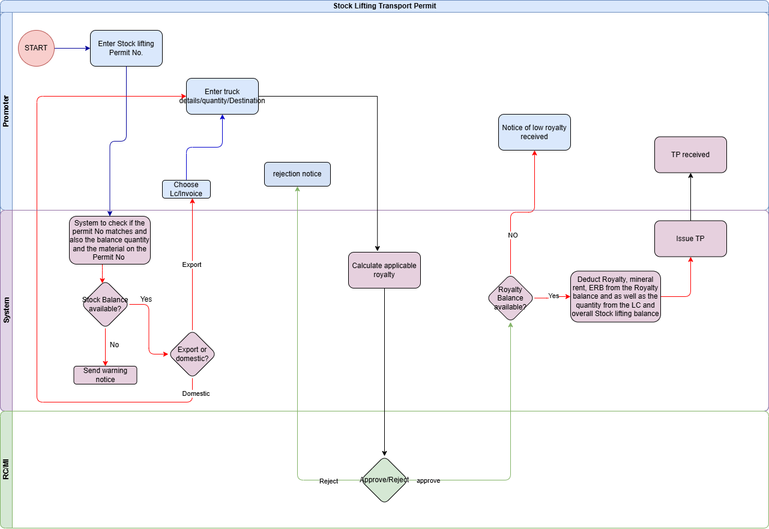

Applicant
    - Input Field for applicant

Field Name | Input Type | Validation | Remarks
Enter Permit No. | Varchar |  | Enter Permit No
Destination | Select | Pull from master | Select the stocklifting permit concerned and whether the destination is Export or Domestic.
Domestic TP
Destination | Select | Pull from master | Select transport to stockyard or other
Transport details | Varchar |  | Enter truck/Quantity/Etc details
Calculate royalty | Button |  | Calculate the applicable Royalty
Submit | Button |  | Submits the TP application
Generate TP | Button |  | System generates the TP
View TP | Button |  | The applicant can view the TP
Export TP
Select LC/Invoice | Select |  | The promoter will select whether they want to export on the existing LC/Invoice or export on a new LC/Invoice.
Upload LC/Invoice | File | Less than 1 MB | The promoter will upload the LC/Invoice file
Transport details | Varchar |  | The promoter will enter the transport details.
Upload Weight Slip | File | Less than 1 MB | The promoter will upload the weight slip.
Calculate Royalty | Button |  | The promoter will click this button and the applicable royalty.
Submit | Button |  | Submit TP application.
Generate TP | Button |  | System then generates the TP.
View TP | Button |  | Will view the system generated TP.

14.2.2 Business Logic for Applicant

Business Rule
BR No. | Business Rule
BR -1 | The promoter/applicant will login to their Stock lifting account.
BR-2 | Then go to the TP services Tab and enter the Stock Lifting permit No. and the CID No. or the License No.
BR-3 | If the permit No and the CID/License No. in which it was issued exists in the system database, they will then choose the destination.
 | Domestic
BR-5 | For domestic transport, the applicant will then enter all the required details and submit the application.
BR-6 | If the application is approved and there is enough royalty balance then the applicant will receive the Transport Permit after deducting the royalty balance.
 | Export
BR-9 | When the destination is selected as “Export” the applicant shall select LC/Invoice to export on.
BR-12 | When the LC/Invoice is selected, then the applicant must enter the details and submit
BR-13 | If the application is approved and there is enough royalty balance then the applicant will receive the Transport Permit after deducting from the royalty balance.

Functional Requirement
FR No. | Functional Requirement
FR-1 | System to check the stock balance quantity and prevent any TP application incase of insufficient balance or exhausted balance.
FR-2 | System to automatically check whether the stock lifting is eligible for export and then show options to export only if eligible
FR-3 | Provisions to check the royalty balance and dispatch records.
FR-4 | Provisions to set notice when the royalty balance reaches a certain custom value.

Regional Coordinator (RC)
    - Input Field for RC/MI

Field Name | Input Type | Validation | Remarks
Domestic
View | Button |  | It will show the TP application.
Approve | Button |  | Approves the TP application
Check Balance | Button |  | Check stock Balance
Comments/Remarks | Text |  | Send remarks for approval (optional)
Reject | Button |  | Rejects the TP application.
Comments/Remarks | Text | Required | Send remarks for rejection
Export
View LC/Invoice | Button |  | View the submitted LC/Invoice.
View | Button |  | View the whole TP application details
Reject TP | Button |  | Rejects TP application
Comments/Remarks | Text |  | Send remarks for rejection
Approve TP | Button |  | Approves TP application
Comments/Remarks | Text |  | Send remarks for approval (optional)

14.3.2 Business Logic for RC/MI

Business Rule
BR No. | Business Rule
BR -1 | The RC/MI will login as agency user
BR-2 | Any new Transport Permit applicant will be shown under the “Transport Permit Service” Tab
 | Domestic Transport Permit
BR-3 | The RC/MI will check the transport permit details and if everything is correct, they will approve the Transport Permit or else reject with remarks.
 | Export Transport Permit
BR-4 | For export Transport permit approvals the RC/MI will go to the Transport Permit services>>Export Transport Permit>>TP and check for new applications and approve or reject the applications with remarks

Functional Requirement
FR No. | Functional Requirement
FR-1 | System to keep track of transported quantity from each site.
FR-2 | Provision to check royalty balance from the respective sites under each region.
FR-3 | Provision to download Transport reports, royalty reports for site for inspectors or region as a whole for RC

Surface collection TP

Process Flow
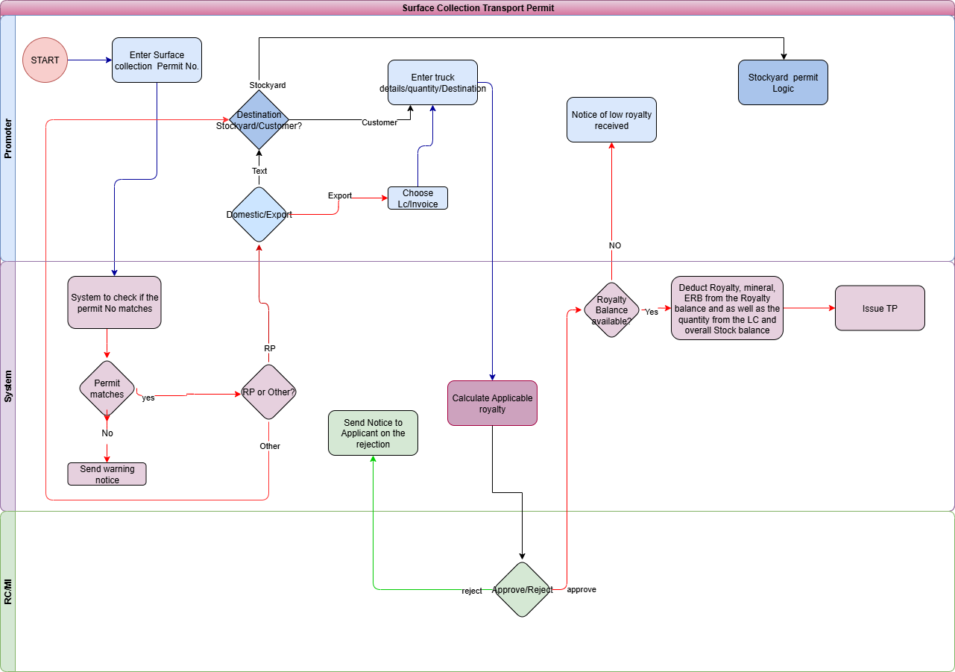

Applicant/Promoter
    - Applicant Input Field

Field Name | Input Type | Validation | Remarks
Enter Permit No. | Varchar |  | Enter Permit No
Other sites
Destination | Select | Pull from master | Select transport to stockyard or other
Transport details | Varchar |  | Enter truck/Quantity/Etc details
Calculate royalty | Button |  | Calculate the applicable Royalty
Submit | Button |  | Submits the TP application
View TP | Button |  | The applicant can view the TP
RP sites (Domestic)
Destination( Export/Domestic) | Select |  | Select whether Export or Domestic.
Domestic Destination | Select | Pull from master | Select transport to stockyard or other
Transport details | Varchar |  | Enter truck/Quantity/Etc details
Calculate royalty | Button |  | Calculate the applicable Royalty
Submit | Button |  | Submits the TP application
Generate TP | Button |  | System generates the TP
View TP | Button |  | The applicant can view the TP
RP Sites (Export)
Select LC/Invoice | Select |  | The promoter will select whether they want to export on the existing LC/Invoice or export on a new LC/Invoice
Transport details | Varchar |  | The promoter will enter the transport details.
Calculate Royalty | Button |  | The promoter will click this button and the applicable royalty.
Submit | Button |  | Submit TP application.
View TP | Button |  | Will view the system generated TP.

15.2.2 Business Logic for Applicants

Business Rule
BR No. | Business Rule
BR -1 | The promoter/applicant will login to their Surface collection account.
BR-2 | Then go to the TP services Tab and enter the Surface collection permit No. and the CID No. or the License No.
BR-3 | If the Surface collection permit No and the CID/License No. in which it was issued exists in the system database, they will then choose the destination.
 | Other Sites
BR-4 | For sites other than RP sites these are not applicable for export and only dispatch to domestic is allowed.
BR-5 | The applicant will enter the transport details, required attachments and submit.
BR-6 | If the application is approved and there is enough royalty balance then the applicant will receive the Transport Permit after deducting the royalty balance.
 | Export
BR-7 | Export is eligible only from RP sites.
BR-8 | When the destination is selected as “Export” the applicant shall select the LC/Invoice to export on.
BR-9 | When the LC/Invoice is selected, then the applicant must enter the details and submit
BR-10 | If the application is approved and there is enough royalty balance then the applicant will receive the Transport Permit after deducting from the royalty balance.

Functional Requirement
FR No. | Functional Requirement
FR-1 | System to check whether that particular surface collection permit is “RP” based or “Direct Allocation” and then allow or disallow for export.  Info: RP based are eligible for export whereas direct allocation are not eligible for export.
FR-2 | Provisions to check the royalty balance and dispatch records.
FR-3 | Provisions to set notice when the royalty balance reaches a certain custom value.

Regional Coordinator (RC)
    - Input Field for RC

Field Name | Input Type | Validation | Remarks
Domestic TP
View | Button |  | It will show the TP application.
Approve | Button |  | Approves the TP application
Comments/Remarks | Text |  | Send remarks for approval
Reject | Button |  | Rejects the TP application.
Comments/Remarks | Text | Required | Send remarks for rejection
Export TP
View LC/Invoice | Button |  | View the submitted LC/Invoice.
View | Button |  | To view the Tp application details
Reject TP | Button |  | Rejects TP application
Comments/Remarks | Text |  | Send remarks for rejection
Approve TP | Button |  | Approves TP application
Comments/Remarks | Text |  | Send remarks for rejection

15.3.2 Business Logic for RC/MI

Business Rule
BR No. | Business Rule
BR -1 | The RC/MI will login as agency user
BR-2 | Any new Transport Permit applicant will be shown under the “Transport Permit Service” Tab
BR-3 | Domestic Transport Permit
BR-4 | The RC/MI will check the transport permit details and if everything is correct, they will approve the Transport Permit or else reject with remarks.
 | Export Transport Permit
 | For export Transport permit approvals the RC/MI will go to the Transport Permit services>>Export Transport Permit>>TP and check for new applications and approve or reject the applications with remarks

Functional Requirement
FR No. | Functional Requirement
FR-1 | System to keep track of transported quantity from each site.
FR-2 | Provision to check royalty balance from the respective sites under each region.
FR-3 | Provision to download Transport reports, royalty reports for site for inspectors or region as a whole for RC
FR-4 | Provision to check royalty balance for the respective sites

Rural Transport Permit

Process Flow
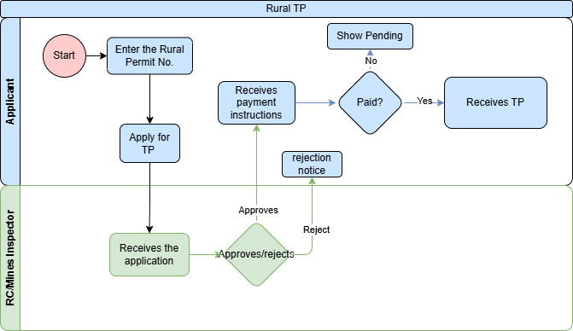

Applicant/Promoter
    - Input Field for Applicant

Field Name | Input Type | Validation | Remarks
Enter Permit No. | Varchar |  | Enter Permit No
Transport details | Varchar |  | Enter truck/Quantity/Etc details
Calculate royalty | Button |  | Calculate the applicable Royalty
Submit | Button |  | Submits the TP application
Generate TP | Button |  | System generates the TP
View TP | Button |  | The applicant can view the TP

    - Business Logic for Applicant

Business Rule
BR No. | Business Rule
BR -1 | The applicant will be able to login using NDI if the system has a recorded Rural permit for that corresponding CID No.
BR-2 | Then select apply for Transport Permit.
BR-3 | Enter all the details and submit.
BR-4 | If the application is approved then, the applicant will receive the payment instructions with the amount to be paid.
BR-5 | After the payment is done, the applicant will receive the Transport Permit

Regional Coordinator (RC/MI)

Input Field for RC/MI

Field Name | Input Type | Validation | Remarks
View | Button |  | It will show the TP application.
Approve | Button |  | Approves the TP application
Comments/Remarks | Text |  | Send remarks for approval
Reject | Button |  | Rejects the TP application.
Comments/Remarks | Text | Required | Send remarks for rejection

16.3.2 Business Logic for RC/MI

Business Rule
BR No. | Business Rule
BR -1 | The RC/MI will login as agency user
BR-2 | Any new Transport Permit applicant will be shown under the “Transport Permit Service” Tab and go to “domestic TP”
BR-4 | The RC/MI will check the transport permit details and if everything is correct, they will approve the Transport Permit or else reject with remarks.

Functional Requirement
FR No. | Functional Requirement
FR-1 | Provision to check the total dispatch records for domestic rural supply

Promoter Annual Report

Process flow
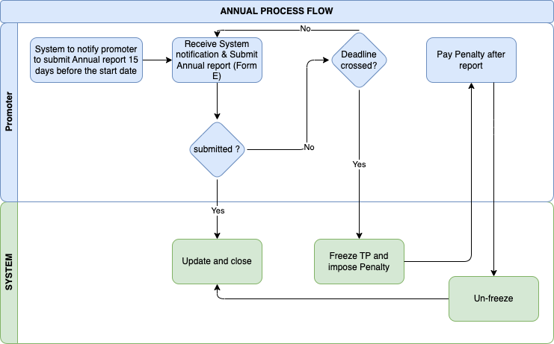

Promoter

Input Form E (Annual Report on Operation of the Mine)
Field Name | Input Type | Validation | Remarks
A. General
a. Details of the Mine
Name | Auto
Manager | Auto
Postal address | Auto
Mobile No. | Auto
Telephone No | Auto
Fax No. | Auto
Email ID | Auto
b. Details of Lessee
Name | Auto
Postal Address | Auto
Telephone No | Auto
Mobile No | Auto
Email ID* | Auto
Fax No. | Auto
Major shareholders of the Company with % of share
Name | Auto
Percentage | Auto
Authorised Representative | Auto
Save as Draft | Button
Next | Button
c. Present Status of the Mine | Radio button | Developing/Production full capacity/Production under capacity/Abandoned
Date of opening: | Date
Date of seasonal closure | Date
Principal mineral extracted: | Dropdown | Pull from master
Subordinate minerals extracted: | Dropdown | Pull from master
Save as Draft | Button
Next | Button
B. GEOLOGY
No. of exploratory boreholes/trial pits | Number
Exploratory borehole meterage drilled (metres) | Number
Reserve estimated (MT) | Number
C. SOCIOLOGICAL ASPECTS
a. Medical Facility
Availability of BHU/dispensary hospital: | Radio Bhutton | Yes/No
Provision of other medical facilities: | Radio Bhutton | Yes/No
b. Educational facility | Radio Bhutton | Yes/No
c. Housing facility provided | Radio Bhutton | Yes/No
d. Recreational facility | Radio Bhutton | Yes/No
e. Canteen/subsidised food | Radio Bhutton | Yes/No
f. Water & sanitation | Radio Bhutton | Yes/No
g. Transport & communication | Radio Bhutton | Yes/No
h. Training | Radio Bhutton | Yes/No
i. Amenities to staff :
Bonus/incentive | Radio Bhutton | Yes/No
Leave Travel Concession (LTC) | Radio Bhutton | Yes/No
Medical re-imbursement | Radio Bhutton | Yes/No
Leave with pay | Radio Bhutton | Yes/No
Overtime Allowance | Radio Bhutton | Yes/No
GIS scheme | Radio Bhutton | Yes/No
Loan facility | Radio Bhutton | Yes/No
Save as Draft | Button
Next | Button
D. MINE PRODUCTION
a. Method of operation
Manual | Radio Bhutton | Production/Loading/Waste Disposal
Mechanised | Radio Bhutton | Production/Loading/Waste Disposal
Semi-mechanised | Radio Bhutton | Production/Loading/Waste Disposal
b. Dust suppression method adopted: | Text
E. DRILLING & BLASTING
a. Drilling Information
No. of Holes | Number
Drill Hole Dia (mm) | Number
Depth of Blast Holes (m) | Number
Meterage Drilled (m) | Number
b. Explosives
Type of explosive and accessories | Dropdown | Pull from master
Brand Name | Text
Manufacturer | Text
Supplier | Text
Annual Consumption | Number
Price per unit (Nu.) | Number
Total explosive cost (Nu.) | Auto | Annual Consumption*Price per unit (Nu.)
Magazine types & capacity | Text
Save as Draft | Button
Next | Button
F. ENERGY CONSUMPTION
Connected Load (KW) | Number
Power Consumption (KWH) | Number
Annual power bill paid (Nu.) | Number
Total P.O.L cost (Nu.) | Number
Total cost of energy consumed | Auto | P.O.L + power) (Nu.
G. EMPLOYMENT
a. Managerial
Name | Text
Designation | Dropdown | Pull from master
Nationality | Radio button | Bhutanese/Non-Bhutanese
Nature of Employment | Radio button | Regular/contract/ casual
Type | Radio button | Skilled/semiskilled/unskilled
Certificate holder | Radio button | Yes/No
Add more | Button
b. Manpower and its costs
Category of workers | Dropdown | Pull from master
Type | Radio Button | Skilled/semiskilled/unskilled
No. of workers | Number
Total mandays | Number
Salary & wages (Nu.) | Number
Add more
c. Summary
Total Workers | Auto
Total Wages and Salary (Nu.) | Auto
Male Workers | Auto
Female Workers | Auto
National | Auto
Expatriate | Auto
Save as Draft | Button
Next | Button
H. SAFETY ASPECTS
a. Injuries during the year
Number of persons injured (Minor) | Number
Number of persons injured (Major) | Number
Number of persons injured (Fatal) | Number
b. Safety appliances provided to the mine workers
Category of workers | Dropdown
Type of appliances | Dropdown
Add more | Button
I. LAND USE AND ENVIRONMENT
Lease hold area
Total demarcated area (acres) | Number
Total excavation area (acres) | Number
SRF (acres) | Number
Private land area (acres) | Number
Save as Draft | Button
Next | Button
J. EQUIPMENTS/MACHINERY
Name of equipment/ machinery | Dropdown
Initial cost (Nu.) | Number
Current value (Nu.) | Number
Make | Number
Capacity | Number
Depreciation (Nu.) | Number
Maintenance cost (Nu.) | Number
Yearly cost (Nu. | Number
Add more | Button
Total | Auto
K. SALES AND MERKETING
a. Sales
Mineral product type | Dropdown | Pull from master
Unit (MT/Cum.) | Number
Raising | Number
Opening balance at stockyard | Number
Domestic | Number
Export | Number
Total Sale | Number
Closing balance at stockyard | Number
b. Marketing
Mineral product type | Dropdown | Pull from master
Quality/grade
Quantity (MT/Cum) | Number
Chemical assay | Number
End use | Number
Selling point | Number
Customer relation (no. of years) | Number
How sale price is determined? | Text
Save as Draft | Button
Next | Button
L. INVESTMENTS, COSTS AND RETURNS
a. Summary
Mineral product | Dropdown
Quantity (MT/Cum.) | Auto
Total Sale Value (Nu.) | Auto
Total Production Cost (Nu.) | Auto
Landed Cost (for captive Mines Only) (Nu.) | Auto
b. Investment (additional investment in current year in terms of capital expense)
Description | Text
Investment value (Nu.) | Number
Add more | Button
Total investment | Auto
c. Break-up of Production Cost
Cost Details | Number
Salary and wages | Number
Energy | Number
Transportation | Number
Explosives | Number
Royalty, rents & taxes | Number
Environment management | Number
Depreciation | Number
Interest on loan | Number
Communication charges | Number
Other expenses | Number
Total | Auto
d. Financing and repayment
Loan position in the year’s beginning (Nu.) | Number
Repayment during the current year (Nu.) | Number
Balance at year-end (Nu.) | Number
e. Environment management budget
Budget allocation for mine environment management & mine rehabilitation activity in the following year (Nu.) | Number
ERB deposited in the joint account (Nu.) | Number
f. Revenue
Royalty & Mineral Rent (Nu.) | Number
CIT/BIT (Nu.) | Number
Rupee earnings during the year | Number
Land lease rent (Nu.) | Number
License Fee (auctioned mines only) (Nu.) | Number
Hard currency earnings during the year | Number
Save as Draft | Button
Next | Button
M. Community development/CSR
Amount spent on CSR activities during the period (Nu.) | Number
Some of the CSR activities along with details of budget
Activity | Text
Amount (Nu.) | Number
Add more | Button
Declaration | Radio Button |  | I hereby declare that the information provided herewith are true to the best of my knowledge and in the event of false or misleading information, I shall be liable for any action under the Mines and Minerals Management Act and Regulations thereof.

Business Logic for Promoter

Business Rule
BR No. | Business Rule
 | Users (individuals or companies) authenticate/log in through National Digital Identity (NDI).
 | The system must notify the promoter to submit the annual report 15 days before the report submission period starts.
 | The deadline for the submission of the annual report is from January 1 till April 30.
 | Applicants will have to submit an annual report within the designated period.
 | If the promoter fails to submit the annual report by the deadline, their TP must be frozen and impose a penalty.
 | Once the promoter submits the overdue annual report and pay penalty, the TP should be unfrozen and the reporting requirement marked as completed.
 | Upon timely submission and approval of the annual report, the process should be closed.

Functional Requirements
FR No. | Functional Requirement
 | Integration with NDI for authentication.
 | The system should automatically send a notification to the promoter 15 days before the annual report submission, reminding them to submit their report.
 | The system should check if the submission deadline has passed. If the deadline is missed and the report is still not submitted, initiate the freezing process for the promoter’s TP and notify relevant stakeholders.
 | The system should send the payment link of the penalty to the promoter for not submitting the report on time.
 | Upon receiving the overdue report and penalty from the promoter, the system should update the TP status to "Unfrozen," allowing normal operations to resume.

Promoter Bi-Annual Reporting

Process flow
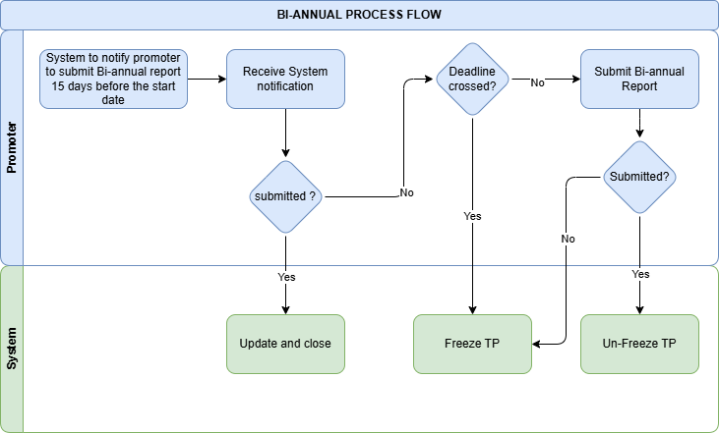

Promoter

Input Form D (Bi-annual Report on Operation of the Mine)

Field Name | Input Type | Validation | Remarks
Period of Reporting | Radio button | First half/Second half
Yearly | Date
Actual number of days operated during the half year | Number |  | In Days
A. DETAILS OF THE MINE
Name of the mine | Auto
Lessee | Auto
Postal address | Auto
Mobile No. | Auto
Telephone No | Auto
Fax No. | Auto
Email ID | Auto
Mineral(s) Mined | Dropdown | Pull from master
Save as Draft | Button
Next | Button
B. SALE OF MINERALS DURING THE PERIOD
Mineral | Dropdown | Pull from master
Postal Specification (size, dimension, grade) | Varchar
Unit (MT/Cum.) | Number
Domestic | Auto
Export | Auto
Total | Auto
C. MINERALS STOCK DETAILS
Mineral Product | Dropdown | Pull from master
Unit(MT/Cum.) | Number
Opening Balance | Auto
Raising | Auto
Total Despatch | Auto
Closing Balance | Auto
NUMBER OF TRUCKLOADS DESPATCHED: | Auto
Save as Draft | Button
Next | Button
D. WASTE GENERATED (with no economic value)
Type of Waste | Dropdown | Pull from master
Unit (Cum.) | Number
Excavated | Number
Disposed off | Number
Place of Disposal | Text
Lead Distance | Number
Method of Disposal | Dropdown | Pull from master
Save as Draft | Button
Next | Button
E. EXPLOSIVE USE AND DRILLING
a. Drilling Information
No. of Holes | Number
Drill Hole Dia (mm) | Number
Depth of Blast Holes (m) | Number
Meterage Drilled (m) | Number
Average Drilling Time/hole (min) | Auto
Total Drilling Time (min) | Auto
b. Explosives
Type of explosive and accessories | Dropdown | Pull from master
Unit | Varchar
Opening Balance | Number
Procurement/Receipt | Number
Consumption | Number
Closing Balance | Auto
c. Blasting Information
Explosive Charge per Hole (average) (unit) | Number
Charge Length per Hole (average) (m) | Number
Cost of Explosive Utilised (Nu.) | Number
Name of the Blaster | Dropdown | Pull from master
License No. | Number
Save as Draft | Button
Next | Button
F. MANPOWER
a. Details
Category of workers | Dropdown | Pull from master
Type | Radio Button | Skilled/semiskilled/unskilled
National worker
Male | Number
Female | Number
Expatriate workers
Male | Number
Female | Number
Total Workers
National | Auto
Expatriate | Auto
Total Mandays Worked | Number
Wages and Salary (Nu.) | Number
b. Summary
Total Workers | Auto
Total Wages and Salary (Nu.) | Auto
Male Workers | Auto
Female Workers | Auto
National | Auto
Expatriate | Auto
Save as Draft | Button
Next | Button
G. RETURN ON MACHINERIES
Name of Equipment | Number
Hired | Radio button | Yes/No
Fleet (No.) | Number
Running cost (Nu.) | Number
Add more | Button
H. MARKET INFORMATION
a. Domestic
Mineral product | Dropdown | Pull from master
Quantity (MT/Cum.) | Number
Price per Unit (Nu.) | Number
Value (Nu.) | Number
Sale Destination | Text
Mineral End Use | Text
Transportation Method | Dropdown | Pull from master
Transport Cost (Nu.) | Number
b. Export
Mineral product | Dropdown | Pull from master
Quantity (MT/Cum.) | Number
Price per Unit (Nu.) | Number
Value (Nu.) | Number
Sale Destination | Text
Mineral End Use | Text
Transportation Method | Dropdown | Pull from master
Transport Cost (Nu.) | Number
Save as Draft | Button
Next | Button
I. COSTS, RETURNS & REVENUE
a. Summary
Mineral product | Dropdown
Quantity (MT/Cum.) | Auto
Total Sale Value (Nu.) | Auto
Total Production Cost (Nu.) | Auto
Landed Cost (for captive Mines Only) (Nu.) | Auto
a. Break-up of Production Cost
Cost Details | Number
Salary and wages | Number
Energy | Number
Transportation | Number
Explosives | Number
Royalty, rents & taxes | Number
Environment management | Number
Depreciation | Number
Interest on loan | Number
Communication charges | Number
Other expenses | Number
Total | Auto
b. Royalty/Tax payment (Nu.)
Type of Levy | Dropdown | Pull from master
Amount (Nu.) | Number
Cheque/draft No. | Number
Date | Number
Revenue Receipt No. | Number
Receipt Date | Number
Add more | Button
Save as Draft | Button
Next | Button
J. SAFETY ASPECTS (accidents, injuries)
Date | Date
Person (s) Injured | Number
Place of Injury | Text
Cause of Injury | Text
Seriousness of Injury
Minor | Number
Major | Number
Fatal | Number
Add more | Button
Declaration | Radio Button |  | I hereby declare that the information provided herewith are true to the best of my knowledge  and in the event of false or misleading information, I shall be liable for any action under the  Mines and Minerals Management Act and Regulations thereof.
Submit | Button

Business Logic for Promoter

Business Rule
BR No. | Business Rule
 | Users (individuals or companies) authenticate/log in through National Digital Identity (NDI).
 | The system must notify the promoter to submit the bi-annual report 15 days before the report submission period starts. The system to notify the promoter two times in a year for the submission of the bi-anuual report.
 | The deadline for the submission of the first bi-annual report is from January 1 to January 15. The deadline for the submission of the second bi-annual report is from July 1 to July 15.
 | Applicants will have to submit a bi-annual report within the designated period.
 | If the promoter fails to submit the bi-annual report by the deadline, their TP must be frozen and impose a penalty.
 | Once the promoter submits the overdue bi-annual report and pay penalty, the TP should be unfrozen and the reporting requirement marked as completed.
 | Upon timely submission and approval of the bi-annual report, the process should be closed.

Functional Requirement
FR No. | Functional Requirement
 | Integration with NDI for authentication.
 | The system should automatically send a notification to the promoter 15 days before the bi-annual report submission, reminding them to submit their report.
 | The system should check if the submission deadline has passed. If the deadline is missed and the report is still not submitted, initiate the freezing process for the promoter’s TP and notify relevant stakeholders.
 | The system should send the payment link of the penalty to the promoter for not submitting the report on time.
 | Upon receiving the overdue report and penalty from the promoter, the system should update the TP status to "Unfrozen," allowing normal operations to resume.

Accident Reporting

Process Flow
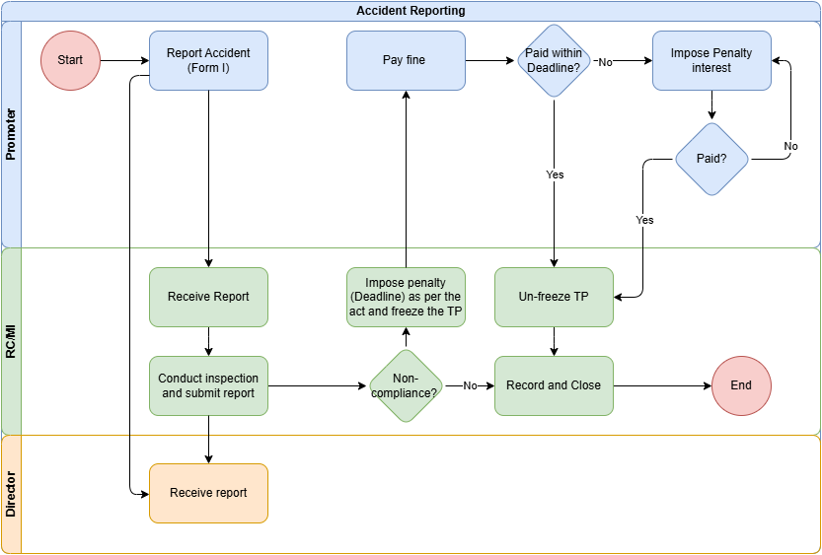

Promoter

Input Form I (Notice of Accident)
Field Name | Input Type | Validation | Remarks
PARTICULARS OF THE ACCIDENTS*
Date and hour of accident occurrence | Date
Place and location in the mine | Text
Number of person (s)
Killed | Number
Seriously injured | Number
Cause of the accident | Text
PARTICULARS OF THE INJURIES, FATALITIES, ETC.*
CID Card No. | Auto
Name of person (s) | Auto
Position/Designation | Auto
Age | Auto
Gender | Auto
Nature of injury and if fatal, cause of death | Text
Add more | Button
Save as Draft | Button
Next | Button

Business Logic for Promoter

Business Rule
BR No. | Business Rule
 | Users (individuals or companies) authenticate/log in through National Digital Identity (NDI).
 | The promoter will submit the report of any accident in Form I to the system as and when an accident occurs.
 | If an accident is due to non-compliance, the promoter must pay the fine within the specified deadline and the system will impose specific actions such as freezing the TP.
 | If the fine is not paid within the deadline, additional penalty interest will be applied. The promoter is responsible for paying both the initial fine and the accrued penalty interest if they miss the original deadline.
 | The applicant is required to comply with any penalties imposed and ensure non-compliance issues are addressed promptly to unfreeze their TP.

Functional Requirement
FR No. | Functional Requirement
 | Integration with NDI for authentication.
 | The system shall allow the applicant to fill out and submit an accident report form (Form I).
 | In addition, the form submission shall support the uploading of relevant documents or images as attachments, with a file size limit
 | The system shall automatically send a confirmation notification (via email or SMS) to the applicant upon successful submission of the accident report.
 | The system shall send reminders to the applicant regarding fine payment deadlines, including initial notices and follow-up reminders if the deadline is approaching.
 | If additional penalty interest is applied due to a missed deadline, the system shall notify the applicant with details on the accrued interest and updated payment amount.
 | Upon successful payment, the system shall generate and send an electronic receipt to the applicant for record-keeping.
 | The system shall allow the applicant to log in and view the status of any submitted accident report

RC/MI

Input field for RC/MI

Field Name | Input Type | Validation | Remarks
View Accident Report | Button |  | View the Accident report submitted by promoters
Submit report | Button
Attach Report | FIle Upload |  | The site verification report

Business logic for RC/MI

Business Rule
BR No. | Business Rule
 | Option to log in as an agency user.
 | The RC/MI must receive and review the accident report submitted by the promoter promptly upon submission.
 | Following the receipt of an accident report, the RC/MI must conduct an inspection and submit an inspection report.
 | If the inspection reveals non-compliance with safety or operational regulations, the RC/MI must impose a penalty as specified by the regulations and freeze the TP of the promoter until compliance is met.
 | If the promoter fails to pay, additional penalty interest should be automatically applied.
 | The system will unfreeze the TP only after verifying that corrective actions have been completed and the penalty is paid.

Functional Requirement
FR No. | Functional Requirement
 | Option to log in as an agency user.
 | The system should enable the RC/MI to receive and view accident reports submitted by the promoter. This includes features to download report details and attachments for further review.
 | The system should allow the RC/MI to log inspection activities, attach supporting documents.
 | The RC/MI should have system capabilities to flag non-compliance, impose penalties, set compliance deadlines, and initiate automatic freezing of the TP until the issues are resolved.
 | After compliance verification, the system should unfreeze the TP by updating the status in the system.
 | The system should support tracking of penalty payments and, if deadlines are missed, apply additional interest automatically. This information should be visible to the RC/MI for monitoring purposes, and alerts should be generated for overdue payments

Director

Input field for Director

Field Name | Input Type | Validation | Remarks
View Accident Report | Button |  | View the Accident report submitted by promoters

Business logic for Director

Business Rule
BR No. | Business Rule
 | Option to log in as an agency user.
 | The Director must be notified of all accident reports submitted by the promoter and receive a copy of the final report from the Regional Coordinator/Mine Inspector (RC/MI) after the inspection.

Functional Requirement
FR No. | Functional Requirement
 | Option to log in as an agency user.
 | The system should notify the Director of all new accident reports submitted by the promoter and provide access to view the initial report details and attachments.
 | The system should allow the Director to view the final inspection report submitted by the RC/MI. This includes access to inspection notes, evidence (e.g., photos), compliance status, and any penalties or corrective actions imposed.

Temporary Closure

Process Flow
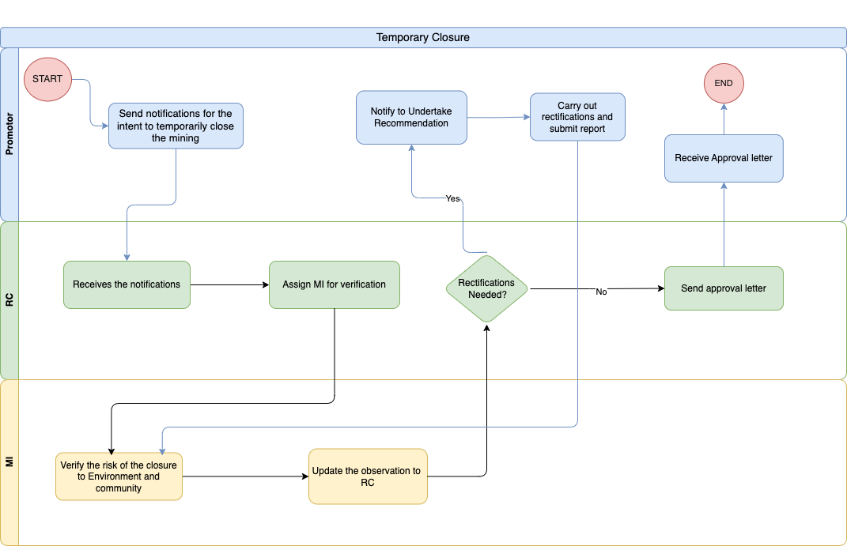

Promoter

Input field for Promoter

Field Name | Input Type | Validation | Remarks
Send notification | Button |  | Sends notification for the intent to temporarily close the mine/quarry
Attach report | Text/File Upload |  | Attach the report
Submit | Button |  | Submits the report

Business logic for Promoter

Business Rule
BR No. | Business Requirement
 | Users (individuals or companies) authenticate/log in through National Digital Identity (NDI).
The lessee notifies the intent to temporarily close the mining operation by depending on the following reasons:
- Market for mineral
- Financial Problem (evidence to be submitted)
- Community complaint (evidence to be submitted)
- Legal issues (evidence to be submitted)
- natural calamities (i.e landslide, water inundation, flash flood, subsidence)
- seasonal closing
- any other reason
 | The RC will check if there needs any rectifications to be carried out before temporarily closing the mine and update the decision to the promoter.
 | If there is a need for rectification to undertake, inform the promoter to do NA and submit a report. The promoter can rectify and resubmit their report as many times as needed based on the feedback provided by the RC. The resubmission cycle will continue until the application meets the satisfaction of the RC.
 | ELse promoter receives approval letter from RC for temporary closure of mine.

Functional Requirement
FR No. | Functional Requirement
 | Integration with NDI for authentication.
 | From the temporary closure dashboard, the promoter should be able to notify the intent to temporarily close mining operation to RC by choosing the option from the dropdown list. If the reason is other, specify the reason.
 | If the proposed temporary closure is more than 2 years, the system should not accept the proposal.
 | the promoter should be able to view the decision of RC.
 | If RC decides to approve the temporary closure of mine, the promoter shall receive an approval letter from RC.
 | Else, the promoter should undertake rectification and submit the report to RC.
 | Integration with SMS gateway for sending notifications to users at every stage

Regional Coordinator

Input field for RC

Field Name | Input Type | Validation | Remarks
View Notification | Button |  | View the Intent to temporarily close
Assign MI | Pull from master |  | Assign MI for verification
Remarks | Text
View Report | Button |  | View the submitted report
Approve report | Button
Remarks | Text |  | Send reasons for approval
Reject Report | Button
Remarks | Text |  | Send reasons for rejection

Business logic for RC

Business Rule
BR No. | Business Rule
 | Option to log in as an agency user.
 | The RC will receive notification from the promoter intending for temporary closure of mine.
 | The RC will then be assigned to MI for verifications.
 | Once MI verifies the risk of closure to the environment and community, the RC review the observation and decide whether there is rectification to be carried out by Promoter.
 | If rectification is needed, RC notify promoters to undertake the rectifications.
 | Else, the RC will send approval letter for temporary mine closure.

Functional Requirement
FR No. | Functional Requirement
 | Integration with NDI to login as Agency user.
 | The RC dashboard should show notifications from promoters intending to temporarily close the mine.
 | The system should allow RC to assign MI to verify the risk of closure to the environment and community.
 | After MI updates the observation to the system, RC should be able to view the report and make decisions based on the observation.
 | If RC decides to approve the temporary closure of mine, the promoter shall receive an approval letter from RC.
 | Else, the promoter should undertake rectification and submit the report to MI.
 | Integration with SMS gateway for sending notifications to users at every stage

Mining Inspector

Input field for MI

Field Name | Input Type | Validation | Remarks
View Closure Notification | Button |  | View the Closure notification
Send rectification works | Text/File Upload |  | Send to promoters to carry out rectification works.
Approve Closure notice |  |  | Approves the temporary closure

Business logic for MI

Business Rule
BR No. | Business Rule
 | The MI verifies the risk of closure to the environment and community.
 | Once verified, the MI will update the observation to RC for necessary decisions to be made.

Functional Requirement
FR No. | Functional Requirement
 | Option to log in as an agency user.
 | The dashboard for MI shall display a list of tasks assigned. The tasks should be organized by priority and deadline to facilitate efficient management.
 | Chief should be able to filter tasks by status (e.g., pending, in progress, completed) for better visibility.
 | The system should allow MI to update the observation after verifying the risk of the closure to the environment and community.

Termination

Process Flow
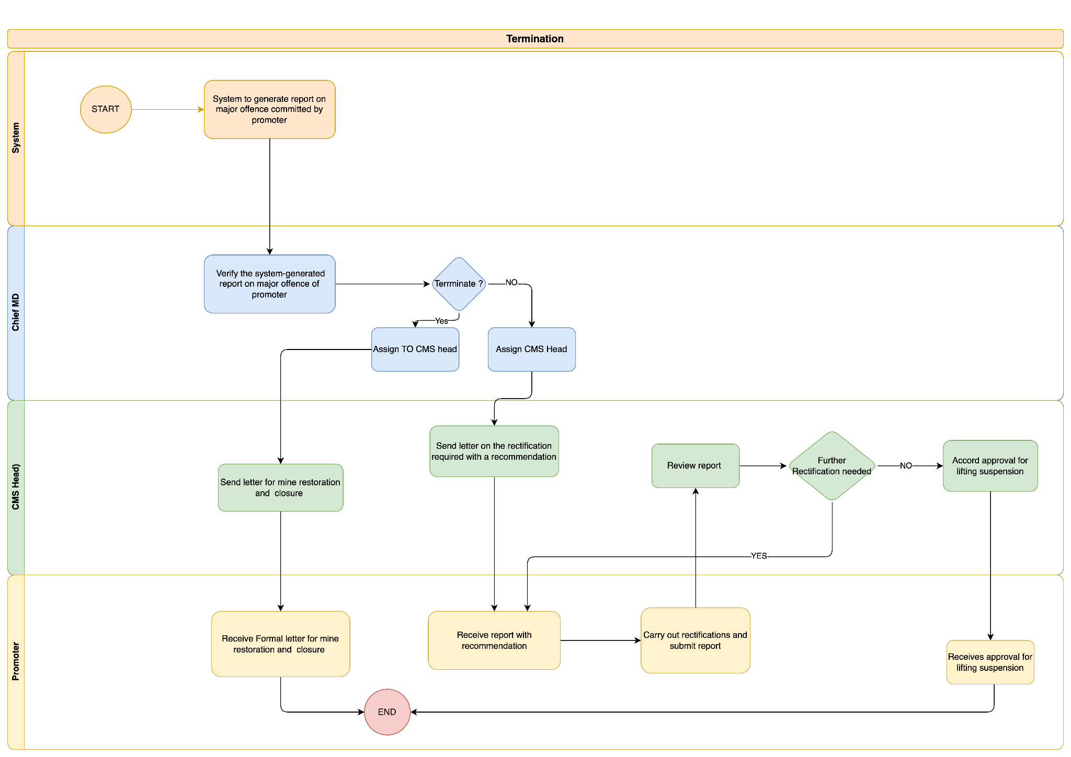

Chief, Mining Division

Input Field for Chief, MD

Field Name | Input Type | Validation | Remarks
major offense Report | Button |  | View System generated major offense Report
Assign to CMS | Button |  | Assign termination CMS head
Remarks | Text field |  | Instructions to CMS head

Business Logic for Chief, MD

Business Rule
BR No. | Business Rule
 | MD chief authenticate/log in through National Digital Identity (NDI).
 | The system to generate major offense of the promoter and notify Chief MD.
 | Chief MD shall verify the system-generated report of the major offense of the promoter.
 | Chief MD shall submit the report to MTC

Functional Requirement
FR No. | Functional Requirement
 | Option to log in as an agency user using NDI.
 | From the reporting dashboard, the chief should be able to view the report of the major offense committed by the promoter.
 | The system should provide an option for the chief to verify the system generated report.
 | Upon verification, the chief shall submit a report to MTC.
 | The system should notify the promoter of major offenses committed.
 | The system should notify the MTC head of the report submitted by Chief MD.

CMS Head, MTC

Input field for CMS Head, MTC

Field Name | Input Type | Validation | Remarks
major offense Report | Button |  | View System generated major offense Report
Send closure letter | File Upload |  | Send closure and restoration letter
Remarks | Text field |  | Additional remarks if any
Send Rectification letter | File Upload
View Rectification report | button |  | View uploaded rectification done
Seek additional info | Button with remarks |  | Prompt the promoter to resubmit the report.
Lift suspension | Button |  | Lift suspension of TP

Business logic for CMS Head, MTC

Business Rule
BR No. | Business Rule
 | The MTC shall review the report submitted by Chief MD.
 | Based on review, MTC shall upload the decision.
 | The MTC shall decide whether to terminate the Mine Leasing Agreement (MLA.
 | If MTC decides to terminate MLA, the MTC shall send a letter to the promoter for mine closure and mine restoration.
 | Else, the MTC shall send rectifications to be carried out with recommendation if any to the promoter.
 | MTC shall review the report on rectifications submitted by the promoter and verify if further rectification is required or not.
 | If further rectification is required, send an order to carry out rectification again.
 | Else, MTC shall accords approval for lifting suspension.

Functional Requirements
FR No. | Functional Requirement
 | Option to log in as an agency user using NDI.
 | The MTC should be able to view the report submitted by the Chief MD and have the option to review it.
 | Upon reviewing the report, the system should provide an option for the MTC to terminate MLA or not.
 | If MTC decides to terminate MLA, the system should notify the promoter with reason for termination and request to send a mine closure and restoration plan.
 | Else, the MTC should be able to send reports on rectifications to be carried out with recommendations to the promoter.
 | Upon submission of a report on rectifications carried out by the promoter, MTC should be able to review the report.
 | If additional changes are required, the Head will forward the report for further changes. The application will proceed to the next stage only after the focal verifies and approves the revisions.
 | ELse, MTC shall accords approval of lifting suspension.
 | The system should notify the promoter on every action taken by MTC if it has to be known by the promoter.

Promoter

Input field for Promoter

Field Name | Input Type | Validation | Remarks
View Report | Button |  | View the rectification required
Attach Report | File Upload |  | Attach the rectification work carried out.
Remarks | Text field |  | Additional remarks if any
Submit report | Button |  | Submit the report.

Business logic for Promoter

Business Rule
BR No. | Business Rule
 | Users (individuals or companies) authenticate/log in through National Digital Identity (NDI).
 | The system notify the promoter on major offenses committed during mining/quarrying lease which will be pulled from form P.
 | Upon decision from MTC, the promoter's MLA will either be not terminated or will be terminated.
 | If MLA is terminated, the promoter will receive reason for termination and Have to submit the mine closure and restoration plan.
 | Else, the promoter will receive a report on rectifications to be carried out with recommendations from MTC.
 | The promoter will carry out rectifications and submit the report. The promoter can rectify and resubmit their report as many times as needed based on the feedback provided by the MD focal. The resubmission cycle will continue until the application meets the satisfaction of the MD focal. Each submission and corresponding review must be tracked, and the application cannot advance to the next stage without approval from the MD focal.
 | If the report is approved by MTC, the promoter receives an approval letter for lifting the suspension.

Functional Requirements
FR No. | Functional Requirement
 | Integration with NDI for authentication.
 | The system should send a report on major offenses committed by the mining/quarrying lease which will be pulled from form P.
 | The promoter will receive the decision made by the MTC based on a system generated report.
 | If the decision is to terminate the MLA, the promoter shall be able to view the reasons for termination and should be able to submit a mine closure and restoration plan.
 | IF the decision is not to terminate the MLA, the promoter shall be able to view the rectifications report with recommendations sent by MTC and should carry out rectifications accordingly. Once the rectifications have been carried out, the promoter should submit the report.
 | Integration with SMS gateway for sending notifications to users at every stage

Immediate suspension

Process Flow
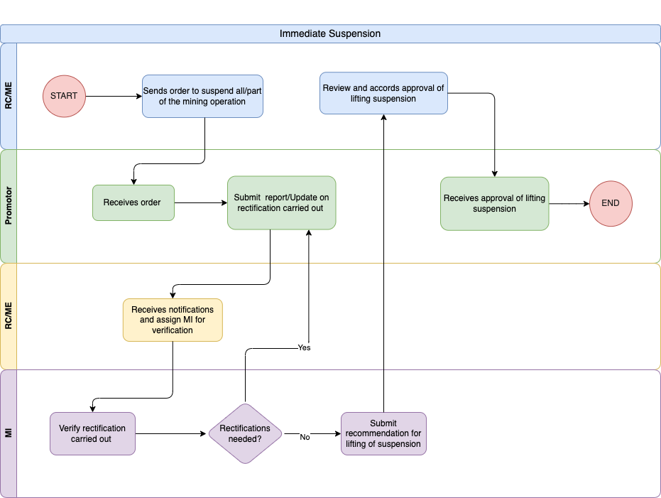

RC/ME

Input field for RC/ME

Field Name | Input Type | Validation | Remarks
Suspend | Button |  | Suspend/stop a portion of the mine
Remarks | Text field |  | Additional remarks if any
View Recommendation | Button |  | View the recommendation from MI
Approve | Button |  | Approves the lifting of suspension
Remarks | Text field |  | Additional remarks if any

Business logic for RC/ME

Business Rule
BR No. | Business Rule
Concerned RC/ME shall suspend the operation of a mine in whole or a part based on the checklist provided with the deadline. Checklist for immediate suspension of part /whole of the mine/quarries:
- Misfire due to blasting
- Undercutting/caving, overhanging
- Sliding area
- Fly rock issues
- Accidents in the mine
- Deviation from mine plan
- Complaint / legal issues/ dispute
- Violation of any provisions of MMMA, MMMR MLA and Permits
- Any other(s)
 | Once MI sends recommendation for lifting of the suspension, the RC/ME will accord approval of lifting suspension to the Promoter.

Functional Requirement
FR No. | Functional Requirement
 | Option to log in as an agency user.
 | The system should provide an option for RC/ME to send an order to suspend the operation of mine in whole/part based on the promoter. The reasons can be selected from the dropdown list.
 | The system should allow RC/ME to view the recommendations submitted by MI for lifting the suspension.
 | The RC/ME should send approval for lifting of suspension to the promoter.

Promoter

Input field for Promoter

Field Name | Input Type | Validation | Remarks
View Suspension | Button |  | Will show the suspension report
Attach report | File upload |  | To attach the rectification work report.
Submit | Button |  | Submits the rectification report.
View | Button |  | Chekc the suspension lifting letter.

Business logic for Promoter

Business Rule
BR No. | Business Rule
 | The promoter receives order from RC/ME on suspending the whole/part of the mining operation.
 | After receiving the order, the promoter has to submit a report on rectifications carried out.
 | Users can revise and resubmit their rectifications report as many times as needed based on the feedback provided by the RC/ME. The resubmission cycle will continue until the report meets the satisfaction of the RC/ME. Each submission and corresponding review must be tracked, and the application cannot advance to the next stage without approval from the RC/ME focal.
 | The promoter will receive the approval letter for lifting suspension only after MI goes for site verification and recommends lifting of suspension to RC/ME.

Functional Requirement
FR No. | Functional Requirement
 | Integration with NDI for authentication.
 | In the promoter dashboard, the promoter should be able to view the order sent by RC/ME on suspending all/part of the mining operation.
 | After receiving the order, the promoter will carry out necessary rectifications.
 | Once the rectifications are carried out, the promoter should be able to upload the report in the system.
 | The promoter shall receive an approval letter for lifting of suspension after being verified.

Mining Inspector

Input field for MI

Field Name | Input Type | Validation | Remarks
View | Button |  | View the rectification report
Approve | Button |  | Approves and verifies the rectification carried out
Remarks | Text field |  | Additional remarks if any
Re-submit | Button |  | Will prompt the promoter to carry out rectification or resubmit the Rectification report
Remarks | Text field |  | Additional remarks if any

Business logic for MI

Business Rule
BR No. | Business Rule
 | The MI receives rectifications report from the promoter and goes for site verification.
 | If further rectification is required, the MI will forward only the specific sections of the report (input fields) that need changes. The MI will submit recommendation for lifting the suspension only after the site verification and approves the revisions.

Functional Requirement
FR No. | Functional Requirement
 | Option to log in as an agency user.
 | The dashboard for MI shall display a list of tasks assigned. The tasks should be organised by priority and deadline to facilitate efficient management.
 | MI should be able to filter tasks by status (e.g., pending, in progress, completed) for better visibility.
 | MI should be able to view the rectifications report uploaded by the promoter.
 | The system should allow MI to submit the recommendation of lifting suspension after site verification.

Mine Restoration

Process Flow
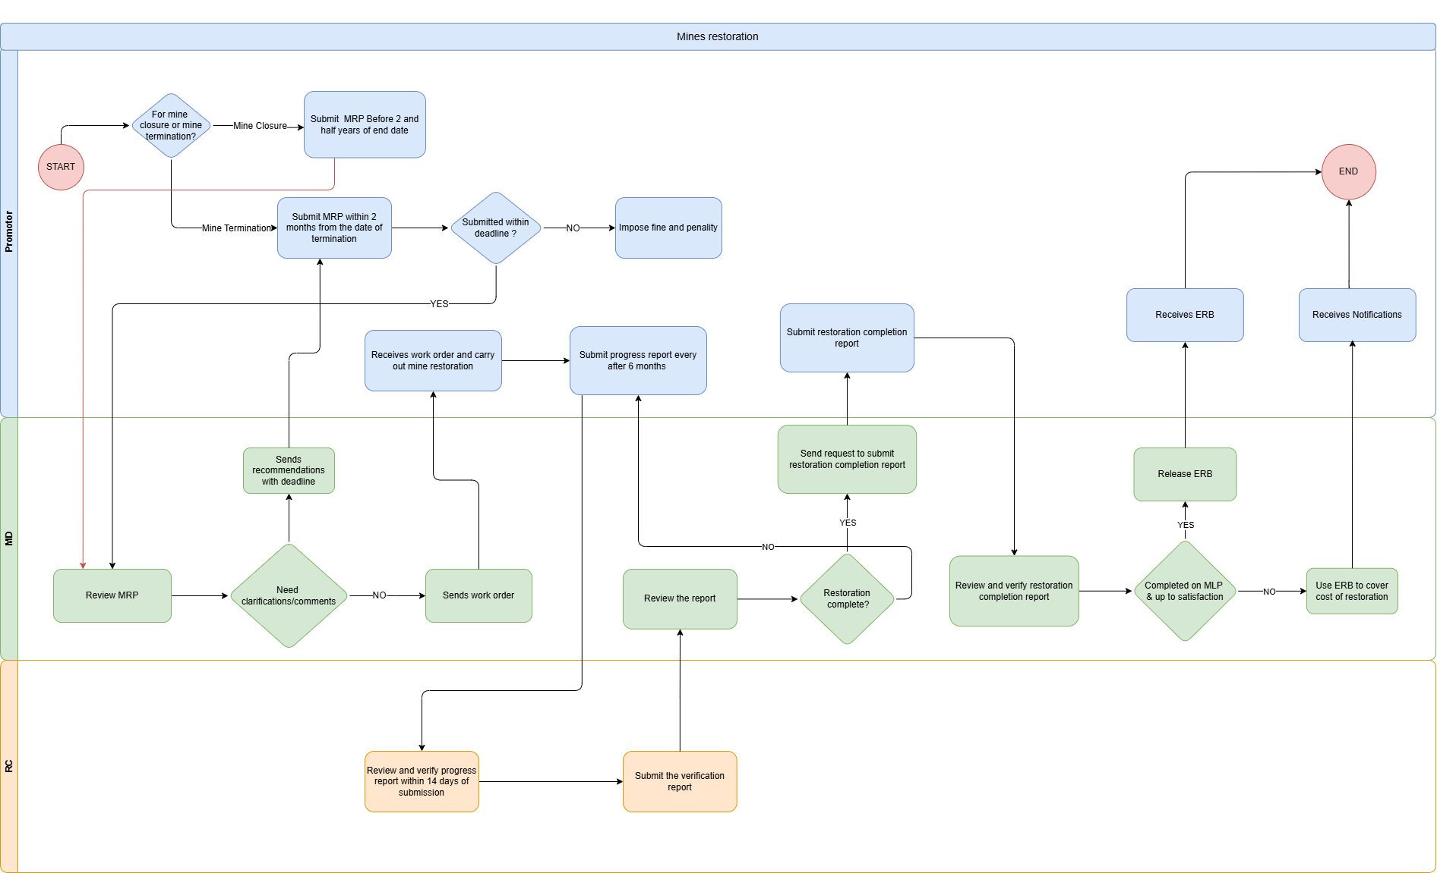

Promoter

Input Field for Promoter

Field Name | Input Type | Validation | Remarks
Restoration | Select |  | Select whether the restoration is for mine closure or due to termination
Attach MRP | File Upload |  | Upload the MRP
Submit | Button |  | Submit the MRP
Attach MRP | File Upload |  | Upload the rectified MRP
Resubmit | Button |  | Resubmit the MRP
View | Button |  | View Work Order
Attach Progress report | File Upload
Submit | Button |  | Submit the progress report

Input Field for progress report

Field Name | Input Type | Validation | Remarks
- Background of Mine
Name of Mine/Quarry* | Auto | Pull from DB
Location Image | File
Lease Area (Acre) | Auto | Pull from DB
Name of Lessee | Auto | Pull from DB
Start Date of Mine Restoration | Date
Progress Report Number | Number | Auto increment
- Details of Progress Made
Date of Progress Report | Date | Auto
Activity Description | Text
Financial Progress (against MRP) | Text
Physical Progress (against MRP) | Text
Pictural evidence | File
Save as Draft | Button
Submit | Button

Input Field for Mine Restoration Completion Report

Field Name | Input Type | Validation | Remarks
- Background of Mine
Name of Mine/Quarry* | Auto | Pull from DB
Location Image | File
Lease Area (Acre) | Auto | Pull from DB
Name of Lessee | Auto | Pull from DB
- Activities Undertaken
Sl. No. | number | Auto increment
Activity Description | Text | Varchar
Duration | Text | Day/month
Cost (Nu. ) | Number
Safe as Draft | Button
Next | Button
Attachment
Remarks | Text | Not mandatory
Pictorial Evidence | File | Multiple image
Maps and plans | File | image/map
Others | File
Save as Draft | Button
Submit | Button

Business Logic for Promoter

Business Rule
BR No. | Business Requirement
 | Promoter (individuals or companies) authenticate/log in through National Digital Identity (NDI).
 | The system will notify the promoter 2½ years before the lease end date to submit the Mining Restoration Plan (MRP)
 | Promoters intending to renew their lease are exempted from submitting the restoration plan, and the lease renewal process will be initiated instead.
 | In cases of termination or surrender of the mining lease, the lessee must submit the MRP within 2 months from the termination or surrender date.
 | If the MRP is not submitted within the specified timeline, fines and penalties will be imposed.
 | If the MRP is submitted within timeline, the restoration plan will be forwarded to ME for review and approval.
 | Promoters must submit a physical progress report every 6 months until the restoration is approved.
 | The system will notify the promoter 1 month before the deadline to ensure timely submission.
 | Once the restoration process is complete, the promoter must submit a Restoration Completion Report for final approval.
 | The applicant will receive the Environmental Restoration Bond (ERB) if the restoration work is completed on MLP and is to the satisfaction of the Mining Engineer (ME). Otherwise, the ERB will be utilized by the Department of Geology and Mines (DGM) to cover the restoration costs.

Functional Requirement
FR No. | Functional Requirement
 | Integration with NDI for authentication.
Notify promoters 2½ years before the lease end date for MRP submission.
Notify promoters 1 month before progress report deadlines
 | Provide an interface for submitting the MRP using a predefined template.
 | Enforce submission deadlines for termination cases or surrender of the mining lease.
Apply penalties automatically if MRP submission is missed.
Implement a system to calculate and impose fines/penalties for missed MRP deadlines.
 | System will auto assign submitted MRP to the concerned focal (ME) for review
 | Provide a template for progress report submission.
 | Facilitate the submission of a Restoration Completion Report by the promoter for final approval once restoration is complete.
Automatically refund the ERB to the applicant through BIRMS if the restoration work is approved by the ME.
If restoration is not satisfactory, the DGM will not release the ERB. promoter will be notified via SMS or email.

Mining Engineer, Mining Division

Input field for Mining Engineer, Mining Division

Field Name | Input Type | Validation | Remarks
View MRP | Button
Reject | Button
Remarks | text |  | Reasons for rejection and to resubmit
Approve | Button |  | Approves the MRP
Remarks | text
View | Button |  | Views both the progress report and the site verification from region
Request Completion report | Button |  | Request to submit the completion report
Issue ERB release | Button |  | Send ERB release letter

Business logic for Mining Engineer, Mining Division

Business Rule
BR No. | Business Rule
 | Option to log in as an agency user.
 | The ME will receive the Restoration plan based on workload.
 | The Mining Engineer (ME) will review the restoration plan and, if additional information is required, will return it to the promoter for revisions and resubmission. This process will repeat until the ME is satisfied with the restoration plan.
 | Upon MRP approval of Restoration plan, a work order will be issued to the promoter to proceed with the restoration process.
 | The ME will receive the Progress report along with the verification report submitted by the RC/MI.
 | The ME will and review the progress report and verification report and this process will continue till the completion of restoration.
 | After the completion of restoration, the ME will request promoter to submit Restoration Completion Report
 | The ME will release the Environmental Restoration Bond (ERB) if the restoration work is completed on MLP and is to the satisfaction of the Mining Engineer (ME). Otherwise, the ERB will be utilized by the Department of Geology and Mines (DGM) to cover the restoration costs.

Functional Requirement
FR No. | Functional Requirement
 | Integration with NDI to login as Agency user.
 | Enable the submission of the Restoration Plan (MRP) and track the review process by the ME.
Allow the ME to provide feedback and request resubmission from the promoter if additional information is required.
Implement an iterative process for plan revisions until the ME is satisfied.
Once approved, generate a work order for the promoter to begin the restoration process.
Allow the ME to receive and review progress reports and verification reports submitted by the RC/MI.
Track the review process until the restoration work is complete, with options for feedback or request for further information.
Once the ME confirms that the restoration is complete, the system will automatically prompt the promoter to submit the Restoration Completion Report.
Provide a template for the promoter to complete and submit the report.
Maintain a detailed log of all actions taken by the ME, including approvals, requests for revisions, and feedback.
Track the issuance of the work order and the progress of the restoration process.
Send automatic notifications to the promoter for each required action (e.g., plan resubmission, progress report submission, final completion report).
Notify the ME when actions are required or reports are due for review.

Regional Coordinator/Mining Inspector

Input field for RC/MI

Field Name | Input Type | Validation | Remarks
View MRP | Button
View Progress Report | Button
Attach report | File Upload |  | Upload verification report
Submit | Button |  | Submits the verification report

Business logic for RC/MI

Business Rule
BR No. | Business Rule
 | The Regional Coordinator (RC)/MI will review and verify the progress report within 14 days of submission and provide a verification report to the Department.

Functional Requirement
FR No. | Functional Requirement
 | Option to log in as an agency user.
Provide a template for progress report submission.
Enable Regional Coordinators to review, verify, and submit a verification report to the Department within 14 days.
 | Upon verification of progress report by the RC, the Progress report along with the verification report will be received by the ME

Surface collection Permit

Process Flow
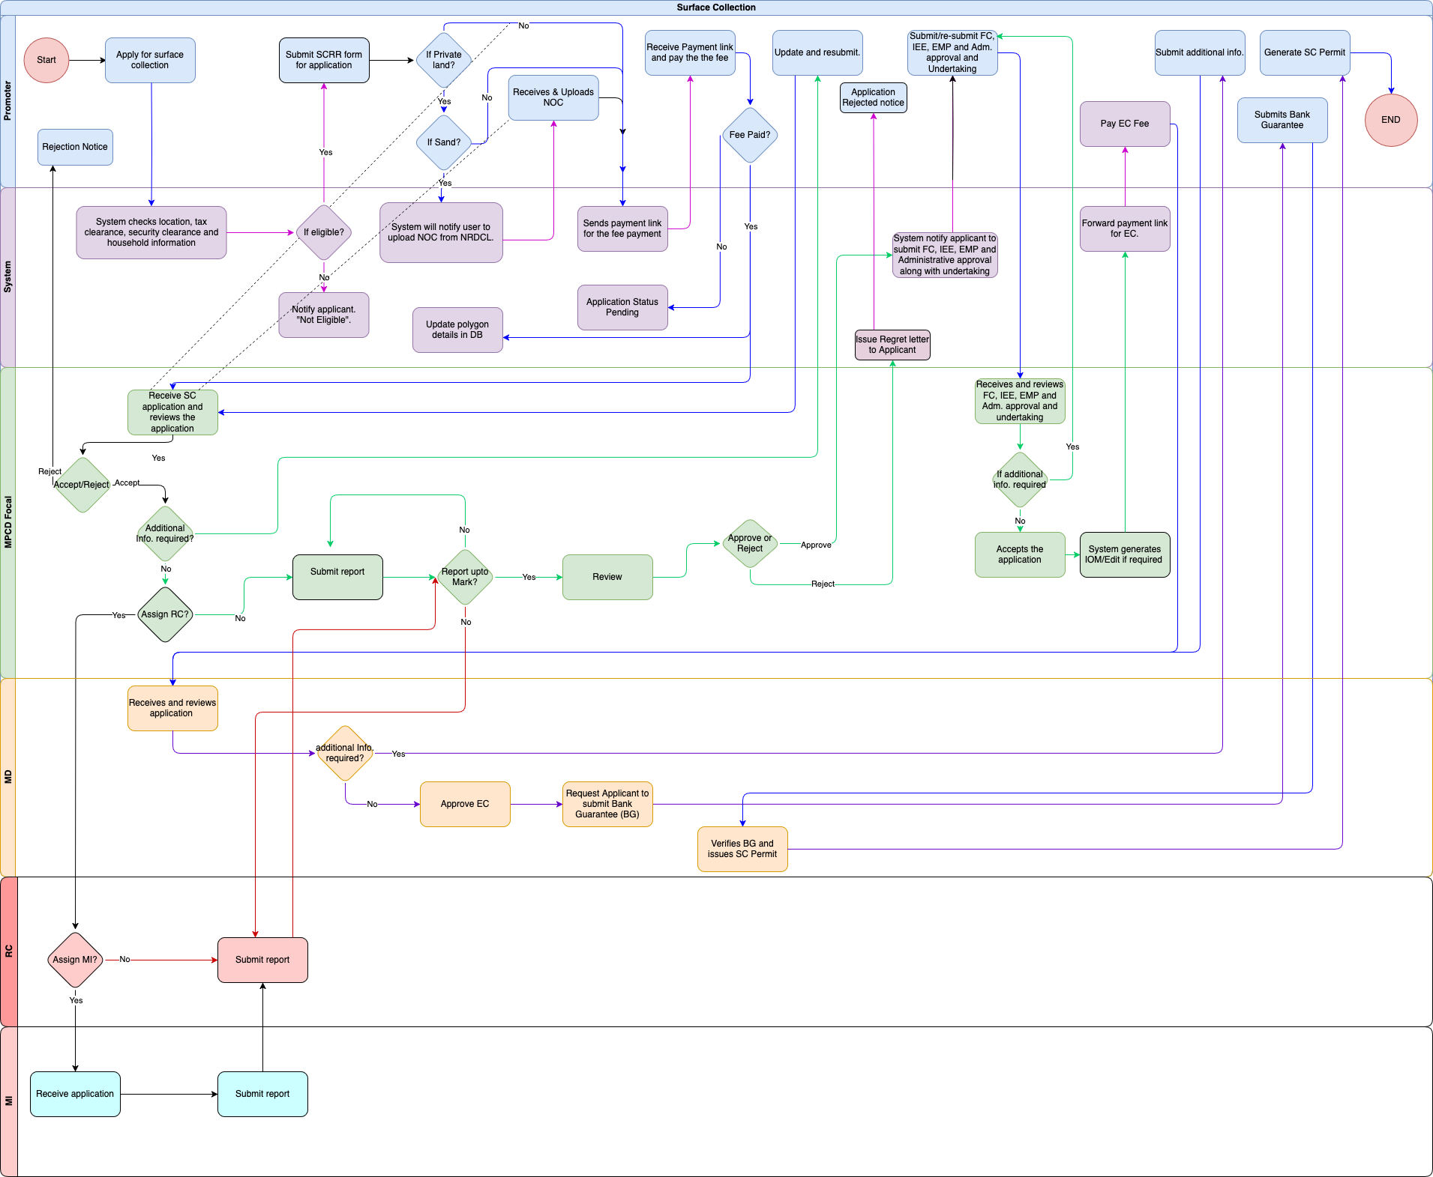

Promoter

Input Field for Promoter
Field Name | Input Type | Validation | Remarks
Section 1 Eligibility Check
CID | Auto | Pull from DCRC(for integration)/NDI should be implemented
Mobile Phone | Auto | Pull from DCRC
Email ID | Auto | Pull from DCRC
Security clearance Validity | Auto | Pull from security clearance system
Tax clearance Validity | Auto | Pull from RAMIS
Household Information | Auto | Pull from DCRC | Checks for the number of operational mining leases in the same household. The maximum allowed number is 2.
Attachment Map | KMZ/KML
Check for Location | Button |  | The system checks if the KMZ and KML attached by the user overlap with other booked polygons or if the area is already booked by others.
Next | Button
Section 2 Detail for proposed surface collection/dredging activity
Type of Activity | Checkbox |  | Types are:  Surface collection, dredging, stock lifting and migration works
Type of materials | Checkbox |  | Types are:  Stones, sand, boulder
Location
Place/village | Select | Masters/DCRC
Gewog | Select | Masters/DCRC
Dzongkhag/Thromde | Select | Masters/DCRC
Collection site | Checkbox |  | Sites are:  1. Land surface  2. Riverbeds/Riverbanks  3. Road Right of Way  4. Land Developments  5. Others
Proposed Area (acres)
State Reserved Forest Land | Number
State Land | Number
Private registered land | Number
Road Right of Way | Number
Number of surface collection/dredging permits in hand | Auto | Pull from DB
Number of applications under process | Auto | Pull from DB
Recommendation Letter from the concerned agency in case of mitigation works or stock lifting from Road Right of Way and land development. | File | Optional | Recommendation Letter from the concerned agency in case of mitigation works or stock lifting from Road Right of Way and land development.
Consent Letter | File | Optional | Consent for use of private land from the land owner (if applicable)
Declaration | Checkbox |  | I, hereby certify that the details given above are true to the best of my knowledge. In case of my false or wrong information, I am liable to be penalized under the prevailing Mines and Mineral Management Act 1995 and its regulation made there under:
Save as Draft | Button
Submit | Button
Surface collection permit Process
Pay Fee | Button |  | Will take into Birms for payment of processing Fee
Resubmit | Button |  | To submit the whole application again
Attach FC | File Upload
Attach IEE | File Upload
Attach EMP | File Upload
Attach Adm Approval | File Upload
Attach undertaking | File Upload
Pay EC fee | Button |  | To take into Birms for payment of EC fees
Upload BG | File Upload
Submit BG | Button
Generate Permit | Button |  | Generates printable Surface collection permit

Business Logic for Promoter

Business Rule
BR No. | Business Rule
 | An applicant (individuals or companies) authenticate/log in through National Digital Identity (NDI).
 | The user will enter the coordinates (Polygon) of the area selected for lease.
 | The system checks if the coordinates entered by the user overlap with other booked polygons or if the area is already booked by others.
 | The applicant cannot proceed with the application if the location is already in use or overlaps with another’s polygon.
 | The system also checks for other eligibility such as valid Tax clearance certificates, security clearance and the number of Surface collection leases in the same household.
 | Only if the above conditions are met, the applicant can proceed with the application
 | The applicant will specify whether they are a state-owned entity or a private individual/company. If the applicant is a state-owned entity, they are eligible to apply for multiple surface collection leases with no restrictions on the area.
 | If the applicant is a private entity, the system will verify the database for any existing surface collection leases associated with the applicant's name (CID). If an existing lease is found, the applicant will not be allowed to proceed with the application.
 | If the applicant is a private entity and no existing lease is found, they will have the option to specify whether they are applying for sand, minerals, or stones and boulders. The maximum area limit will be determined based on the selected category.
 | If the applicant is a private entity and if they are applying for sand, the applicant will be notified by the system to submit NOC from NRDCL. The application cannot proceed further without uploading NOC (NRDCL system integration).
 | The applicant must submit a surface collection application (Form SCRR (Annex 1)) along with a consent letter (if the proposed area falls within private land).
 | The SMS will be sent to a user to pay the application fee. The application cannot advance to the next stage without completing the payment process.
 | Once the payment is cleared, the application will be forwarded to the relevant MPCD officials.
 | The applicant should be able to resubmit the application with the required information or documents based on the recommendations or feedback provided by the DGM.
 | The applicant will submit/fill in IEE and EMP through the template along with administrative approval from the concerned Gewog Office.
 | The applicant should be able to resubmit the IEE and EMP with the required information or documents based on the recommendations or feedback provided by the DGM.
 | The applicant will receive the payment Link via email/SMS to pay EC fees.
 | The applicant will pay the EC fees through the BIRMS payment gateway.

Functional Requirement
FR No. | Functional Requirement
 | Integration with NDI for authentication.
 | Integration with the DCRC system for household information to check for the number of operational mining leases in the same household. The maximum allowed number is 2.
 | Integration with the Tax system for validating tax clearance certificate
 | Integration with security clearance system, RBP for Security clearance validation
 | Integration with SMS gateway for sending notifications to users at every stage
 | Data migration from a legacy system to fetch the area/location of the existing lease with coordinates (Polygon)
 | The system sends an SMS reminder for every action required from the applicant side.
 | Release area/polygon if no action is taken.
 | The system captures the initial application, SMS notification, application revision (if any), EMP and IEE submission, and timestamp for reporting.
Eligibility for Maximum area (Acre) based on category:
- Sand: Maximum 3.
- Stones & boulders: Max 5.
- Minerals: Max 5.
 | The applicant will receive a payment link via SMS/email
 | The application will only be forwarded to the MD for the processing of the Environmental Clearance (EC) after the payment is made. Otherwise, the application status will remain pending.

MPCD Officer

Input field for MPCD Officer
Field Name | Input Type | Validation | Remarks
View Application | Button
Accept Application | Button
Remarks | Text/Varchar
Reject Application | Button
Remarks | Text/Varchar
Req Additional Info | Button
Remarks | Text/Varchar
Assign | Select |  | Select: RC/MPCD focal
Remarks | Text/Varchar
MPCD taking up the site visit
Attach report | File Upload
Submit report | Button
Resubmit Report | Button
View Report | Button
Approve | Button
Remarks | Text/Varchar
Reject | Button
Remarks | Text/Varchar |  | Reasons for rejection
View Clearances | Button |  | View the uploaded FC, IEE,EMP, etc
Request additional Info | Button |  | Request promoter to submit the required docs.
Generate IOM | Button |  | This will prompt the system to generate a sample notesheet
Edit IOM | Button |  | Modify the system generated IOM
Issue IOM | Button |  | Submit the IOM to MD

Business logic for MPCD Officer

Business Rule
BR No. | Business Rule
 | The system will automatically assign the application to the MPCD focal based on their current workload.
 | Email and system notifications will be sent to the assigned MPCD focal upon assignment of the application.
 | MPCD focal can re-assign the task to another MPCD focal if he/she is busy/on leave.
 | The MPCD focal Officer reviews the submitted application
 | If additional information is required, the focal will forward only the specific sections of the application (input fields or documents) that need further details or changes, along with remarks outlining the necessary updates. The application will proceed to the next stage only after the focal verifies and approves the revisions.
 | After the focal reviews and site verifications, the application is forwarded to the Mining Technical Committee (MTC) meeting for endorsement.
 | The MPCD focal will update the decisions from the MTC meeting, and if additional information is required, the focal will forward the application for the necessary changes to be made. This resubmission cycle will continue until the application satisfies the MPCD focal. All submissions and their corresponding reviews must be tracked, and the application cannot progress to the next stage without acceptance from the MPCD focal.
 | If the application is accepted and the proposed area is on private land, the system will notify the applicant through SMS and email to submit the IEE, EMP, and administrative approval from the relevant Gewog Administration office.
 | If the application is accepted and the proposed area is not on private land, the system will notify the applicant via SMS and email to submit the IEE, EMP, and administrative approval from the relevant Gewog Administration office. Simultaneously, the system will request forest clearance from the OFS system.
 | The MPCD focal will review the submitted IEE, EMP, and administrative approval. If additional information is required, the focal will request it by forwarding the application back to the applicant.
 | If the MPCD focal accepts the IEE and EMP, the system will automatically share the payment link to promoter for EC.
 | Once the Payment is made by the promoter, the application is forwarded to ME, MD for review and issuance of EC.

Functional Requirement
FR No. | Functional Requirement
 | Option to log in as an agency user.
 | The dashboard for MPCD focal shall display a list of tasks along with their current status. The tasks should be organised by priority and deadline to facilitate efficient management. The dashboard must provide real-time updates on task status, allowing MPCD to track progress.
 | Users should be able to filter tasks by status (e.g., pending, in progress, completed) for better visibility.
 | The dashboard should also include visual indicators (e.g., colour codes) to represent different task statuses at a glance.
The system shall provide an option for the focal to review the application form and associated documents before submission.
focal must be able to view all input fields and uploaded documents in a read-only format for verification purposes.
The review option should allow the focal to navigate through each section of the application seamlessly.
A summary of the application, including key information and document names, should be displayed during the review process.
The workload assessment will be determined by predefined metrics, such as the number of pending applications or tasks assigned to each MPCD focal.
The assignment process should ensure that applications are evenly distributed to optimise efficiency and reduce bottlenecks.
 | Integration with Gmail to send email notifications.
 | Option for resubmissions or additional information requests with an option to write remarks.
 | Workflow to handle MTC decision-making and updates.
 | Integration with BIRMS payment Gateway for EC fee payment.
 | Integration with the OFS system for sending requests for FC.
 | Integration with the NRDCL system for sending requests for NOC.
 | The system captures the application assigned, reassignment, SMS notification and approved (IEE and EMP) timestamp for TAT calculation and reporting

Mining Engineer, MD

Input field for Mining Engineer, Mining Division

Field Name | Input Type | Validation | Remarks
View Application | Button |  | View the IOM along with the clearances and docs.
Resubmit Application | Button |  | Ask the promoter to submit additional Docs
Generate EC | Button |  | System generates EC
Edit EC | Button |  | Option to edit the EC if required
Issue EC | Button |  | Issue the EC to Promoter
Request BG | Button |  | Request to submit the BG
Remarks | Text
Generate Permit | Button |  | System generates Sample permit
Edit Permit | Button |  | Modify the permit
Issue Permit | Button

Business logic for Mining Engineer, Mining Division

Business Rule
BR No. | Business Rule
 | The system will automatically assign the application to the Mining Engineer (ME) based on their current workload.
 | Email and system notifications will be sent to the assigned ME upon the assignment of the application.
 | The ME can re-assign the task to another ME if he/she is busy/on leave.
 | The ME reviews the forwarded application for the EC and surface collection.
 | If additional information is required, the focal will forward only the specific sections of the application (input fields or documents) that need further details or changes, along with remarks outlining the necessary updates. The application will proceed to the next stage only after the focal verifies and approves the revisions.
 | After the focal reviews, the ME processes for issuance of EC and approves the EC.
 | Once the ME approves the EC, the system notifies the applicant to submit a bank guarantee. All submissions and their corresponding reviews must be tracked, and the application cannot progress to the next stage without receiving approval from the ME.
Upon receiving the bank guarantee, the Environmental Clearance (EC) will be issued.The Mining Engineering issuing the EC should have the option to edit the EC if required.
Otherwise, reject the application.
BR-9 | The Mining Engineer, MD will issue the Permit
BR-10 | An SMS notification will be sent to the applicant upon the completion of the process.

Functional Requirement
FR No. | Functional Requirement
 | Option to log in as an agency user.
 | The dashboard for ME shall display a list of tasks and their current status. The tasks should be organised by priority and deadline to facilitate efficient management. The dashboard must provide real-time updates on task status, allowing ME to track progress.
 | The ME should be able to filter tasks by status (e.g., pending, in progress, completed) for better visibility.
 | The dashboard should also include visual indicators (e.g., colour codes) to represent different task statuses at a glance.
The system shall provide an option for the focal to review the application form and associated documents before submission.
focal must be able to view all input fields and uploaded documents in a read-only format for verification purposes.
The review option should allow the focal to navigate through each section of the application seamlessly.
A summary of the application, including key information and document names, should be displayed during the review process.
The workload assessment will be determined by predefined metrics, such as the number of pending applications or tasks assigned to each ME.
The assignment process should ensure that applications are evenly distributed to optimise efficiency and reduce bottlenecks.
 | Integration with Gmail to send email notifications.
 | Option for resubmissions or additional information requests with an option to write remarks.
 | The system will notify the applicant to submit the bank guarantee.
 | The system captures the application assigned, reassignment, SMS notification and approved (for EC) timestamp for TAT calculation and reporting.

Stock Lifting

Process Flow
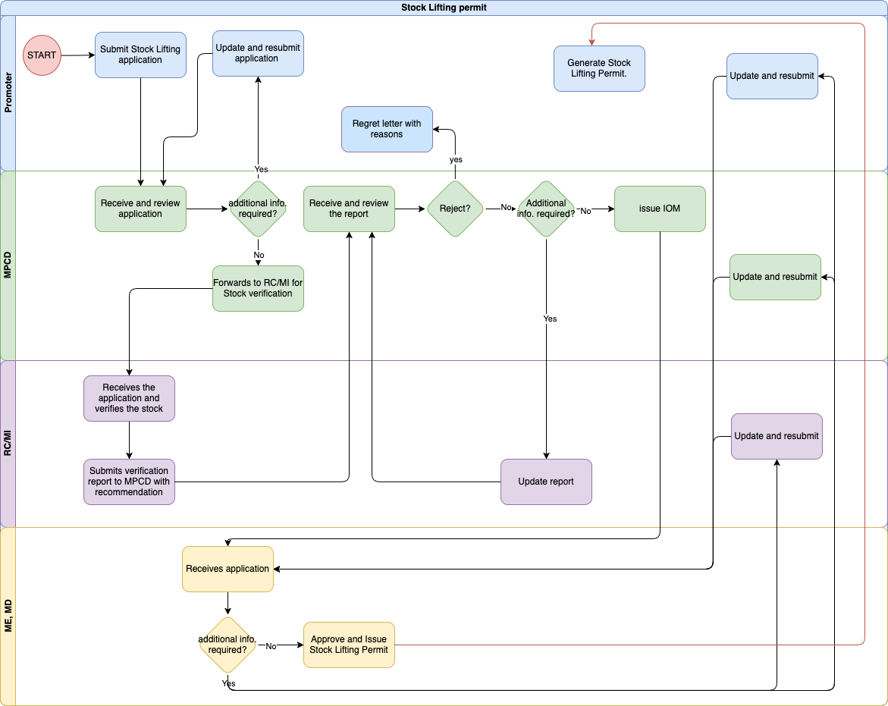

Promoter

Input field for Promoter

Field Name | Input Type | Validation | Remarks
Submit Application | File upload |  | Attaches the application and submits
Resubmit Application | File upload
View | Button |  | Views regret letter
View Permit | Button |  | View Stocklifting permit

Business logic for Promoter

Business Rule
BR No. | Business Rule
 | Users (individuals or companies) authenticate/log in through National Digital Identity (NDI).
 | The applicant will submit a Stock Lifting application (Form) along with the necessary approvals from the relevant agencies.
 | The applicant should resubmit the application with the required information or documents based on the recommendations or feedback provided by the MPCD focal.
 | The applicant will receive an SMS or email notification detailing the reason for the rejection of the application.
 | After receiving approval for stock lifting, the applicant can proceed with the transfer permit (TP) process at any time.

Functional Requirement
FR No. | Functional Requirement
 | Integration with NDI for authentication.
 | Integration with SMS gateway for sending notifications to users at every stage
 | The system captures the initial application, SMS notification, application revision (if any), and timestamp for reporting.
Agency Approvals submission (upload required documents).
System-generated application ID for tracking

MPCD Officer

Input field for MPCD Officer

Field Name | Input Type | Validation | Remarks
View Application | Button |  | View the stocklifting application.
Request resubmission | Button
Review report | Button
Approve | Button
Remarks | Text
Reject | Button
Remarks | Text
Assign RC | select
View Report | Button
Request Additional Info | Button
Remarks | Text
Approve | Button
Remarks | text
Reject | Button
Remarks | text
Generate IOM | Button
Edit IOM | Editing
Issue IOM | Button

Business logic for MPCD Officer

Business Rule
BR No. | Business Rule
 | The system will automatically assign the application to the MPCD focal based on their current workload.
 | Email and system notifications will be sent to the assigned MPCD focal upon assignment of the application.
 | MPCD focal can re-assign the task to another MPCD focal if he/she is busy/on leave.
 | The MPCD focal Officer receives and reviews the submitted application.
 | If additional information is required, the focal will forward only the specific sections of the application (input fields or documents) that need further details or changes, along with remarks outlining the necessary updates. The application will proceed to the next stage only after the focal verifies and approves the revisions.
 | If the application is approved, MPCD forwards the application to the respective RC for stock verification.
 | If rejected, notify the applicant with reasons.
 | The MPCD focal receives and reviews the verification report. If additional information is required, the focal will forward only the specific sections of the application (input fields or documents) that need further details or changes, along with remarks outlining the necessary updates. The application will proceed to the next stage only after the focal verifies and approves the revisions.
 | If everything is in order, the application is forwarded to MD for final verification and issuance of the permit.

Functional Requirement
FR No. | Functional Requirement
 | Option to log in as an agency user.
 | The dashboard for MPCD focal shall display a list of tasks along with their current status. The tasks should be organised by priority and deadline to facilitate efficient management. The dashboard must provide real-time updates on task status, allowing MPCD to track progress.
 | Users should be able to filter tasks by status (e.g., pending, in progress, completed) for better visibility.
 | The dashboard should also include visual indicators (e.g., colour codes) to represent different task statuses at a glance.
The system shall provide an option for the focal to review the application form and associated documents before submission.
focal must be able to view all input fields and uploaded documents in a read-only format for verification purposes.
The review option should allow the focal to navigate through each section of the application seamlessly.
A summary of the application, including key information and document names, should be displayed during the review process.
The workload assessment will be determined by predefined metrics, such as the number of pending applications or tasks assigned to each MPCD focal.
The assignment process should ensure that applications are evenly distributed to optimise efficiency and reduce bottlenecks.
 | Integration with Gmail to send email notifications.
 | Option for resubmissions or additional information requests with an option to write remarks.
 | Workflow to handle MTC decision-making and updates.
 | Integration with the OFS system for sending requests for FC.
 | Integration with the NRDCL system for sending requests for NOC.
 | The system captures the application assigned, reassignment, SMS notification and approved timestamp for TAT calculation and reporting

RC/MI

Input field for RC/MI

Field Name | Input Type | Validation | Remarks
View Application | Button |  | View the stocklifting application.
Attach report | File Upload
Submit | Button
Remarks | text
Attach Report | File Upload
Resubmit | Button
Remarks | text

Business logic for RC/MI

Business Rule
BR No. | Business Rule
 | RC (Regional Collector) or MI (Mineral Inspector) verifies the stock as per the application and documentation.
 | RC submits the verification report to the MPCD.
 | RC can reject the application based on ground reality. If rejected, the applicant will be notified of the reasons.
 | The RC should resubmit the verification report after incorporating the recommendations from the MPCD if necessary.

Functional Requirement
FR No. | Functional Requirement
 | Option to log in as an agency user.
 | The dashboard for RC/MI focal shall display a list of tasks along with their current status. The tasks should be organised by priority and deadline to facilitate efficient management. The dashboard must provide real-time updates on task status, allowing RC to track progress.
 | Users should be able to filter tasks by status (e.g., pending, in progress, completed) for better visibility.
 | The dashboard should also include visual indicators (e.g., colour codes) to represent different task statuses at a glance.
The system shall provide an option for the focal to review the application form and associated documents before submission.
focal must be able to view all input fields and uploaded documents in a read-only format for verification purposes.
The review option should allow the focal to navigate through each section of the application seamlessly.
A summary of the application, including key information and document names, should be displayed during the review process.
The workload assessment will be determined by predefined metrics, such as the number of pending applications or tasks assigned to each RC/MI focal.
The assignment process should ensure that applications are evenly distributed to optimize efficiency and reduce bottlenecks.
 | Integration with Gmail to send email notifications.
 | Option for resubmissions or additional information requests with an option to write remarks.
 | The system captures the application assigned, reassignment, SMS notification and approved timestamp for TAT calculation and reporting

Mining Engineer, MD

Input field for Mining Engineer, MD

Field Name | Input Type | Validation | Remarks
View | Button |  | View the stocklifting application with IOM
Request resubmission | Button
Generate Permit | Button |  | System generates a permit
Edit Permit | Edit
Issue Permit | Button

Business logic for Mining Engineer, MD

Business Rule
BR No. | Business Rule
 | The system will automatically assign the application to the Mining Engineer (ME) based on their current workload.
 | Email and system notifications will be sent to the assigned ME upon the assignment of the application.
 | The ME can re-assign the task to another ME if he/she is busy/on leave.
 | The ME reviews the forwarded application for the stock lifting.
 | If additional information is required, the focal will forward only the specific sections of the application (input fields or documents) that need further details or changes, along with remarks outlining the necessary updates. The application will proceed to the next stage only after the focal verifies and approves the revisions.
 | If everything is in order, the stock lifting permit is issued for verified stock.
 | An SMS notification will be sent to the applicant upon the completion of the process. Simultaneously the Chief, MD will be notified.

Functional Requirement
FR No. | Functional Requirement
 | Option to log in as an agency user.
 | The dashboard for ME shall display a list of tasks and their current status. The tasks should be organised by priority and deadline to facilitate efficient management. The dashboard must provide real-time updates on task status, allowing ME to track progress.
 | The ME should be able to filter tasks by status (e.g., pending, in progress, completed) for better visibility.
 | The dashboard should also include visual indicators (e.g., colour codes) to represent different task statuses at a glance.
The system shall provide an option for the focal to review the application form and associated documents before submission.
focal must be able to view all input fields and uploaded documents in a read-only format for verification purposes.
The review option should allow the focal to navigate through each section of the application seamlessly.
A summary of the application, including key information and document names, should be displayed during the review process.
The workload assessment will be determined by predefined metrics, such as the number of pending applications or tasks assigned to each ME.
The assignment process should ensure that applications are evenly distributed to optimise efficiency and reduce bottlenecks.
 | Integration with Gmail to send email notifications.
 | Option for resubmissions or additional information requests with an option to write remarks.
 | The system will notify the applicant to submit the bank guarantee.
 | The system captures the application assigned, reassignment, SMS notification and approved timestamp for TAT calculation and reporting

Rural Permit

Process Flow
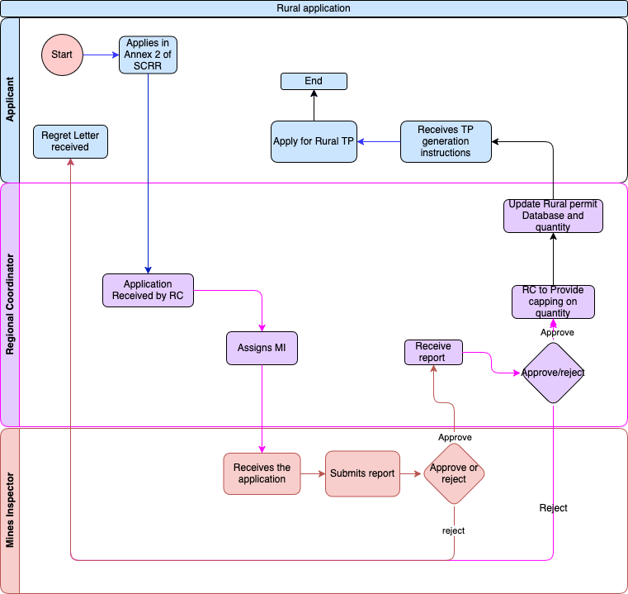

Promoter

Input field for Promoter

Field Name | Input Type | Validation | Remarks
Submit Application | File upload |  | Attaches the application and submits
Resubmit Application | File upload
View | Button |  | Views regret letter
View Permit | Button |  | View rural permit

Regional Coordinator
    - Input Field for Regional Coordinator

Field Name | Input Type | Validation | Remarks
View | Button |  | View the rural application
Assign MI | Select |  | Select from the list of MI in that region
View Report | Button
Approve | Button
Remarks | Text
Reject | Button
Remarks | Text

Mines Inspector
    - Input Field for Mines inspector

Field Name | Input Type | Validation | Remarks
View | Button |  | View the rural application
Attach Report | File Upload
Submit | Button
Approve | Button
Remarks | text
Reject | Button
Remarks | Text

Auction of surface collection (Minerals & stone and boulders)

Process Flow
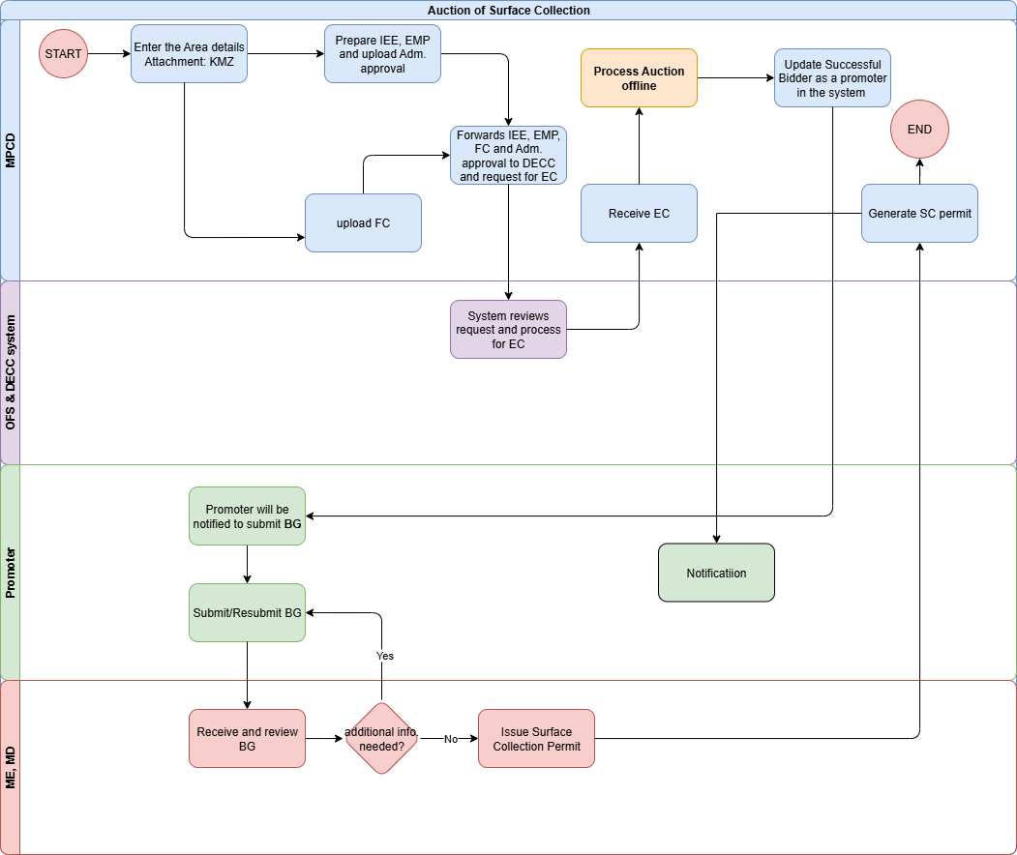

MPCD Focal

Input field for MPCD

Field Name | Input Type | Validation | Remarks
Location | Varchar
Area | Number |  | Area in acres
Material | Varchar
Map | File |  | Upload the KMZ of the auction site
Upload IEE | File
Upload EMP | File
Upload Adm Approval | File
Upload FC | File
Submit for EC | Button |  | Submits all the data that is complied to DeCC system/email to process for EC
Update details of BID winner
Name of Bid winner
Contact Number
Email Address
Other details
Request BG | Button |  | Sends request to Promoter for BG
BG instructions | Varchar |  | This instructions will be sent along with the request for BG.
Generate Surface Collection Permit | Button |  | Generates the Surface collection permit

Business logic for MPCD

Business Rule
BR No. | Business Rule
 | MPCD focal enter area details and also attaches the required attachments in the system for Surface collection.
MPCD initiates the Forestry Clearance (FC) process through the OFS system.
FC is necessary for surface collection activities to ensure compliance with environmental protection regulations.
MPCD processes the Environmental Clearance (EC) through the DECC (Department of Environment and Climate Change) system.
Documents required for EC:
- IEE (Initial Environmental Examination).
- EMP (Environmental Management Plan).
- FC (Forestry Clearance).
- Public Consultation or Administrative Approval from the concerned agency.
 | After receiving the EC approval from DECC, MPCD proceeds with the auction (offline process).
 | After identifying the successful bidder, the MPCD focal enters the lease details into the system for surface collection.
 | The successful bidder is notified to submit the Bank Guarantee (BG) to proceed further with the surface collection.

Functional Requirement
FR No. | Functional Requirement
 | Option to log in as an agency user.
 | MPCD should be able to initiate and track FC requests within the system.
 | MPCD should be able to initiate and track EC requests within the system.
 | Receive EC approval from DECC and FC approval from OFS in real time and update the system.
Once the EC & FC are obtained, MPCD proceeds with the offline auction process.
The option to record auction details (successful bidder, auction outcomes) in the systems.
 | Once the MPCD focal creates the successful bidder's details, the bidder will function the same as a promoter and will have access to all other services, including the transfer permit process, renewal process, and others.
 | Integration with Gmail to send email notifications.
 | Integration with SMS gateway to send sms notifications.
 | Workflow to handle auction offline and update.
 | Integration with the OFS system for sending requests for FC.
 | Integration with the DECC system for sending requests for EC.
 | Notify the successful bidder through the system to submit the required Bank Guarantee (BG)
 | The system captures the application assigned, reassignment, SMS notification and approved timestamp for TAT calculation and reporting

Promoter

Input field for Promoter

Field Name | Input Type | Validation | Remarks
View | Button |  | To view the instructions for BG and the attached files.
Submit BG | File |  | Upload Bank Guarantee
Resubmit BG | File

Business logic for Promoter

Business Rule
BR No. | Business Rule
 | The Promoter will be notified through email or SMS to submit the Bank Guarantee (BG) to proceed further with the surface collection with the instructions.
 | After the MD approves the Bank Guarantee, the promoter will receive a notification confirming the approval of the Surface Collection Permit and will be able to generate the permit from the system.

Functional Requirement
FR No. | Functional Requirement
 | Option to log in as an agency user.
 | Once the MPCD focal creates the successful bidder's details, the bidder will function the same as a promoter and will have access to all other services, including the transfer permit process, renewal process, and others.
 | After receiving approval for stock lifting, the applicant can proceed with the transfer permit (TP) process at any time.
 | Once the MPCD focal creates the successful bidder's details, the bidder will function the same as a promoter and will have access to all other services, including the transfer permit process, renewal process, and others.

Mining Engineer, MD

Input field for Mining Engineer, MD

Field Name | Input Type | Validation | Remarks
View | Button |  | Views the whole auction data
View BG | Button
Request resubmission of BG | Button |  | To send for resubmission of BG
Remarks | varchar |  | The remarks will be attached along with the resubmission.
Issue SC Permit | Button |  | Will issue the SC permit

Business logic for Mining Engineer, MD

Business Rule
BR No. | Business Rule
 | Once the leasee submits the bank guarantee, the system will automatically assign the application to the Mining Engineer (ME) based on their current workload.
 | Email and system notifications will be sent to the assigned ME upon the assignment of the application.
 | The ME can re-assign the task to another ME if he/she is busy/on leave.
 | MD focal reviews the submitted BG and issues the Surface Collection (SC) permit if the BG is valid or request for resubmission of the BG.
 | An SMS notification will be sent to the applicant upon the completion of the process. Simultaneously the Chief, MD will be notified.

Functional Requirement
FR No. | Functional Requirement
 | Option to log in as an agency user.
 | The MD will have the option to review the Bank Guarantee and approve the Surface Collection (SC) permit.
 | The MD will have the option to issue the Surface Collection (SC) permit.
 | Integration with Gmail to send email notifications.
 | Option for resubmissions or additional information requests with an option to write remarks.
 | The system will notify the applicant to submit the bank guarantee.
 | The system captures the application assigned, reassignment, SMS notification and approved timestamp for TAT calculation and reporting

Renewal for SC for State-owned company

Process Flow
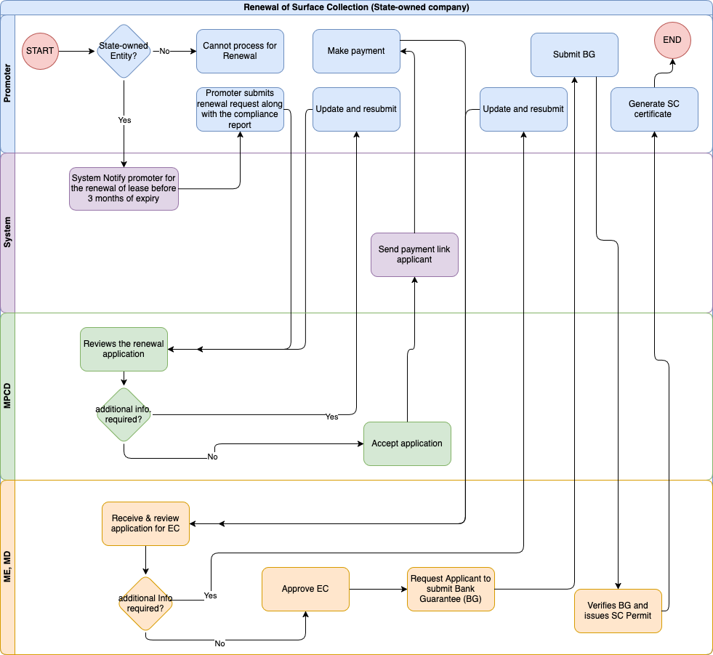

Promoter

Input field for Promoter

Field Name | Input Type | Validation | Remarks
Location | Varchar
Area | Number |  | Area in acres
Material | Varchar
Map | File |  | Upload the KMZ of the auction site
Compliance Report | File |  | Upload the self compliance monitoring report
Submit for renewal | Button
Resubmit | Button |  | To resubmit incase the MPCD focal requested for additional info.
Pay EC fee | Button |  | To pay the EC fees through Birms
Resubmit | Button |  | To resubmit incase the MD focal requests for additional info.
Submit BG | File Upload
Resubmit BG | File Upload
View Permit | button |  | To view the SC permit and also the System generated TP generation instructions.

Business logic for Promoter

Business Rule
BR No. | Business Rule
 | The promoter (individuals or companies) authenticate/log in through National Digital Identity (NDI).
 | Only the Stateowned entity can apply for renewal process and for private entities, the renewals are treated as new application and need to follow the same process as new application.
 | The system automatically notifies the SOE 3 months prior to the permit expiry, alerting them to begin the renewal application process.
 | A promoter initiates the renewal process for the Surface collection.
SOE submits a renewal application along with:
A compliance report detailing adherence to prior permit terms and conditions.
 | IF all the required info are submitted and the application is accepted, the applicant will receive a EC payment instruction along with a link to pay through BIRMS.
BR-7 | Once the payment is made if all the required documents are submitted, the applicant will receive an EC along with the BANK Guarantee instructions.
BR-8 | The applicant will then submit the Bank Guarantee and if the Bank Guarantee is approved , the applicant will receive the Surface collection Permit along with the TP generation Instructions.

Functional Requirement
FR No. | Functional Requirement
 | Integration with NDI for authentication.
 | Integration with the Tax system for validating tax clearance certificate
 | Integration with security clearance system, RBP for Security clearance validation
 | Integration with SMS gateway for sending notifications to users at every stage
 | The system sends an SMS reminder for every action required from the applicant side.
 | The system captures the initial application, SMS notification, application revision (if any), EMP and IEE submission, and timestamp for reporting.
 | The application will only be forwarded to the MD for the processing of the Environmental Clearance (EC) after the payment is made. Otherwise, the application status will remain pending.
FR-8 | Provision to update the earlier submitted details incase resubmission is requested.

MPCD Focal

Input field for MPCD Focal

Field Name | Input Type | Validation | Remarks
View | Button |  | Views the whole Renewal application along with any attachments
Request resubmission | Button
Remarks | Varchar |  | Remarks to be sent along with the request for resubmission.
Accept application | Button

Business logic for MPCD Focal

Business Rule
BR No. | Business Rule
 | The system will automatically assign the application to the MPCD focal based on their current workload.
 | Email and system notifications will be sent to the assigned MPCD focal upon assignment of the application.
 | MPCD focal can re-assign the task to another MPCD focal if he/she is busy/on leave.
 | The MPCD focal Officer reviews the submitted application
 | If additional information is required, the focal will forward only the specific sections of the application (input fields or documents) that need further details or changes, along with remarks outlining the necessary updates. The application will proceed to the next stage only after the focal verifies and approves the revisions.
 | After the focal reviews and accepts, the application is forwarded to MD for further review and for EC renewal process.

Functional Requirement
FR No. | Functional Requirement
 | Option to log in as an agency user.
 | The dashboard for MPCD focal shall display a list of tasks along with their current status. The tasks should be organised by priority and deadline to facilitate efficient management. The dashboard must provide real-time updates on task status, allowing MPCD to track progress.
 | Users should be able to filter tasks by status (e.g., pending, in progress, completed) for better visibility.
 | The dashboard should also include visual indicators (e.g., colour codes) to represent different task statuses at a glance.
The system shall provide an option for the focal to review the application form and associated documents before submission.
focal must be able to view all input fields and uploaded documents in a read-only format for verification purposes.
The review option should allow the focal to navigate through each section of the application seamlessly.
A summary of the application, including key information and document names, should be displayed during the review process.
The workload assessment will be determined by predefined metrics, such as the number of pending applications or tasks assigned to each MPCD focal.
The assignment process should ensure that applications are evenly distributed to optimise efficiency and reduce bottlenecks.
 | Integration with Gmail to send email notifications.
 | Option for resubmissions or additional information requests with an option to write remarks.
 | The system captures the application assigned, reassignment, SMS notification and approved timestamp for TAT calculation and reporting.

Mining Engineer, MD

Input Field for Mining Engineer, MD

Field Name | Input Type | Validation | Remarks
View | Button |  | View the whole application along with any remarks from the MPCD focal.
Request resubmission | Button |  | To request for resubmission of any specific portion
Remarks | Varchar |  | This remarks will be sent along with the request for resubmission.
Approve for EC | Button
Request BG resubmission | Button
Approve BG | Button
Issue SC permit | Button

Business Logic for Mining Engineer, MD

Business Rule
BR No. | Business Rule
 | The system will automatically assign the application to the Mining Engineer (ME) based on their current workload.
 | Email and system notifications will be sent to the assigned ME upon the assignment of the application.
 | The ME can re-assign the task to another ME if he/she is busy/on leave.
 | The ME reviews the forwarded application for the renewal of EC.
 | If additional information is required, the focal will forward only the specific sections of the application (input fields or documents) that need further details or changes, along with remarks outlining the necessary updates. The application will proceed to the next stage only after the focal verifies and approves the revisions.
 | After the focal reviews, the ME processes for issuance of EC and approves the EC.
 | Once the ME approves the EC, the system notifies the applicant to submit a bank guarantee. All submissions and their corresponding reviews must be tracked, and the application cannot progress to the next stage without receiving approval from the ME.
Upon receiving the bank guarantee, the Environmental Clearance (EC) will be issued.
Otherwise, reject the application.
 | An SMS notification will be sent to the applicant upon the completion of the process.

Functional Requirement
FR No. | Functional Requirement
 | Option to log in as an agency user.
 | The dashboard for ME shall display a list of tasks and their current status. The tasks should be organised by priority and deadline to facilitate efficient management. The dashboard must provide real-time updates on task status, allowing ME to track progress.
 | The ME should be able to filter tasks by status (e.g., pending, in progress, completed) for better visibility.
 | The dashboard should also include visual indicators (e.g., colour codes) to represent different task statuses at a glance.
The system shall provide an option for the focal to review the application form and associated documents before submission.
focal must be able to view all input fields and uploaded documents in a read-only format for verification purposes.
The review option should allow the focal to navigate through each section of the application seamlessly.
A summary of the application, including key information and document names, should be displayed during the review process.
The workload assessment will be determined by predefined metrics, such as the number of pending applications or tasks assigned to each ME.
The assignment process should ensure that applications are evenly distributed to optimise efficiency and reduce bottlenecks.
 | Integration with Gmail to send email notifications.
 | Option for resubmissions or additional information requests with an option to write remarks.
 | The system will notify the applicant to submit the bank guarantee.
 | The system captures the application assigned, reassignment, SMS notification and approved (for EC) timestamp for TAT calculation and reporting

Exploration GeoPhysics

Process Flow
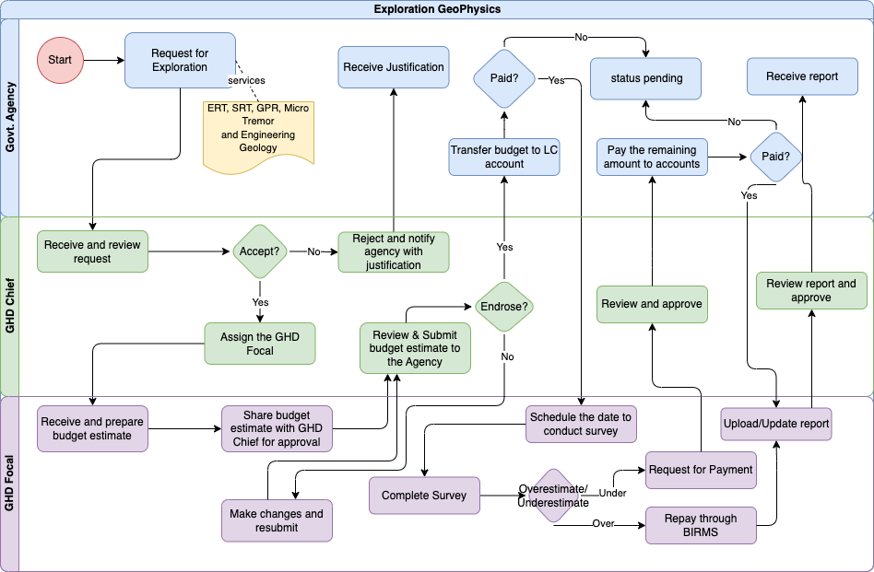

30.2 Govt. Agency ( Applicant)
30.2.1 Input Field for Govt. Agency

Field Name | Input Type | Validation | Remarks
Select service | dropdown
Name of the Requesting agency | Varchar
Location | Varchar
Purpose | Varchar
Proposal | File
Remarks | Varchar
Pay to LC account | Button |  | For payment through BIRMS
Make additional Payment | Button |  | For any additional payment
Remarks | Varchar
View Receipt | Button
View/Download report | Button

30.2.2 Business Logic for Govt. Agency

Business Rule
BR No. | Business Rule
BR-1 | The Govt. Agency applicant will login through his/her NDI account.
BR-2 | The applicant will then go to the Exploration Geophysics services and select the specific service.
BR-3 | The applicant will then enter all the required information and submit.
BR-4 | Once the application is accepted the applicant will receive a payment instruction and will need to pay through BIRMS.
BR-5 | If during the estimation of the Cost by the GHD focal was more than the budget expenditure, the Applicant will receive a notice of repayment from the GHD to the applicant.
BR-6 | If during the estimation of the Cost by the GHD focal was less than the budget expenditure, the Applicant will receive a notice with instructions for additional payment to the service provider.
BR-7 | Once all the payments are resolved the Applicant will receive the report.
BR-8 | An SMS notification will be sent to the applicant upon the completion of the process.

Functional Requirement
FR No. | Functional Requirement
FR-1 | Option to log in as a user.
FR-2 | Provision to pay to LC account through BIRMS.
FR-3 | Provision to receive Payment from LC account to the applicant’s account head.
FR-4 | Integration with Gmail to send email notifications.
FR-5 | Option for resubmissions or additional information requests with an option to write remarks.
FR-6 | The system captures the application assigned, reassignment, SMS notification and approved (for EC) timestamp for TAT calculation and reporting

30.3. Chief GHD
30.3.1 Input Field for Chief GHD

Field Name | Input Type | Validation | Remarks
View | Button |  | View the service requested and all the related documents.
Reject | Button
Remarks | Varchar
Accept | Button
Remarks | Varchar
Assign Focal | Drop down
View Budget Estimate | Button
Request resubmission of Budget estimate | Button
Remarks | Varchar |  | This remarks will be sent along with the request for budget estimate
Approve Budget estimate | Button
View repayment | Button |  | To view the additional payment request
Approve repayment | Button
Remarks | Varchar
View Report | Button
Approve Report | Button
Remarks | Varchar |  | Optional
Request resubmission of report | Button
Remarks | Varchar

30.3.2 Business Logic for Chief GHD

Business Rule
BR No. | Business Rule
BR-1 | The Chief GHD will login as an agency user.
BR-2 | If there are any new applications for Exploration Geophysics then it will show in notification.
BR-3 | The chief GHD will view the application and accept if the required documents are complete and reject otherwise.
BR-4 | If the application is accepted then the Chief will assign any focal from the drop down.
BR-5 | If the budget estimate from the GHD focal is found to be suitable, then the chief will submit to the applicant with remarks.
BR-6 | Incase the budget estimate comes up short and additional funds are required, the request for additional fund is received by the chief from the GHD focal and the chief will review and send to the applicant if approved if not will request for resubmission of the budget estimate from the GHD focal.
BR-7 | The chief will review the report and if approved will submit to the applicant.

Functional Requirement
FR No. | Functional Requirement
FR-1 | Option to log in as an agency user.
FR-2 | Provision to check No. of applications processed.
FR-3 | Provision to pay to LC account.
FR-4 | Integration with Gmail to send email notifications.
FR-5 | Options to assign/reassign any work to the officials of GHD.
FR-6 | The system captures the application assigned, reassignment, SMS notification and approved (for EC) timestamp for TAT calculation and reporting

30.4 GHD Focal
30.4.1 Input Field for GHD Focal

Field Name | Input Type | Validation | Remarks
View | Button |  | View the service requested and all the related documents.
Reject | Button
Remarks | Varchar
Budget Estimate | File |  | To upload the tentative budget estimate
Remarks | Varchar |  | To be sent to the MPCD focal.
Submit Budget Estimate | Button
Resubmit Budget | Button
Submit Budget Expense | varchar
Budget expenditure | File
Request payment/Make payment | Button |  | To either make payment to the applicant incase of over estimation of budget or to request for additional payment incase of insufficient budget.
Upload Receipt | file
Remarks | varchar
Report | file
Submit | Button
Resubmit | Button

30.4.2 Business Logic for GHD Focal

Business Rule
BR No. | Business Rule
BR-1 | The GHD focal will login as an agency user.
BR-2 | If there are any new applications for Exploration Geophysics then it will show in notification.
BR-3 | The GHD focal will view the assigned application and then prepare a budget proposal and submit.
BR-4 | If the budget estimate is accepted by the chief GHD then the process will move forward. If it is not approved then the Process will loop until approved.
BR-5 | After carrying out the study, if the budget estimated is less of what was actually spent, then the GHD focal will request for additional payment, if the budget estimate is more than the actual expenditure the GHD focal will repay back to the applicant and upload the receipt.
BR-6 | When all budget works are settled, then the GHD focal will upload the report.
BR-7 | The chief will review the report and if approved will submit to the applicant, otherwise a loop between the GHD focal and the chief will remain until approved

Functional Requirement
FR No. | Functional Requirement
FR-1 | Option to log in as an agency user.
FR-2 | Provision to check No. of applications processed.
FR-3 | Provision to pay to LC account.
FR-4 | Integration with Gmail to send email notifications.
FR-5 | Options to assign/reassign any work to the officials of GHD.
FR-6 | The system captures the application assigned, reassignment, SMS notification and approved (for EC) timestamp for TAT calculation and reporting

Geology Survey Division Services

Geological mapping

Mineral Prospecting

Mineral exploration

Study of construction material

Mineral and rock sampling

Geological core logging

Chemical Laboratory Analytical Services

Survey and GIS

Drilling

Sample Transport Clearance

Others(Specify)
Note: All the Geology Survey Division services mentioned above will follow the same process.

Process flow
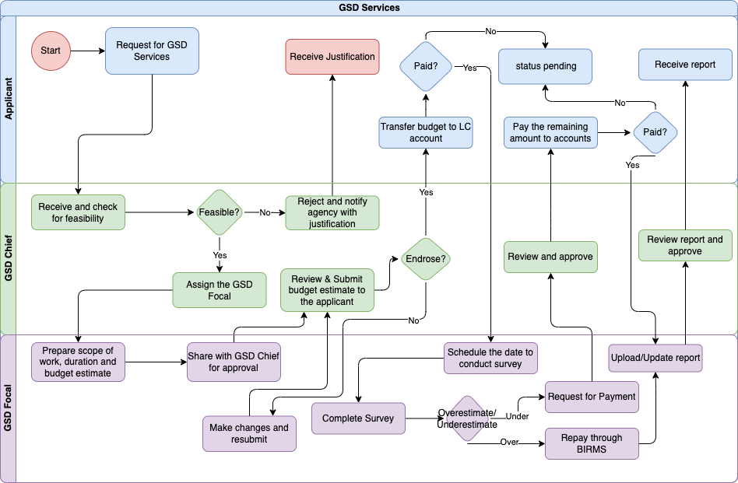
30.2 Applicant
30.2.1 Input Field for Applicant

Field Name | Input Type | Validation | Remarks
Select service | dropdown
Name of the Requesting applicant | Varchar
Location | Varchar
Purpose | Varchar
Proposal | File
Remarks | Varchar
Pay to LC account | Button |  | For payment through BIRMS
Make additional Payment | Button |  | For making any additional payments if required.
Remarks | Varchar
View receipt | Button |  | To view the payment receipts
View/download Report | button |  | To download the report submitted by the focal.

30.2.2 Business Logic for applicant

Business Rule
BR No. | Business Rule
BR-1 | The applicant will login through his/her NDI account.
BR-2 | The applicant will then go to the GSD services and select the specific service.
BR-3 | The applicant will then enter all the required information and submit.
BR-4 | Once the application is accepted the applicant will receive a payment instruction and will need to pay through BIRMS.
BR-5 | If during the estimation of the Cost by the GSD focal was more than the budget expenditure, the Applicant will receive a notice of repayment from the GHD to the applicant.
BR-6 | If during the estimation of the Cost by the GSD focal was less than the budget expenditure, the Applicant will receive a notice with instructions for additional payment to the service provider.
BR-7 | Once all the payments are resolved the Applicant will receive the report.
BR-8 | An SMS notification will be sent to the applicant upon the completion of the process.

Functional Requirement
FR No. | Functional Requirement
FR-1 | Option to log in as a user.
FR-2 | Provision to pay to LC account through BIRMS.
FR-3 | Provision to receive Payment from LC account to the applicant’s account head.
FR-4 | Integration with Gmail to send email notifications.
FR-5 | Option for resubmissions or additional information requests with an option to write remarks.
FR-6 | The system captures the application assigned, reassignment, SMS notification and approved (for EC) timestamp for TAT calculation and reporting

30.3. Chief GSD
30.3.1 Input Field for Chief GSD

Field Name | Input Type | Validation | Remarks
View | Button |  | View the service requested and all the related documents.
Reject | Button
Remarks | Varchar
Accept | Button
Remarks | Varchar
Assign Focal | Drop down
View Budget Estimate | Button
Request resubmission of Budget estimate | Button
Remarks | Varchar |  | This remarks will be sent along with the request for budget estimate
Approve Budget estimate | Button
View repayment | Button |  | To view the additional payment request
Approve repayment | Button
Remarks | Varchar
View Report | Button
Approve Report | Button
Remarks | Varchar |  | Optional
Request resubmission of report | Button
Remarks | Varchar

30.3.2 Business Logic for Chief GHD

Business Rule
BR No. | Business Rule
BR-1 | The Chief GSD will login as an agency user.
BR-2 | If there are any new applications for Exploration Geophysics then it will show in notification.
BR-3 | The chief GSD will view the application and accept if the required documents are complete and reject otherwise.
BR-4 | If the application is accepted then the Chief will assign any focal from the drop down.
BR-5 | If the budget estimate from the GSD focal is found to be suitable, then the chief will submit to the applicant with remarks.
BR-6 | Incase the budget estimate comes up short and additional funds are required, the request for additional fund is received by the chief from the GSD focal and the chief will review and send to the applicant if approved if not will request for resubmission of the budget estimate from the GSD focal.
BR-7 | The chief will review the report and if approved will submit to the applicant.

Functional Requirement
FR No. | Functional Requirement
FR-1 | Option to log in as an agency user.
FR-2 | Provision to check No. of applications processed.
FR-3 | Provision to pay to LC account.
FR-4 | Integration with Gmail to send email notifications.
FR-5 | Options to assign/reassign any work to the officials of GHD.
FR-6 | The system captures the application assigned, reassignment, SMS notification and approved (for EC) timestamp for TAT calculation and reporting
FR-7 | Provision to reassign and trace to be left.

30.4 GSD Focal
30.4.1 Input Field for GSD Focal

Field Name | Input Type | Validation | Remarks
View | Button |  | View the service requested and all the related documents.
Reject | Button
Remarks | Varchar
Budget Estimate | File |  | To upload the tentative budget estimate
Remarks | Varchar
Submit Budget Estimate | Button
Resubmit Budget | Button
Submit Budget Expense | varchar
Budget expenditure | File
Request payment/Make payment | Button |  | To either make payment to the applicant incase of over estimation of budget or to request for additional payment incase of insufficient budget.
Upload Receipt | file
Remarks | varchar
Report | file
Submit | Button
Resubmit | Button

30.4.2 Business Logic for GSD Focal

Business Rule
BR No. | Business Rule
BR-1 | The GSD focal will login as an agency user.
BR-2 | If there are any new applications for Exploration Geophysics then it will show in notification.
BR-3 | The GSD focal will view the assigned application and then prepare a budget proposal and submit.
BR-4 | If the budget estimate is accepted by the chief GSD then the process will move forward. If it is not approved then the Process will loop until approved.
BR-5 | After carrying out the study, if the budget estimated is less of what was actually spent, then the GSD focal will request for additional payment, if the budget estimate is more than the actual expenditure the GSD focal will repay back to the applicant and upload the receipt.
BR-6 | When all budget works are settled, then the GSD focal will upload the report.
BR-7 | The chief will review the report and if approved will submit to the applicant, otherwise a loop between the GSD focal and the chief will remain until approved

Functional Requirement
FR No. | Functional Requirement
FR-1 | Option to log in as an agency user.
FR-2 | Provision to check No. of applications processed.
FR-3 | Provision to pay to LC account.
FR-4 | Integration with Gmail to send email notifications.
FR-5 | Options to assign/reassign any work to the officials of GHD.
FR-6 | The system captures the application assigned, reassignment, SMS notification and approved (for EC) timestamp for TAT calculation and reporting
FR-7 | Provision to reassign.

Sample Transport Clearance

Process Flow
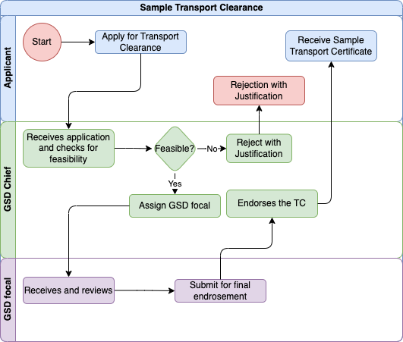

32.2 Applicant
32.2.1 Input Field for Applicant

Field Name | Input Type | Validation | Remarks
Name of Individual/agency/organization/corporation/Company | varchar
Contact no | num
Email Address | varchar
Name of the rock/Mineral | varchar
Nos. of Sample | Num |  | Option to add No of samples for each sample
Form of Sample | Dropdown | Solid/powder/other
Specify | varchar |  | To specify for other forms
Total Weight | num
Unit | Dropdown | KG/G
Purpose of shipping | varchar
Mode of shipping | Dropdown | Air/Road/Rail
Destination | varchar

32.2.2 Business Logic for Applicant

Business Rule
BR No. | Business Rule
BR-1 | The applicant will login as user.
BR-2 | The applicant will select the “Sample Transport Clearance” service
BR-3 | The applicant will then enter all the required details.
BR-4 | Incase the application gets rejected the applicant can view the justification.
BR-5 | If the application is approved, the applicant can view and download the Sample Transport Clearance.

32.3 GSD Chief
32.3.1 Input Field for GSD Chief

Field Name | Input Type | Validation | Remarks
View | Button |  | To view the application submitted
Reject | Button
Justification | Varchar
Assign GSD Focal | Select from list |  | Select from the list of GSD focals
View recommendation | Button |  | View recommendation given by the GSD focal
Approve | Button |  | Approves the Sample transport clearance
Reject | Button
Justification | varchar |  | For rejection after viewing the recommendation of the GSD focal.

32.2.2 Business Logic for GSD Chief

Business Rule
BR No. | Business Rule
BR-1 | The chief will login as agency user.
BR-2 | The chief will check the sample transport clearance pending applications
BR-3 | If the application is found not feasible the chief will reject the application
BR-4 | If the application is found feasible then it will be assigned to the GSD focal.
BR-5 | The Chief will view the recommendation provided by the GSD focal and will approve or reject with justification

32.4 GSD Focal
32.4 Input field for GSD Focal

Field Name | Input Type | Validation | Remarks
View | Button |  | To view the application submitted
Recommendation | varrchar
Submit | Button |  | Submit the recommendation

32.4 Business logic GSD Focal

Business Rule
BR No. | Business Rule
BR-1 | The GSD focal will login as agency user.
BR-2 | The focal will check the sample transport clearance pending applications assigned to him/her.
BR-3 | The focal will provide the recommendations and will submit

Manual Entry of Mining, Quarrying, surface collection and stock lifting.

Process flow
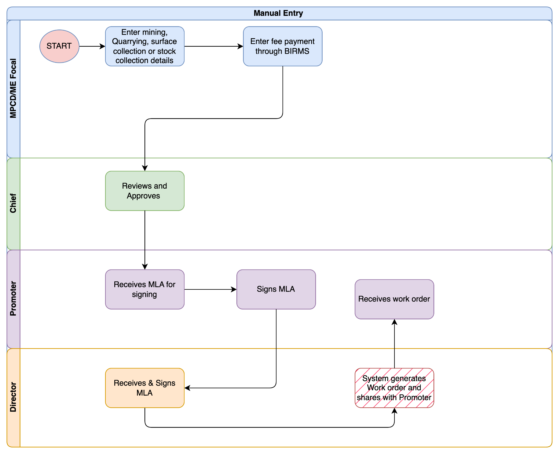

MPCD/MD focal

Input fields for MPCD / MD focal

Field Name | Input Type | Validation | Remarks
Enter Details | Varchar
Activity | Select |  | Mine/quarry/SC
Area | Num
Eligible for Export? | Drop down |  | Yes/No
Attach Files | Multiple File Upload

Business Logic for MPCD / MD focal
BR No. | Business Requirement
 | The Mine Leasing Section head will enter a Mine lease details with the remarks.
 | The Mining, quarrying Lease, surface collection, stock lifting permit will be added to the system only when endorsed and approved by the mining Chief.
 | Then the manually added lease or permit will have all the services.

Chief,MD
    - Input Field for Chief MD

Field Name | Input Type | Validation | Remarks
View | Button
Approve | Button
Remarks | text
Reject | Button
Remarks | Text

Promoter
    - Input Field for Promoter

Field Name | Input Type | Validation | Remarks
View | Button
Sign MLA | Digital Signature
View Work Order | Button

Director
    - Input Field for Director

Field Name | Input Type | Validation | Remarks
View | Button |  | View MLA
Sign MLA | Digital Signature

Data Requirements
  - NDI level I & II integration - Implement National Digital Identity (NDI) Level I & II authentication for secure user verification. Introduce digital signature functionality for key transactions and approvals, ensuring legal validity and traceability.
  - Environment Clearance Service System
    - Inputs (to Environment Clearance System):
Application ID / Reference Number
Project details (location, category, scope)
    - Outputs (to MAS):
Clearance approval status
Clearance certificate number & issue date
Validity period
  - NLCS
    - Inputs:
CID / Owner ID
Land/Plot ID
    - Outputs:
Land ownership details (thram, plot number, area, location)
Encumbrance / mortgage information
  - BIRMS payment integration
  - RMA/BoB - automate exchange rate updates for international transactions
    - Inputs (to RMA/BoB):
Request for daily exchange rates
    - Outputs (to MAS):
Exchange rate values (Nu. to USD, INR, EUR, etc.)
Effective date/time
  - G2C systems - Business license and company registration systems
    - Inputs:
CID / Business License Number / Company Registration Number
    - Outputs:
Business name
Registration date & validity
License type and sector
License status (active/suspended/cancelled)

  - NSW - National Single Window for streamlined import/export processes.
  - DCRC - for household information
    - Inputs:
CID of applicant / household member
    - Outputs:
Household composition (family members, relationship)
Household number & address
Demographic details (DOB, gender, marital status)
  - RAMIS - Tax clearance
    - Inputs:
TPN / CID / Company registration number
    - Outputs:
Tax clearance status (cleared / pending)
Validity period of clearance
Outstanding dues (if any)
  - Security Clearance (RBP)
    - Inputs:
CID number
    - Outputs:
Security clearance status (approved/rejected/pending)
Certificate issue date & validity

Data and User Management

User Authentication and Authorization:
    - Secure Login: The system must allow users to log in securely using unique credentials (username and password) or National Digital Identity (NDI) for authentication.
    - Role-Based Access Control: Users can be assigned roles with corresponding permissions to access appropriate system functionalities, ensuring that each user can only access data and features relevant to their role.

System Administration:
    - User, Role and Permission Management: Create a comprehensive administration module for managing users, roles, and permissions, ensuring secure and efficient control of system access.
      - Users can be assigned/mapped with multiple roles based on respective authority.
      - Roles can be mapped with multiple permissions and a permission can be mapped with multiple roles.
    - System Monitoring: Include functionalities for monitoring system performance, managing regular data backups, and maintaining system security to ensure reliability and availability.

User Management
Field Name | Input Type | Validation | Remarks
Full Name | Text | Required
Username | Text | Required | Should allow only Alphanumeric
Contact | Number | Required
Designation | Select | Required | Pull from Masters
CID | Big Integer | Required
Email | Email | Required | Should havea valid email
Agency | Select | Required
Division | Select | Required

BR No. | Business Requirement
 | Admin can input the full name of the account user.
 | After entering the full name input the username, it should be unique. If the existing username is entered again it should display the validation message saying the username already exists.
 | Enter the contact number, it should be a unique number. If the existing contact number is entered it should display the validation message saying the contact number exists. This field should accept only eight digits.
 | Enter the cid of an account user. This field should accept only 11 digits of numbers, else display validation messages.
 | Enter the valid email of an account user.
 | Select the agency of an account user.
 | The respective divisions of an agency will be displayed as options. Select division for an account user.
Should not allow you to create an account with existing CID, Contact, Email and username.
The system should be able to generate random passwords while creating accounts for the user.
When the account is created successfully, the system should send user credentials to the registered mail.

Role Management
Field Name | Input Type | Validation | Remarks
Name | Text | Required | Input the name of a role.

BR No. | Business Requirement
 | Admin can input the name of a role. Should not allow the creation of an existing role name.

Permission Management
Field Name | Input Type | Validation | Remarks
Name | Text | Required | Input the name of a permission.

BR No. | Business Requirement
 | Admin can input the name of a permission. Should not allow the creation of an existing permission name.

Map User Role
Field Name | Input Type | Validation | Remarks
User | Select | Required | Select from Existing account user.
Role | Checkbox |  | Check/map selected users to single or multiple roles.

BR No. | Business Requirement
 | Admin can select user accounts.
 | The select user can be mapped to the roles by checking the displayed list of roles. Also the roles will be unmapped with the users when unchecked.

Map Role Permission
Field Name | Input Type | Validation | Remarks
Role | Select | Required | Select from Existing roles.
Permission | Checkbox |  | Check/map selected roles to single or multiple permissions.

BR No. | Business Requirement
 | Admin can select roles.
 | The selected roles can be mapped to the permissions by checking the displayed list of permissions. Also, the permissions should be unmapped with the roles when unchecked.

Master Data Management:
    - Centralized Data Management: Develop a centralized master data management system to manage master data, such as Year, Division, Agency, Dzongkhag, Dungkhag, Gewog, Village
    - Data Validation and Consistency: Implement robust validation rules and workflows to maintain data consistency, accuracy, and uniformity across the integrated system, minimizing errors.

Data Integrity and Security for Digital Archival System
    - Record Locking: Implement mechanisms to lock archived records once they have been uploaded and validated in the system. This ensures that archived documents and data cannot be altered, deleted, or tampered with after archiving unless authorized by designated administrators. This will protect the integrity of the archived information over time.
    - Audit Trails: Establish comprehensive audit trails that log all actions within the archival system, including access, modification, and deletion of records. The audit logs should record who accessed or modified the data, what specific actions were taken, and when these actions occurred. This helps maintain accountability, providing transparent and traceable records for audits and compliance.
    - Secure Data Storage: Ensure that all archived data, documents, and records are stored securely. This includes applying encryption and security protocols to prevent unauthorized access or breaches. Access to the system should be restricted through role-based access control (RBAC), ensuring that only authorized users can view, modify, or manage archived information.
    - Data Backup and Disaster Recovery: Implement regular data backup procedures to safeguard against accidental loss or corruption of records. A disaster recovery plan should also be in place, ensuring that archived records can be restored promptly in the event of hardware failures, data breaches, or other emergencies.

Reporting and Analytics:
    - Comprehensive Reporting: The system should generate detailed reports on archival documents, including the number of records uploaded, records accessed, and documents archived within specific time frames.
    - Advanced Analytics: Administrators and authorized users should have access to analytics dashboards that provide insights into archival trends, such as the volume of records archived over time, the frequency of record retrieval, and patterns in data access. Analytics can help visualize system usage, and monitor archival efficiency and data accessibility. This information will assist in optimizing system performance and ensuring effective long-term data management.
    - Super Admin
      - No. of users in the system
    - Agency Admin
      - No. of users in the system
    - DGM Director:
      - Dashboard on the overall statistics of the construction (Planning, design, Construction), occupancy, hotel. The report can be in graphical in format.
      - Shall have provision to view the reports based on the filter conditions which are in the master lists and as per dzongkhag, RoID, Thromde.
      - Shall have provision to export the report in Excel, CSV, and PDF format for internal consumption
      - Shall have provision to view and export the report based on the status of the construction, on-going construction,occupancy status, etc.
    - Chiefs(MPCD/MD/GSD/GeoHazard)
      - Dashboard on the overall statistics of the construction(Planning, design, Construction ), occupancy, hotel. The report can be in graphical in format.
      - Shall have provision to view the reports based on the filter conditions which are in the master lists and as per Dzongkhag/RoID/Thromde.
      - Shall have provision to export the report in Excel, CSV, and PDF format for internal consumption
      - Shall have provision to view and export the report based on the status of the construction, on-going construction,occupancy status, etc
      - To View work loads/TAT/work status of the staff.
    - Agency User(MD/MPCD/GeoHazard/GSD/RC/MI)
      - Dashboard on the overall statistics of the construction(Planning, design, Construction ), occupancy, hotel. The report can be in graphical in format.
      - Shall have provision to view the reports based on the filter conditions which are in the master lists and as per Dzongkhag/RoID/Thromde
      - Shall have provision to export the report in Excel, CSV, and PDF format for internal consumption
      - Shall have provision to view and export the report based on the status of the construction, on-going construction,occupancy status, etc.

Dashboard
      - Director :
- National-level analytics on Mines.
- Comparative performance data across regions.
- Strategic planning insights.
- Alerts/Notifications: Important alerts for approvals, regulatory changes, or incidents in the mines (e.g., accidents, environmental violations).
- Active Mines Overview
- Production Levels: Real-time data on the amount of minerals being extracted, sorted by mine, type of mineral, and production rates.
- Revenue and Tax Collection
- Licenses and Permits: Data on the number of active, expired, and pending mining, and surface collection.

      - Chiefs:
- Division-specific reports and dashboards.
- Summary of ongoing and completed projects.
- Option to assign / re-assign focal officer
- Alerts/Notifications: Important alerts for approvals, regulatory changes, or incidents in the mines (e.g., accidents, environmental violations).
- Active Mines Overview
- Production Levels: Real-time data on the amount of minerals being extracted, sorted by mine, type of mineral, and production rates.
- Explosive Purchased data.
- Revenue and Tax Collection
- Licenses and Permits: Data on the number of active, expired, and pending mining, and surface collection.
- Penalty Imposed: ( With selection of time frame)
- List of Reports

      - Regional Coordinators(RCs):
- Project timelines and progress under the respective regions.
- performance tracking.
- On-ground status updates.
- Production Levels: Real-time data on the amount of minerals being extracted, sorted by mine, type of mineral, and production rates in respective regions
- Revenue and Tax Collection
- Explosive Purchased data.
- Mining leases, surface collection permits, stock lifting permits, and their details are in respective regions.
- Validity of EC of all mines and surface collection in respective regions.
- Details of all mines and quarries in the respective region.
      - Section Heads:
- Daily task management.
- Field reports submission and tracking.
- Production Levels: Real-time data on the amount of minerals being extracted, sorted by mine, type of mineral, and production rates.
- Revenue and Tax Collection

