2d First Person Shooting game.

Name: The Distance

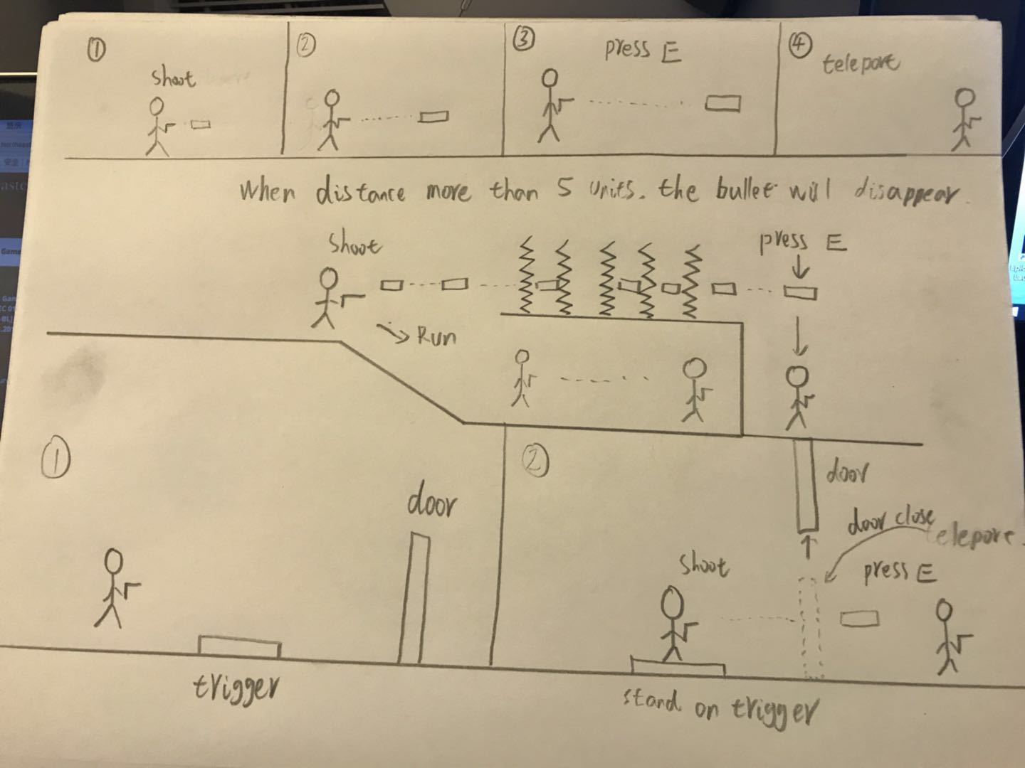
In the horizontal version of the shooting game, the player can fire a bullet. When the distance is more than five units, the bullet will disappear. The player can swap the position with the bullet at any time before the bullet disappears. With this feature, players can solve many of the obstacles encountered in the game.

