
has two game modes: competitive and cooperative.



How to play?
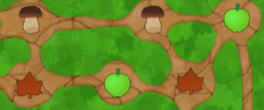
A turn begins with collecting items, which can be used to move to neighbouring tiles on the game map. For every move the corresponding item shown on the tile the player wants to move to is used up.

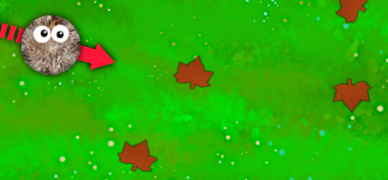
A player collects items by rolling over them with a hedgehog. Note that only a maximum of four items should be collected.
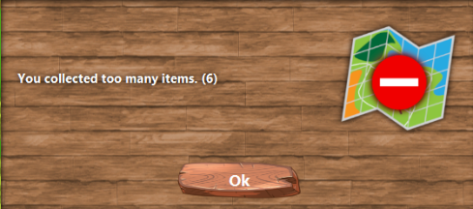
If more than four items are collected, the move does not count and it is the next players turn. If no suitable items or no items at all are collected, no move can be performed and it is the next players turn.
If the cooperative mode was chosen a fox chases the players. The fox only moves if at least one move has been performed.
The number of moves a fox performs per turn, as well as the general hedgehog's rolling properties, depend on the selected difficulty level.

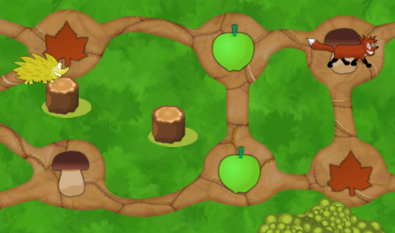
Cooperative mode:
The goal of the cooperative game mode is to reach the finish line with the hedgehog (the players) before being caught by the fox (the computer).

It is recommended to use up any collected items to reach the finish line. Alternatively, pressing the "Continue"-button can skip the turn, so that a new turn is started without the fox moving forward.

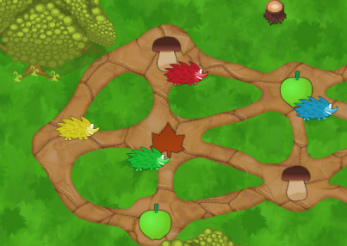
Competitive mode:
The goal of the competitive game mode is to reach the finish line before the other players. It is played hedgehog vs. hedgehog (player vs. player).

