Git Command prompt to use clone,add,commit,status and push.

Git Clone:

Command: git clone <https://github.com/DGS2020/Java8-Application>

Below are reference screenshot:

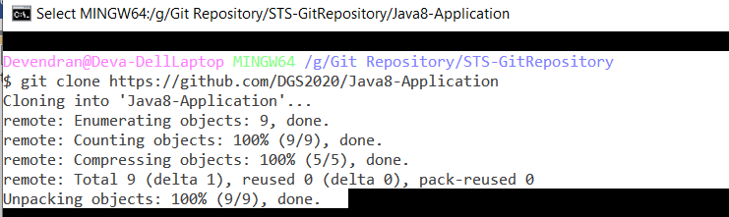

If you want to add the new file below are the command:

git add .

below are the files added.

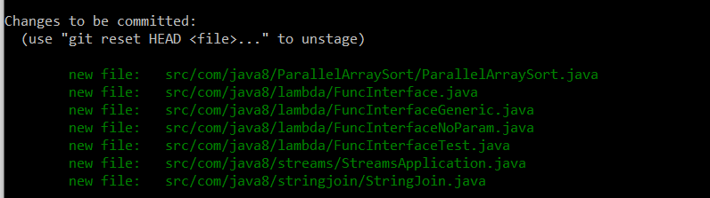

Git status 🡪 it is used for showing current status.

After added commit for the below command

git commit -m "Committed Java 1.8 examples in new repository"

above command double quotes we have mention the comments to identify easily.

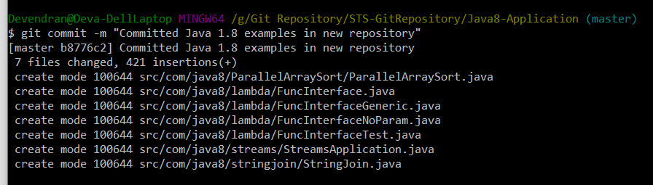

Git push command:

Git push origin master

