Dolagobinda sahoo

Set up

This document gives the overview of how to set up the application in the local machine for the development.

Project manager

Contents

Introduction 2

Software Requirements and Technology details 2

Required Software 2

Technology Details 2

Setting up the application 2

Taking checkout 2

Folder Structure 3

Client Project 3

Server Project 3

Running the application 3

# Introduction

This document describes the setup of the application “**Project Manager**” in the local machine for development and debugging purpose.

# Software Requirements and Technology details

## Required Software

These are the list of the software installed in the system to debug/develop and run the application:

1. Visual Studio 2017
2. Visual Studio Code (preferable latest version)
3. SQL Server Management Studio 2017
4. Google Chrome
5. Node JS v 8.12.0
6. GIT BASH and GIT UI (for connecting to the repository)

## Technology Details

These are the list of the technologies used in the application:

1. Angular 4 (UI)
2. HTML (UI)
3. CSS3 and BOOTSTRAP (UI)
4. .NET Framework
5. Web API 2.0 (C#)
6. Entity Framework (C#)
7. SQL (C#)

# Setting up the application

## Taking checkout

1. Visit the URL where the code is checked in.
   1. https://github.com/DGS223677/FSA_Assignment.git
2. In the Assigned VDI Code is present at below location
   1. C:\Users\Administrator\Source\Repos\FSA_Assignment
   2. 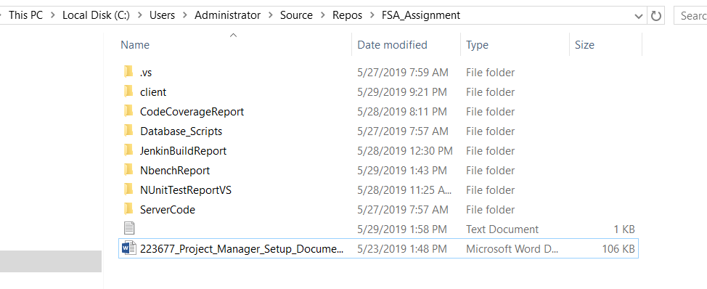

## Folder Structure

In the main folder **FSA_Assignment** are two folders.

1. Client:   
   This folder contains the angular part of the code.
2. Server:   
   This folder contains the C# part of the code.
3. Database :

This Folder contain the script for DB and table creation

### Database Creation (If code needs to be tested in any other machine)

1. Open the SQL Server Management Studio Choose the server as “DOTNET”
2. Go to path **FSA_Assignment** **/Database_Scripts** and run the scripts in below order
   1. Run the script “**CreateDatabase_Script.sql**”
   2. Run the script “**CreateTables_Script.sql**”
   3. Once the scripts Run DB “ProjectManager” and Tables will be created like below

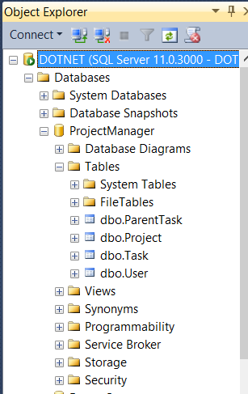

### 

# Running the application

### **Client**

1. Go to the path **FSA_Assignment /client** where you can see the file ***angular.json***
2. Inside the Client Folder check for ***node_modules*** *Folder* 
   1. *If* ***node_modules*** *Folder is not present (in case missed )* 
      1. Open command prompt and type

cd C:\Users\Administrator\Source\Repos\FSA_Assignment\client

* + 1. run this command “npm install –g @angular/cli”
    2. After this installation is done, run this command “npm install -f”
    3. This will install Let all the npm packages required for this project
    4. Once the installation is done “*node_modules*” will be available in the Client folder

1. Run the command “npm start”

### Server

1. Open the folder **FSA_Assignment /ServerCode**/**ProjectManager**
2. Open the file “**ProjectManager.sln**” in Visual Studio 2017and and select the “ProjectManager” project as startup project and Build the Project
3. Once build is complete then Start the application
4. open Google Chrome and enter the URL “**localhost:4200**”