Interactive Lessons # 1 – Static Electricity, Charge and Coulomb’s Law
Calculus Physics 2
We will be using FLUX, the interactive physics simulator built for this course, for this Interactive Lesson. It runs in a web browser — there is nothing to download or install, and it works on a laptop, a Chromebook or a phone.
Go to the link below
https://flux-phy2049.pages.dev
Note: the simulator opens on the last lab you used. The exam number tabs (1–7, W) run across the top, with that exam’s labs listed underneath. A lab’s address is bookmarkable, so a link such as https://flux-phy2049.pages.dev/#/e2/conductors opens that lab directly.
Before you start
- Open the simulator and click through the exam tabs to see what is there. Drag to orbit, scroll to zoom, and press R to reset the camera if you lose the scene.
- Every lab has a Setup panel on the right with a Scenario dropdown. The lesson tells you which scenario to choose — start each Activity from the one named.
- The panel on the left is the important one: it shows the governing equation, the live numbers, and a short explanation of what the scene is doing. Read it.
- The strip along the bottom is the readout. Those are the values you are asked to record.
- If you change something and want to start over, re-select the scenario from the dropdown.
Learning Objectives for this simulation.
- Explain what conservation of charge means for a neutral object placed in an electric field.
- Describe the polarization effect and explain why a charged object attracts a neutral one.
- Use Coulomb’s law quantitatively: predict a force, then check it against the simulator.
- Explain why the electric field is zero inside a conductor, and what grounding changes.
- Explain what makes a gas break down, and what a spark’s energy actually is.

Activity # 1 – Coulomb’s law: attraction and repulsion
Open Exam 1 → Force. Choose the scenario “Two positives (repel)”.
Click a charge to select it. The gold arrow is the net force on the selected charge; the thin arrows are the individual pairs. You can drag a charge, or type exact coordinates into the boxes in the Setup panel (they are in centimetres).
Question 1) Select the +2.00 μC charge and record |F_net| from the readout. Which way does the gold arrow point, and why?

Question 2) Now select the other charge. How does the magnitude of the force on it compare with your answer to Question 1? Which law of motion does that illustrate?

Question 3) Using the coordinate boxes, double the separation between the two charges. Predict what happens to |F_net| before you look, then record the new value. Does it match Coulomb’s law?

Now switch the scenario to “Opposite charges (attract)”.
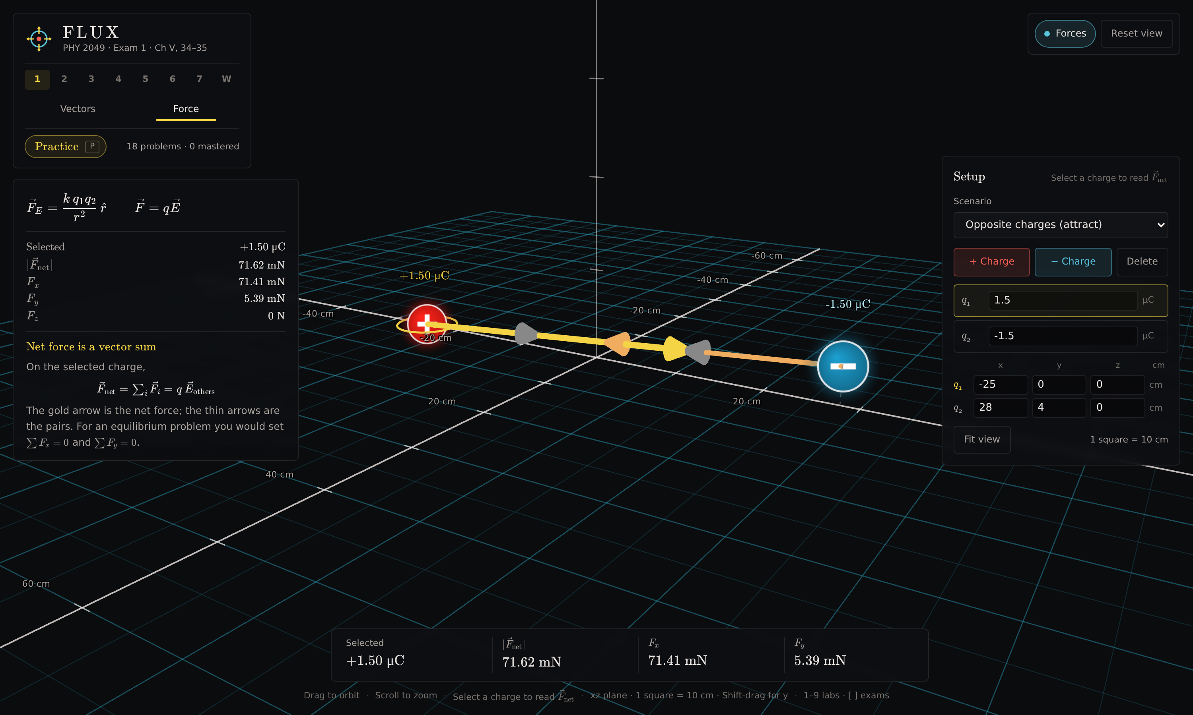
Exam 1 → Force, “Opposite charges (attract)”. The readout reports the net force on the selected charge.
Question 4) Describe what changes about the force arrows when one charge is made negative. What stays the same?

Question 5) Change q₂ from −1.50 μC to −3.00 μC in the Setup panel. Predict the new |F_net| from your Question 4 reading first, then record the value the simulator gives.

Activity # 2 – Polarization: a neutral conductor near a charge
Open Exam 2 → Conductors and choose the scenario “Neutral isolated sphere + outside q”.
The sphere is a neutral metal ball. The point charge q sits to its right. Surface colour shows the surface charge density σ — blue is induced negative, red is positive (the key is at the bottom left). Click on empty space to move the probe.
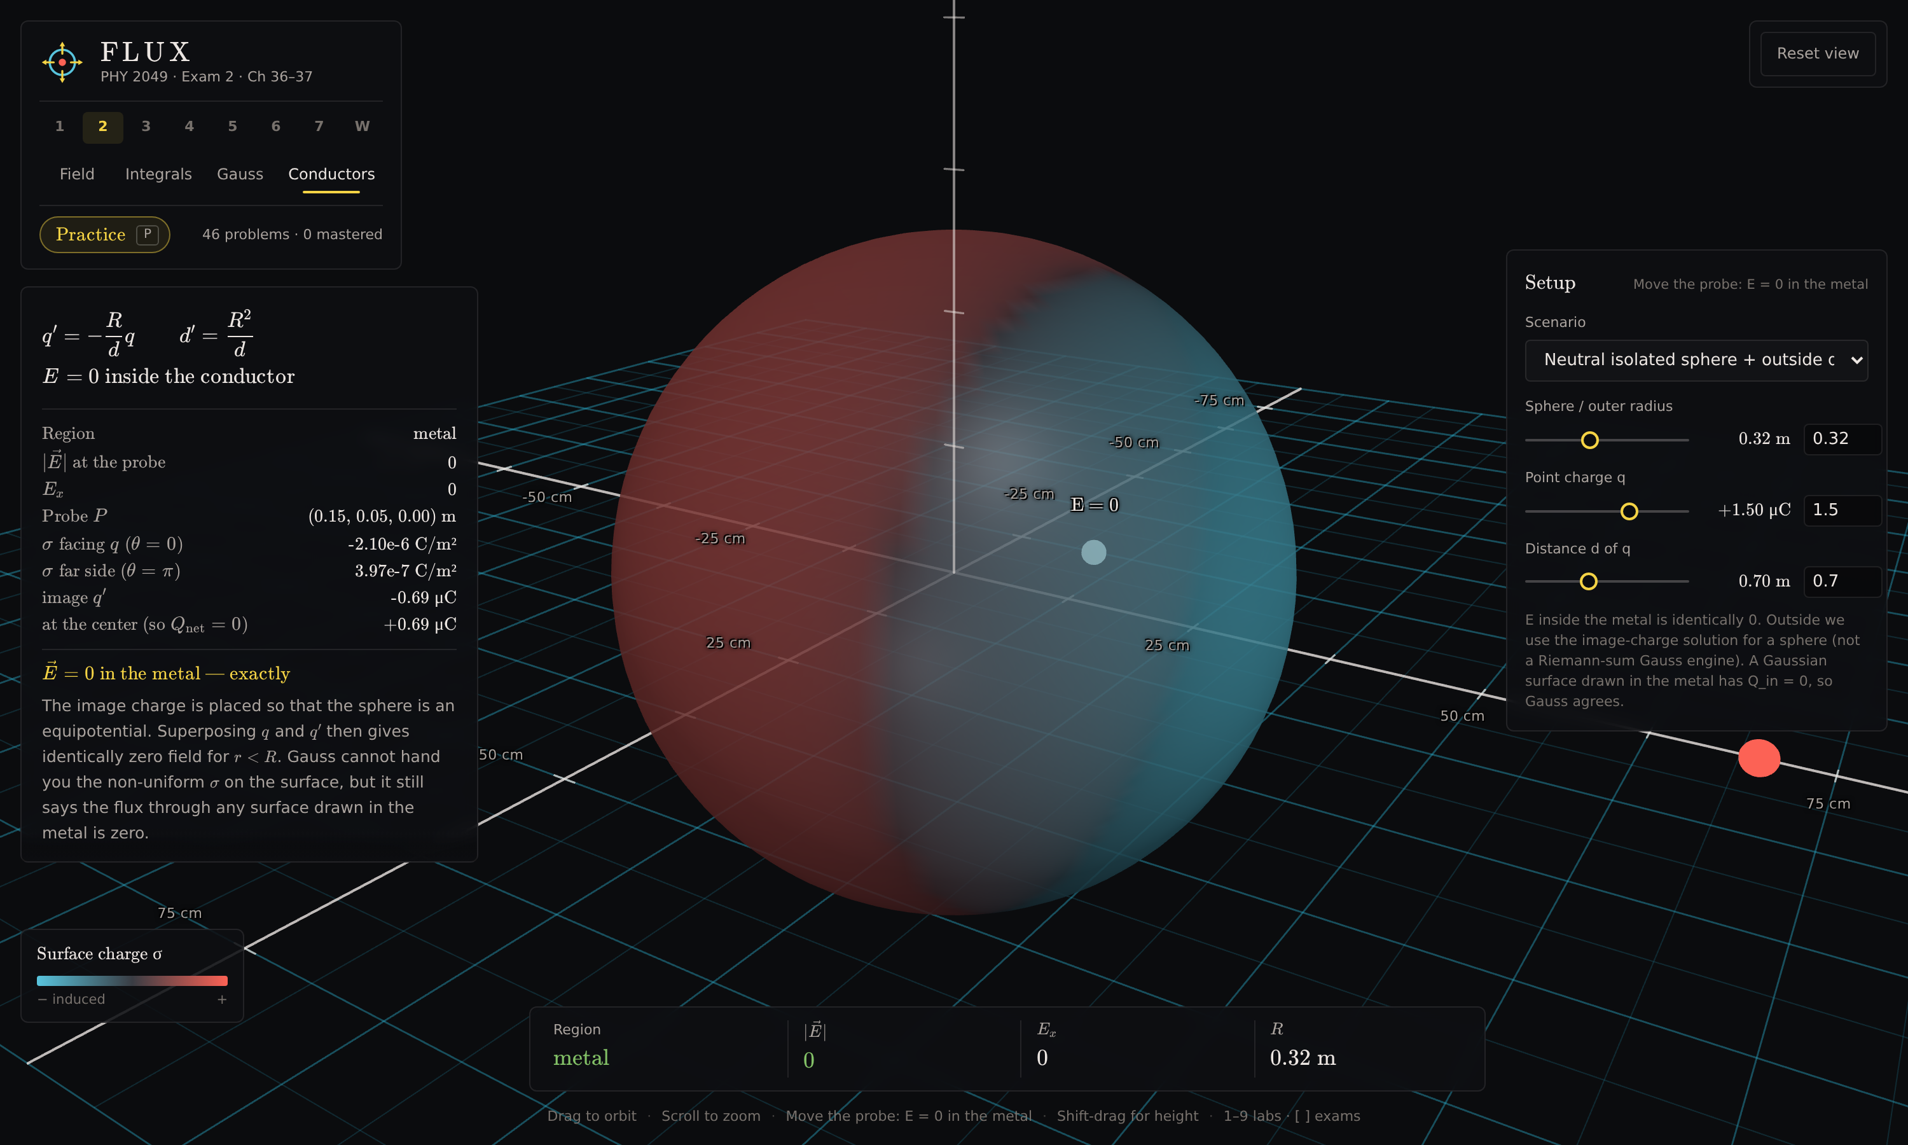
Exam 2 → Conductors, “Neutral isolated sphere + outside q”. The left panel reports σ on the near and far faces, and the induced charge against the compensating charge at the centre.
Question 6) Describe the charge on the side of the sphere facing q, and on the far side. Record σ facing q (θ = 0) and σ far side (θ = π) from the left panel.

Question 7) The left panel reports an induced charge and an equal, opposite charge at the centre, so that Q_net = 0. Explain what this is telling you about conservation of charge. Has any charge been added to the sphere?

Question 8) Explain why the electrons in the metal arrange themselves this way. What would happen to a free electron inside the metal if they did not?

Question 9) The sphere is electrically neutral overall. Explain why it is nevertheless attracted to q. (Hint: compare the distance from q to the induced negative charge with the distance to the positive charge.)

Question 10) Move the probe to a point inside the metal and record Region and |E| from the readout. Then move it outside. State the rule this demonstrates in one sentence.

Question 11) Drag the “Distance d of q” slider to bring q closer. What happens to the induced σ, and why?

Activity # 3 – Grounding
Stay in Conductors and switch the scenario to “Grounded sphere + outside point charge”.
A grounded conductor can exchange charge with the earth, so it is no longer required to stay neutral.
Question 12) Compare the surface charge on the grounded sphere with the neutral sphere in Activity # 2. What is different?

Question 13) Is the grounded sphere still neutral overall? Explain what grounding has allowed to happen.

Question 14) A balloon rubbed on a sweater sticks to a wall. Using your answers to Activities 2 and 3, explain why the wall does not need to be charged for this to work.

Activity # 4 – Shielding
Switch the scenario to “Faraday cage — charge in the cavity”.
Question 15) A charge sits inside a hollow conductor. Describe the charge that appears on the inner wall and on the outer surface, and explain why each one is there.

Question 16) Move the probe into the metal shell and record |E|. Explain what this means for someone sitting inside a car during a lightning strike.

Activity # 5 – Breakdown: why you get a shock off a doorknob
Open Exam 3 → Breakdown and choose the scenario “Doorknob spark”.
You are the sphere on the left, charged to the potential shown; the plate on the right is the grounded doorknob. Two rules for when the air lets go are reported side by side: Paschen’s law, and the 3 MV/m dielectric-strength rule. They do not agree, and the lesson is in the disagreement. The gap in the picture is drawn on a log scale so it stays visible — every number on the panels is the real one.
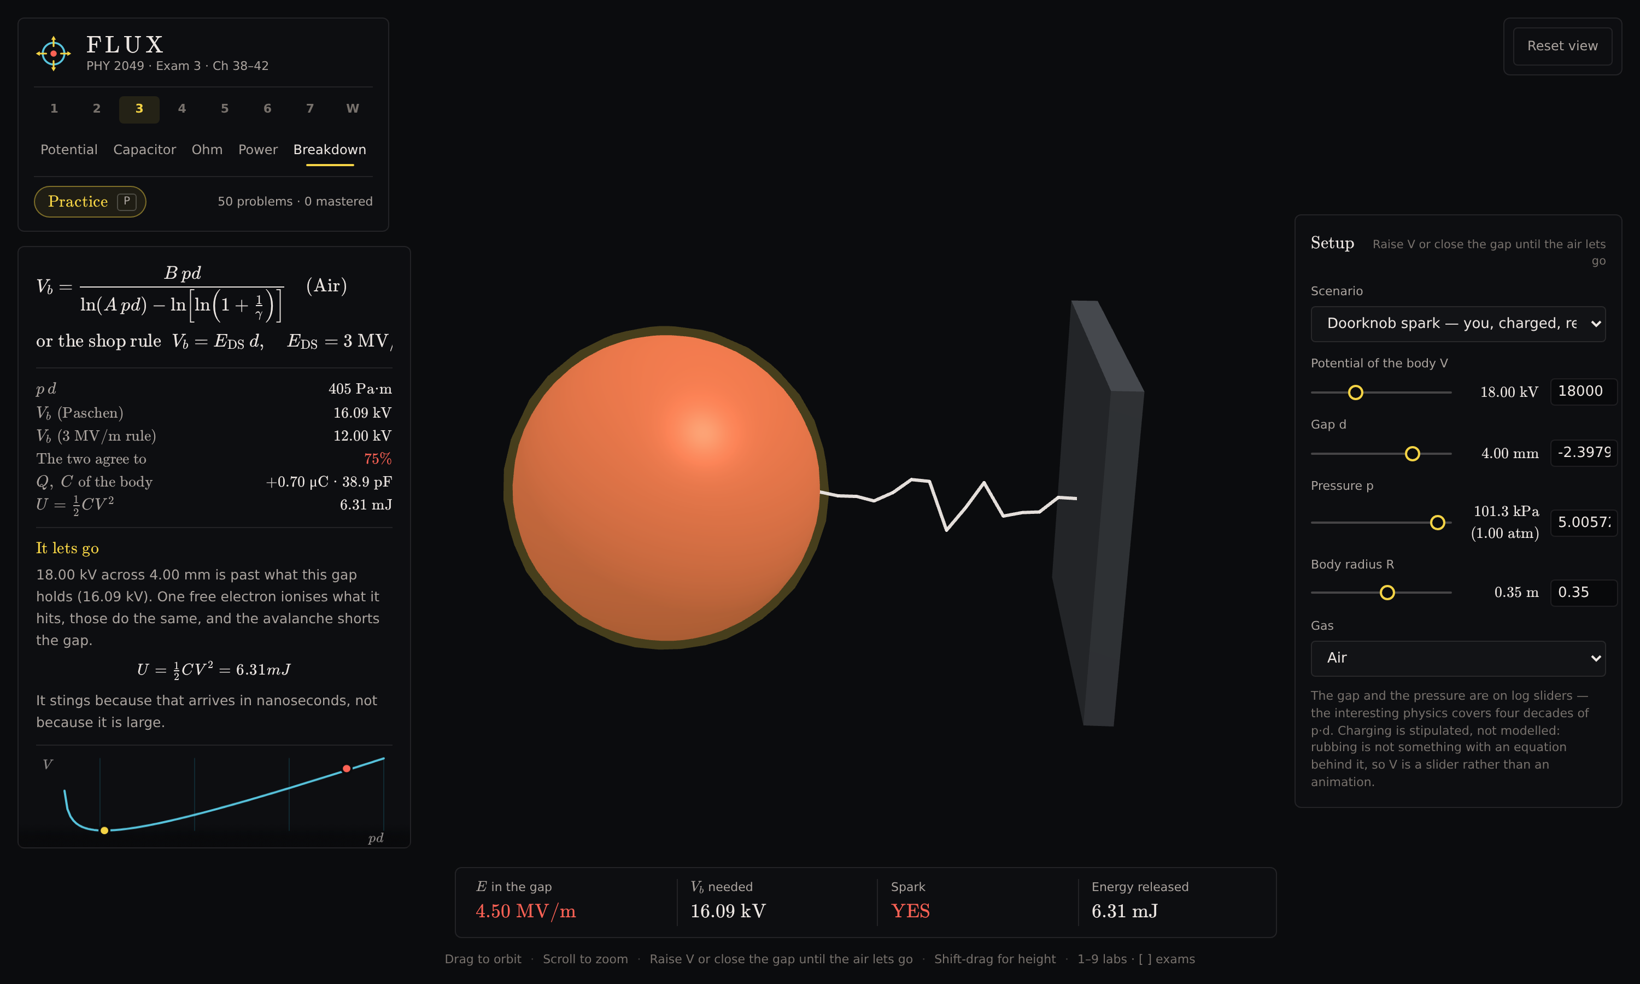
Exam 3 → Breakdown, “Doorknob spark”. 18 kV across a 4 mm gap. The plot is the Paschen curve; the yellow dot is its minimum and the red dot is where you are on it.
Question 17) Record E in the gap, the breakdown voltage the gap needs, and the energy released. The panel also reports how far apart the two rules are here — record that too.

Question 18) Switch to “Same charge, hand further away”. The charge on you has not changed. Explain why there is now no spark, and which quantity changed to stop it.

Question 19) Find the energy released in Question 17 in joules. A dropped paperclip lands with roughly 1 mJ. Given that, explain why the shock hurts.

Question 20) Read the lowest point of the Paschen curve (the yellow dot) from the panel: what is the smallest voltage that can break down a gap of air at all, and at what value of p·d? Is any voltage below that ever enough?

Question 21) Switch to “Thin air”. Here p·d sits to the LEFT of that minimum. Widen the gap with the slider and watch the breakdown voltage. What happens, and why does the 3 MV/m rule get this case exactly backwards?

When complete, upload this Lesson to this assignment in Canvas.

Note for the instructor — what carries over and what does not
This is a direct conversion of Interactive Lesson # 1. All three original learning objectives transfer, two of them with more behind them than the PhET activities had. The one genuine gap is narrow and named below.
Original objective | PhET (Balloons / Travoltage) | FLUX
Polarization; a charged object attracting a neutral one | Qualitative. Charges shown as coloured dots that shift. | Covered, and quantified. σ is reported on the near and far faces in C/m², and the induced charge is shown against the compensating charge so Q_net = 0 is visible as a number.
Conservation of charge | Shown by electrons transferring from the sweater to the balloon. | Covered for induction only. The sphere stays neutral while separating charge. FLUX has no triboelectric charging — nothing is rubbed against anything.
Breakdown in air, and the factors affecting it | The spark in John Travoltage. Qualitative: charge builds, then it jumps. | Covered by the Breakdown lab (Activity # 5), and further than the original went. Paschen’s law against the 3 MV/m rule, with the threshold, the gap, the pressure and the gas all adjustable, and the energy of the spark in joules.
Quantitative Coulomb’s law | Not available. | Added. Exact charges and coordinates can be typed in, and forces are read in newtons, so a prediction can be checked against a number.
Field inside a conductor | Not available. | Added. A movable probe reports E = 0 inside the metal and the region it is in.
Why a gas has a breakdown minimum | Not available. | Added. The Paschen curve is plotted with the operating point on it, so the regime where a WIDER gap breaks down more easily — the reason vacuum insulates — is visible rather than asserted.

Two further differences worth knowing:
- Every value the simulator reports is computed a second time by an independent method and checked against the first — 307 such checks run before each release. The two figures shown side by side in several labs (“numerical” and “analytic”) are that comparison, visible to the student.
- Each lab carries a practice bank. Pressing P opens generated problems for that chapter which load their own setup into the lab, so a student can be asked to predict a number and have it checked. That is not something the PhET activities can do, and it could replace or supplement the written questions above.

The one thing that does not transfer: triboelectric charging. Nothing in FLUX is rubbed against anything, because nothing predicts how much charge a sweater gives a balloon — there is no equation behind it to check against, and every other number in this app is checked against an independent second calculation. Activity # 5 therefore sets the charge with a slider and says so on screen. If seeing charge transfer by rubbing is itself an objective, the PhET balloon remains the better tool for that one thing.
Otherwise the lesson stands on its own: Activities 1–5 as written need nothing but the link.

