A Study of Planck’s Law and Blackbody Radiation

Danny Geisz & Heidi Hu

**Objectives:**

For our capstone project, we wish to test Planck’s Law for the Blackbody Radiation spectrum. Planck’s Law gives the spectral radiance of a blackbody in terms of the temperature of the blackbody and wavelength emitted. In this lab, we will measure the temperature of an approximate blackbody and the luminosity of light emitted from the approximate blackbody at different wavelengths. By varying the temperature of the blackbody, we can find the wavelength at which the luminosity is greatest for a given temperature, and we can use this to experimentally determine Wien’s constant and Planck’s unreduced constant. We would also like to show that our data generally agrees with the distribution given by Planck’s Law, and at the very least we would like to show that our data contradicts Classical Theory, i.e. the Ultraviolet Catastrophe.

**Equipment:**

* Photodetector & Computer with corresponding software (like in Lab 2)
* Tungsten Lightbulb
* DC Power supply. If possible, this power supply should give us voltage and current readings
* Multimeter
* Diffraction Grating with the highest possible Slit Density
* Optical Bench Stands
* Ruler & Meterstick
* Opaque Box with a slit (To place over the Tungsten Bulb)
* Optical Pyrometer, or some other device that can be used to measure the temperature of the bulb. If the lab does not have access to this type of sensor, we can use a different method to determine the temperature of the lightbulb, but it will be less accurate.

**Experimental Setup and Procedure:**

Refer to the following diagram for experimental setup:

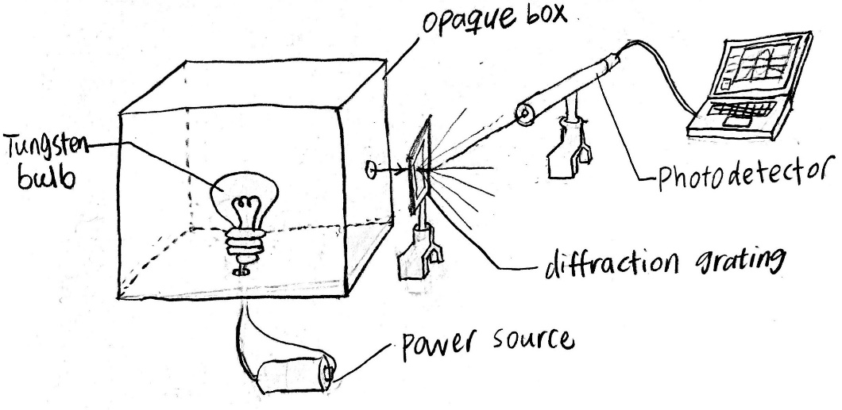

Note that the Power Source in the above diagram should be a DC power supply, not just a battery because we need to vary the voltage in order to vary the temperature of the bulb.

Procedure:

1. Measure the temperature of the Tungsten Bulb
   1. We will either do this by directly measuring the temperature of the bulb with an optical pyrometer, or we will use the equation for the Temperature Dependence of Resistivity by measuring the resistance of the bulb using the Power Supply readings or multimeter.
2. Measure the luminosity of the light emitted at different wavelengths
   1. To do this, we will keep the aperture of the photodetector at a constant distance from the diffraction grating, and by measuring the luminosity of the light emitted at different angles, we use a measurement the angle between the photodetector and the vector normal to the grating to find the luminosity of the light emitted at different wavelengths.
3. Repeat steps 1 and 2 for different temperatures of the Tungsten Bulb
   1. By varying the voltage across to the Tungsten Bulb, we can change the temperature of the filament inside the bulb.

**Expected Outcome:**

Once we finish the lab work, we should have data for the spectral luminosity of a tungsten bulb at different temperatures. If we can accurately calculate the effective area of the aperture of the photodetector, we can then find the spectral radiance of the tungsten bulb at different temperatures. Either way, we can use our data to find the wavelength at which the luminosity or radiance of light emitted reaches a maximum for a given temperature, and we can use this data to calculate Wien’s constant and Planck’s unreduced constant. We can also use our data to show that blackbody radiation behaves according to Planck’s law, and contradicts the classical prediction.