Investor Summary – AI Enabled Automobile Application
Prepared by: Deepak George Anthraper
Target launch: On or before December 2025

Auto-Ignition & Remote Access
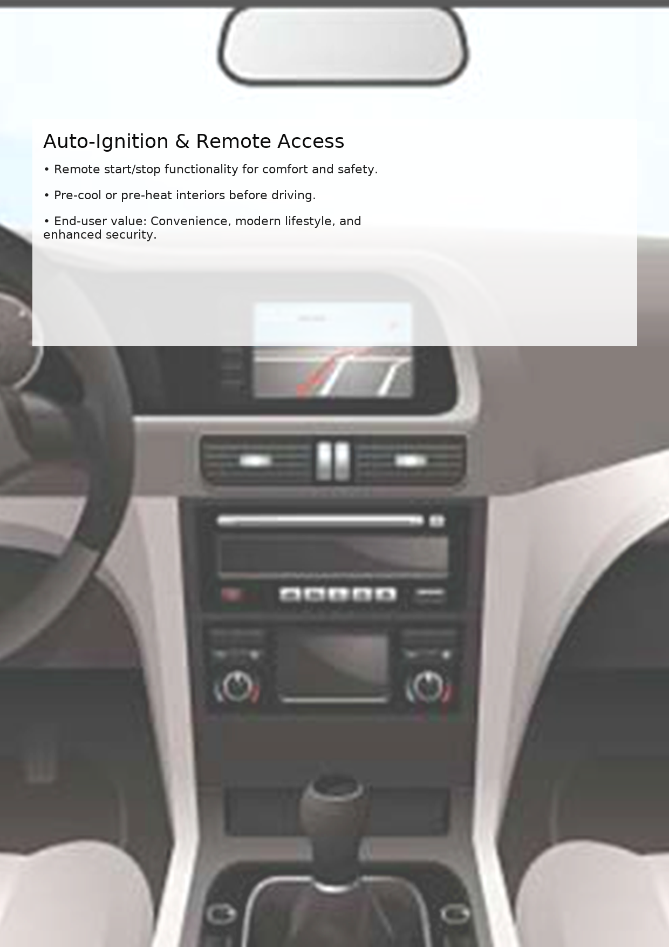

Predictive Maintenance
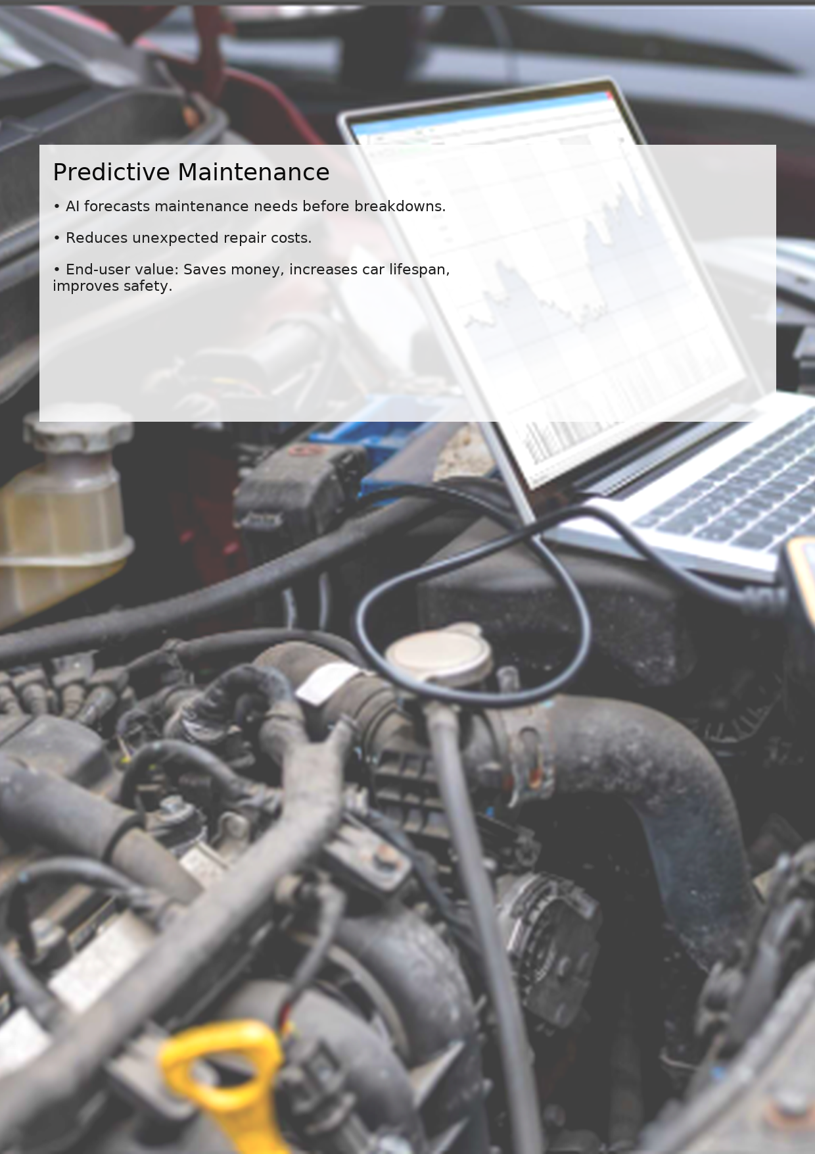

E-Commerce for Car Detailing
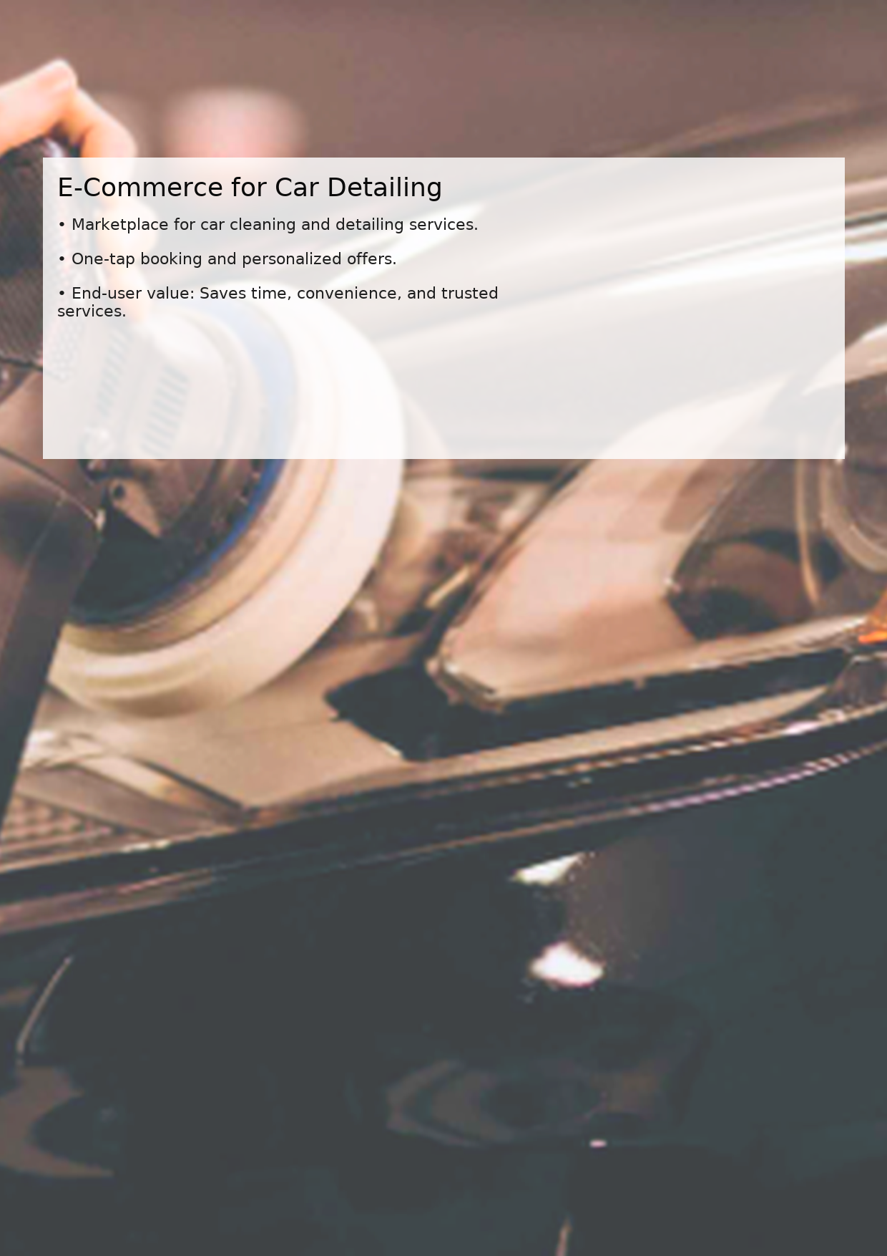

Investment Overview
Funding sought: ₹10,00,000 (₹10 Lakhs) per annum, starting 2025.
Repayment scheduled: June 2026 with 10% ROR → repayment ₹11,00,000.

Repayment Schedule
Year | Investment (₹ Lakhs) | Rate of Return | Repayment (₹ Lakhs) | Repayment Date
2025-26 | 10 | 3.5% | 11 | June 2026

Contingency Funds & Investor Surety
• Provident Fund Account: ₹xx Lakhs
• Immovable Assets: ₹xx Lakhs
These assets provide investor surety, strengthening repayment capability and financial resilience.

Financial Projection (2025-26)
• App Launch: On or before December 2025
• Expected Revenue Streams: subscriptions, premium access, marketplace fees
• Break-even target: Q3 2026
• First-year projected revenue: ₹25–30 Lakhs (conservative).

Signatory
For and on behalf of Deepak George Anthraper
(Flagship Product: AI-Enabled Automobile Application)
Authorized Signatory: ______________________
Date: ______________________
Deepak George Anthraper – AI Enabled Automobile Application

