***Mạch đặc biệt (Thevanin): Chế độ làm việc***

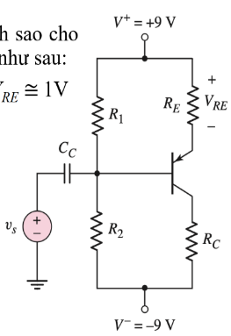

***Mạch khuếch đại E chung***

***Có RE Không có RE***

***Bảng màu***

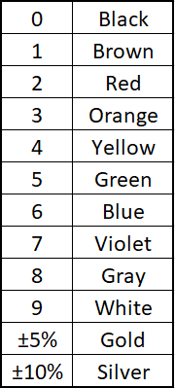VT = 0,026

***Op-amps***

**Đặc tính Volt-Ampe:**

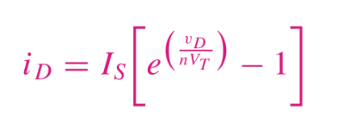

***Op-amps***

****DAC 4 bits R/2R

**Khuếch đại vi sai**

Mạch đặc biệt:

***Nếu có R5 và vI3:***

(Tương tự với Rn)

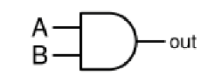

**and**

**or**

**not**

**nand**

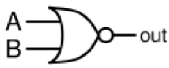

**nor**

**xor**

**xnor**

Mealy Moore

*Made by KhaMinhBao team*