1 - Screenshot - contact admin

2 - install wsl

3 - install docker desktop ( to configure contact admin)

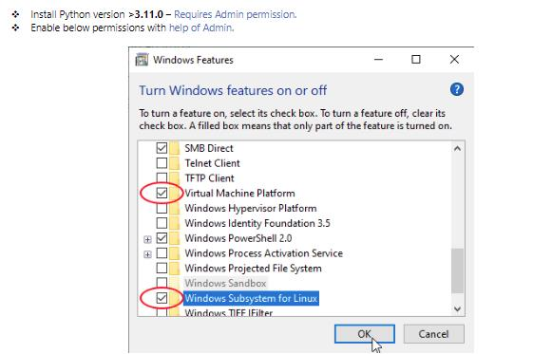

two ways we can use docker ka:

1- by using ubunttu we can install & run docker , athuku we have commands

<https://pureinfotech.com/install-ubuntu-windows-10/> - either can install ubuntu by commands or install directly from marketplace

[01_Docker_Installation.pdf](https://iz-my.sharepoint.com/:b:/r/personal/pandeeswaran_r_intelizign_com/Documents/Microsoft%20Teams%20Chat%20Files/01_Docker_Installation.pdf?csf=1&web=1&e=MxX6sC)

2 - docker desktop . Many are using docker desktop that is easy to use and configuration

**PULL DATA FROM GITLAB**

[**https://docs.gitlab.com/ee/gitlab-basics/start-using-git.html**](https://docs.gitlab.com/ee/gitlab-basics/start-using-git.html)

1. **Install git from software center**
2. **Open the file explorer location in gitbash**
3. **Configure git**

git config **--global** user.name "your_username"

git config **--global** user.email [your_email_address@example.com](mailto:your_email_address@example.com)

**4- Clone a repository**

git clone <https://gitlab.intelizign.com/baseline/data-engineering-and-data-vault_2.0.git>

Go to visual studio code -> version control -> select the branch and pull the changes.

sudo docker compose up --build