# DOCKER INSTALLATION

On WSL Ubuntu

❖ Install Python version >3.11.0 – Requires Admin permission.

❖ Enable below permissions with help of Admin.

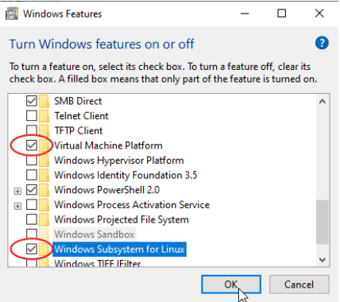

❖ Install Ubuntu (windows sub system for Linux) from Microsoft Store.

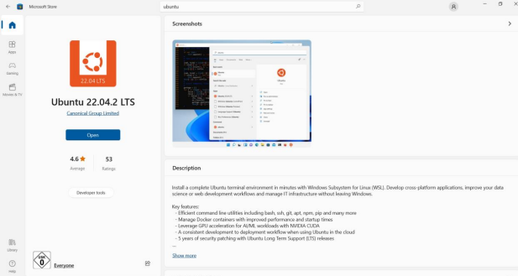

<https://learn.microsoft.com/en-us/windows/wsl/install-manual#step-4---download-the-linux-kernel-update-package>

**Or by running command in the windows PowerShell as an admin**

* wsl --install --d Ubuntu-22.04

❖ Check wsl version by running following command in windows PowerShell

* wsl -l -v

❖ If version is 1 set it to 2 by using following command (Change the distro name to your ubuntu version)

* wsl --set-version Ubuntu-22.04 2

❖ Open the Ubuntu command line to do the following steps

**To remove the Docker Engine, if already exists**

* sudo apt remove docker docker-engine docker.io containerd runc

## Install prerequisites for Docker

### Updating apt package index:

* sudo apt update && sudo apt upgrade
* sudo apt install --no-install-recommends apt-transport-https ca-certificates curl gnupg2

Change the network config so that Docker can interact with the firewall using the command below:

* update-alternatives --config iptables

➢ Choose the legacy version

**To avoid issues during the future steps, make sure Ubuntu trusts the Docker packages**

* . /etc/os-release
* curl -fsSL https://download.docker.com/linux/${ID}/gpg | sudo tee /etc/apt/trusted.gpg.d/docker.asc
* echo "deb [arch=amd64] https://download.docker.com/linux/${ID} ${VERSION_CODENAME} stable" | sudo tee /etc/apt/sources.list.d/docker.list
* sudo apt update

**To download latest version**

* sudo apt install docker-ce docker-ce-cli containerd.io

**To download specific version**

# List the available versions:

* apt-cache madison docker-ce | awk '{ print $3 }'

List of available versions are listed like this

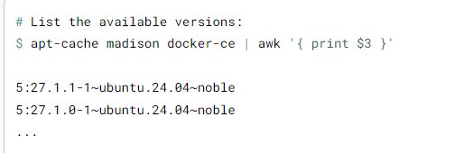

**Select the desired version and install:**

* VERSION_STRING=5:27.1.1-1~ubuntu.24.04~noble
* sudo apt-get install docker-ce=$VERSION_STRING docker-ce-cli=$VERSION_STRING containerd.io

## Configure our user to work with Docker

**Add our user to the Docker group:**

* sudo usermod -aG docker $USER
* getent group | cut -d: -f3 | grep -E '^[0-9]{4}' | sort -g
* getent group | grep 36257 || echo "Yes, that ID is free"

➢ If it is free

* sudo sed -i -e 's/^\(docker:x\):[^:]\+/\1:36257/' /etc/group
* sudo groupmod -g 36257 docker
* vim ~/.bashrc

## Set Docker to autostart

**Go into edit mode by pressing `i` and paste the following lines at the end of the file.**

* DOCKER_DISTRO="Ubuntu"

DOCKER_LOG_DIR=$HOME/docker_logs

mkdir -pm o=,ug=rwx "$DOCKER_LOG_DIR"

/mnt/c/Windows/System32/wsl.exe -d $DOCKER_DISTRO sh -c "nohup sudo -b dockerd < /dev/null > $DOCKER_LOG_DIR/dockerd.log 2>&1"

**Once done press**

**ESC to exit edit mode and type `:wq` and press enter**

* . ~/.bashrc

sudo docker ps

## Start the docker daemon:

**Open the nano text editor:**

* sudo nano /etc/docker/daemon.json

**Paste the following at the end of the file:**

* {"hosts": ["unix:///var/run/docker.sock", "tcp://0.0.0.0:2375"]}

Press ctrl-s to save, then ctrl-x to close nano.

**Start Docker:**

sudo dockerd

Reference: <https://dataedo.com/docs/installing-docker-on-windows-via-wsl>