**Can we listen to single Kinesis from multiple Glue jobs? Advantages and disadvantages**

Yes, this process generally involves using AWS Glue to create multiple data processing jobs, each of which reads data from the same Kinesis stream but may perform different transformations or analytics tasks.

**Advantage:**

**Custom Processing:** Different Glue jobs could be designed to perform specific transformations, aggregations, or analyses on the data.

Each glue performs their own tasks independently

**Disadvantage**:

**Cost**: Running multiple Glue jobs simultaneously may increase the cost of your AWS infrastructure, as you'll be paying for the resources used by each job.

**Monitoring**: need to keep track of the status of each job

**Complexity**: Managing multiple Glue jobs that consume data from the same Kinesis stream can add complexity to architecture.

**Note (my perception):**

This use case - kinesis data as an input and need to perform multiple processing. Instead of using multiple glue, this setup below also do the same:

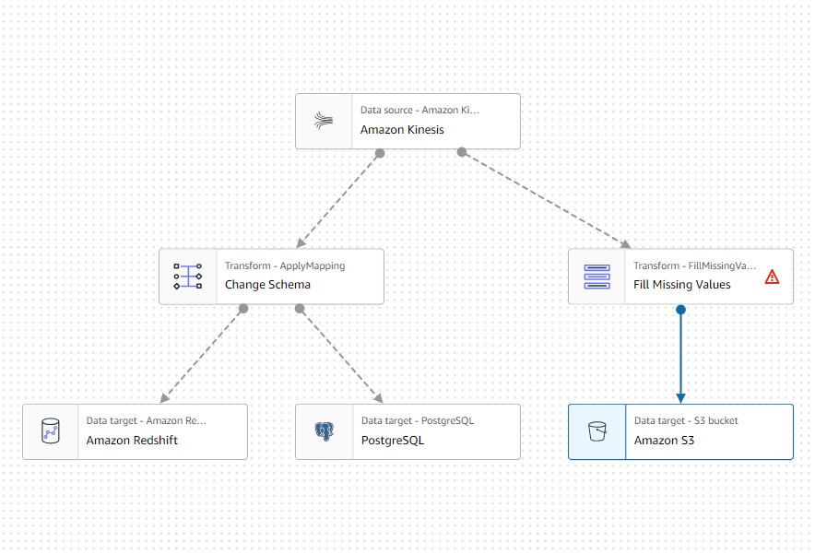

**Prepare Cost, benefit analysis for 1 kinesis and 1 Glue job versus 1 Kinesis and multiple glue jobs** (pricing mentioned here is Frankfurt region)

**Kinesis pricing** :

1.On demand – pay per GB of data written and read from your data streams

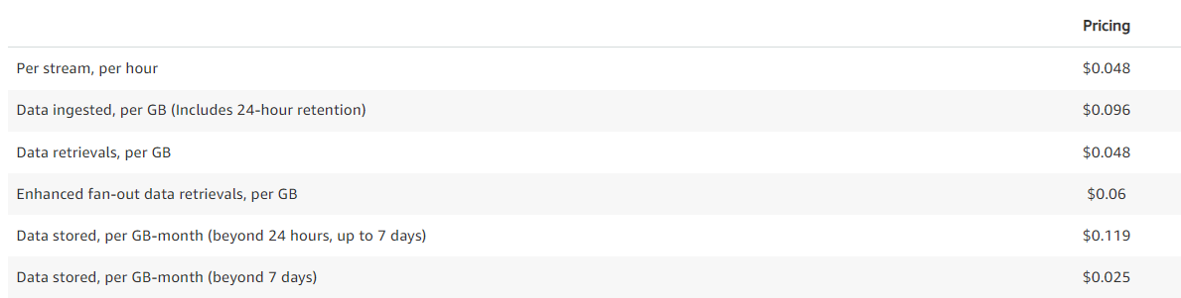  
2. Provisioned mode - you specify the number of shards necessary for your application based on its write and read request rate

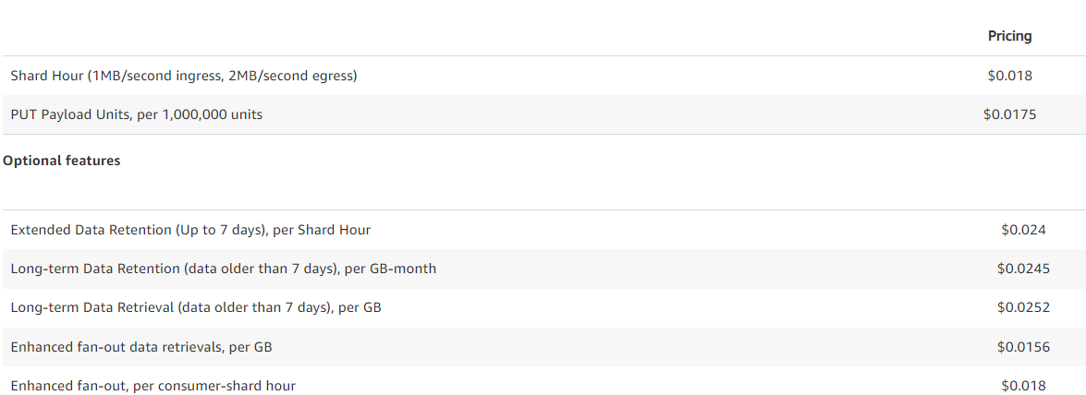

**Glue pricing:**

**ETL job**: pay for the time that your ETL job takes to run. AWS charges an hourly rate based on the number of data processing units (DPUs)

**Data catalog storage**: store up to a million objects for free. More than million object, will be charged $1.00 per 100,000 objects over month

**Crawler**: $0.44 per DPU-Hour, billed per second, with a 10-minute minimum per crawler run

**Data brew interactive session**: The first 40 interactive sessions are free for first-time users of Data Brew. Charged $1.00 per session

**Data brew jobs**: pay for the time that you use to clean when the job runs. Charged $0.48 per Data Brew node hour

Glue pricing is categorized by many components. We might be using all those in running a job. If we use multiple glue, we need to pay for all those components for each glue.

So, **1 kinesis with glue cost < 1 kinesis with multiple glue**