**MATERIAL PRIORITIZATION**

Mendix version – **9.24.17**

The project has two major pages

1.Dashboard Page

2.Planning Page

**DASHBOARD PAGE:**

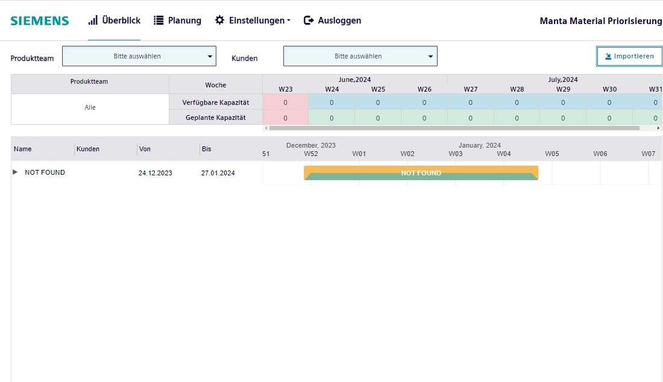

This page has visual representation of false order- BRECHUNUNG orders (Ist situation – false)

It has product team & customer dropdown that reflects with both capacity table & gantt chart

The top page has a capacity table, with a calendar that starts from the given capacity_calendarWeek and ends with capacity_calendarWeek +9 days.

Gantt chart shows the false order representation with calendar that false order start week

Functionality in gantt chart:

Gantt chart shows the orders of each product team

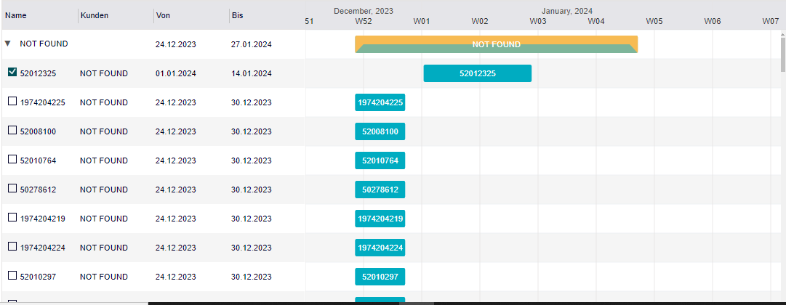

OCH of order check box- is an order fix, it will move to top, once it is checked we can change the timeline of the orders (i.e start & end date of orders) by dragging the timeline of orders

Import button:

It is placed in the top right corner of the page

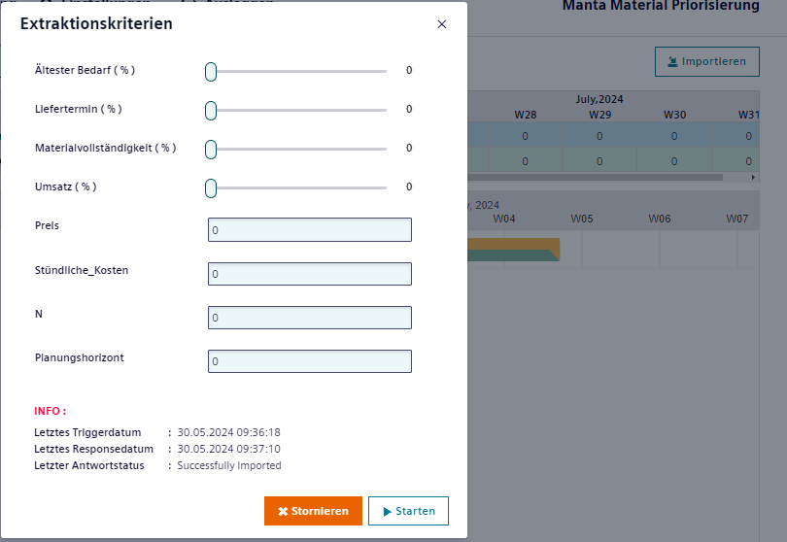

On click of btn, pop up will open, give the required input and click Run.

On click of run, api will trigger based on the input & retrieves false order data & store it in db.

Once Run btn clicked, import btn start loading until the response stored in backend.Once process done loading bar will change to import button.

**PLANNING PAGE:**

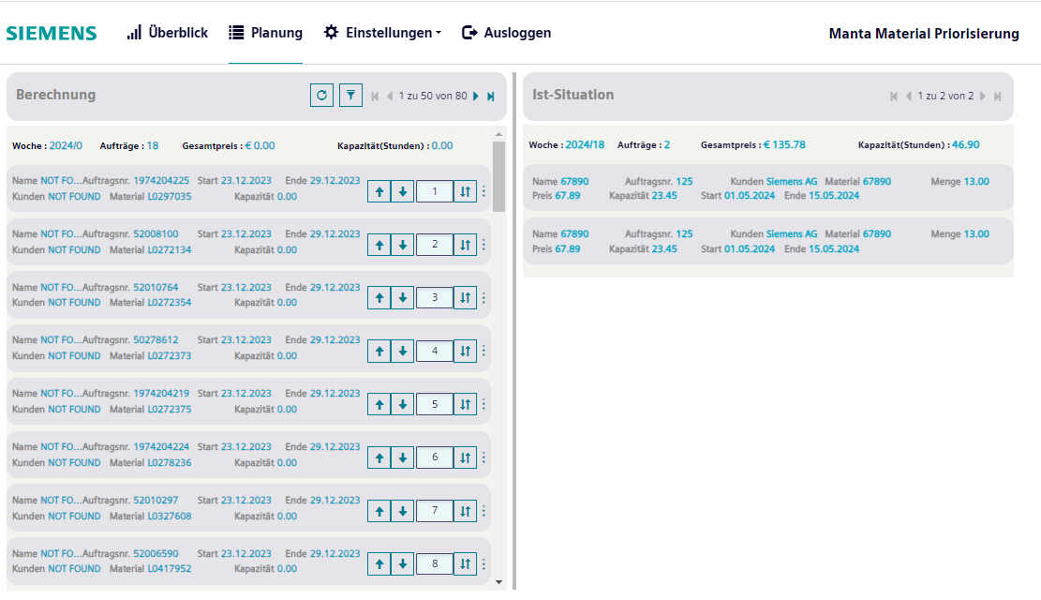

It has product team, calendarWeek & customer dropdown that reflects with both right & left side of the page

Left side – BRECHUNUNG orders (Ist situation – false)

This side has the orders based on the week.

Here, we can modify the order priority by clicking up and down arrow button & index number button only within the same week, also we have menu button, there are two options called move first and move last within the same week.

Order fixes are filled with color

Right side – IS-SITUATION orders (Ist situation – true)

This side has the orders based on the week. Only we can view the orders from SAP

**SNOWFLAKE**

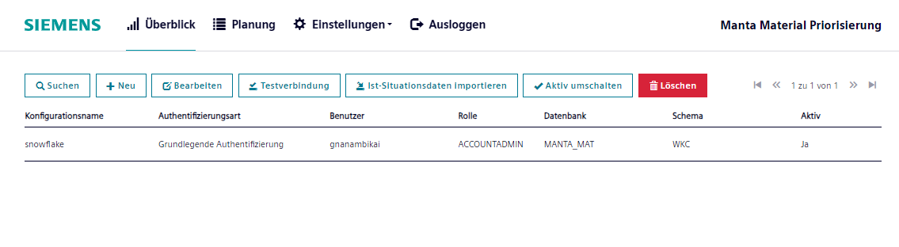

Configure snowflake credential, click import button, to retrieve ist situation orders from snowflake by giving from and to date of the data.

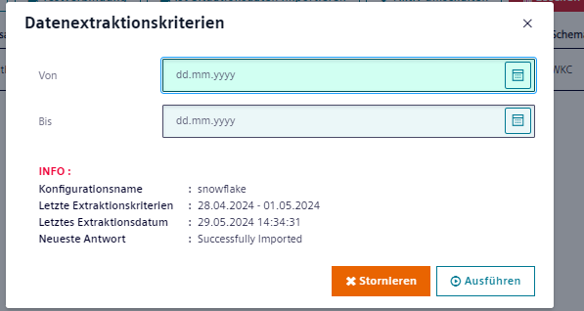

Import those data into mendix database.

**API CONFIGURATION:**

