How to deploy your application to the cloud  
<https://docs.mendix.com/developerportal/deploy/mendix-cloud-deploy>  
  
After you’re done with development and have locally tested your code works as expected, that’s when you commit your code on the division-branch. (Such as EPS-branch)

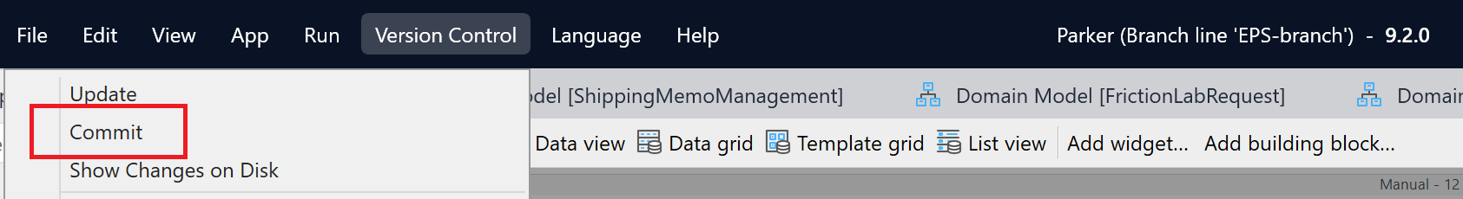

When the commit has been completed, open the Development-branch, and merge the changes:  
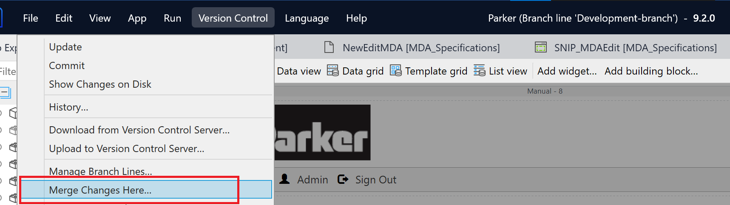

Click on Advanced merge, select the revision you want to merge into the development-branch.

After you click on merge, the local instance of studio pro will display all the changes made in the division-branch. Ensure there are no errors or conflicts in the changes tab. Once all errors/conflicts have been resolved, commit the changes on the development-branch and mention which versions have been merged. Once you have committed your changes, go to the developer portal. (https://sprintr.home.mendix.com/)

On the developer portal navigate to the Parker project.

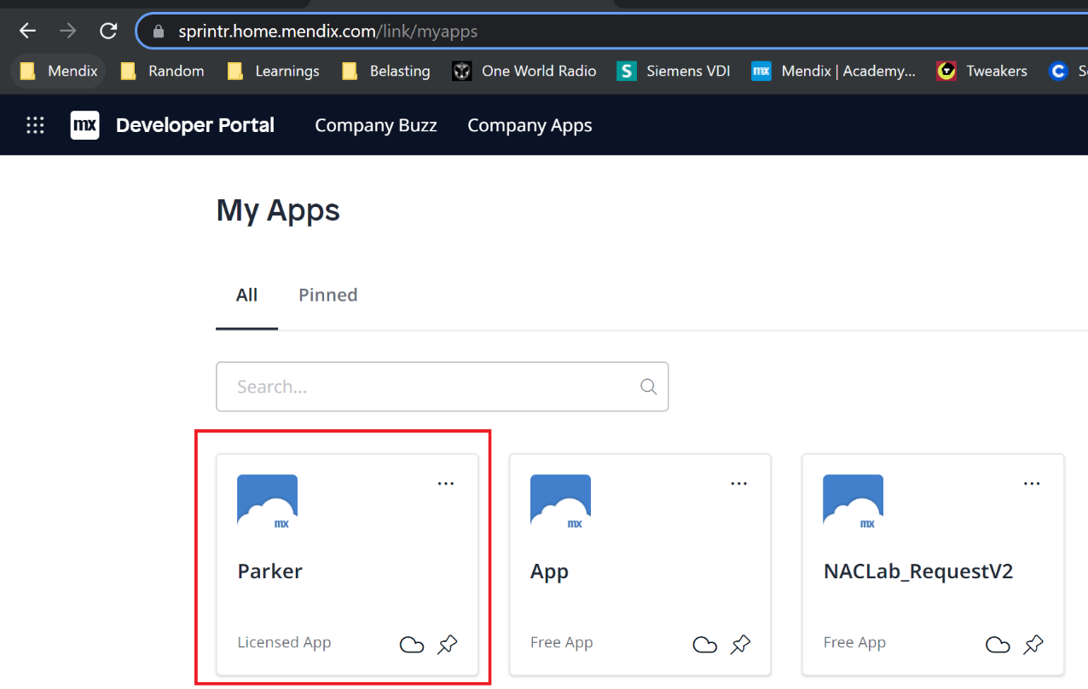

Click on environments:  
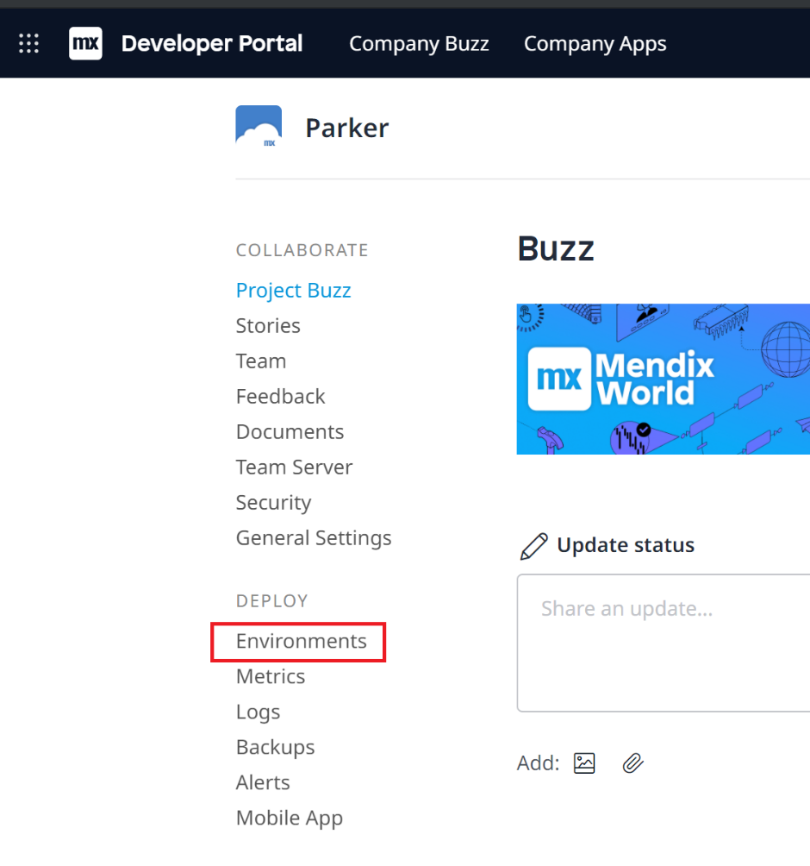

Click on Create Package From Teamserver:  
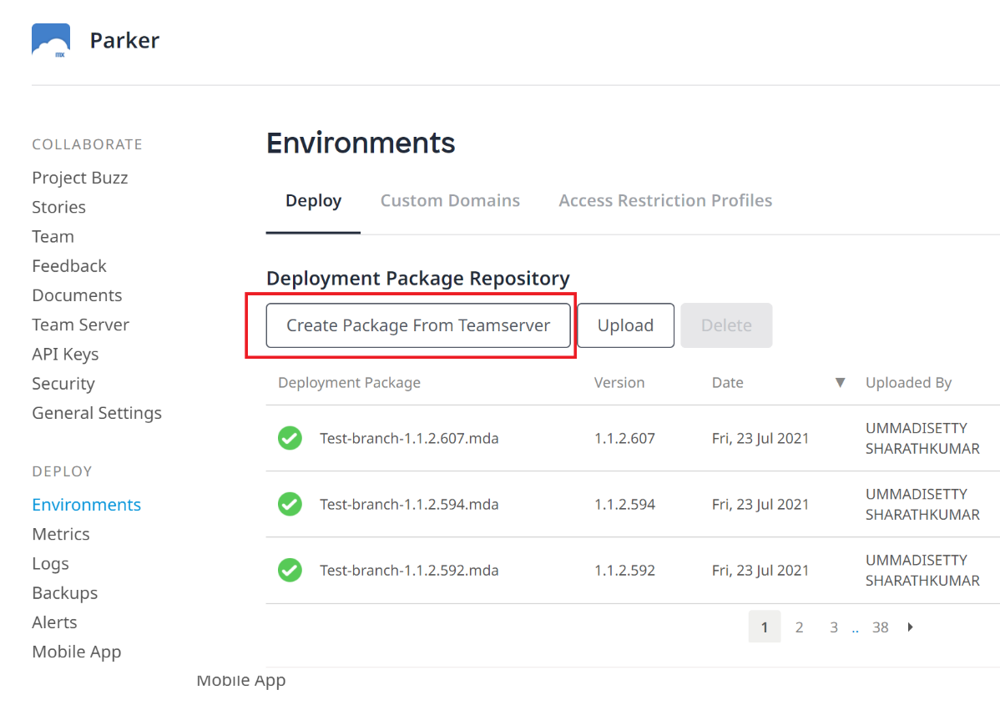

Select the branch we’ve merged the changes in (development-branch) and click on next:  
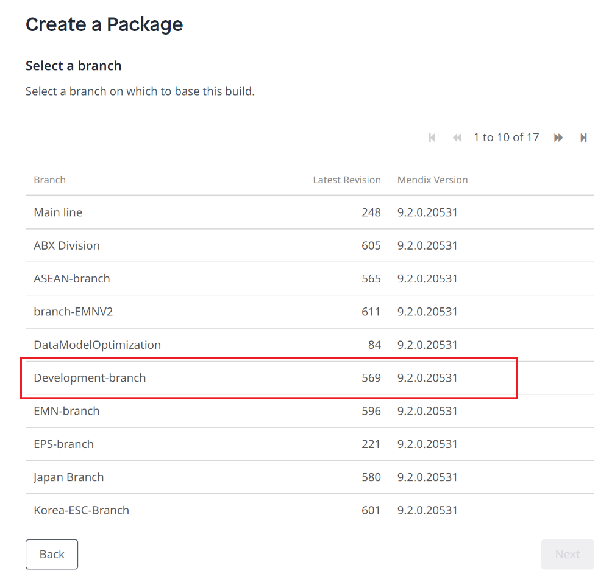

Select the revision that has the merged changes and click next:  
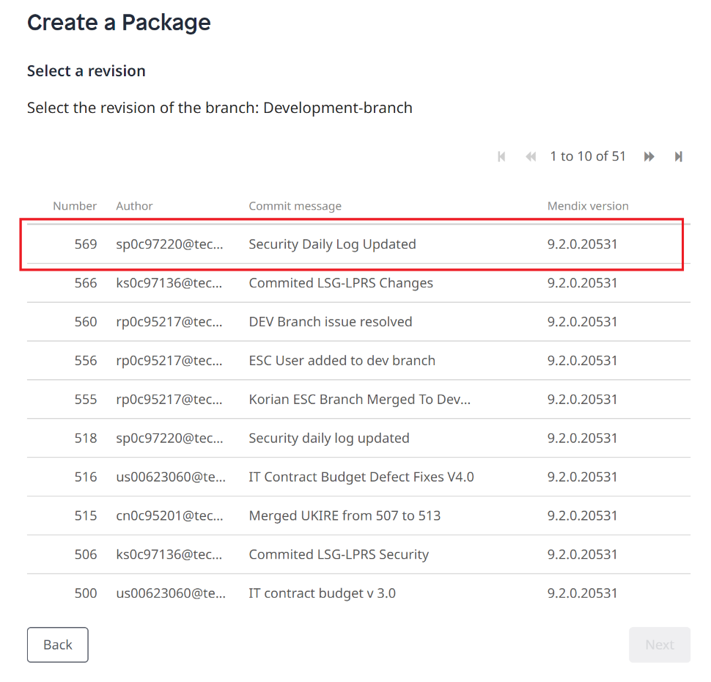  
  
Update version accordingly (depending on major update/minor update/bug fix) and click this revision:

After the package is completed click on the deploy button:  
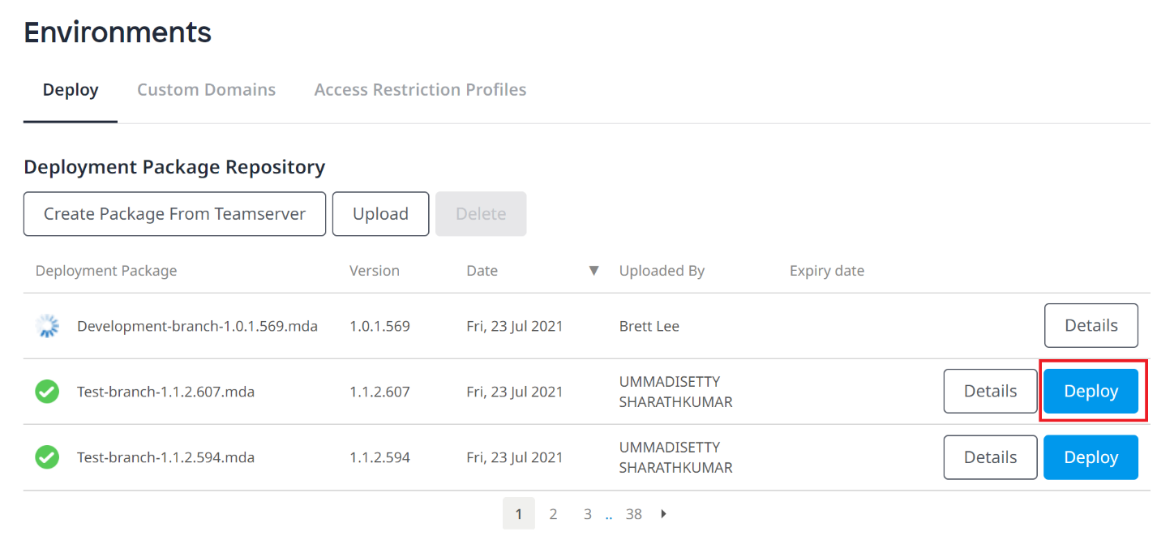

Select the environment you want to push this package and then click on transport:  
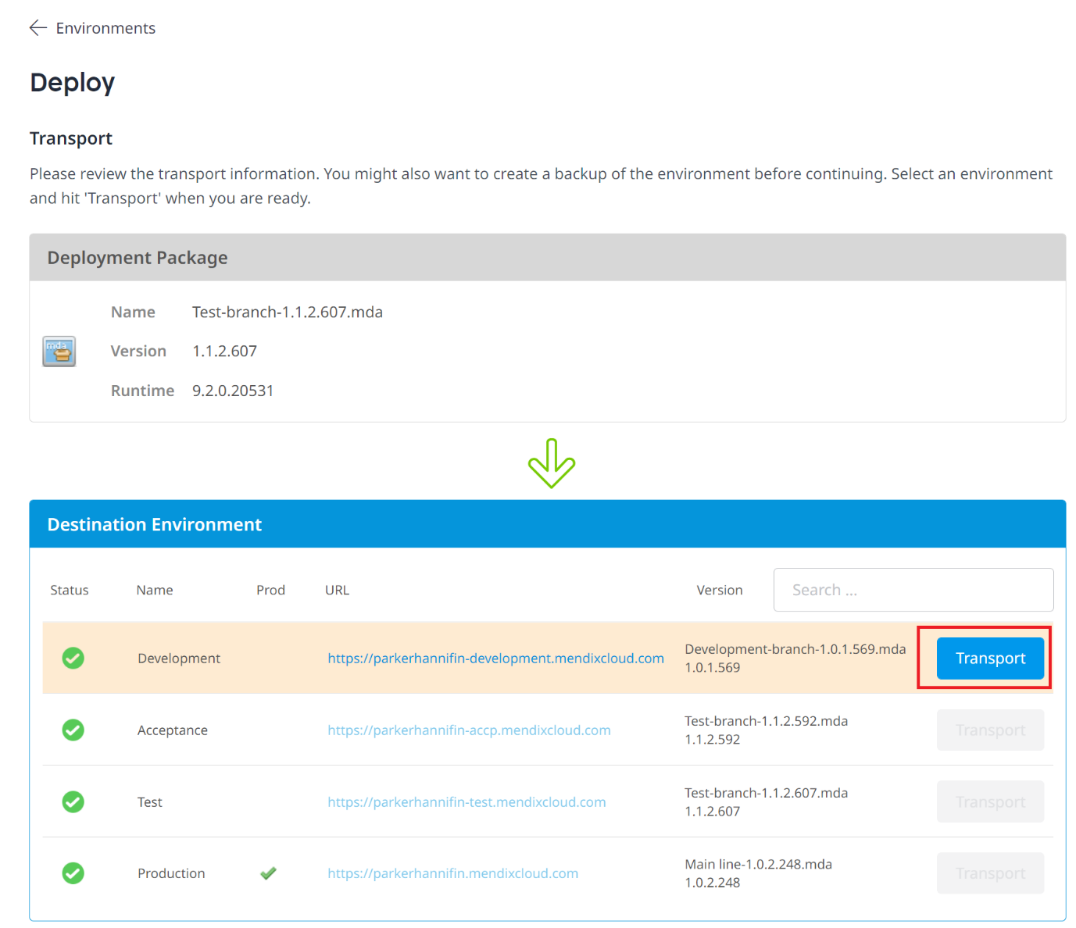  
After you’ve clicked on transport, the package will be pushed to the environment, click okay to continue:  
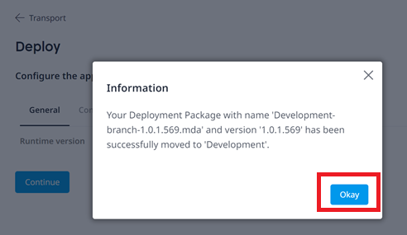

Then transport the package to the environment, click on continue:  
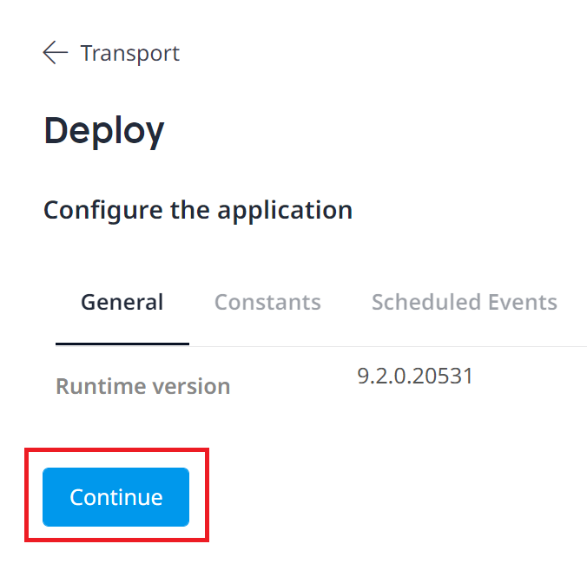

Restart environment by clicking on the restart environment   
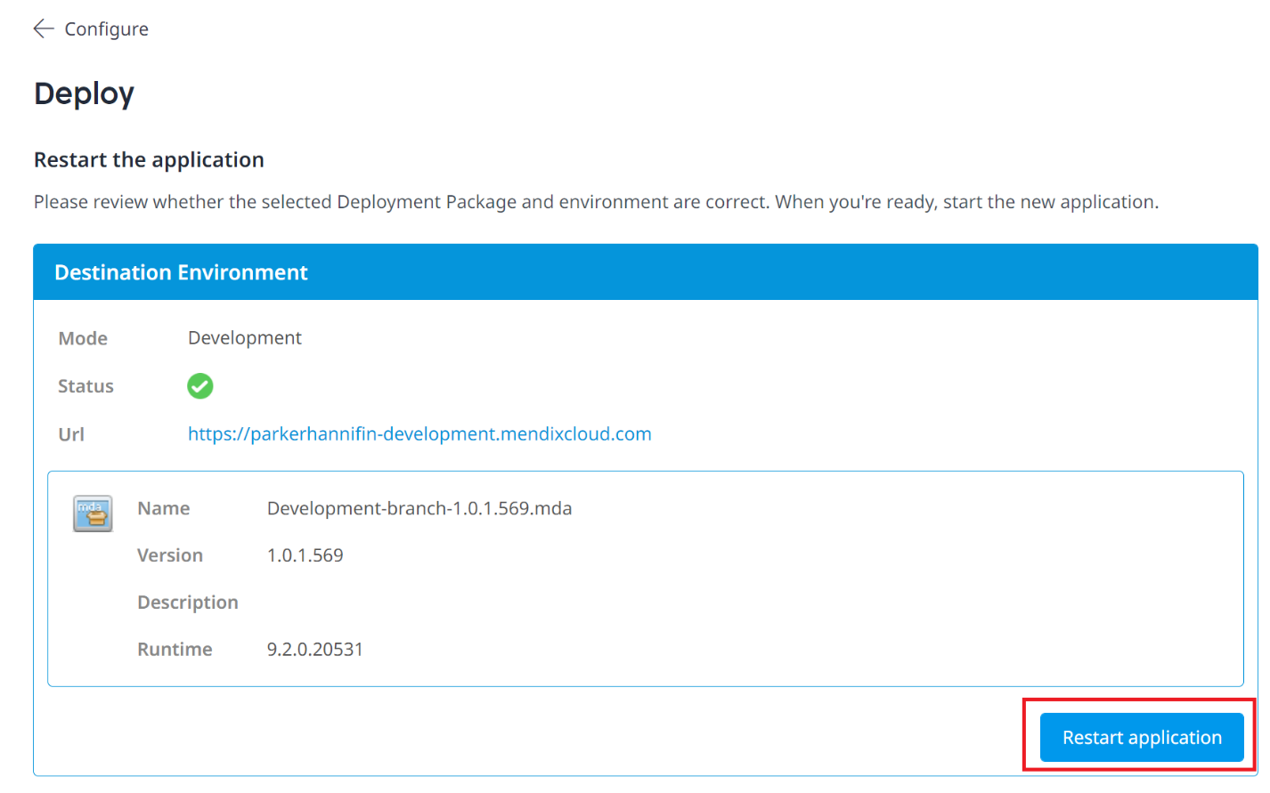  
  
After the environment has been restarted, the latest changes will have been pushed to the selected environment.

Note: For pushing to Test, Acceptance, Prod should grab the latest from the development-branch and merge it into those specific branches.