# PYTHON

## Strings

Print (‘Hello Python’)

Print (“Hello Python”)

Print (‘’’Hello Python’’’)

A = ‘python’

Print(f’Hello {A}’)

**Slicing**

b = "Hello, World!"  
print(b[2:5])

Print(b[::-1]) -> String reversal operator

**Split()**

a = " Hello World! "

b = a.split()

**Escape Character**

txt = "We are the so-called \"Vikings\" from the north."

**Place holder**

#named indexes:

txt1 = "My name is {fname}, I'm {age}".format(fname = "John", age = 36)

#numbered indexes:

txt2 = "My name is {0}, I'm {1}".format("John",36)

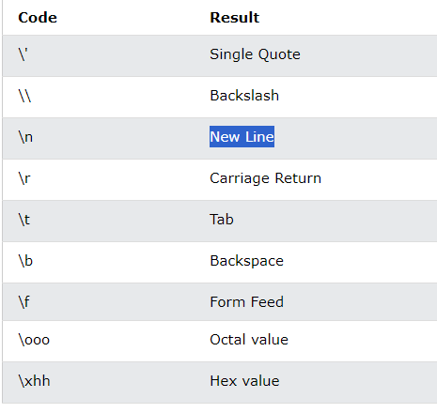

## Python Collections (Arrays)

There are four collection data types in the Python programming language:

* **List** is a collection which is ordered and changeable. Allows duplicate members.
* [**Tuple**](https://www.w3schools.com/python/python_tuples.asp) is a collection which is ordered and unchangeable. Allows duplicate members.
* [**Set**](https://www.w3schools.com/python/python_sets.asp) is a collection which is unordered, unchangeable*, and unindexed. No duplicate members.
* [**Dictionary**](https://www.w3schools.com/python/python_dictionaries.asp) is a collection which is ordered** and changeable. No duplicate members.

**When to use**

**Lists** are used when you have data you want to further modify, alter like sorting and all.

**Dictionary** is used when you have to sets of data where data of the first set corresponds to data of other set. And the position of the data doesn't matter only the relation of the two sets matters.

A **tuple** is used when position of the data is very important and you don't want to alter the position throughout.

### List

**Change list items**

By assigning the index of the list or by insert method

thislist = ["apple", "banana", "cherry", "apple", "cherry"]

**Thislist[2] = “Orange”**

**thislist.insert(3, "watermelon")**  
print(thislist)

List can also written as

thislist = list (("apple", "banana", "cherry"))

Since it is order we can access by **indexing**

Negative indexing reprsents from the last obj in a list

**In Operator**

thislist = ["apple", "banana", "cherry"]  
if "apple" in thislist:  
 print ("Yes, 'apple' is in the fruits list")

**Remove List item**

.remove(item in a list)

.pop(index value in a list)

.pop() - remove last obj in list

.clear

Del list [index value in a list]

Del list

**Sort List**

thislist.sort() - sort ascending - alphabetically

thislist.sort(reverse = True) - sort descending – alphabetically

thislist.sort(key = str.lower) - sort based on lower case

thislist.sort(key = len)- sort basedon len of list

**Copy list**

mylist = list.copy()

mylist = list(thislist)

mylist = thislist[:]

**Join List**

list3 = list1 + list2

list1.extend(list2)

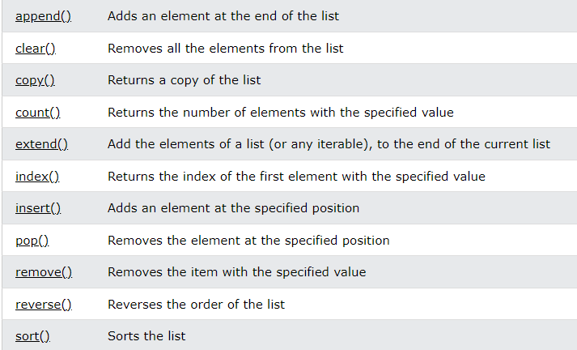

Tuple