Sudo apt update

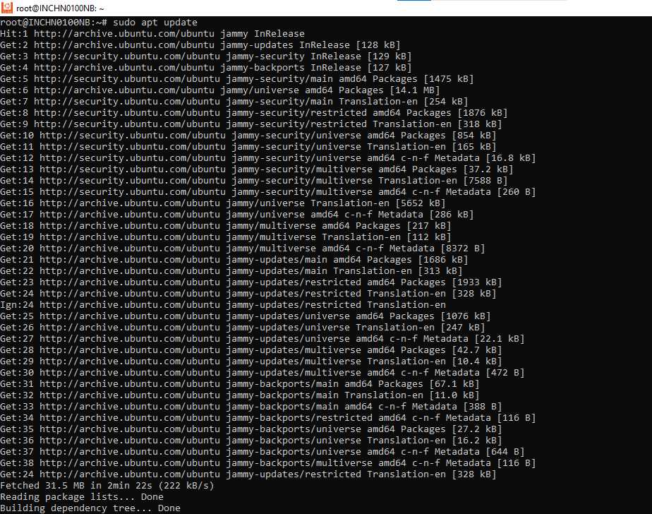

sudo apt install samba

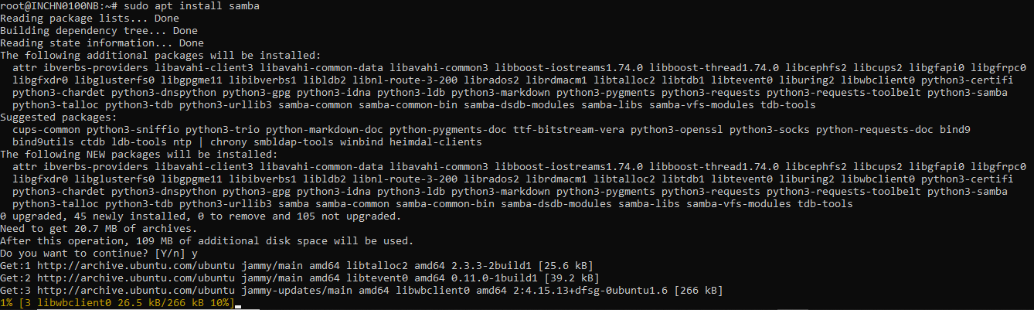Y

sudo systemctl status smbd

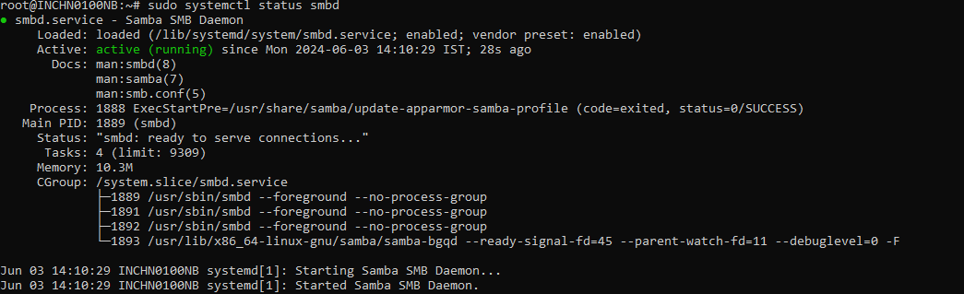

sudo ufw allow 'Samba'



sudo cp /etc/samba/smb.conf{,.backup}

sudo nano /etc/samba/smb.conf

sudo systemctl restart smbd

sudo systemctl restart nmbd

sudo mkdir /samba

sudo chgrp sambashare /samba

**sudo useradd -M -d /samba/Smbuser -s /usr/sbin/nologin -G sambashare Smbuser**

**sudo mkdir /samba/ Smbuser**

**sudo chown Smbuser:sambashare /samba/Smbuser**

**sudo chmod 2770 /samba/ Smbuser**

**sudo smbpasswd -a Smbuser**

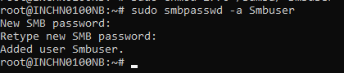

**sudo smbpasswd -e Smbuser**



sudo systemctl enable nmbd

sudo systemctl enable smbd

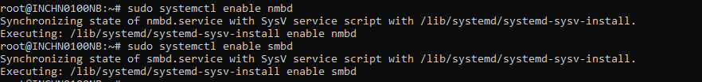sudo nano /etc/samba/smb.conf

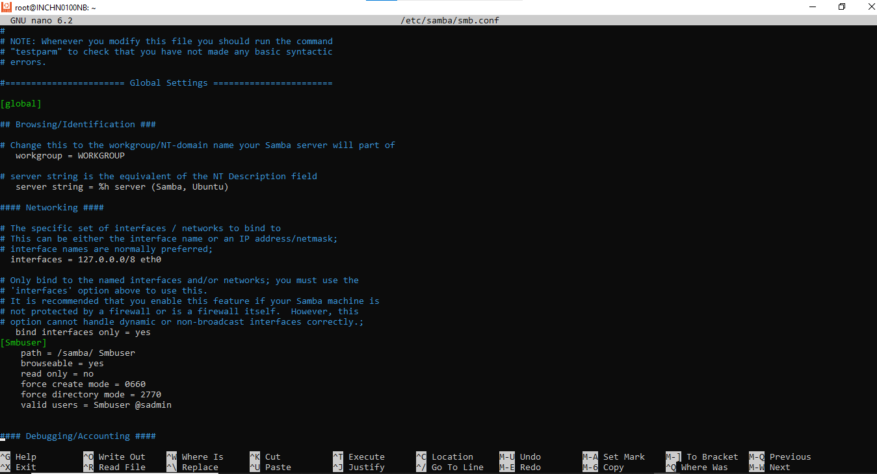

[Smbuser]

path = /samba/ Smbuser

browseable = yes

read only = no

force create mode = 0660

force directory mode = 2770

valid users = Smbuser @sadmin

Ifconfig

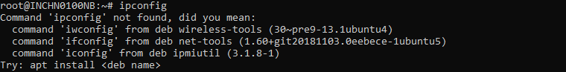If found like this

Apt install net-tools

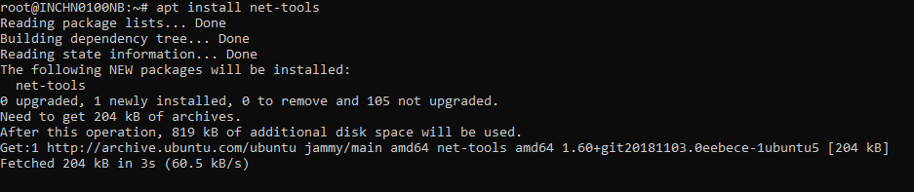Then give ifconfig

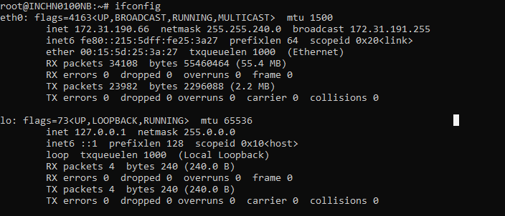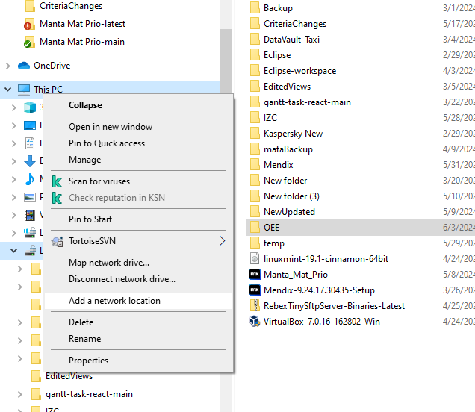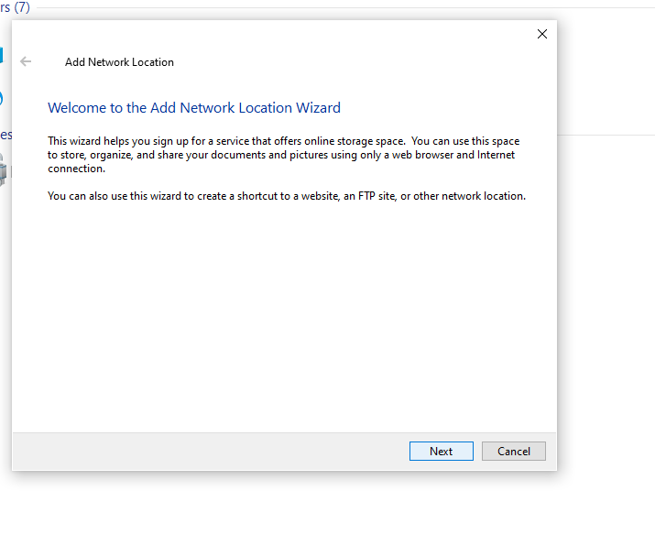click Next

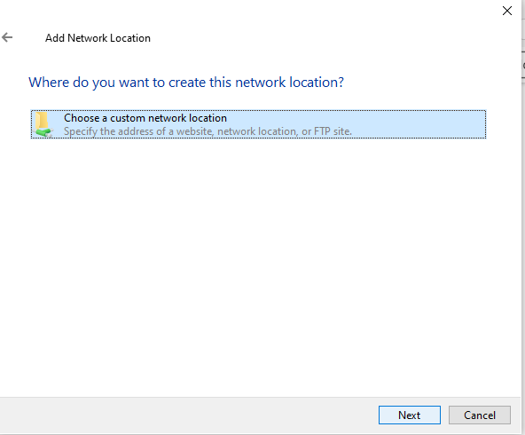

Click Next

