HIGHRISE HAVOC

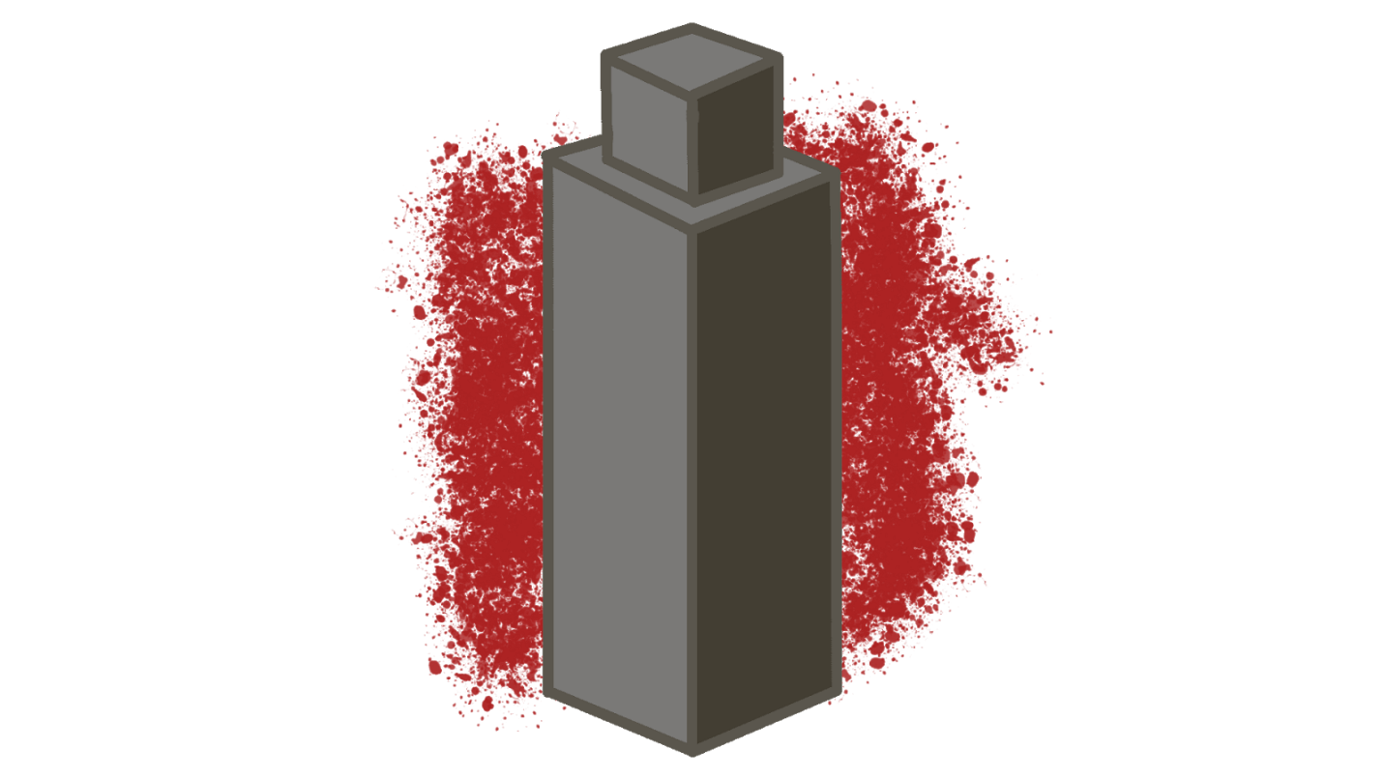

Game Design Document

This page: Table of Contents and Team Member Listing

|  |  |  |
| --- | --- | --- |
| Table of Contents  [1 Game Overview](https://n-xovwktmtjsnaxyc2mwes2xu7pohqedmdm6zjw5q-2lu-script.googleusercontent.com/userCodeAppPanel)  [2 High Concept](https://n-xovwktmtjsnaxyc2mwes2xu7pohqedmdm6zjw5q-2lu-script.googleusercontent.com/userCodeAppPanel)  [3 Unique Selling Points](https://n-xovwktmtjsnaxyc2mwes2xu7pohqedmdm6zjw5q-2lu-script.googleusercontent.com/userCodeAppPanel)  [4 Platform Minimum Requirements](https://n-xovwktmtjsnaxyc2mwes2xu7pohqedmdm6zjw5q-2lu-script.googleusercontent.com/userCodeAppPanel)  [5 Game Objectives](https://n-xovwktmtjsnaxyc2mwes2xu7pohqedmdm6zjw5q-2lu-script.googleusercontent.com/userCodeAppPanel)  [6 Game Rules](https://n-xovwktmtjsnaxyc2mwes2xu7pohqedmdm6zjw5q-2lu-script.googleusercontent.com/userCodeAppPanel)  [7 Game Structure](https://n-xovwktmtjsnaxyc2mwes2xu7pohqedmdm6zjw5q-2lu-script.googleusercontent.com/userCodeAppPanel)  [8 Game Play](https://n-xovwktmtjsnaxyc2mwes2xu7pohqedmdm6zjw5q-2lu-script.googleusercontent.com/userCodeAppPanel)  [8.1 Game Controls](https://n-xovwktmtjsnaxyc2mwes2xu7pohqedmdm6zjw5q-2lu-script.googleusercontent.com/userCodeAppPanel)  [8.2 Game Camera](https://n-xovwktmtjsnaxyc2mwes2xu7pohqedmdm6zjw5q-2lu-script.googleusercontent.com/userCodeAppPanel)  [8.3 HUD](https://n-xovwktmtjsnaxyc2mwes2xu7pohqedmdm6zjw5q-2lu-script.googleusercontent.com/userCodeAppPanel)  [9 Players](https://n-xovwktmtjsnaxyc2mwes2xu7pohqedmdm6zjw5q-2lu-script.googleusercontent.com/userCodeAppPanel)  [9.1 Characters](https://n-xovwktmtjsnaxyc2mwes2xu7pohqedmdm6zjw5q-2lu-script.googleusercontent.com/userCodeAppPanel)  [9.2 Metrics](https://n-xovwktmtjsnaxyc2mwes2xu7pohqedmdm6zjw5q-2lu-script.googleusercontent.com/userCodeAppPanel)  [9.3 Weapons](https://n-xovwktmtjsnaxyc2mwes2xu7pohqedmdm6zjw5q-2lu-script.googleusercontent.com/userCodeAppPanel)  [10 NPC](https://n-xovwktmtjsnaxyc2mwes2xu7pohqedmdm6zjw5q-2lu-script.googleusercontent.com/userCodeAppPanel)  [10.1 Enemies](https://n-xovwktmtjsnaxyc2mwes2xu7pohqedmdm6zjw5q-2lu-script.googleusercontent.com/userCodeAppPanel)  [11 Art](https://n-xovwktmtjsnaxyc2mwes2xu7pohqedmdm6zjw5q-2lu-script.googleusercontent.com/userCodeAppPanel)  [11.1 Setting](https://n-xovwktmtjsnaxyc2mwes2xu7pohqedmdm6zjw5q-2lu-script.googleusercontent.com/userCodeAppPanel)  [11.2 Level Design](https://n-xovwktmtjsnaxyc2mwes2xu7pohqedmdm6zjw5q-2lu-script.googleusercontent.com/userCodeAppPanel)  [11.3 Audio](https://n-xovwktmtjsnaxyc2mwes2xu7pohqedmdm6zjw5q-2lu-script.googleusercontent.com/userCodeAppPanel)  [12 [Minimum Viable Product (MPV)](https://n-xovwktmtjsnaxyc2mwes2xu7pohqedmdm6zjw5q-2lu-script.googleusercontent.com/userCodeAppPanel)](https://n-xovwktmtjsnaxyc2mwes2xu7pohqedmdm6zjw5q-2lu-script.googleusercontent.com/userCodeAppPanel)  [13 Wish List](https://n-xovwktmtjsnaxyc2mwes2xu7pohqedmdm6zjw5q-2lu-script.googleusercontent.com/userCodeAppPanel)   |  | | --- | |  | | Game Development Team Members    PRODUCER  Diego Gomez    PRODUCTION MANAGER  Diego Gomez    PRODUCTION COORDINATOR  Diego Gomez  GAME DESIGNERS  Diego Gomez  SYSTEMS/IT COORDINATOR  Diego Gomez  PROGRAMMERS  Diego Gomez  TECHNICAL ARTISTS  Diego Gomez  AUDIO ENGINEERS  Diego Gomez  UX TESTERS  Diego Gomez |
|  |  |

|  |
| --- |
|  |

# 1 Game Overview

Title: Highrise Havoc

Platform: PC Standalone

Genre: Top-Down Shooter, Action

Rating: Teen ESRB

Target: Casual Gamer ( aging from 13 - 30)

Release Date: November 2019

Publisher: Pizzaface Games

Highrise Havoc is a top-down shooter where the player is an ex-special forces soldier who is trying to rescue his daughter who has been kidnapped. During the war this soldier collapsed the infrastructure of a notorious terrorist group and now the leader is trying to get his revenge by kidnapping his daughter and to lure him into a trap. The player must go up every floor of the high rise to reach the top kill the leader and rescue his daughter. You have nothing but your knowledge of firearms, high level tactics and the strong will to get to your daughter.

# 2 High Concept

Highrise Havoc is set in a high-rise building where you must make kill everyone on each floor to progress to the next floor. Every Floor is a different layout with different enemy patterns and enemy types.

# 3 Unique Selling Points

* Synthwave soundtrack
* Unique life/death system
* Nostalgic 80’s feel

# 4 Platform Minimum Requirements

PC Standalone

OS:Windows XP

Graphics card: DX9 (shader model 2.0) capabilities; generally everything made since 2004 should work

# 5 Game Objectives

The objective of the game is to eliminate every enemy on each floor to proceed, and save your daughter on the top floor.

# 6 Game Rules

The game level is a closed environment set in a child’s room where the Player is attacked by a  group of terrorists. The player can move around and attack these enemies with his pistol and soon to be implemented with assault rifles and shotguns that he can pick up from enemies. Each enemy has a different behavior and different weapons. After clearing all the enemies on a floor the Player is clear to move to the next floor until he reaches the top.

# 7 Game Structure

Main Menu -------> GamePlay ------> Restart Screen ------> Credits

# 8 Game Play

## 8.1 Game Controls

ESC - Main Menu

W - Move Forward

A - Move Left

S - Move Down

D - Move Right

Left Click - Fire

R - Restart From Checkpoint

## 8.2 Game Camera

When the game starts the camera remains over the top of the player looking down and keeps the Player in the center of the screen.

### 8.3 HUD

This game implements a minimalistic HUD where there is nothing obscuring and cluttering the players view of the game. Only a retry menu appears when you die in the game.

# 9 Players

## 9.1 Characters

The man lives a rough life at the age of  55. He was living a very peaceful life until his daughter was captured and now he must return to his old ways of killing.

## 9.2 Metrics

Speed: 5

Max Health: 5

Attack Damage: 2

Time to attack : As fast as you can pull the trigger

## 9.3 Weapons

Pistol - Fires .45 ACP for maximum damage

# 10 NPC

## 10.1 Enemies

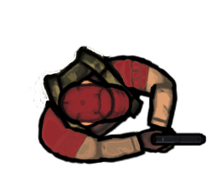 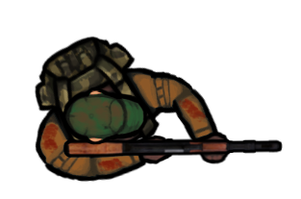 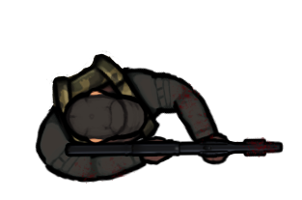

The enemies spawn in different locations and have different patterns of movement until they see the player and then they follow the player until they kill them.

Pistol Enemy

Speed: 2

Max Health: 5

Attack Damage: 2

Time to Attack: 0.4

AR Enemy

Speed: 3

Max Health: 5

Attack Damage: 3

Time to Attack: 0.3

Shotgun Enemy

Speed:2

Max Health: 5

Attack Damage: 1(per pellet)

Time to Attack: 0.8

Each Enemy has its own spawn point and will only spawn once and will not spawn again unless you press retry.

# 11 Art

The game takes place in a high-rise building so the environment is a very professional and business setting.  Below are the pillars, walls and floors.

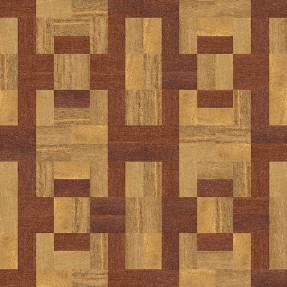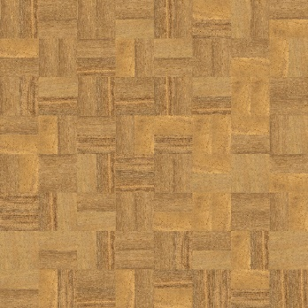

## 11.1 Setting

## 11.2 Level Design

For the first room I went for a lobby with pillars taking some inspiration from the matrix lobby scene and since it's a high-rise I knew it had to be a little fancy.

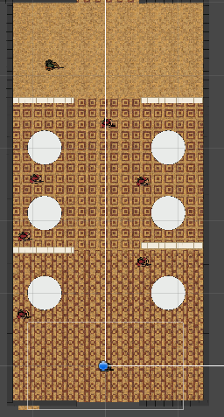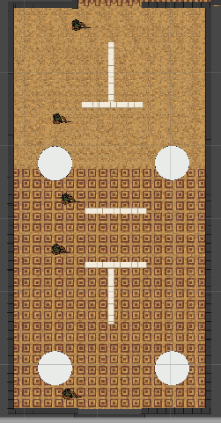

For the second room I went for a art museum design with walls in the center of the room and pillars on the side I was trying to find a way to maximize cover but also make the room layout also make sense so I chose to go for art museum setup.

## 11.3 Audio

Name Category Description

Abandoned Streets by Jordan F Main Menu Music Plays on the Main Menu

Overdrive by Lazerhawk Background Music Plays during game

FirePistol FX Plays when anyone fires a weapon

# 12 Minimum Viable Product (MPV) Environment

* One Player character to choose from (soldier)
* Built for PC Platform
* Only one weapon
* 2 Rooms

# 13 Wish List

* Add more weapons
* Bullet time
* Fix physics when shooting enemies
* Boss
* Limited weapon magazines
* Doors
* Penetrable walls

Genre

The genre of my game is a top down shooter mixed with low health and synthwave music very much taking notes from a game series called hotline miami.

Bibliography

Pictures

“Home.” Bullets PNG Image, <http://pngimg.com/download/35620.(PistolBullet)>

“Home.” Bullets PNG Image, http://pngimg.com/download/35622.(AKBullet) .

Gombart, https://opengameart.org/content/animated-top-down-survivor-player. “Animated Top Down Survivor Player.” OpenGameArt.org, OpenGameArt.org, 18 July 2017, <https://opengameart.org/content/animated-top-down-survivor-player>.

Plaintextures. “Wooden Floors.” OpenGameArt.org, OpenGameArt.org, 8 Apr. 2013, <https://opengameart.org/content/wooden-floors>.

“Home.” Blood PNG Image, http://pngimg.com/download/6143.(Blood) “Download Bullet Shot Hole Png Image HQ PNG Image.” FreePNGImg, 16 June 2015, <https://freepngimg.com/png/6867-bullet-shot-hole-png-image>.

“Metal Background - Unlimited Download. Cleanpng.com.” Cleanpng.com, <https://www.cleanpng.com/png-ball-bearing-stainless-steel-metal-3101498/>.

“Home.” Raccoon PNG, http://pngimg.com/download/16969. “Home.” Pizza PNG, <http://pngimg.com/download/44089>.

Audio

Koenig, Mike. “9mm Gunshot Sounds: Effects: Sound Bites: Sound Clips from SoundBible.com.” Free Sound Clips, 20 Mar. 2016, <https://soundbible.com/2120-9mm-Gunshot.html>.

YouTube, YouTube, <https://www.youtube.com/watch?v=SG_0VX2IrNc.(Lazerhawk,Overdrive)>

F., Jordan. YouTube, YouTube, https://www.youtube.com/watch?v=Ed1U6SThL6A.

Coding

YouTube, YouTube, 20 Dec. 2017, https://www.youtube.com/watch?v=JivuXdrIHK0.(Pause Menu)

“TOP DOWN SHOOTING in Unity.” YouTube, YouTube, 1 Sept. 2019, <https://www.youtube.com/watch?v=LNLVOjbrQj4&t=676s>.

“Hotline Miami Clone in Unity - Floor Transitions & Main Menu Part 1.” YouTube, YouTube, 6 Apr. 2016, https://www.youtube.com/watch?v=xko4RszjV5Y&list=PLdgLYFdStKu2RTKC6f9LhIC2Xb6e JfRag&index=13.

“Unity 2D Rain Tutorial .” YouTube, YouTube, 28 Apr. 2019, <https://www.youtube.com/watch?v=xkB6yzCBfgw>.

“Mini Unity Tutorial - How To Create Scrolling Credits Scene - Beginners Tutorial.” YouTube, YouTube, 1 July 2017, <https://www.youtube.com/watch?v=cj6hwCjiVZE>.

“Unity Top Down Colliders and Character Movement - Tutorial.” YouTube, YouTube, 3 Dec. 2018, https://www.youtube.com/watch?v=Cry7FOHZGN4&t=72s.