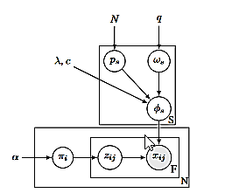

**Fig. 1.13.** Bayesian case model: graphical representation in Plate notation (Kim 2015)