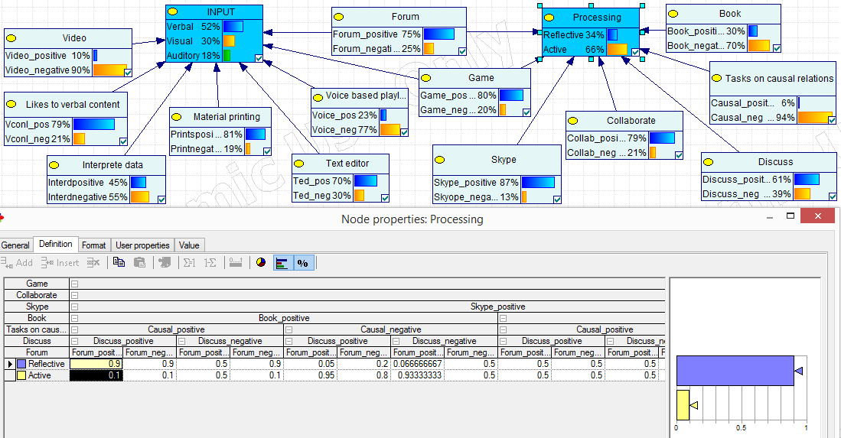

**Fig. 1.5.** Bayes network for modelling the learning style of a learner