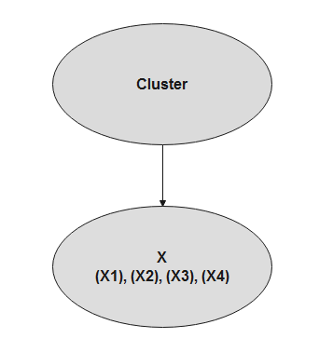

**Fig. 1.12.** Bayesian network mixture model ([Bayes Server Learning Center](https://www.bayesserver.com/docs/)  2020)