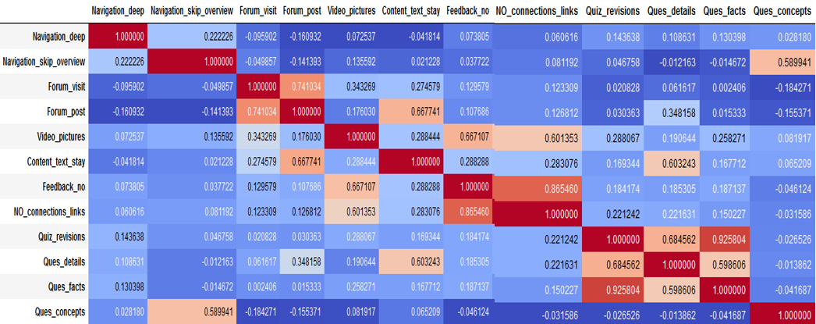

**Fig. 2.2.** Correlation matrix of data features in a data set

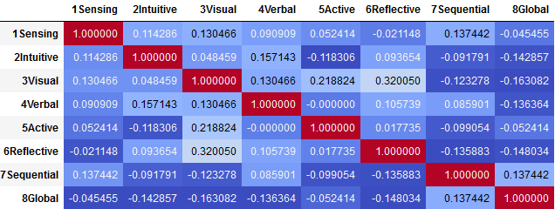

**Fig. 2.3.** Correlation matrix of labels in a data set

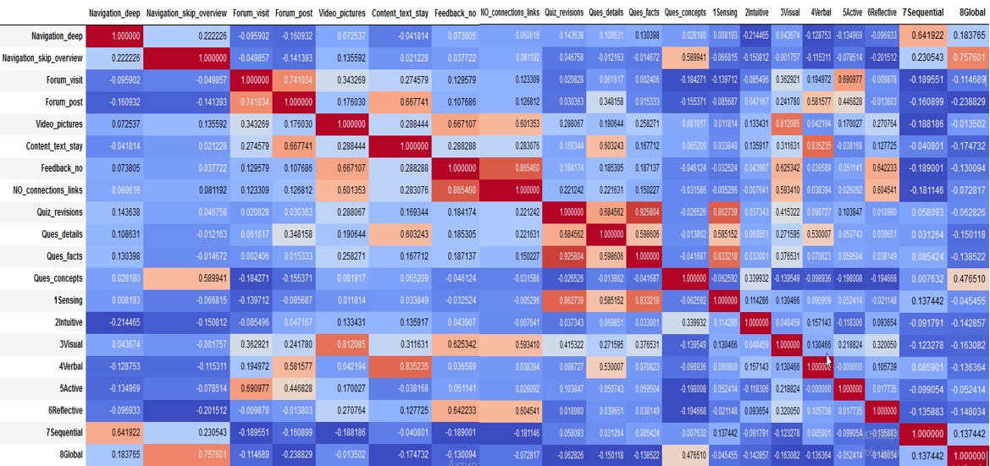

**Fig. 2.4.** Correlation matrix of a complete data set