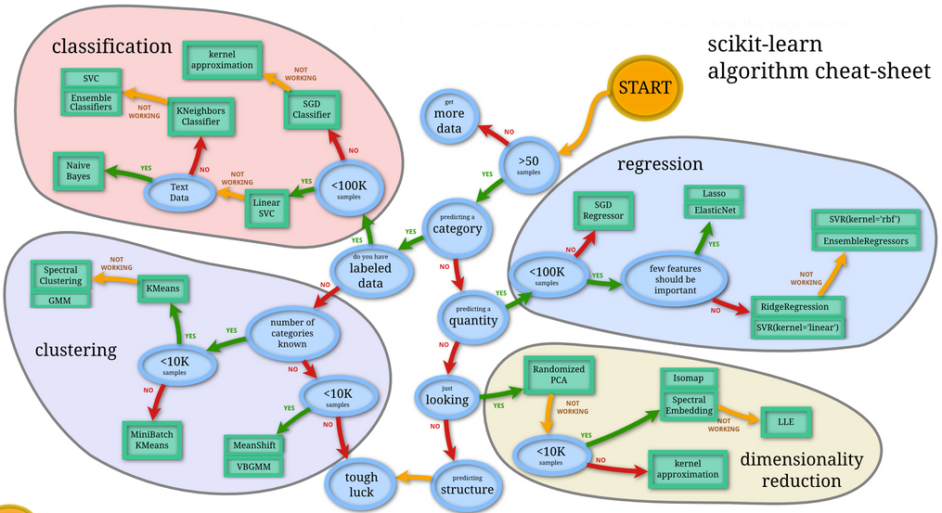

**Fig. 1.19.** **Scikit-learn algorithm cheat-sheet sheet** (Pedregosa et al. 2011)

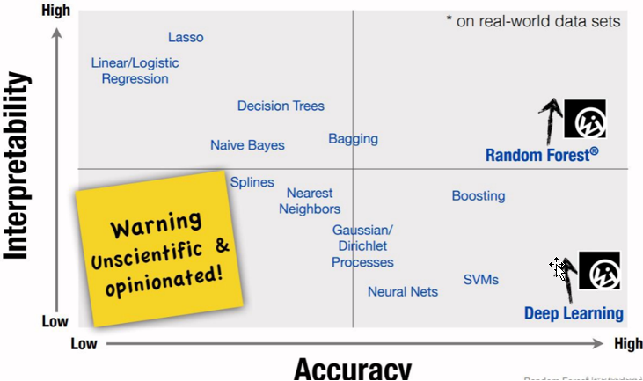

**Fig. 1.20.** Trade-off between accuracy and interpretability (Breton 2021)