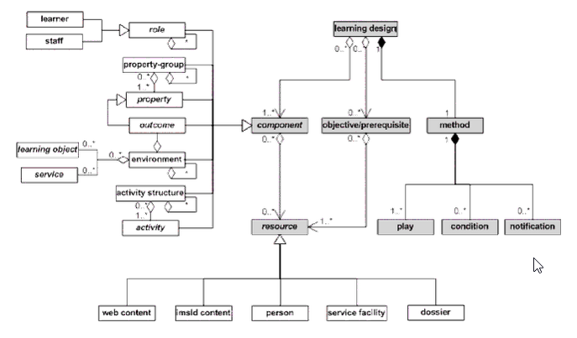

**Fig. 3.3. Semantic aggregation levels in the Learning Design Level C specification** (IMS Learning Design Information Model, Version 1.0., Final Specification**)**

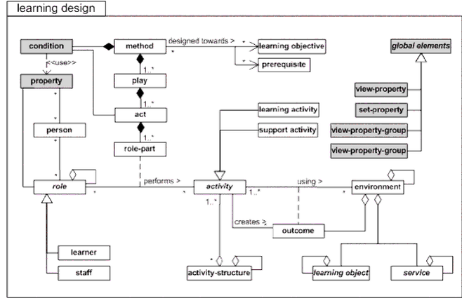

**Fig. 3.4**. **Conceptual model of overall Learning Design** (IMS Learning Design Information Model, Version 1.0., Final Specification)

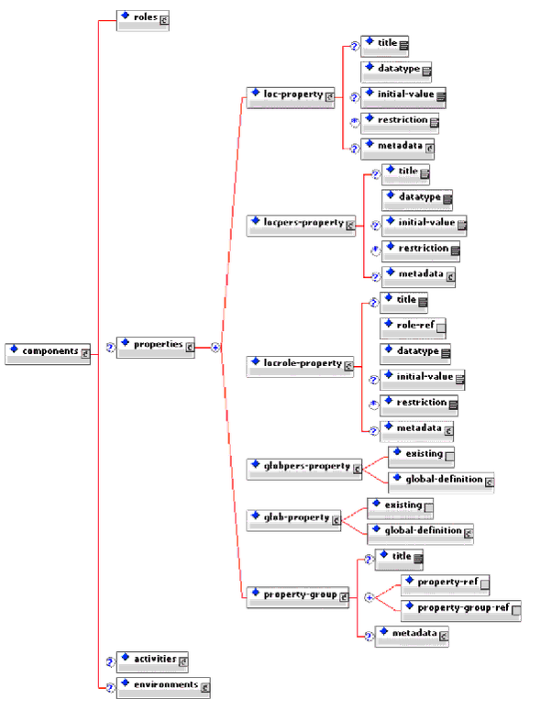

**Fig. 3.5.** Element “properties” is added to the content model of the element “Components” (IMS Learning Design Information Model, Version 1.0., Final Specification)