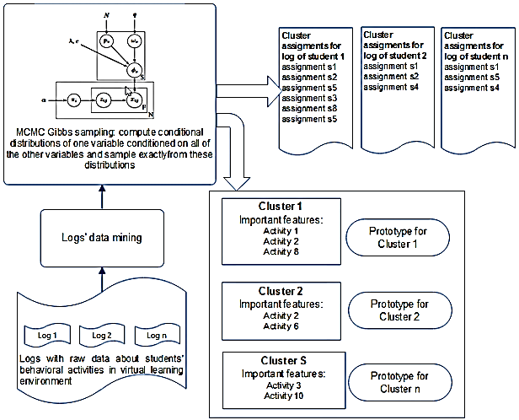

**Fig. 1.14.** Generation of students’ learning style clusters represented by prototype and important features using BCM