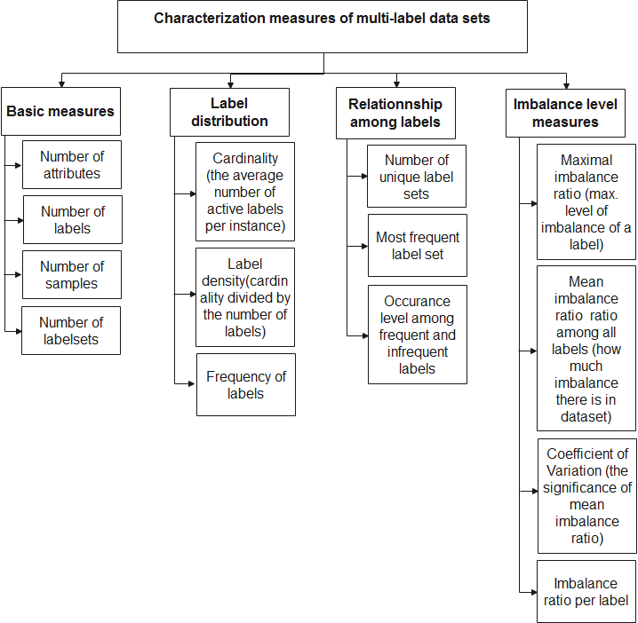

**Fig. 2.1.** Characterization measures taxonomy