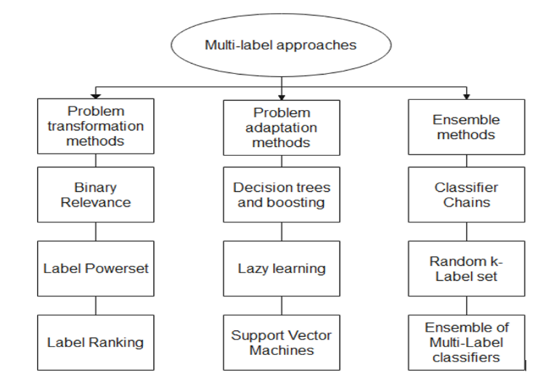

**Fig. 1.4.** Multi-label classification approaches (Madjarov *et. al.* 2012)