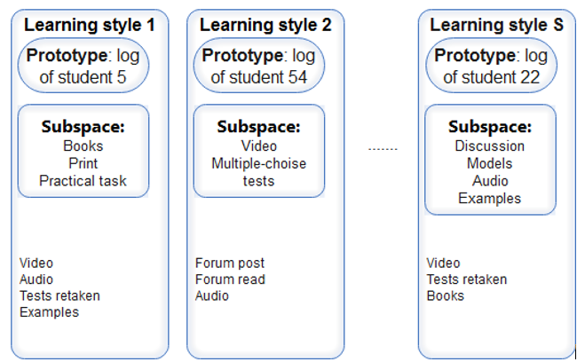

**Fig. 1.17.** Prototypes and subspaces of learning style clusters in BCM