There are the following multi-class classification strategies (Pedregosaet al. 2011):

* *One-vs-Rest* strategy that splits a multi-class classification into one binary classification problem per class (Fig. 1.2., ref. file *str.docx*);
* *One-vs-One* strategy that splits a multi-class classification into one binary classification problem per each pair of classes (Fig. 1.3., ref. file *str.docx*);
* ***Error-Correcting Output Codes*** technique that allows a multi-class classification problem to be reframed as multiple binary classification problems, allowing the use of native binary classification models to be used directly. Unlike [*One-vs-rest* and *One-vs-one* methods](https://machinelearningmastery.com/one-vs-rest-and-one-vs-one-for-multi-class-classification/) that offer a similar solution by dividing a multi-class classification problem into a fixed number of binary classification problems, the *error-correcting output codes* technique allows each class to be encoded as an arbitrary number of binary classification problems. When an overdetermined representation is used, it allows the extra models to act as “error-correction” predictions that can result in better predictive performance.

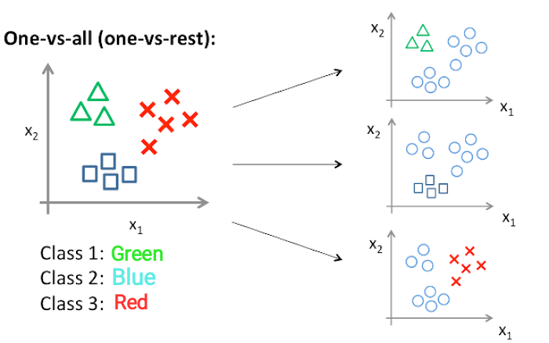

**Fig. 1.2.** *One-vs-Rest* multi-class classification strategy (Amey 2020)

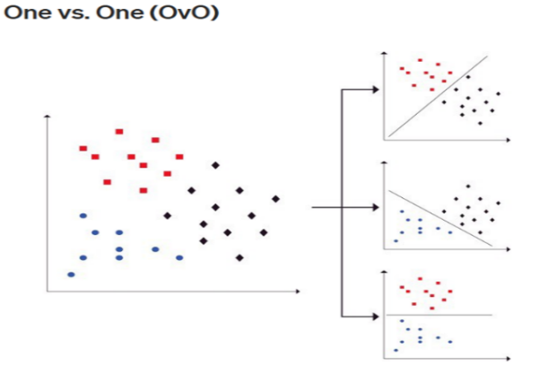

**Fig. 1.3.** *One-vs-One* multi-class classification strategy (Amey 2020)