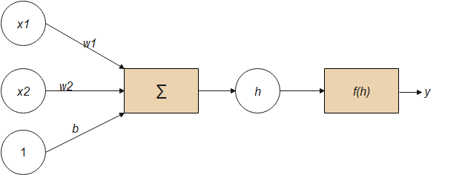

**Fig. 1.9.** Transformations of the inputs entered into the network