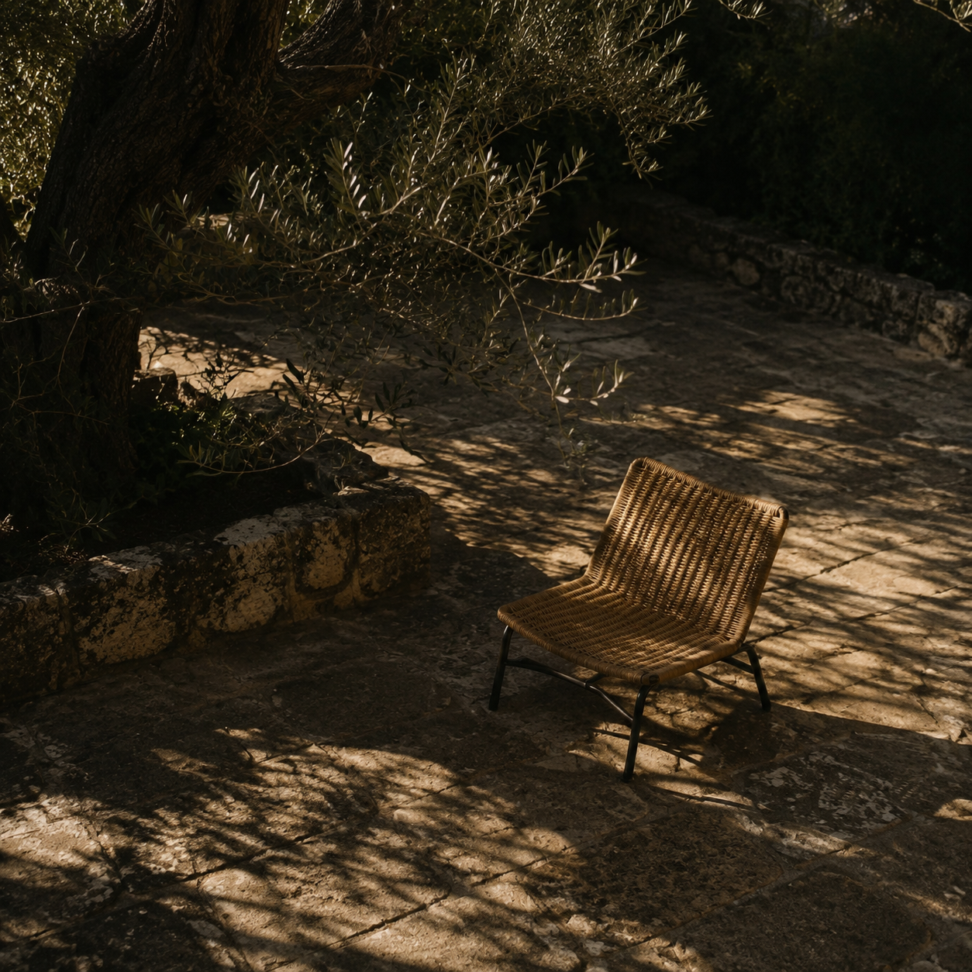

CHUTE Design Evolution Report
Short subtitle describing the report up to two lines of text |  | Prepared by [Author]  [Month YYYY]

Contents

Executive summary 2
At a glance 2
Introduction 2
Key findings 3
Context and conditions 3
Patterns in the evidence 3
Implications 3
Recommendations 4
Conclusion 4
Appendix 5
Notes 5
Source placeholders 5

Executive summary
The supplied reference is within reach as a disciplined translation: CHUTE can evolve from an arcade quiz into a compact match-intelligence terminal while preserving its Neo Arcade identity, quiz semantics, TxLINE evidence and Solana proof layer.
At a glance

The highest-leverage move is a component-level redesign: dominant match metric, one decisive action, evidence-backed chart, accessible sheet primitives and restrained motion.
- Current scope
- CHUTE already has consolidated tokens, replay and predictive modes, ranking, wallet flow and proof metadata. The missing layer is composition and interaction polish, not core product capability.
- Key findings

The reference uses oversized numeric hierarchy, fluorescent lime as a decision color, stacked cards, compact navigation and analytical charts. These patterns map naturally to CHUTE Matchday, Quiz, Reveal and Result screens.
Implications
The current angular Neo Arcade language should remain for identity and competition. Rounded terminal surfaces can be introduced for data and interaction, producing a hybrid system rather than a generic fintech clone.

Key takeaway. Proceed with a component-level redesign, not a wholesale framework replacement.
Recommendations

Adopt Motion for gestures and transitions, Radix primitives for accessible behavior-heavy components, Recharts for evidence-backed charts, and consolidate the current icon overlap during migration.
Phase A — surface foundation. Add terminal surfaces, MetricHero, ThesisCard and ProofCapsule.

Phase B — analytical interaction. Add snapshot-backed SignalChart, selected-card transitions and accessible wallet/network sheets.
Phase C — result and social layer. Redesign ranking, proof reveal, share card and replay/predictive QA.

Conclusion

The design level is achievable with the existing stack. The implementation should protect data truth and scoring invariants while upgrading hierarchy, density, motion and mobile ergonomics.
Appendix
Theme | Observation | Implication
Lorem | Dolor sit amet | Consectetur adipiscing
Ipsum | Sed do eiusmod | Tempor incididunt
Dolor | Ut labore et dolore | Magna aliqua

Evidence and constraints
The source was supplied as an image, not a URL; therefore no Firecrawl website scrape was possible. Local CHUTE source and official library documentation were used as evidence.
- Source placeholders
- User-provided reference image. CHUTE source repository. Official Motion, Radix Primitives and Recharts documentation.
- Review the outcome. Duis aute irure dolor in reprehenderit in voluptate velit esse cillum dolore eu fugiat nulla pariatur.

Conclusion
Itaque earum rerum hic tenetur a sapiente delectus, ut aut reiciendis voluptatibus maiores alias consequatur aut perferendis doloribus asperiores repellat.
Excepteur sint occaecat cupidatat non proident, sunt in culpa qui officia deserunt mollit anim id est laborum.

Appendix

Notes
Lorem ipsum dolor sit amet, consectetur adipiscing elit. Integer nec odio. Praesent libero. Sed cursus ante dapibus diam.
Suspendisse potenti. Nunc feugiat mi a tellus consequat imperdiet. Vestibulum sapien. Proin quam. Etiam ultrices.

Source placeholders
- [Author or organization]. [Source title]. [Publisher], [Year].
- [Author or organization]. [Report or article title]. [Month Year].
- [Dataset owner]. [Dataset name and version]. Accessed [Month Year].
- [Interviewee or team]. [Interview or workshop notes]. [Date].

Template note. Replace bracketed placeholders, update the table of contents, and confirm page references before publishing.

